DEVELOPING STUDENT-STAFF PARTNERSHIPS TO ENHANCE DIGITAL CAPABILITIES REPORT
PILOT PHASE

OUTSTANDING TEACHING, LEARNING
& ASSESSMENT PROGRAMME

ETFOUNDATION.CO.UK

Contents
01 Foreword 3
02 Introduction and context 4
03 Programme overview 6
04 Summary – emerging effective practice 9
05 Programme outcomes and impact 11
06 Lessons learnt 14
07 Recommendations – for providers and the ETF 15
08 Annex 1 – Project reports 17
09 Annex 2 – Overview of practical outputs 40
All project outputs and case studies referenced within this report can be found in the OTLA EdTech toolkit,
hosted on the same web page as this report.

01 Foreword
The Education and Training Foundation (ETF) is the government backed, sector-owned national professional development body for the further education and training sector. Our role is to support the continuing transformation of our technical and vocational education system by developing has world-class leaders, teachers and trainers, leading to ever-improving learner outcomes, a more highly skilled workforce for employers, and a stronger economy, country and society.
Outstanding Teaching, Learning and Assessment (OTLA) is one of the ETF’s flagship programmes, and includes training courses, collaborative projects and our regional Professional Exchanges. Our collaborative projects aim to improve teaching, learning and assessment by giving practitioners the time and space to explore solutions to the challenges they face.
This strand of OTLA took a unique approach by exploring how the digital capability of students could be harnessed to support staff in their use of technology for teaching, learning and assessment. We wanted to discover whether the knowledge and enthusiasm of students would bring new insight and new approaches to the use of technology in learning.
This report, with the toolkit, has therefore been created through the collaborative research of practitioner colleagues working directly with their students. We hope you find the approach practical and valuable in your organisation.

VIKKI LIOGIER
Head of Learning Technologies, Education & Training Foundation

This strand of OTLA has been managed by the Strategic Development Network (SDN), who have also edited this toolkit.
Acknowledgments:
We would like to thank all the students and staff who participated in these pilot projects, particularly the four project leads who drove this initiative – Andrew Dixon (Bishop Auckland College), Sky Caves (Basingstoke College of Technology), Luke Mullender (CityLit), Peter Kilcoyne (Heart of Worcestershire College).
We would also like to thank Vikki Liogier (Head of Learning Technologies at ETF) who initiated this programme of research and Linda Simpson (OTLA Programme Adviser) who supported us throughout.

02 Introduction and context

About OTLA
The Foundation’s OTLA programmes draw together activity to support practitioners to improve and develop their practice.
This strand of OTLA activity is driven by the values and expectations set out in the Foundation’s Digital Teaching Professional Framework; a drive towards Ofsted outstanding (and similar success with other metrics); a clear focus on proven methodologies; intelligent and purposeful use of learner data and the need to work collaboratively across organisational boundaries and across a variety of provider types, to source the most effective teaching, learning and assessment and share this with the sector.
The two aims of the OTLA programme are to:
• Improve the quality of teaching, learning and assessment in the FE and training sector
• Support increased professionalism for practitioners in the sector
This programme was commissioned through Phase 4 of the OTLA Collaborative Projects strand. Collaborative projects focus on provider and practitioner defined problems, often linked to a current theme important to the sector – in this case, the new apprenticeship standards. Projects centre on developing evidence-based solutions to improve teaching, learning and assessment to outstanding. Previous phases have produced a wide range of outputs hosted on the OTLA Exhibition site.
Click here to visit the OTLA Exhibition Site.

About the Student-Staff EdTech pilot programme
One of the core training priorities for the Foundation, highlighted by 2,300 sector leaders and practitioners in 2018 as part of their Training Needs Analysis, was the need to use digital and new technologies more effectively within teaching and learning.
In response, the ETF developed:
• a sector EdTech Strategy. Click here to view the EdTech Strategy
• a Digital Teaching Professional Framework (DTPF) – a competency framework for teaching and training practitioners, designed to focus on the benefits of good pedagogy supported by technology to enhance learning. Click here to view the Digital Teaching Professional Framework
• the Enhance Digital Teaching Platform – a professional development interface including online bite-size training modules mapped to the DTPF, with a badged recognition structure. Click here to view the Enhance Digital Teaching Platform
• a Digital Perspectives report exploring staff development barriers and solutions. Click here to view the Digital Perspectives report

Links listed above can be found on the ETF website EdTech area. Click here to visit the ETF website EdTech area.
The Student-Staff EdTech pilot programme was an integral part of the ETF EdTech Strategy to foster robust and close partnerships with FE and Training organisations and remove barriers to staff development.
Four collaborative projects were commissioned to explore how the digital capability of students could be harnessed to support staff in their use of technology for teaching, learning and assessment. These pilot projects provided an opportunity for providers to test specific models of student-staff partnerships, measure which are most effective in enhancing learning and share the findings
with the wider sector.
Projects commenced in December 2018 and completed in March 2019, with final practical and research outputs being produced in April 2019.

03 Programme overview

Objectives
The objectives of the pilot were to identify, explore, develop and disseminate, through four practitioner-led collaborative projects, effective approaches to developing student-staff partnerships to enhance staff members’ digital capabilities.
In particular, the four projects were commissioned to explore how students’ digital capability could support teachers and trainers in developing their understanding and effective use of learning technologies.
These short pilots allowed providers to start testing what works and how best to build staff skill and confidence in the development of student-staff partnerships and in the use of technology to support and enhance learning. The intention was to build an evidence base that would inform future OTLA programmes.
The four projects focused on three research questions:
1. Can training organisations leverage students’ digital capability to support teachers and trainers in developing their understanding and effective use of learning technologies?
2. What are the most effective and sustainable approaches?
3. What are the challenges and barriers?

Programme outputs, KPIs and timescales
1. Four collaborative projects:
a. Promotion of the programme including a programme prospectus and three pre-application collaborative webinars resulting in the recruitment and commissioning of four high quality projects
b. Programme launch with leads (November 2018)
c. Delivery of projects in line with commissioned milestones and deliverables
2. 200 direct project participants from c.12 participating providers (December 2018 – March 2019).
a. 40 individuals involved in practitioner-research project teams and in output development.
b. Student-staff CPD partnerships covering at least 100 individuals with a minimum of four partnerships per organisation.
3. Four online Communities of Practice / CPD sessions combining partnerships from across the four projects.
4. Four sets of project outputs, for example (March 2019).
a. Student partner role descriptions.
b. Recruitment processes for student partner.
c. Specifications for student partner CPD.
d. Guidelines for practitioner involvement.
5. 20 mini-case studies from student-staff CPD partnerships (April 2019).
6. Involvement of 400 additional indirect participants within participating providers using cascading and CPD.
7. Consolidated outputs (based on inter-project collaboration between the four projects) in the form of a toolkit for the sector drawing together individual project resources and case studies (May 2019).
8. Final programme report integrating learning from all four projects and framed within previous OTLA evaluations, summarising activity and evaluating the pilot, including recommendations for further phases of activity (May 2019).
9. Practice sharing webinars, for practitioners across the sector (May 2019).
10. 1,000 broadcast participant downloads, views and webinar participants (May 2019 onwards).

The four pilot projects
The four project pilots were led by:
• Bishops Auckland College
• Basingstoke College of Technology
• City Lit
• Heart of Worcestershire College
The four collaborative project groups included over 50 practitioners from a range of organisations, including independent training providers, FE Colleges and Local Authority providers. Over 100 individuals were involved in the student-staff partnerships.
SDN worked hard to ensure project leads had a clear understanding of collaborative practitioner inquiry, and how it differs from conventional research. In particular, drawing on Professor Jean McNiff’s description:
• Conventional research asks: “What is happening here?”
• Collaborative practitioner inquiry asks: “How can we improve what is happening here?”

Project focus and technologies
Most project leads and their partners trialed the student-staff partnerships in a range of contexts and with students on different courses and levels. The majority of these students were however classroom based. City Lit focused their student-staff partnerships on ESOL and Essential Skill students and staff.
Work-based learning and adult community provider partners involved in the projects found it harder to pilot in their context within the timescales of the project, as they lacked the weekly face-to-face learner interaction needed to progress project activities.
Project leads and their partners explored and tested a range of technology platforms, apps and tools, including:
Google Classroom Google Drive
Google Apps Google forms
One Note Moodle
Kahoot Nearpod
PowerPoint Padlet
H5P G Suite for Education
Office 365 apps Kahoot!
Facebook Instagram
ClickView Mahara
Trello

Management approach
• Programme management: Drawing on its tried and tested programme management model, SDN appointed a central management and administration team, supported by its expert network of Associates. The programme management team:
• Reported progress regularly to the ETF
• Oversaw the tendering and commissioning process for projects
• Facilitated communications with the sector
• Coordinated CPD and mentoring for projects
• Facilitated sharing practice and progress between mentors
• Provided guidance on the development of the practical and research outputs
• Conducted evaluation throughout
• Developed the final programme outputs, including the toolkit and research report
• Oversaw the dissemination of the programme findings and outputs through a series of webinars and sector communications
• Research management: An overarching research framework was developed and included within the programme prospectus. This shaped the project applications, their research approach and evaluation methodologies, as well as the broader programme evaluation.
SDN’s Lead Mentors Louise Doyle and Anna Sutton supported projects to refine their research approach right at the beginning and provided guidance on what we mean by practitioner inquiry and how it differs to conventional research. Each mentor also provided support and guidance throughout.
• Project mentoring: Each project was assigned an expert project mentor from SDN’s Associate team. Mentors were matched based on the project focus, their expertise and geography. Mentors:
• Supported the initiation of each project, including refining the research questions
• Provided regular guidance throughout and acted as a critical friend
• Provided CPD and coaching where needed
• Encouraged collaboration and sharing between projects
• Helped projects to maintain momentum and meet deadlines
• Reviewed draft and final outputs – both practical and research
• Supported the dissemination of project findings

04 Summary – emerging effective practice
The four projects broadly delivered the following model, with various adaptations and adjustments made reflecting the organisation structure / partners, different uses of technology and the support required for particular learners.
1. Set-up • Promotion, incentives and recruitment of staff and students
• Project launch and briefing for each participant
• Establishing student-staff partnerships
• Agreeing activities, timescales, reporting and communication (at a partnership and project level)
2. Research • Research to identify where development of digital skills was greatest, among staff
• Reviewing digital tools, platforms and apps to enhance learning
• Testing shortlisted tools and agreeing which to pilot within the classroom
3. Implementation • Student demonstrations of tools with staff, and with other students in their class
and delivery • Integration of tool within the classroom to drive and enhance relevant learning activities
4. Evaluation • Initial evaluation and debrief from learners – adjustments made
• Evaluation and feedback from staff-student partnerships and learners at the end of the project

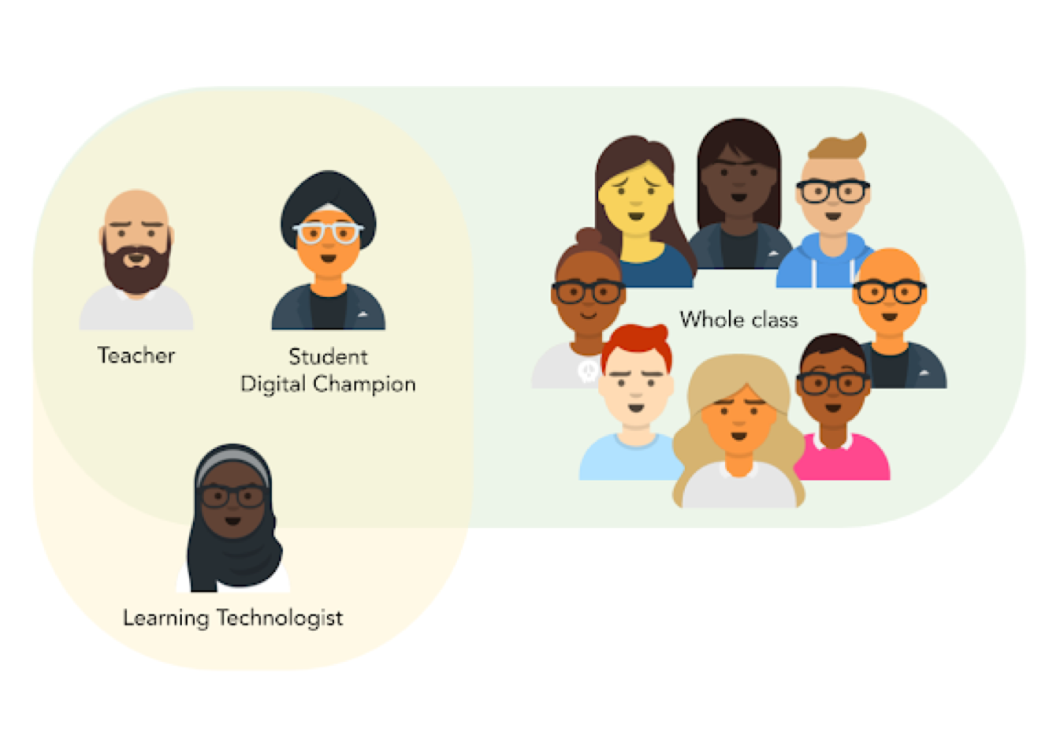

Incentivising students and staff
Students were incentivised to become digital ambassadors / mentors and engage in the project. Project leads communicated the benefits of the project to students, setting out the opportunity for personal development and a certificate. Other incentives were also offered (e.g. vouchers, money, trips) upon successful completion of the project.
In general, it was felt that many students were keen to engage in the project as an opportunity for personal development. With project activities conducted over a short intensive time period, the added incentives helped to keep students engaged and motivated throughout. If the project was conducted over a longer timeframe, it was felt that certification or digital badges would be a sufficient incentive.
For staff, incentives worked best where they were either given the time to conduct the project, financially remunerated for their time, or given Time Off in Lieu (TOIL). Although staff could see the importance of developing their digital skills in this way, their time needed to be freed up to fully engage.

Digital skills initial assessment
City Lit conducted a digital skills’ initial assessment with staff and students at the beginning – this helped to identify individual and organisational digital skills’ gaps and provided useful data to inform the specific focus of each partnership.

Launching with a whole class
At Mid Kent College, one member of staff launched the project with the entire class of a teacher who had expressed interest, as opposed to with a pre-recruited partnership team. The whole class engaged in the research stage, looking for tools to suit the prerequisites specified by their teacher. After the session, two students came forward to express an interest in leading on the project - these students then became the partnership members. This was a particularly effective approach as the whole class felt invested and involved in the process, which made the implementation stage a lot smoother.

Defined roles for student partners
City and Islington College assigned the student partners with individual responsibilities prior to their implementation session. For example, one student was responsible for creating how-to guides for the students to refer to, whilst another was given the responsibility of preparing the teacher for the session. This approach worked particularly well in making the project inclusive for different types of learners and playing to each of their strengths, which is an important consideration for a project that involves such a broad range of skills and activities.

Using existing digital leaders to support new ones
Basingstoke College of Technology brought in existing Digital Leaders (students in a part-time digital support role) to give advice and guidance to the student partners. The Digital Leaders were able to give a unique insight into what it’s like to assist staff in using technologies from a student perspective, the benefits it brought and potential challenges to overcome. This was particularly valuable as the students involved in the partnership had no prior experience working with staff and were not very confident in their abilities. Hearing from other students who had started where they were and were now confident and accomplished in their roles, was useful to motivate and reassure student partners.

Levels
Student-staff projects proved most effective with Level 3 students, compared to students who were on Level 2 or 1 courses. In general, entry level and Level 2 students (with the staff partners) required greater input, support and training to get the best out of the process.

Pairs versus single mentors
One partner organisation used pairs of student mentors rather than a single mentor. This approach proved to be particularly effective. Evidence from the interviews with student mentors showed that working together led to greater motivation, sharing ideas and arriving at different solutions to problems.

Building in time and training
There was a clear correlation between the amount of training and support given to student mentors and the success and effectiveness of the partnership. Making sure there is sufficient time built in for this – at the start and throughout - taking account of timetabling constraints and availability of students is an important consideration. It was felt that most student-staff partners would need to meet for at least one hour per week on a regular basis, to allow for sufficient digital skills analysis and development, research, educational application of digital tools, planning delivery of teaching and assessment and evaluation.

05 Programme outcomes and impact
This pilot programme was delivered over a four-month period, with project evaluations taking place throughout and at the end. As such, this report captures the immediate impact of their activities (rather than any longer-term outcomes and impact).

Programme reach and impact in numbers

4
Collaborative projects successfully established

226  Staff and students involved  in projects  nts involved in | 408  Indirect participants – other staff  who benefited from the project | 24,300  Expected dissemination  (broadcast)–

Programme dissemination activities
In addition to project reach, SDN plans to conduct a number of activities to disseminate the research
findings and practical outputs to practitioners across
the sector, including:
• Two case study webinars through SET/ETF (200 broadcast)
• Article in the Digital edition of InTuition and ETF newsletters (already disseminated – 17,000 broadcast)
• Toolkit promotion through SDN Digest (6,900 broadcast)
• Social media dissemination – SDN and ETF LinkedIn and Twitter (200 broadcast)

Impact on practice
For project participants
SDN conducted a short survey at the beginning of project delivery and then towards the end, to measure the level of confidence of practitioners involved in projects in their ability to plan and conduct collaborative inquiry. The survey was based on a rating scale where 1 was ‘not at all confident’ and 100 was ‘completely confident’. Although not all practitioners responded, it gives a useful indication of the type of practitioners involved and their level of confidence:
 | Range | Average rating
Beginning of project | 8 – 100 | 69
End of project | 10 – 93 | 73
 | Distance travelled | +4

An important impact of the programme for several project leads and their organisations, has been their adoption of practitioner research and drawing on students to enhance staff digital learning and skills.

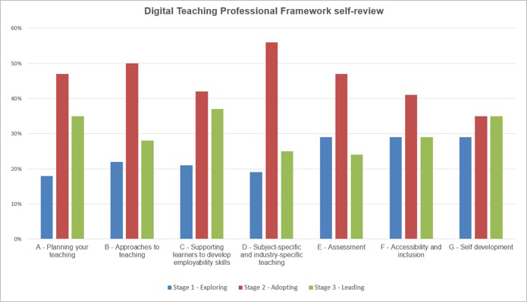

One practitioner fed back:
“It was a very useful project. It was relatively simple and straightforward to carry out, we had great back up and there was a clear tangible goal”.

Outcomes for teachers; impact on students
Outcomes for teachers, and its impact on teaching, learning and assessment
All teachers at Basingstoke College (and its partners) reported some level of increased engagement with learning technologies amongst their learners and many reflected that the project had given them more confidence to use digital technologies in their teaching practice in future. Learning Technologists also reported on the usefulness of working more closely with teachers and students on specific activities which will improve approaches to supporting students and staff in enhancing their digital skills in the future.
Practitioners involved in the Heart of Worcestershire College project felt the project had been a positive process through which they made significant improvements in their skills and confidence in the use of digital technology to support teaching and learning.
Students involved in the partnerships were asked to comment on how they thought staff had developed:
“It allows for the teacher to understand what sort of lessons students want and to allow for the teacher
to find out how the students best learn.”
“Keeps practitioners up to date on their skills with technology.”

Practitioners similarly reported that the project had stretched and challenged their own practice, their adoption of new technologies to aid their teaching and using new methods of learning within the classroom. Practitioners reported that the new skills that they acquired would be used in other classes they were teaching and applied in a range of new ways.
“The two outstanding projects so far are the Instagram and Facebook projects. These have really increased motivation and participation in lessons and have basically replaced their VLE, which these particular learners do not like. The teachers in question have both said on numerous occasions that these digital methods have allowed them to flip their classroom in a way that Moodle has never allowed.” BISHOP AUCKLAND COLLEGE
Both staff and students reported a positive impact on teaching, learning and assessment. In general, learners enjoyed and engaged positively with new technological approaches being used in their classes.
Some teaching sessions were informally evaluated and observed. One activity, an online case study which previously would have been done as an A4 document, was evaluated by an ILT colleague. Learners feedback at the end of the session:
“It was a good way of using group discussion and teamwork.”
“It worked well and was more interesting than reading it off of paper.”
“We developed a greater understanding and worked as part of a team to get the best information and learning.”
Impact on students
For Basingstoke College (and partners), most teachers reported increased numbers of students able to access online learning resources. This was one of the objectives of the project. The digital skills’ initial assessment completed by all students was a useful output from the project.
In every classroom that took part in the project, there were enthusiastic students, interested in being the class digital champion. The student digital champions were all very motivated to help other students.
At Heart of Worcestershire College, students involved in the project all reported positive outcomes, including improvements in their own confidence, benefitting from working in a real-life partnership with a professional practitioner, improving problem solving skills and improving their own digital skills.
Staff involved in the partnerships were also asked to comment on how they thought students had developed:
“Students are now able to draw on a wider range of technologies and help teachers integrate these new systems into college life.”
“I believe it has helped students’ bond more with their practitioners and help each other learn more about technology and each other’s understanding of it.”
“The teacher gets to see the issues from a student’s point of view.”
“Gives the student mentoring skills.”
“I think it benefits the students (who now) know how to present a good presentation.”
Project leads also reported that students have gained useful employability skills e.g. using Office forms and OneDrive.

06 Lessons learnt

What has worked well?
• Drawing on SDN’s contact base and our partnerships with regional and national networks allowed us to promote the opportunity of running a project quickly and effectively. We also drew on our experience with the OTLA apprenticeship programme to make sure the prospectus and supporting documents were clear and provided the right level of detail. This resulted in a set of high-quality bids being received. Organisations who were awarded projects were largely those who had a clear ILT lead and previous experience in running OTLA or digital research projects. This was particularly important, given the short timescales of the pilots and allowed projects to quickly set up and deliver activities in a way that produced tangible results and research findings by April 2019.
• The focus on the programme itself resonated with providers, particularly colleges. Although some of the project leads already had digital student champions in place, harnessing students’ digital capabilities to support and mentor staff, as part of a structured project, was seen to have real value and staff/students were keen to engage. The early outcomes and impact (as set out above) confirm this and many of the colleges involved are strongly considering implementing student mentors as part of their long-term digital learning strategies
• Assigning an expert mentor to each project to provide support, input and guidance throughout was welcomed by projects and helped projects to quickly get off the ground, maintain momentum and underpin the quality of the practical and research outputs.
• Working with projects upfront to understand the nature of practitioner inquiry and spending time at the start to shape and refine their project model was vital. We held an initial inception meeting to help project leads shape their project with follow-up CPD where needed. Feedback from project participants was very positive.
• Drawing on previous experience, we will be pulling all practical and research outputs into a single easy-to-use toolkit allowing practitioners to quickly access the findings and outputs of most interest to them. We will also be hosting two webinars to disseminate the findings and outputs, which has proved to be an effective way of disseminating the findings in previous programmes.

Where can improvements be made?
• All project leads fed back that the intensive time-constrained nature of the pilots was challenging and didn’t give them space to innovate or try different models / approaches in response to the early outcomes of the project. The initial recruitment of
the students and staff and the training / support provided up front was crucial to the success of each partnership. Additional time would have allowed project leads to build and schedule this in with each partnership more effectively.
• Overall, the student-staff partnership model works well within colleges for classroom-based courses. It required consistent and regular face-to-face interactions (normally weekly) between the student/s and staff. For work-based learning programmes and for Adult Community providers, however, there is often little or no ILT support available to help drive the project and face-to-face interactions with the student in the workplace are often sporadic or conducted online. In some cases, collaborative technologies such as G Suite and Office 365 can help address some of these challenges. Work-based learning and ACL providers could see the benefits, however further research is required to identify and test models, with greater flexibility, that prove to be most effective within these contexts.
• If we were to run the programme again, we would look to:
• encourage all mentors and project leads to schedule in regular ‘touch-points’ right at the start, to avoid any delays to the project and progress reporting.
• reduce the number of written monthly reports and instead replace some of these with regular online meetings, to gain project updates and allow for greater sharing between projects. It would also give mentors the opportunity to mentor and coach the projects more effectively, rather than spend time chasing project leads for reports. Using online Zoom meeting technology, with virtual breakout rooms, worked well and we would look to replicate this.
• avoid asking projects to specify their practical outputs too precisely upfront in all cases – giving project leads space to let the activities and research define their outputs.

07 Recommendations – for providers and the ETF

Recommendations for providers looking to replicate the student-staff partnership model
Senior management buy-in and your digital strategy – to embed the project and maximise its effectiveness, the approach and outcomes need to be agreed at an organisational level and align to your digital and personal development strategies as an organisation.
Use the Digital Teaching Professional Framework (DTPF)– to guide your focus throughout research and to get a clear focus on what kinds of digital skills a teacher is trying to develop. The Enhance Digital Teaching Platform is an excellent resource to support learning for staff.
Measuring impact – conduct an initial skills’ assessment with staff to inform the focus of each project, agree a set of KPIs and look at how you will benchmark and measure outcomes and impact throughout.
Tools – draw on the OTLA student-staff partnership toolkit to access guidance, case studies and tools to inform your model and support implementation.
Selection of mentors – a lot of thought and care should be put into the selection of student mentors. They should have good digital skills, have the confidence to partner with a practitioner and be reliable enough to see the project through.
Training of student mentors – giving student mentors the right training at the start of the project and continued support throughout is vital. For example, what does it mean to be a student mentor, what digital learning technologies are currently used by the organisation, what needs to be considered when exploring other technologies and how might it aid and improve teaching and learning?
Selection of technology – getting student mentors to focus on existing learning technology being used in the college is a useful place to start, as well as drawing on technologies students may be using in their everyday lives that could support teaching and learning. Students and staff will need to liaise closely with ILT teams before any implementation to make sure they align with safeguarding, GDPR, sustainability, security policies and costs.
Incentives – where possible incentives should be made available to both staff and student mentors. There are some suitable qualifications that could be attached to the mentoring process. This would help in formalising the process, could potentially lead to some funding drawdown and would add a further incentive.
Staff – in part, staff should be selected based on their need for extra digital learning support, willingness to engage in a mentoring process and keenness to learn the use of new learning technologies to support their teaching and learning. Ultimately however, all teaching staff should be encouraged to engage, so that pedagogic approaches better embed EdTech in a way that promotes enhanced teaching, learning and assessment.
Involvement of ILT and quality teams – the mentoring project and the organisation should be managed and monitored by a cross-organisational team with a clear lead (e.g. ILT or quality teams).
Time – effective mentoring requires regular time input from both the student mentor and the staff participant and should be accounted for as part of their timetable. Conducting this over a 6-12-month period would allow for adjustments to be made and clear evidence of impact on students’ learning.
Ongoing evaluation – the mentoring process should be subject to ongoing evaluation including teaching and learning observations and regular feedback from both student mentors, the staff involved, students within the classroom and the team / person who is managing the project.
Based on their experience in the project, Basingstoke College refined their model to share with the wider sector, as set out below:
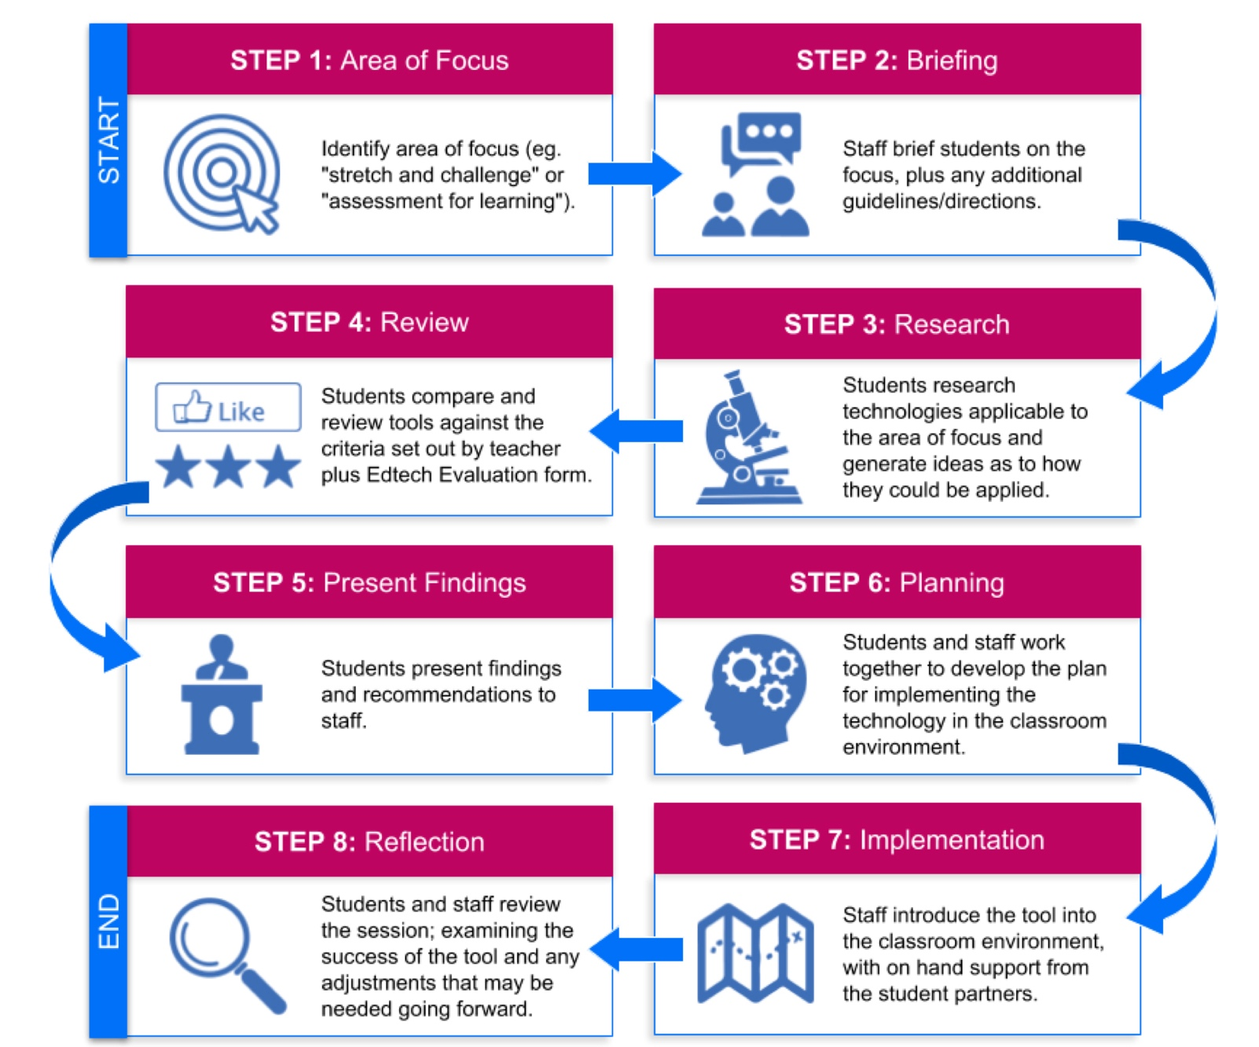

Recommendations for the ETF
Evidence from the four pilot projects has shown the student-staff model to work well, particularly within a college context. There is real value for the staff involved and student mentors. Early indications are showing improvements to teaching and learning within the classroom.
Where funding allows, SDN would suggest commissioning a second wave of projects, building on what has been learnt from the pilots to test a wider variety of models within different organisational contexts and allow for a longitudinal measurement of its impact on teaching, learning and assessment.
In particular, we would recommend that any future programme:
• builds on what has worked well from the four pilot projects
• allows greater flexibility, so that models can be adapted for different organisational contexts and programmes (particularly for work-based learning)
• gives more time to adjust and test new approaches as early lessons are learnt and allows new technologies to be implemented over a longer period of time to truly measure its impact on teaching and learning

08 Annex 1 – Project reports

Heart of Worcestershire College
1. Project team – direct participants and their roles
The project team was drawn from four organisations. Heart of Worcestershire College, Solihull College, Blackburn College and Aspiration Training Ltd.
The key roles were as follows:
Project Manager – overall responsibility for managing the project including outputs, research, organising meetings and timely completion.
College Managers – leading on delivering the project in their own organisations including selection of practitioners and students, liaising with ILT teams, ensuring completion of project tasks, supporting research and managing timely completion in their own organisation.
ILT staff – providing training opportunities for student mentors and supporting practitioners and mentors in the use of digital technologies.
Practitioners – working in partnership with other project participants and their student mentors to develop and deliver a range of digital learning activities and to participate in research activities.
Students – participating in training opportunities provided by the ILT team, working in partnership to mentor the practitioners and participating in research activities.

2. Context – project organisations’ current use of learning technology to support teaching, learning and assessment
Heart of Worcestershire College has a strong focus on blended learning with all full-time courses at levels two and three having regular weekly blended learning sessions through its SOLA (Scheduled online learning and assessment) model. The college also leads the blended learning consortium. The main learning technology used to support teaching, learning and assessment are Moodle, Office 365, ClickView and Mahara.
Blackburn College uses Moodle as its learning platform. The college also supports the use of Office 365 and Google Apps. The college also makes widespread use of blended learning.
Solihull College uses Moodle as its learning platform. The college also uses Office 365, ClickView and has done a range of work in piloting the use of virtual reality. Solihull college has also adopted and implemented the SOLA model of a blended learning.
Aspiration Training Ltd uses the Smart Assessor portfolio platform to support digital learning.

3. Approach taken to the student-staff partnerships
a. Model – how did you structure and deploy the partnerships?
Partnerships began with the selection of practitioners. The colleges selected three practitioners each and Aspiration Training Ltd selected one assessor. These were chosen based on an interest in the use of learning technology and a willingness to participate in the project as a means of improving their skills, knowledge and confidence. The practitioners then explained the project to their students and asked for volunteers who would be interested in participating in the project. The students were selected through looking at the existing digital skills, potential for being a good mentor and commitment to following through a project over a number of months. Heart of Worcestershire College, Blackburn College and Aspiration Training all had one mentor per practitioner while Solihull College used pairs of mentors.

Once selected student mentors were offered training by the ILT teams in the colleges. It was planned that this would include an element of work shadowing, but time constraints and student timetables made this difficult in most cases. However, most of the students were able to meet with ILT staff for between one and three hours each and were given an introduction to college ILT applications as well as engaging in discussions about how these might be employed with their practitioners and fellow students. This aspect of the project was much more challenging for the work-based learning partner as they didn’t have an ILT team and the learner was not based on site. Training and awareness raising on the different technical options available was delivered remotely by the assessor who was working in partnership with the mentor.
Mentors were also given guidance around the mentoring process and the role of a mentor. This included being introduced to the mentoring record document with guidance on how this should be completed throughout the project.
The mentors and the practitioners that they were working with were then given the task to meet regularly, identify opportunities for the use of digital technology to support teaching and learning and to design and implement three learning activities for the purpose of the project.
b. How did you motivate / incentivise the partnerships?
Students:
Students were incentivised to become mentors in several ways; it was explained to them this would be a useful and powerful learning experience that would be beneficial to them on their CVs, future job and or university applications. They would also learn some useful new digital skills. The financial incentive of a £50 Amazon voucher was also offered for successful completion of the project.
Practitioners:
The practitioners were incentivised through the opportunity for professional development in learning new digital skills via the project. They were also offered a £200 bonus for successful completion of the project.
c. How did they work together – what did they explore?
After the learners completed the training for the project, they began mentoring the practitioners. This involved them meeting on at least a weekly basis. In these meetings discussions took place around how a range of learning technologies could be used to enhance teaching and learning. A wide range of technologies was employed through the project across a number of different learning scenarios. These included Google forms, one note, Moodle, Kahoot, Padlet, Nearpod, Office 365, PowerPoint, H5P and Trello.
Through the mentoring process the student mentors and practitioner worked together to design and implement learning activities with these technologies which were delivered in class. Following delivery, the mentors and practitioners discussed and evaluated the learning session.
d. Did you take into account the diverse needs of students and staff? (e.g. different levels, different subjects, equality and diversity, learning support)
In order to make the pilot most effective in representing the diversity of the sector we made efforts to recruit both practitioners and learners from a range of subjects, different levels and with a range of digital skills and competence. Subject areas included hospitality, IT, business, health and social care and supported learning. These varied from entry level to level three. Staff and students involved were approximately half male and half female and came from a range of ethnic backgrounds. When asked to rate their digital skills at the start of the project on a scale of 1 to 5, staff ranged from 2 to 5 with an average of just over 3.
The different needs of students were taken into account through initial meetings where their digital skills and confidence in being mentors were assessed. Where possible, given time and timetabling constraints, extra support was provided where needed.
e. What elements of your approach were most effective / least effective?
Levels:
The approach proved most effective at level three compared to students who were studying on levels below this. This doesn’t mean that only level three learners should engage in mentoring. However entry level one and level two learners need more support and training for themselves and their practitioners to get the best out of this process.
Pairs versus single mentors:
One of the partners used pairs of mentors rather than a single mentor. This approach proved to be particularly effective. Evidence from interviews with the mentors showed that there were great benefits in working together in terms of motivation, sharing ideas and arriving at different solutions to problems.
Training and support:
There were significant differences in the amount of training and support that we were able to give to different mentors down to timetabling constraints and their general availability. It was clear that this did have a positive impact on the effectiveness of mentoring and it should be an important consideration when planning this kind of project.
College vs WBL:
Overall this approach did prove more effective in the college versus the work-based learning environment. A number of factors were involved here such as little or no ILT support available in the workplace learning provider and the difficulty in mentoring when there is very little or no face-to-face contact between assessors and apprentices.
f. What were the main challenges and barriers and what action did you take to overcome these?
Time of pilot:
The nature of this project being part of a pilot meant that we were working in a shorter timeframe than we would be if this was something actually being implemented by a college. Most of the challenges that we faced came from managing the delivering of the project within this compressed timeframe.
Timetabling constraints:
With practitioners teaching up to 26 hours a week and some mentors being on compressed timetables and only in college three days a week, most of which was in class, in some cases it proved difficult to find time for practitioners and mentors to meet and for mentors to meet with ILT staff for training. This was managed by encouraging flexibility e.g. meeting at the end of the day, coming in on their day off and by compressing the training for mentors where necessary.
These problems can be seen illustrated in the following quotes from surveys when participants were asked about challenges:
“Finding time to be able to work on together.”
“The time constraint and the fact we are only in three days a week.”
“We had a limited timescale so had to squeeze things in a bit more than we would have liked.”

4. Practical outputs – what were these? How were they embedded and used? In what ways did they support your research and practice?
Mentoring Record:
This document was used by the mentors to record meetings and discussions, to support planning and for evaluation of learning activities. Information from this was important for the research component of this project and both learners and their practitioners commented that the document proved a useful framework for keeping a record of the project as well as evaluating impact.
Mentoring PowerPoint:
This was an accompanying resource to work alongside the mentoring record. It explains the mentoring process and how-to fill-in the mentoring record above. This proved to be very useful in introducing the learners to what is expected of a mentor as well as how to fill-in in the mentoring record.
Staff Specification:
The staff specification outlined the role of the practitioner who was being mentored. This was used to explain the role to potential participants. It was useful in clarifying what was involved and in the recruitment of practitioners to the project.
Student Specification:
This outlined the role of the mentor in the project. It was useful to the practitioners in helping them identify potential mentors and to the students who were involved in clarifying what their role would be.

5. Research outcomes and impact
a. Outcomes for the learners involved in the partnerships
Learners in the project all reported positive outcomes for themselves. These were in areas such as improvements in confidence, benefitting from working in a real-life partnership with a professional practitioner, improving problem solving skills and improving their own digital skills.
b. Outcomes for the practitioners involved in the partnerships
The key findings of this project were that all the practitioners involved reported this to be a positive process through which they made significant improvements in their skills and confidence in the use of digital technology to support teaching and learning.
This is reflected in these comments from mentors:
“The teacher has a better understanding of our knowledge as students and how he can work with students to use better technology.”
“It allows for the teacher to understand what sort of lessons students want and to allow for the teacher to find out how the students best learn.”
Practitioners similarly reported positive impacts:
“Use of different packages and stretch and challenge of technologies used.”
“I have learnt how to use a new technology in my teaching.”
“Found out new ways to use different Microsoft 365 programmes, new methods to use within the classroom.”
c. Impact on the quality of their teaching, learning and assessment
Both practitioners and mentors reported positive impact on teaching, learning and assessment. When followed up with learner participants, they generally enjoyed and engaged positively with new technological approaches being used in their classes.
Practitioners reported that new skills that they had learnt would be used in other classes they were teaching and applied in a range of new ways.
Some teaching sessions were informally observed, and these were evaluated as good teaching and learning sessions.
One activity, an online case study which previously would have been done as an A4 document was evaluated by an ILT colleague. Learner feedback included:
“I think it was a good way of using group discussion and teamwork.”
“I think it worked well because we developed more of an understanding and worked as part of a team to get the best information and learning.”
This was a good illustration of benefits learners were experiencing through the project.
It is also noteworthy that learners and mentors gained useful employability skills e.g. in use of Office forms and OneDrive through the project.

6. Impact data – direct, indirect, reach, broadcast (and evidence of impact)
Twenty-nine direct participants completed the project – four Managers, nine Practitioners, five ILT Support and 11 Student Mentors.
Indirect participants included over 100 learners who participated in learning activities.
The Student Mentor project was discussed at two regional Blended Learning Consortium (BLC) meetings with a total of 42 participants from member colleges. It is planned this will be further added to with a BLC webinar and a workshop at our conference in July.
The project lead also wrote a short article which was published in the March edition of Intuition Magazine.

7. Models of outstanding practice that have been identified
Key features of outstanding practice with mentoring are:
• The right people are selected for mentor and practitioner roles. While our participants were, on the whole, keen and engaged and there was a low drop-out rate, outstanding practice would involve more time and a more robust selection process being employed
• Training and support. Outstanding practice would involve a strong induction / training programme for both mentors and practitioners. It would also include regular ongoing support.
• The mentoring process. Outstanding practice would involve mentor and practitioner being able to meet for an hour per week on a regular basis. These meetings would cover digital skills analysis and development, digital tools, educational application of digital tools, planning delivery of teaching and assessment and evaluation of delivery.

8. How have you used and embedded the Digital Teaching Professional Framework?
The partners discussed the use of the Digital Teaching Professional Framework, but it was decided time would be better focussed on the mentoring process, delivery and evaluation of learning activities and research into impact and best practice rather than focusing too much on these.
If a longer time frame was to be available in a similar project these would have been useful.

9. If you were to continue using this approach, what recommendations would you make for future implementation? What factors are key to the sustainably of your approach in your organisation?
The three colleges involved in the project are all strongly considering implementing student mentors as part of their long-term digital learning strategies. It is felt that the following would be key factors for long-term success and sustainability.
• There should be a cross college approach with use of mentors in a range of different curriculum areas. In general, lessons learned suggest that this will work best with a focus on level three learners and courses. It would be hoped that the new skills that practitioners pick up through mentoring would cascade down on courses that they deliver at lower levels.
Future mentoring should be strategically managed and be in line with organisations’ teaching and learning, digital learning and or digital strategies.
It is planned that future implementation will be led by ILT teams within some cases involvement from quality teams.
• Planning for mentoring in 2018 to 2019 will begin in the summer term in order that mentors can be recruited and trained early in the autumn term.
• It is planned that the use of mentoring qualifications will be explored to offer a framework for Mentors to work against for motivation, to improve CVs and to allow possible drawdown of funding.
• Extended planning time as well as a full year to run a mentoring program would enable far more comprehensive training and support for mentors to be put in place. Lessons learned from the present project suggest this would be highly beneficial.
• More time would be put into the selection of mentors and practitioners. For mentors the selection process would include looking at digital skills, interpersonal skills and commitment to see out the project.
For practitioner selection we would look at them having not only enough digital skills to engage, but also enough need to develop further skills to make the process beneficial to them. A commitment to complete the project would also be of high importance.
For both teachers and mentors, it would need to be clear that they would be able to find the time to meet regularly.

10. What would be your key recommendations to other organisations adopting this approach?
When asked about rollout in other colleges our practitioners were very positive about the transferability of this model.
“I feel the student mentor model would be very useful if it was rolled out to other Colleges.”
“I think it would enhance partnership working, mutual respect and bring some areas up to date with advances.”
“I feel it would be a good model to roll out. Many staff would benefit from this kind of programme.“
Selection of mentors:
A lot of thought and care should be put into the selection of mentors. They should have good digital skills, have the confidence to partner with a practitioner and be reliable enough to see the project through.
Training of mentors:
Giving mentors the right training at the start of the project and continued support throughout the project would make them more effective in this work. This should cover being a mentor, digital learning technologies used by the college, things to take into account when looking at other technologies and planning of effective teaching
and learning.
Selection of technology:
Start by supporting mentors to initially focus on existing learning technology being used in the college. However, at times they may be aware of technologies they use in their everyday lives that would have potential use for teaching and learning. It should be made clear to mentors that they should discuss these with the ILT team before any implementation due to potential issues that may occur with such things as safeguarding, GDPR, sustainability, security and costs.
Incentives:
Where possible incentives should be made available to both practitioners and mentors.
Ongoing support for mentors:
Ideally a mentoring program should run across the whole academic year. Mentors would need initial training as described above and they should also get continued support with regular meetings to monitor the process.
Mentoring qualification:
There are some suitable qualifications that could be attached to the mentoring process. This would help in formalising it, could potentially lead to some funding drawdown and would add a further incentive.
Mentors taught by practitioners:
Mentoring is most effective where the mentor is part of the practitioner’s teaching group.
Practitioners:
Practitioners should be selected based on need for extra digital learning support, willingness to engage in a mentoring process and keenness to learn the use of new learning technologies to support their teaching and learning.
Involvement of ILT and Quality teams:
The mentoring project and the college should be managed and monitored by a cross college team. Ideally this might be the ILT/digital learning to and or the quality team.
Time:
Effective mentoring requires regular time input from both the mentor and the practitioner. This should be planned into a mentoring project plan
Ongoing evaluation:
The mentoring process should be subject to ongoing evaluation including teaching and learning observations and regular feedback from both mentors and practitioners to the team/person who is managing the project.

Bishop Auckland College
1. Project team – direct participants and their roles
Our project team was made up from three organisations – Bishop Auckland College, Darlington Borough Council Learning and Skills, South West Durham Training.
The key roles within our project:
Project Manager – responsibility for project management including outputs, organising meetings, setting clear targets to achieve and conduct the research.
Partner Managers – taking on the role of leading the project within their own organisations alongside teachers, learning coaches, learning support assistants and learners.
Teachers, learning coaches, learning support assistants– working in partnership with other project participants
and their student mentors to develop and deliver a
range of digital learning activities and to participate in research activities.
Learners – participating in and delivering training provided by the ILT team, working in partnership to mentor the practitioners and participate in research activities.

2. Context – project organisations’ current use of learning technology to support teaching, learning and assessment
Bishop Auckland College uses Moodle as its learning platform. This is used sporadically throughout the college by both teachers and learners. From another recent digital project, learners found a trial of Google classroom very useful and preferred this to Moodle. This was identified by the learners because they could access learning materials more easily and could even complete and submit work on mobile devices on the bus on the way home.
The most common learning technology methods used within teaching, learning and assessment are Moodle, Flip-grid, ClickView, Quizizz, Kahoot and Adobe spark.
Darlington Borough Council Learning and Skills use interactive whiteboards and have started to experiment with Quizizz and PowToon.
South West Durham Training have historically used very little digital technology within teaching, learning and assessment practices, apart from the interactive whiteboards. They have a small amount of staff that are confident to experiment with new methods of
digital technology.

3. Approach taken to the student-staff partnerships
a. Model – how did you structure and deploy the partnerships?
We started our project with a meeting of project leads and agreed to approach certain members of staff as well as openly inviting all staff within each organisation to partake in the project. We thought by specifically targeting staff that have been pro-active with the use of digital technology in the past, this may influence others to take part.
These were chosen based on an interest in the use of learning technology and a willingness to participate in the project as a means of improving their skills, knowledge and confidence.
We then held an initial meeting with all interested staff members from all three organisations. This was very beneficial having all the project leads together as they all received a consistent message regarding what the project entailed. At this point, three members of staff decided that the commitment was too large to take on and came to the decision to not take part in the project (which we didn’t see as a negative thing at the time as this could have detrimental to the project if they had dropped out part-way through).
The staff members then explained the project to their learners and asked for volunteers who would be interested in participating in the project.

We then held a meeting with all partner managers, project leads and all learners that are involved in each project. At this point, learners spent thirty minutes with their member(s) of staff to identify three possible methods of digital technology and try to select their favourite to move forward with and integrate into their learning. Learners then had the opportunity to discuss how their own individual project would look and a rough timescale of when significant activities would take place.
b. How did you motivate / incentivise the partnerships?
Learners:
As a group of partner managers and project leads, we decided that learners would engage in the project more if we gave them the opportunity to decide their own incentive.
Learners largely decided on large group outings which were discussed in great detail at the initial meeting event. Some projects even decided to join-up and arrange their incentive activities together. Most of our projects also included their staff members within their incentive activities which also helped with relationship building. We experimented with when the learners received their incentives within the timescale of the projects, but we found that this did not really affect the learners’ engagement at all, especially not in a negative way.
Practitioners:
The practitioners were incentivised through the opportunity for professional development in learning new digital skills via the project. They were also given one-hour per-week to engage with their group of learners which from the feedback was very positive with the members of staff.
They did identify that time was the one major factor as to why they wouldn’t engage with new methods of digital technology.
c. How did they work together – what did they explore?
As stated previously, each project group decided on three initial methods of digital technology and then came to a final decision as to which one they would implement during the project.
Learners and staff members met on at least a weekly basis, most a lot more than this due to the groups involved. In these meetings, discussions took place around how a range of learning technologies could be used to enhance their own particular learning experiences. A wide range of technologies were employed through the project including Facebook, Kahoot, Quizizz, ClickView, WhatsApp messenger, Snapchat, Mentimeter and PowToon.
d. Did you take into account the diverse needs of students and staff? (e.g. different levels, different subjects, equality
and diversity, learning support)
In order to make the overall project as effective as possible, we tried to ensure that there was a diverse range of learners involved in the project. The only issue we had was the group of foundation learners we tried to include struggled to meet deadlines and remain engaged. We tried to experiment with additional learning support staff and vary how the incentives were used, but to no avail. From the initial meeting, we made efforts to recruit both practitioners and learners from a range of subjects, different levels and with a range of digital skills.
Subject areas included hospitality, IT, Sport, English, Uniformed Services, Foundation Learning, Health and Social Care, Performing Arts, Art and Design, maths and Bricklaying. These varied from entry level to level five. Staff and students involved were approximately 65% male and 35% female and came from mainly white British backgrounds. (One Syrian learner was part of the Bricklaying project).
e. What elements of your approach were most effective / least effective?
A very strong point about our project was our initial meetings with all project managers and partner managers before starting each project. As stated previously, at this early stage of the project staff were very clear about the demands of the project and some decided to withdraw.
Giving the learners the choice of their incentive/incentive activity was a huge success of our particular project. I believe, from speaking to staff and learners, that this increased their engagement in the project, as opposed to just receiving a voucher for example.

f. What were the main challenges and barriers and what action did you take to overcome these?
Timing of the project - because the project was introduced to staff and learners part-way through the year, it meant that all involved needed to re-plan schedules of work which can be difficult within our sector when curriculum planning had already been organised. If the project had run from September, we could have advertised the project during fresher’s events, etc.

4. Practical outputs – what were these? How were they embedded and used? In what ways did they support your research and practice?
Initial meeting presentation
This included expectations of staff and students that were involved in the overall project.
Staff Specification
The staff specification outlined the role of the staff member. This was used to explain the role to potential participants. It was useful in identifying what was involved and in the recruitment of members to the project.
Student Specification
This outlined the role of the mentor in the project. It was useful to the practitioners in helping them identify potential mentors and to the students who were involved in clarifying what their role would be.

5. Research outcomes and impact
a. Outcomes for the learners involved in the partnerships
From speaking to the learners directly both during the project and after the project all reported positive outcomes for themselves. The expected areas of development such as improving their own digital skills was evident throughout, but the general improvements in working as part of a team and the improvement in working relationships between staff and learners featured consistently in learner feedback.
b. Outcome for the practitioners involved in the partnerships
Practitioners involved reported this to be a positive process through which they made significant improvements in their skills and confidence in the use of digital technology to support teaching and learning.
Staff members also commented upon the positives of the project and gave examples such as the improved working relationships between staff and learners. The members of staff attending the incentive activity played a major part
in this.
c. Impact on the quality of their teaching, learning and assessment
In some areas, attendance improved during the period of the project as some staff included a percentage attendance that learners had to meet to qualify for the incentive. This obviously had a direct impact upon teaching, learning and assessment as learners had a better opportunity of succeeding if they are in lessons. Learners were more engaged in projects and their own learning as they had chosen the method of digital technology they were using. This helped when setting homework as learners were more likely to engage with the tasks/teacher compared with the previous Moodle process.

6. Impact data – direct, indirect, reach, broadcast (and evidence of impact)
All direct participants completed the project. These were one Director of Curriculum, three Managers, 13 Teachers, two ICT staff and four Learning Support Assistants.
Staff from across the three organisations attended our dissemination event to showcase the work carried out during the project. 67 teaching staff from Bishop Auckland College were in attendance, 12 teaching staff from South West Durham and seven from Darlington Borough Council Learning and Skills.
Bishop Auckland College has showcased some of the work carried out to learners that were not involved in the process during tutorials and online learning sessions reaching over 600 learners during this time. These sessions have a register which allowed for this data to be captured.
One of the groups from Darlington Borough Council Learning and Skills visited the Darlington Hippodrome and created a marketing theme for Dorian Grey. They used PowToon to showcase their work and present it to the Theatre staff and guests whilst demonstrating how PowToon can encourage learner interaction and creativity. 14 staff and 45 guests (some parents and members of the teaching staff) were present for this showcase activity.

7. Models of outstanding practice that have been identified
• Ensure that the staff and learners fully understand what the project entails prior to starting
• Have a mix of experienced and novice staff in terms of digital capability
• Let learners choose their own method of incentive
• Allow time for learners and staff members to meet in a relaxed environment

8. How have you used and embedded the Digital Teaching Professional Framework?
Most staff were aware of the Digital Teaching Professional Framework prior to the project starting. Every direct participant carried out a questionnaire prior to starting their project and once again at the end of the project. The results showed a clear improvement – even for the staff members that rated their capabilities as being ‘advanced’.

9. If you were to continue using this approach, what recommendations would you make for future implementation? What factors are key to the sustainably of your approach in your organisation?
• Ensuring staff are given adequate time in a relaxed environment to meet with learners to carry out meaningful discussions regarding the use and capabilities of the digital technology.
• Learners are given freedom and ownership of the projects and are trusted in the direction they take (with support from staff).

10. What would be your key recommendations to other organisations adopting this approach?
Incentives
Give learners ownership of what their incentives would be. This has definitely had a positive effect on the participation of the learners. The main incentive for staff is that they were given one-hour per-week to fully embrace the project.
Method of digital technology
We tried to let the learners decide on the method of digital technology they wished to introduce into their own learning. We found this was very popular with staff and learners across the three organisations. Learners commented on the fact that the methods of digital technology were not additional to what they use on a daily basis and they can access them much more easily than
the traditional learning platforms.
Time
Staff and learners are given time to fully agree how their own project will look and how they will reach their final target together. This must be done in a relaxed environment.

Basingstoke College of Technology
1. Context
This project has been a collaboration between Basingstoke College of Technology, Midkent College & City and Islingston College. Across our colleges, we have been trialing a model for utilising student-staff partnerships to:
• enhance digital capabilities in staff
• promote a culture of collaborative innovation
• affect organisational level change in attitudes and approaches to embedded digital pedagogy
As a pilot phase project, we have run six partnerships - two per college - on a condensed timeline of our proposed model. The following overview is intended to give you an insight into the practical application of the model and our findings from this pilot phase.
Prior to embarking on this project, each of our organisations already had approaches in place for improving digital teaching, learning and assessment throughout our respective colleges. However, we were all keen to explore new methods and approaches, with views to adapt our practice to ensure we’re providing optimum support for both staff and students to engage with and improve digital teaching, learning and assessment practice.

2. How were the partnerships structured and deployed?
Each of our partnerships used the model outlined below to inform the general running order, with various adaptations and adjustments to suit individual needs e.g. differing levels of structure and staff support dependent on learner needs/abilities.
Each model involved three key stages:
1. Project launch
This was the initial meeting with the partnership group where staff and students would gain an overview of the project, understand the context and identify the specific area of focus for their project.
Area of focus: a key attribute of this model is the establishment of an area of focus made at the beginning of the project - used as a ‘project brief’ of sorts - which was generally devised collaboratively between the teachers and students. The area of focus could be derived from the college or departmental Quality Improvement Plan (eg. improving stretch and challenge), the teacher’s own goals (eg. improve classroom engagement using gamification) or a focus communicated by the students (eg. a more streamlined/efficient method for handing in and having work marked)
Teachers were provided with a template and an example of what details they should include in their brief to ensure students had sufficient information for the next step. Students were also advised to look over the mock conversation on page two to gain an understanding of what they needed to be thinking about whilst investigating and reviewing tools.
It was also made clear to all partnership members that communication between the staff and students would be a key element to the success of the project and that, although stage two technically doesn’t need the involvement of the teacher, students shouldn’t hesitate to reach out with any questions as this would help to ensure that their recommendations were suitable for the teacher’s needs.
In practice - one of our partnerships, Art & Design at Basingstoke College of Technology, used Google Hangouts to communicate between teachers and students. This secure messaging platform enabled participants to share ideas between meetings, as well as communicate with their teacher for one-off questions during periods of the project where she didn’t need to attend. This was important as we were mindful to ensure the project required minimal time commitments from the teacher’s perspective to what they would get out of it, so minimising meeting time was essential.
2. Research and reviewing
At this stage, students took to researching digital tools, platforms and apps that could be used to address the area of focus or brief. In some cases, students considered tools or platforms they already knew - including edtech tools they’d used in other classes and more general digital tools such as social media platforms - as well as researching tools specifically for the project. At this stage, learners were generally guided by a technology specialist at the college, though, given the structure and guidance provided in the project workbook and the edtech evaluation form, more able students were able to undertake this process independently.
The second part of this stage - reviewing - involved further exploration and testing of a shortlisted selection of tools. Once the students identified a few possibilities, they tested them against two measures:
A. General usability and features of the tool for educational technology
All partnerships reviewed the tools using an Edtech Evaluation form (included within the toolkit). The form
was created using Google Forms as two of our organisations use G Suite for Education though the third, which uses Microsoft, simply copied the questions over to a Microsoft Form. Equally, any other questionnaire platform would be suitable, in accordance with organisations’ platforms and needs.
B. Suitability of the tool to for their area of focus
Students referred back to their brief and assessed the tool’s suitability for the required usage. In some cases, students created a mock lesson environment replicating how the tool would be used in class - for example, collaboratively mind mapping - and then discussed the effectiveness of the tool afterwards. Depending on the ability and level of autonomy the students required, some groups did this under the supervision of a member of staff and others more independently, using the guidance materials provided in the workbook.
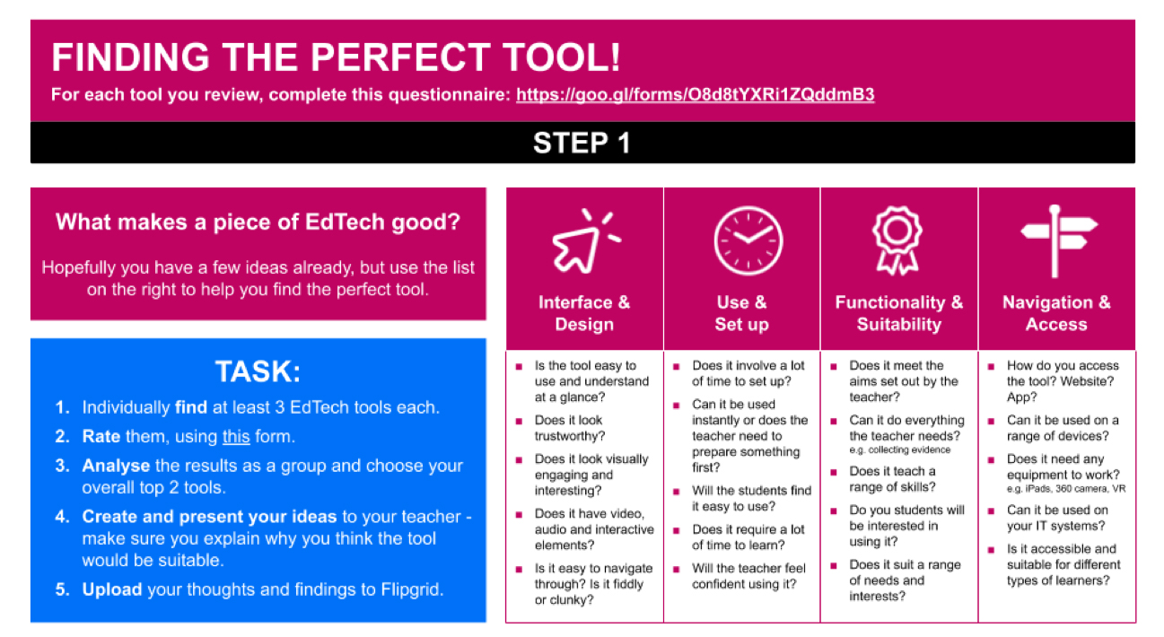
Example of guidance provided in the project workbook can be found in the OTLA EdTech toolkit

Students then discussed their findings and selected what they considered to be the most suitable and effective tool, which they then experimented with further to ensure they were comfortable with its usage before feeding this back to their teacher.

3. Feedback, planning and implementation
Having agreed on their recommendation, students met again with the teacher and presented their findings, including an overview of the tool they had identified and a live demo of the tool in action. This step was crucial as it provided the teachers with an opportunity to safely experiment with the tool before implementing it in a classroom environment, whilst having the on-hand support from the students to answer any questions about the tool’s features and functionality.

Once the teachers were comfortable with the tool, the group planned how and when they would implement it into the classroom environment. Some groups arranged a time slot at the beginning or end of a lesson where they could do a short presentation to the class and then run a practice activity with the tool, whereas others decided to jump straight in to using it in a real lesson environment. This was decided on a case by case basis, taking into consideration the type of learners, lesson or activity the tool was being used with/for. When it came to the lesson, the student partners were in the class to support both the teacher and their peers in using the tool for the first time. This was another stage which teachers in particular found invaluable because it eased the pressures and worries associated with introducing new technologies to the classroom, as the students were on hand to assist with any technical issues.
Finally, after the lesson, the partnership team ran a debrief where they discussed what had gone well and what they would change for next time. This enabled staff to consider how or whether they would use the tool going forward, with an established team around them to support them in doing this however they deemed appropriate.

4. How were the partnerships motivated / incentivised?

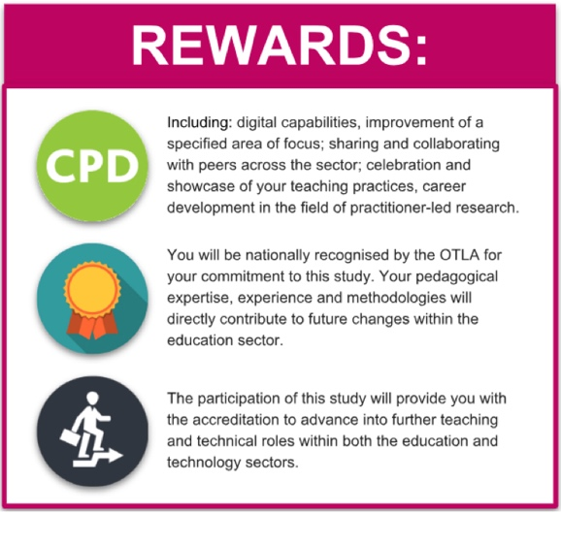
Extracts from student (above) and staff (below) workbooks
The incentives available to each partnership were the same (see above), though the way in which these incentives
were advertised and used were different between partnerships varied – which was reflected in the way partners were recruited.
For each partnership, the first stage was recruiting staff members. In this instance, the project coordinators at each organisation used a combination of methods - advertising the project through e-leaflets and all staff communications and approaching staff members known to have open minded and growth attitudes to learning technologies and new methods of teaching and learning. In all cases, we found it was the teachers who we’d approached directly who participated and remained engaged in the project - others, who had expressed an interest initially from the open call, later dropped out.
Recommendation – on reflection, we feel there are multiple reasons for the difficulty in engaging a range of staff members. The most common reason for not wishing to participate in the project was the inability to commit the time - something which was only possible for the partners we did work with because they considered the project a priority for their own development and the improvement of their practices. Whilst we appreciate there is an element to this which will be dependent on organisational cultures and general staff workload, the project team have suggested one or both of the following would improve the uptake from less typically engaged staff members:
I. Official recognition and/or certification – either from a national source such as the ETF or at an organisational level
II. TOIL or cash bonus equating to project activity hours (NB: our model estimates an average of four hours of activity for teachers, excluding the research commitments from this project, in the time frame we used for the pilot)
When it came to recruiting students, the primary incentives and motivations varied between colleges.
• At Midkent, students were introduced to the project in the class presentation and the partners came forward based on the information in the project workbook. This approach was successful in that it put more onus on the students and they were motivated from the offset by the prospect of influencing the uses of technology in their class. On the other hand, the students recruited this way may have a skewed perspective of how well their peers would interact with the tools as they are likely to be generally more interested and willing to try new things than their peers.
• At Basingstoke College of Technology, students were selected by their teachers, generally on the basis that it would be good experience for the learners and them needing work experience hours for their programme of study. This approach worked well in
that the students were committed, because they needed the hours for their course. However, compared to those recruited by the method at Midkent, they were initially less passionate about the project and the aims.
Recommendation – on the one hand, the former approach aided the project’s success as the learners were engaged and self-motivated from the offset. This was particularly useful with regards to time commitments from the staff as these students were able to complete large chunks of the project with little guidance. On the other hand, the latter approach had an unexpected benefit in that students who began the project with little interest in the subject matter became increasingly inspired and motivated throughout as they became more aware of the impact they could have on both their own and their peers’ learning experiences. Despite a slow start, 5 out of 6 of the learners on work experience said they would be keen to participate again.
• At City and Islington, the primary incentive for the students was the skills and knowledge they would gain and the experience for their CVs/LinkedIn profiles. Additionally, vouchers were considered a good incentive from the students as it justified the time outside of their course commitments to put into the project.
Although the incentives/rewards available for each partnership were equal, it’s clear that different incentives work for different students and that there are particular implications and outcomes of each approach. Due to this, when considering incentives and motivators for partnerships, we’d recommend organisations consider:
1. The type of learners they are hoping to attract
e.g. learners looking to move into work soon may be more incentivised by work-based rewards such as recommendations or accreditations
2. The potential negative implications
e.g. only completing the project to get the reward
3. The potential positive outcomes
e.g. attracting partners who wouldn’t usually engage in this type of project

5. What were the practical outputs? How were they embedded and used?
Each partnership was launched using the project workbook, which each student and staff partnership member received as both a digital and hard copy. This served as an information leaflet providing key information and context for the project, as well as a catalogue of resources that could be used at each stage of the project. The resources provided in the workbook were:

For students – primarily aimed at supporting during the research and reviewing stage of the project. These resources (Slides 8 - 10) provided checklists curated by Learning Technologists on the features and functionalities a digital tool should ideally include to be an effective classroom tool, as well as prompts about considerations the teacher may have. As with all of the project outputs, each partnership used them to different extents and were able to modify them. These resources in particular were aimed at higher level learners to stretch and challenge and give them an opportunity to step into a learning technologist’s shoes - giving them further experience and portfolio work should they be interested in pursuing a career in the sector.
For staff – primarily aimed at supporting the implementation stage. These resources (Slides 8–11) included practical lesson planning aids (specifically adapted for technology enhanced teaching, learning and assessment) and a checklist to advise on how they could prepare and utilise their student partners prior to the implementation session.
In addition, the partnership teams were provided with practical aids, which complemented the guides provided
in the workbooks. These were:
• Brief and response example/template
• Edtech Evaluation Form (for students)
• Session Review (for students and staff)
Finally, the project produced a leaflet to provide an overview of the project, which was used in two organisations to promote the project and recruit partners.

6. Research outcomes and impact
a. Outcomes for the learners involved in the partnerships
The majority of students involved reported increased confidence in working collaboratively with staff members on a project and feeling involved and valued within their college and course.
The majority of responses indicating an increase of one point marker on the given scale (question below is one of three questions from the student engagement questionnaire):
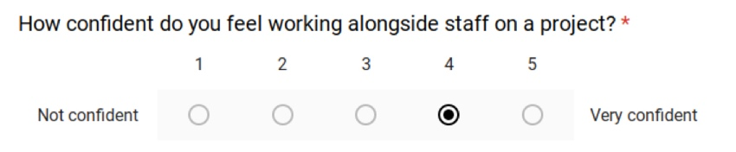
Before
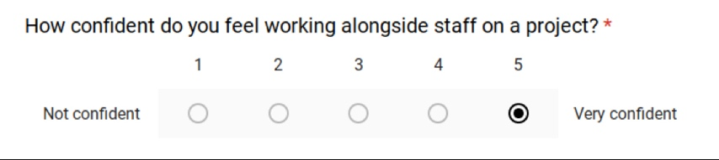
After
“Being involved in this project … made me feel like I have a
real say in the way the college works. I would be more than happy to do this again if the chance ever came up.” –
ELLA COTTRELL, STUDENT
b. Impact on practitioners involved and the quality of their teaching, learning and assessment
To establish a baseline measure for digital capabilities amongst staff participants, teachers rated themselves against up to three relevant strands from the Digital Teaching Professional Framework.

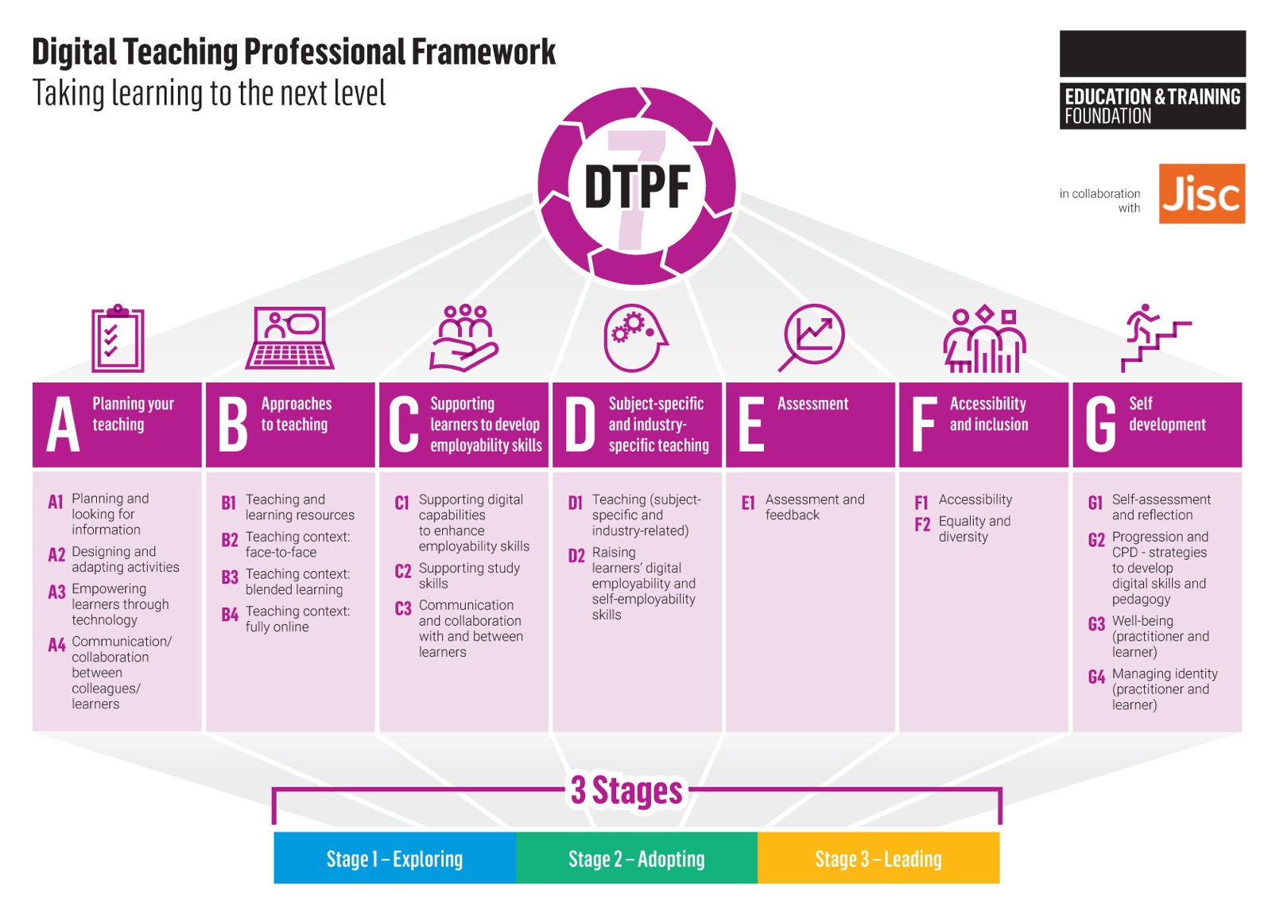
Teachers picked the strands that were most closely related to their area of focus and then identified which stage they felt their practice sat within. This was completed at the beginning and then repeated at the end of the project to measure for changes. Within the context of this project, most teachers rated themselves the same at the beginning and end, with a few moving up one stage. However, all participants commented that they did feel more confident in the area that they chose for their focus, particularly in
the context of the class with which they had implemented new technologies.
Due to this, we would suggest that there would be a more consistent improvement against this measure over a longer period of time; once teachers have had more time to adapt and apply both the specific tools and techniques they have learned in this project and the general approach to exploring and adopting new methods.

7. Models of outstanding practice that have been identified
Due to the flexibility of the model, there were various adaptations in each organisation and partnership. From these adaptations, we have reviewed the effectiveness of different approaches at different stages of the project and have identified the following as some examples of outstanding practice:
1. Launching with a whole class
At Midkent, Andy Dowell, Head of Innovation, launched the project with the entire class of a teacher who had expressed interest, as opposed to with a pre-recruited partnership team. The whole class engaged in the research stage, looking for tools to suit the prerequisites specified by their teacher. After the session, two students came forward to express an interest in leading on the project - these students then became the partnership members. This was a particularly effective approach as the whole class felt invested and involved in the process, which made the implementation stage a lot smoother.

2. Defined roles for student partners
At City and Islington, Kerry Vandersteen, Digital Education Coordinator, assigned the student partners with individual responsibilities prior to the implementation session. For example, one student was responsible for creating how-to guides for the students to refer to, whilst another was given the responsibility of preparing the teacher for the session. This approach works particularly well in making the project inclusive for different types of learners and playing to each of their strengths, which is an important consideration
for a project that involves such a broad range of skills and activities.
3. Using existing digital leaders to support new ones
At Basingstoke College of Technology, Sky Caves, Learning Technologist, brought in existing Digital Leaders (students in a part-time digital support role) to give advice and guidance to the student partners. The Digital Leaders were able to give a unique insight into what it’s like to assist staff in using technologies from a student perspective, the benefits it brought and potential difficulties to be aware of. This was particularly valuable for this partnership as the students involved in the partnership had no prior experience of working with staff and were not very confident in their abilities. Hearing from other students who had started where they were and were now confident and accomplished in their roles was useful to motivate and reassure the student partners.

8. Key recommendations
In addition to the specific recommendations mentioned throughout this report, corresponding to certain steps of the model, the project team have reflected on the following points which we would likely change and adapt going forward and recommend to other organisations looking to adopt this model:
1. Project duration and timing. For the purpose of this pilot, we had a prescribed time frame in which to run the project. Due to the multifaceted nature of the model, it would be better suited over a longer time period and at a different point in the academic year. Some of the suggestions made have been:
a. Running the project over the course of the Autumn term (September – December) as an induction project. We feel this would be beneficial as it would set a precedent for students and staff with regards to using digital technologies; establish an open dialogue between staff and students with regards to areas for improvement in courses and improve learner engagement from the beginning of the year, a perspective from which there’s scope to tie the project into the work of Student Unions or other student voice projects.
b. Running the project ongoing across the year, adapting the model and timeline in respect to the staff and student needs and the scale of change/impact proposed eg. accounting for the difference between introducing a new tool to be used for very particular activities such as mind mapping and introducing a new method of formative assessment across a course.
Depending on the duration and timing of the project, it may be useful to combine or alter the three stages (as above) as you see fit. As such, we have provided a breakdown of the more specific steps taken by each partnership, regardless of where these steps crossed over into the three project stages:
2. Senior management involvement and inclusion in strategic planning. To embed the project and maximise its effectiveness, we would recommend ensuring the running of the projects and the outcomes are agreed at an organisational level. Possible approaches we have identified include:
a. Embedding the project within a qualification for students or CPD for staff. For organisations who are interested in introducing this model as a part of a larger digital strategy, there may be scope to use the model as a project-based learning activity to complement a digital learning qualification for students or CPD programme for staff. Qualifications for students could include the NCFE Level 2 Certificate in Digital Skills for Work and/or CPD for staff could include the Chartered College of Teaching’s Future Learn course, Using Technology in Evidence-Based Teaching and Learning
Another consideration is providing staff and students with the time and support to effectively engage in the project. One option for this would be, as mentioned above, to run the project as a part of a college wide induction. Naturally, this type of commitment would require a holistic approach and understanding of the practical commitments required from all key stakeholders.

City Lit
City Lit developed their final research report as a Google Site (QR code below). Click here to visit the Google Site.
Here is a summary of their findings:
1. Context
Our focus in terms of learning technology was on the use of cloud-based tools, primarily G Suite for education / Microsoft Office 365. All participating colleges have seen increasing use of these tools for teaching and learning in recent years, driven by the ease of use of these applications, as well as the opportunities that they offer for collaboration and how they can be used for various teaching and learning activities.
Of the four participating colleges, three are currently using Google Classroom –
Morley & WMC Camden use G Suite for Education alongside Moodle and have trialled Google Classroom in certain departments.
City Lit moved from using Moodle as their primary VLE three years ago to use G Suite for Education / Google Classroom.
RHACC use Office 365.
All these colleges use other common educational technology tools such as Padlet, Kahoot! etc which could be included in a project such as this.
All participating colleges recognise some common challenges to using digital tools like these for Adult Learning courses:
• Length of courses / time in the classroom – the majority of courses are non-accredited, short (10 weeks or less) and meet for just a few hours a week.
• Digital capabilities of learners – learners’ digital capabilities and access to devices can vary greatly. As learners are not often in the college, supporting learners’ digital skills’ needs can be a challenge.
• Confidence / time to experiment for teachers – teachers also may not be in the college that often. e.g. City Lit has over 1,000 teachers with a third teaching less than 30hrs a year. All colleges also have a diverse curriculum and varied digital capabilities amongst teachers.
• Through the ease of use (and access / setup), plus the opportunities for collaboration offered by technologies such as G Suite and Office 365 applications, we see potential for some of these challenges to be addressed.

2. Approach
a. Model – how did you structure and deploy the partnerships?
We had nine student-teacher partnerships in total (we aimed for 12 but lost a few along the way).
The partnerships were focussed on courses in Essential Skills / ESOL.
Programme Managers and Learning Technologists identified teachers who they believed would benefit from taking part in the project. We approached teachers who had attempted to use tools such as Google Classroom previously but had experienced certain barriers to their effective use, e.g. lack of engagement amongst students, confusion over how applications such as Google Drive worked.
Where possible we tried to identify student digital champions before the courses had begun. In many cases this was not possible and students would be asked at the end of a digital skills’ initial assessment whether they would be interested in being a digital champion.
After an initial meeting between the direct participants for each partnership, teachers and their digital champions would then meet a few times throughout the course. Due to the limited time that project participants would have to meet face-to-face, we tried to encourage use of digital platforms to communicate.
b. How did you motivate / incentivise the partnerships?
Each individual college decided how to incentivise student participation in the project. All colleges chose to give some kind of voucher to students. Initially we wanted to use digital credentials (badges) to incentivise student participation. We believe that digital credentials would have worked well, but needed more time to successfully implement this.
Many of the student digital champions seemed to be quite motivated just by helping the other students. Students seemed to value the certification they would be receiving from ETF for taking part in the project.
Teachers were reimbursed for the extra time they would be putting into the project. Teachers also valued the certification that they would receive from ETF.
c. How did they work together – what did they explore?
Google Classroom - create question conversation exercises:
Student digital champions supported other learners with how to access and use Google Classroom. The specific activities in each partnership explored how the ease of communication using Google Classroom could be used for teaching and learning activities. In two of the partnerships, student digital champions assisted with a conversation exercise activity.
Google Classroom - student access / quizzes:
Champions helped tutors in a range of ways in class – logging into computers, looking up information online efficiently and effectively, downloading the Google Classroom app. Generally, they helped other students around barriers and to get over their reluctance to use technologies. Champions have a troubleshooting role and are particularly useful in large classes when the tutor is busy.
Google Classroom - records of learning:
The student digital champion met with the tutor and tested the Google classroom to evaluate its effectiveness, familiarise themselves with the environment, explore its basic functions and identify potential areas of difficulty for her fellow students.
Padlet - collaborative documents:
One partnership looked at how they could use Padlet. The student digital champion, teacher and learning technologist met at the start of the course to look at Padlet and think of ways that it could be brought into lessons
d. How did you take into account the diverse needs of students and staff? (e.g. different levels, different subjects, equality and diversity, learning support)
One of the major challenges faced by colleges in our context is in the diverse needs of students and staff across many different subject areas.
In this project we chose to focus on one subject area - ESOL / Essential Skills. We also chose to focus on teachers who had some experience of using digital technologies in their practice. Our model for this project was largely about providing individual support. Teachers had support from their digital champion as well as personalised support from Learning Technologists. Our aim for working with teachers was to see how cloud-based digital technologies might help them with learning activities they might already be doing.
In terms of the diverse needs of students. Our digital skills initial assessment was aimed at getting a general understanding of the class group profile - the level of confidence using digital technology for learning, opinions on how digital might be used on their course and how much. As well as a general group profile, the initial assessment would show that there were some learners in the class who didn’t feel confident using digital technologies. A large part of the digital champions’ role would be in supporting these learners to take part in specific digital learning activities.
Some partnerships still highlighted the problems faced by some students in accessing resources or completing activities. While this was significant in some partnerships, the project did give the opportunity for students to report back to others about these problems.
e. What elements of your approach were most effective / least effective?
Most effective:
The digital skills initial assessment gave us some useful data to work with, helped to get information out to the class group about what we were trying to do on the project and helped in finding a specific focus for each partnership.
Least effective:
Our approach to induction for both teachers and students came too late in some partnerships. Had we been clearer about some of the requirements for the project at the very beginning of a course then we would have had more time to explore specific learning activities in each partnership.

f. What were the main challenges and barriers and what action did you take to overcome these?
Time was a big barrier to getting the partnerships in place and working together on specific activities. We hoped that online communication might resolve some of these barriers, but particularly where student partners hadn’t been identified before the course had started, the lack of face-to-face meetings in-between weekly classes made it difficult to get specific activities planned.
These were issues that we couldn’t really overcome once the project was underway. Lessons going forward will be to:
• Work with teachers more at the start of the project to refine the focus of the project before the course has begun. More focus on the Digital Teaching Professional Framework will help here.
• Ensure that student digital champions are in place as soon as possible and make time for induction meetings at the start of the course.

3. Practical outputs
Digital Skills initial assessment
Google Forms and Microsoft Forms versions. Short form designed to gather level of confidence / opinion, experience using common digital technologies, ideas on how digital could be useful in their learning.
These digital skills initial assessments worked well, giving all participants some useful data to work with and providing a good introduction to all students on the courses about what we were trying to do on the project. Eight of the nine partnerships used these initial assessments at the start of the course.
Cloud-based tools training resources
Resources produced by Learning Technologists for both Teachers and Student Digital Champions. These were created during each project and designed to make the activities used for the project easily understandable by all direct participants.
We had initially planned to create a bank of training resources around how to use the core G Suite for Education and Office 365 apps. These would be simple resources introducing teachers and students to the applications, what they do and an example of how they might be used in teaching and learning. These would be in formats that could be easily shared and accessed in online course areas (Google Classroom / Microsoft Teams / Moodle).
With so much to do at the start of the project we didn’t manage to get these resources created. Instead, training resources were created by Learning Technologists and teachers as the project progressed and were generally quite specific to each partnership. There wasn’t as much sharing of resources between different partnerships as we had intended.
Project role descriptors
Induction material including role descriptors for four direct participant roles – Student Digital Champion; Teacher; Learning Technologist; Programme Manager.
A general induction guide was created using Google Slides. This could be easily shared between different colleges and printed if necessary. Each college could take a copy of the general template and edit as necessary.
This induction material worked well in some ways - being able to edit for different project participants was useful.

4. Research outcomes and impact
a. Outcomes for the learners involved in the partnerships
Digital Champions:
In every course that took part in the project there were some enthusiastic learners, interested in being the class digital champion. The student digital champions were all very motivated to help other students. Most feedback from the digital champions was fairly informal responses to questions about how they experienced the project with some positive statements. Going forward we would like focus more on how being a digital champion can enhance students’ own digital skills.
All students:
Most teachers reported increased numbers of students able to access online learning resources. This was one of the objectives of the project. The digital skills initial assessment completed by all students was a useful output from the project. If we are to continue this approach it would be useful to follow this up with further feedback from the whole class on how the digital champion project may have helped them.
b. Outcomes for the practitioners involved in the partnerships
Programme Managers / Learning Technologists:
As with all participants, Learning Technologists noted the difficulties posed by the timescale of the project. One Learning Technologist mentioned that they felt the project had helped them to develop their project management skills.
“I found it really useful to be more directly involved in courses. We often visit classes to demonstrate to students how to login to Google Classroom and do basic training with teachers, but we maybe don’t focus on what these technologies can actually do to support learning in different classes. This project gave us the opportunity to work closer with students and teachers...I just wish we had a bit more time.”
Teachers:
Most teachers felt that the project was very effective in increasing learner engagement with digital technologies and giving them the opportunity to explore different uses of digital technology for teaching, though perhaps less effective in developing their own digital skills or those of their learners.
c. Impact on the quality of their teaching, learning and assessment
On the whole most Programme Managers and Learning Technologists felt that the problems around time that impacted most projects meant that the full benefits to implementing student-staff partnerships in this way have not been realised in this pilot. However, all colleges taking part believe that the model could be developed in future to have a greater impact on teaching, learning
and assessment.
“I can’t measure the full impact yet, but I believe that this project, after it is disseminated to other staff who didn’t participate, could help on the quality of teaching, learning and assessment. It has had immediate impact to staff and students who took part and I could see improvement for example with their use of Google Classroom, compared to the beginning of the project.”

5. Impact data – direct, indirect, reach, broadcast (and evidence of impact)
Direct
• At this stage we have gathered some qualitative data from teacher diaries, project updates and case studies with informal information on how the project impacted all direct participants.
• All teachers reported some level of increased engagement with learning technologies amongst their learners and many reflected that the project had given them more confidence to use digital technologies in their teaching practice in future.
• Learning Technologists also reported on the usefulness of working more closely with teachers and students on specific activities which will improve approaches to supporting students and staff in enhancing their digital skills in the future.
• The impact on student digital champions’ digital skills and development is something we will need to gather more information on. More focus on their development through participating in the project could improve the approach going forward. In the partnerships that were most effective, digital champions supported other learners and the teacher well and provided the platform for teachers to be able to develop their understanding and effective use of learning technologies.
Indirect
• Each college aimed to reach 25 teachers or staff involved in teaching and learning through departmental meetings / training sessions.
• Part of the aim of this dissemination will be to gather opinion on how useful the approach could be going forward, how could it be implemented across the department, how could the approach be refined / improved?
Broadcast
• Each college aimed to disseminate information about the project across their own organisation through staff newsletters, emails, etc.
• Information will also be disseminated at Adult & Community Learning events such as the London e-learning roundtable held every 3 months and attended by approximately 30 e-learning practitioners and teaching staff.
6. Models of outstanding practice that have been identified
Most feedback from project participants has highlighted the short timescale for this project. At this stage it is difficult to highlight specific models of outstanding practice that we have identified through piloting this model of student-teacher partnerships. However, the experience has left most participants believing that there is value in this approach and that it does have potential to address some of the common challenges faced by colleges working with these technologies in the Adult Learning / Skills sector.
The issues around time impacted the project most at the start of the activity and research stage. The courses that took part in the project were all relatively short and attempts to identify participants, embed the professional standards and induct project participants all within the first few weeks of the course proved problematic. Even with these challenges most participants reported increased engagement with these technologies for learning. We believe that with some amendments for future implementation that will address some of the time issues, this model could have further impact on teaching, learning and assessment.

7. How have you used and embedded the Digital Teaching Professional Framework?
As part of their induction, teachers completed a self-review, selecting up to three areas of the Digital Teaching Professional Framework that they would like to develop in this project.
We had planned to use the areas highlighted by the teacher to inform the specific activities that each partnership would carry out. However, this is something that we lost focus on as the project progressed.
Questions from the Digital Teaching Professional Framework and how much they thought the project had helped them to develop in each of the seven sections were given to teachers in a project review. However, without the framework being more firmly embedded in the project throughout, the feedback did not tell us much. Teachers would probably benefit from more time focussed on the framework at the start of the project and be given more time to critically assess how they apply it to their practice.

8. If you were to continue using this approach, what recommendations would you make for future implementation? What factors are key to the sustainably of your approach in your organisation?
All Learning Technologists and Programme Managers that have responded to the project review form at this stage have suggested that they intend to continue this model of student-staff partnerships in the future. Time was identified as the main barrier to successful implementation by all, but alongside this, ‘further developing a role definition for student champions’ and ‘identifying alternative and sustainable incentives for the role’ were cited as areas to develop for future implementation.
“Time to do this was quite short, once we had identified the tutors and the learners. Seeing the learners for two hours a week over five sessions meant the tutors were quite limited in what they could actually do.”

9. What would be your key recommendations to other organisations adopting this approach?
• Use Digital Teaching Professional Framework to guide focus throughout research and to get a clear focus on what kinds of digital skills a teacher is trying to develop.
• Establish student-teacher partnerships as early as possible at the start of a course and have clear guidelines on what is expected of the student digital champion role.
• Gather some quantitative data on the impact the project had on all direct participants and all learners in the classes taking part.
To view City Lit’s full online report presentation, click here

09 Annex 2 – Overview of practical outputs

Programme toolkit
An overarching easy-access toolkit has been designed, providing:
• an overview of the programme
• a summary of each project and their model / approach
• recommendations for other providers who want to adopt similar approaches
• download links to their full case study and research outputs
• download links to their practical outputs
The toolkit is hosted on the Excellence Gateway website and allows practitioners from across the sector to dip into the projects / models of most interest to them and access the insights and outputs with ease.

Dissemination webinars
As additional outputs, the two webinar recordings will be made available to the sector to access and will be disseminated widely. These include:
WEBINAR 1 – Basingstoke College of Technology and Bishop Auckland College. Click here to download Webinar 1
WEBINAR 2 – Heart of Worcestershire College and City Lit. Click here to download Webinar 2

