
Entry 1: Writing
Agriculture

Module: Induction

Module aims

Main aim
We are learning to write short notes for work using simple sentences.

Other learning aims
We are learning:
- To write in simple sentences
- To write short messages
- To write words in the plural

Module: Induction

Main aim: We are learning to write short notes for work using simple sentences.
Writing sentences
Aim: We are learning to write in simple sentences.

In English simple sentences are made up of:

subject – verb – object or S V O
Oleg digs the trench. Sal wears boots. We plant seeds.
The subject is what the sentence is about.
The verb is the action that happens.
The object shows what the action is about.
Sentences start with a capital letter:
He has a spade. She helps me. Tell me your name.
Sentences end with a full stop.


Task 1: Completing sentences
We are using an induction text to answer questions in sentences. Read the text. Then read the questions. Find the answer in the text. Complete the sentences from the text.
Your line manager tells you about your job on your first day. Your line manager is the person in charge. You learn what to do in your job. You learn the names of people who tell you what to do. You learn the names of other people you work with. We call this induction.
An induction is training for new employees.
Questions can start with:
What to find out something
Who to find out about a person
How to find out about something
1. What is an induction?
An induction is ___________________________________________.
2. Who tells you about your job?
Your ___________________________________________________.
3. Who is in charge?
Your line manager ________________________________________.

In our garden centre your induction lasts for four weeks. Everyone who works for us learns the same things. This makes sure that each person does a good job.
You find out how to do different tasks. You learn how to use equipment. You learn about plants. You find out where to go for first aid.
We tell you about health and safety.

4. How long does your induction last?
Your induction ______________________________________________.
5. What do you find out?
You find out ________________________________________________.
You find out ________________________________________________.
6. What do we tell you about?
We tell you about ____________________________________________.

There are different names for a line manager
Supervisor • Team leader • Manager • Boss • Head gardener • Head groom

Task 2: Parts of a sentence
Here are some sentences about induction. Use the information to show which word is the:
subject verb object
We have done an example for you:
Your manager gives a talk
S V O

1. The talk is on the first day.
2. You learn the names of people.
3. The induction lasts for four weeks.
4. Each person learns the same things.
5. Each person does a good job.
6. You plant seeds. | 
7. You find out about soils. | 
8. You ask the person in charge. | 
Is the word order the same in your language?

Using punctuation

Each sentence starts with a capital or upper case letter: A T H
Each sentence ends in a full stop .
We use capital letters for proper nouns, too. Proper nouns are people’s names, for instance Abdi or Lidia.
We use capital letters for:
people’s names Stef Novak, Lee Yin, Rasiq Patel, Esam Labeeb
names of places Norfolk, London, Carlisle, Exmoor, Gatwick Airport
names of companies Boots, Aldi, Marks and Spencer
names of days or months Monday, April.
When you write about yourself I

Task 3: Using punctuation
Look at the writing. It needs some punctuation. Put in the correct punctuation. The first one is an example.

1. i need a watering can
I need a watering can.
2. my name is maya
____________________________________
3. please help me move the table
____________________________________
4. can you get sam a bag of compost?
____________________________________
5. you must not smoke there
____________________________________
6. what day am i working?
____________________________________
7. you are working on tuesday
____________________________________
8. i go to leeds on friday
____________________________________

Writing short sentences
Aim: We are learning to write short messages.
Sometimes you have to write things down. You write names of things and numbers. You write messages. You write in simple sentences.
Lidia works as a garden centre assistant. She plants seeds. She looks after plants. She cleans tools. Bill, her boss asks her to write a message.
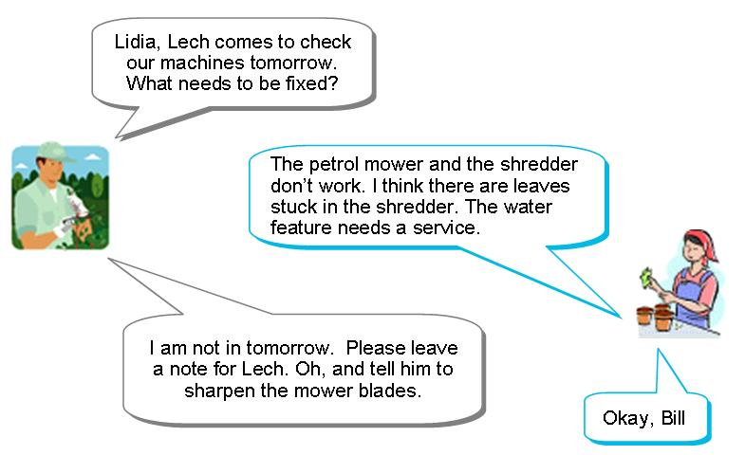
What does Lidia write?
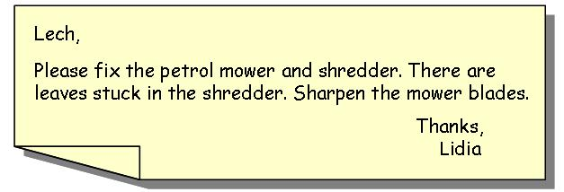
Task 4: Writing messages
1. There are problems in the garden centre. Read what Sam says to Lidia. Write a note to tell Bill, the manager. Write in simple sentences.
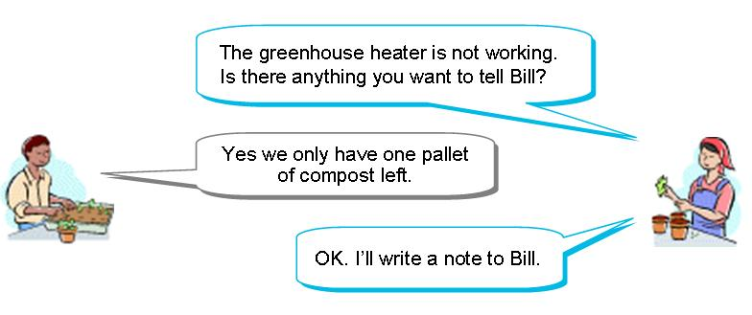

Write the note to Bill:

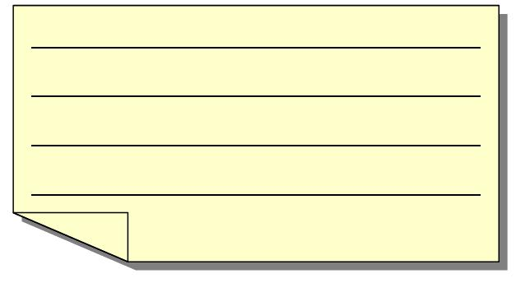

 |  | 
heater | pallet | compost

2. Lidia and Sam check the delivery. Read their conversation. Then write a note to Bill. Write in simple sentences.
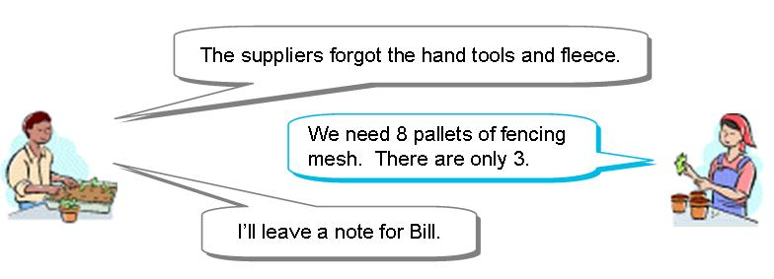
Write the note to Bill:

 |  | 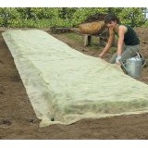
fencing mesh | hand tools | fleece

Making the plural of nouns
Aim: We are learning about writing words in the plural. Plural means more than one.
A noun is a word that names something. The word horse is a noun. Your name is a noun.
When you write about more than one thing, you add an ‘s’ to the end of the noun

farmer farmers  horse horses | 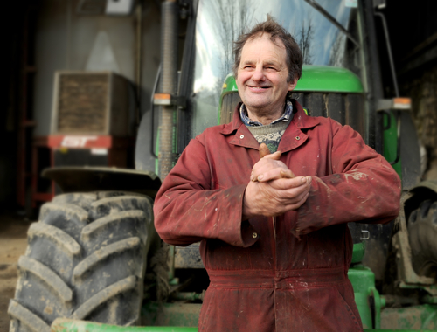  farmer |   1 horse |   2 horses
If a noun ends in s ss x z sh ch, you add es to the end of the word.
  branch branches |   grass grasses |   fox foxes
There are some words that do not follow the rule.
person | people
woman | women
man | men
child | children
foot | feet
goose | geese | 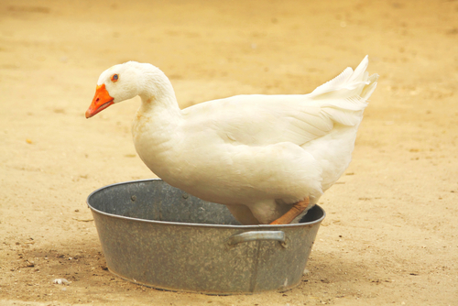
sheep | sheep | 

Word Check
singular the form of the word we use when we write or talk about one thing
plural the form of the word we use when we write or talk about two or more things

Task 5: Plurals
Here are some words you hear at work. The words are in a sentence. They have a line under them. Write that word in the plural in the gap. There are two examples.
Note how the verb changes in some of the plural sentences.
There is one job to do. The goose is in the field.
There are many jobs to do. The geese are in the field.

1. Check the delivery note.
Check the delivery _________.
2. The person works as a fruit picker.
The _________ work as fruit pickers.
3. Induction lasts a week.
Induction lasts four _________.
4. The man learns to use a mower.
The _____ learn to use a ________.
5. The head groom is in charge.
The ______________ are in charge.
6. The woman is a trainer.
The __________ are trainers.
7. Write your name on the duty sheet.
Write your _______ on the duty sheet.
8. There is one thing to do.
There are many ________ to do.

Task 6: Word grid
Here are some of the words from the reading tasks. Fill these words into the word grid. We have put some letters in the grid to help you.

induction | people | home | fire
supervisor | weeks | women | pots
person | emergency | things | names

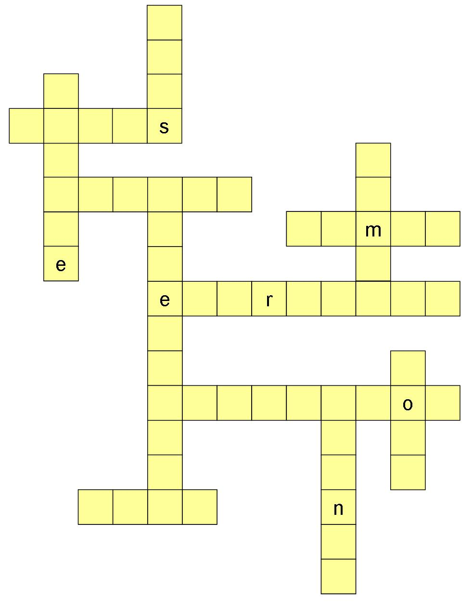
How did you get on?

Module 1: Induction answers

Task 1 answers

1. What is an induction?
An induction is training for people who are new to a job.
2. Who tells you about your job?
Your line manager tells about your job.
3. Who is in charge?
Your line manager is the person in charge.
4. How long does your induction last?
Your induction lasts for four weeks.
5. What do you find out?
You find out how to do different tasks.
You find out where to go for first aid.
6. What do we tell you about?
We tell you about health and safety.

Task 2 answers
1. The talk is on the first day.
S V O
2. You learn the names of people.
S V O
3. The induction lasts for four weeks.
S V O
4. Each person learns the same things.
S V O
5. Each person does a good job.
S V O
6. You plant seeds.
S V O
7. You find out about soils.
S V O
8. You ask the person in charge.
S V O

Task 3 answers
1. i need a watering can
I need a watering can.
2. my name is maya
My name is Maya
3. please help me move the table
Please help me move the table.
4. can you get sam a bag of compost?
Can you get Sam a bag of compost?
5. you must not smoke there
You must not smoke there.
6. what day am i working?
What day am I working?
7. you are working on tuesday
You are working on Tuesday.
8. i go to leeds on friday
I go to Leeds on Friday.

Task 4 answers
Your note may look like this.

1. | 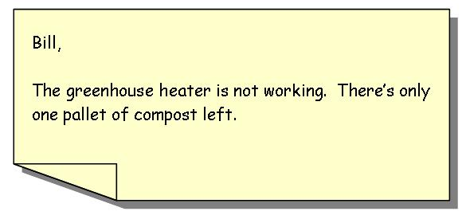
There are different ways to write your notes. Ask someone to read your notes and tell you if they are correct.

2. | 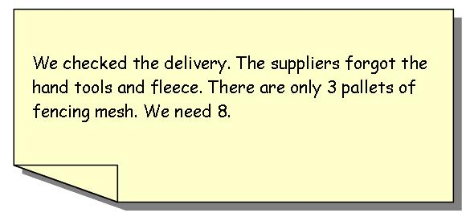

Task 5 answers

1. Check the delivery note.  Check the delivery notes. | Grammar check  You don’t use a in the plural:  …as a fruit picker  …as fruit pickers  She is a farmer.  They are farmers.  He is a jockey.  They are jockeys.
2. The person works as a fruit picker.
The people work as fruit pickers.
3. Induction lasts a week.
Induction lasts four weeks.
4. The man learns to use a mower.
The men learn to use mowers.
5. The head groom is in charge.
The head grooms are in charge.
6. The woman is a trainer.  The women are trainers. | Grammar check  Small words like  a an the  are called articles.
7. Write your name on the duty sheet.
Write your names on the duty sheet.
8. There is one thing to do.
There are many things to do.

Task 6 answers

induction | people | home | fire
supervisor | weeks | women | pots
person | emergency | things | names



