
Entry 1: Reading
Agriculture

Module: Words at work

Module aims

Main aim

We are learning the names of some of the things you use in your job.

Other learning aims
We are learning:
- To identify the letters of the alphabet
- The names of some clothes you wear at work
- The names of parts of the body
- About the present continuous tense

Module: Words at work
Aim: We are going to learn the names of some of the things you use in your job.

Task 1: Learning the names of work items
Here are the names of things you use. Can you match them to the pictures? You can write the name under the picture. The first one is an example.

spade | jacket |  | first aid box |  | shoe |  | gloves
beehive |  | tractor |  | boots |  | fork

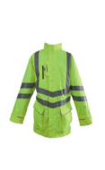 |  | 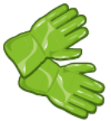 |  | 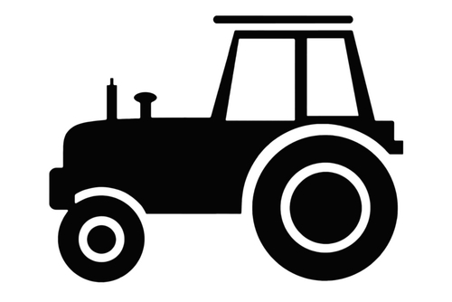
jacket

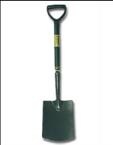 |  | 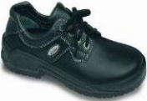 |  | 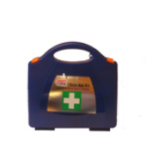

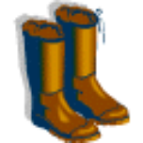 |  | 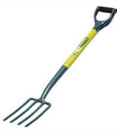 |  | 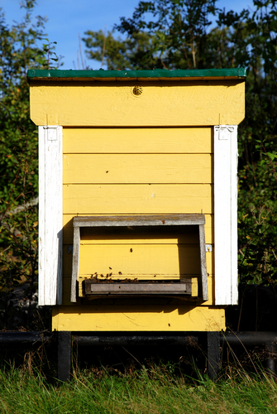
When we talk about more than one thing we put an s at the end of the word.
1 glove ̶ 2 gloves
1 fork ̶ 3 forks
We also say a pair of shoes, a pair of gloves and a pair of boots. A pair means 2.

The Alphabet
We call the 26 letters we use to make words the alphabet.
There two types of letters:
Upper case A B C D E F G H I J K L M N O P Q R S T U V W X Y Z
Lower case: a b c d e f g h i j k l m n o p q r s t u v w x y z

Task 2: The letters of the alphabet
Find the words that start with each letter. The first one is an example.
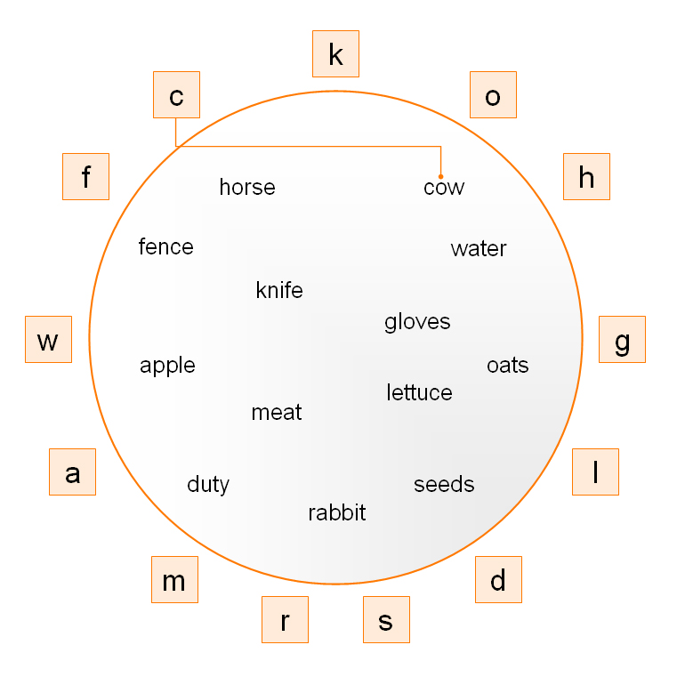
Names of protective clothing
Aim: We are learning the names of some clothes you wear at work. We are also learning names of parts of the body.
There are clothes you wear at work. They keep you safe. Read the names of the clothes.

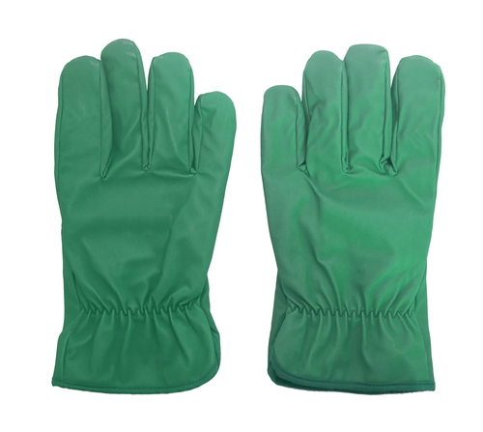 | gloves | 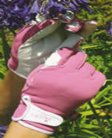
 |  | She wears gloves on her hands
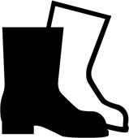 | boots | 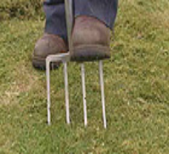
 |  | He wears boots on his feet
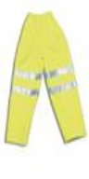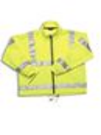 | waterproof clothes | 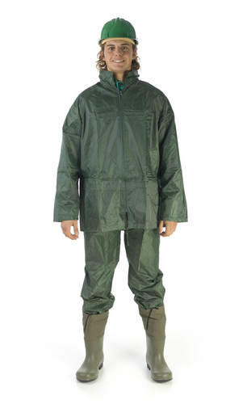
 |  | He wears waterproof clothes
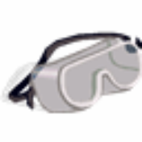 | goggles | 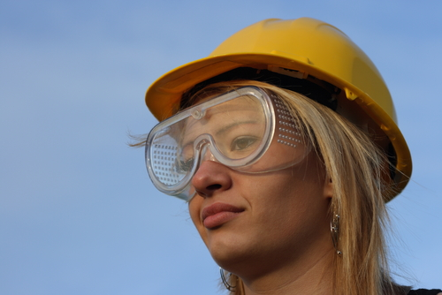
 |  | She wears goggles over her eyes
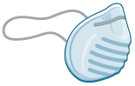 | face mask | 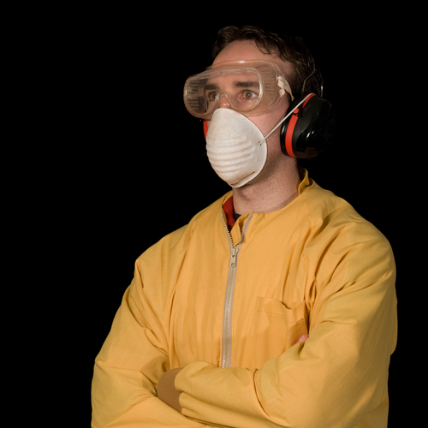
 |  | He wears a face mask over his mouth and nose

Task 3: Clothes for work
Can you name the clothes? Underline the word the correct word. The first one is an example.

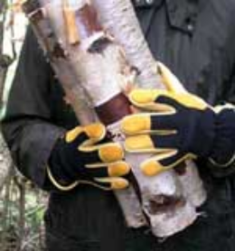 | He wears his  hard hat  gloves  boots  mask
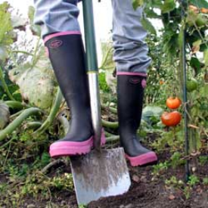 | She is wearing  a hard hat  gloves  boots  a mask
He is wearing
waterproof clothes
gloves
boots
a mask
He wears his
gloves
waterproof clothes
boots
mask


Task 4: Word grid
Here are pictures of things you see at work. Write the name in the grid. There are some letters in the grid to help you.

 | 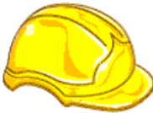 | 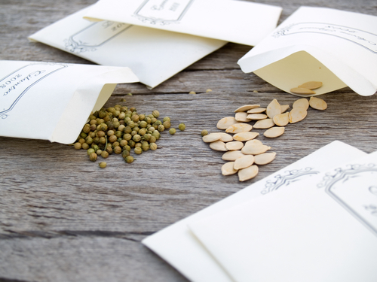 | 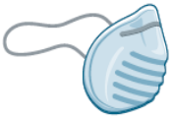
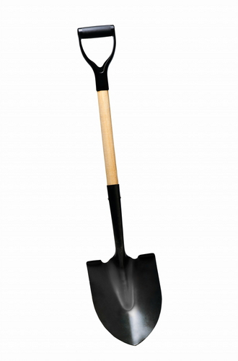 | 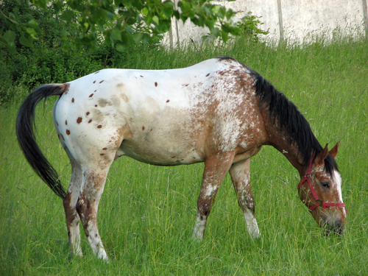 |  | 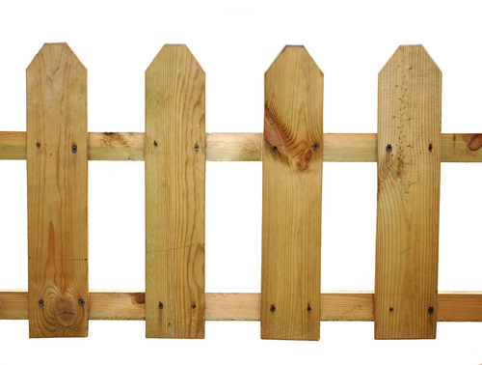
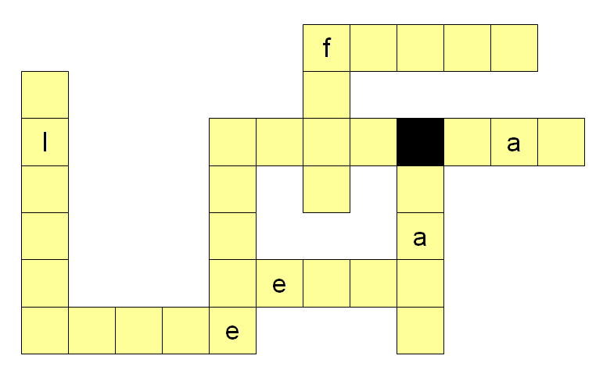

How did you get on?
Module 1: Words at work answers

Task 1 answers

jacket |  | gloves |  | tractor

spade |  | shoe |  | first aid box

boots |  | fork |  | beehive
Task 2 answers

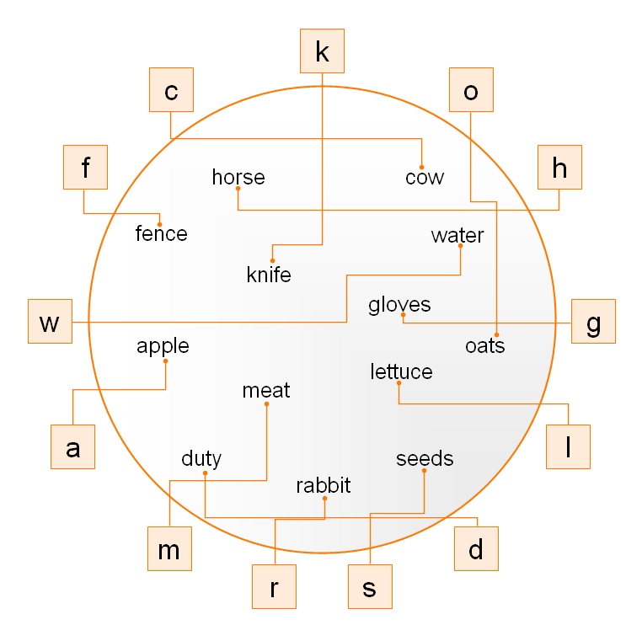

Task 3 answers

He wears his
hard hat
gloves
boots
mask
She is wearing
a hard hat
gloves
boots
a mask
He is wearing
waterproof clothes
gloves
boots
a mask
He wears his
gloves
waterproof clothes
boots
mask

Task 4 answers



