
Entry 2: Reading
Agriculture

Module: Duties at work

Module aims

Main aim
We are learning about the things that you must do at work. You will find out the meaning of words in the text.

Other learning aims
We are learning:
- The meaning of words in the text
- Reading text to show we understand it
- The meaning of words to do with lifting and carrying things

Module: Duties at work
Aim: We are learning about the things that you must do at work. You will find out
the meaning of words in the text.
When you work in land industries, you should know about health and safety. This is important for you. It is important for the people you work with.

Read the text about rules at work.

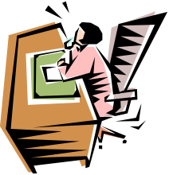 | What you must do and what your employer must do  Your employer is the firm or person who gives you a job. The employer must make sure you are safe at work. You find out about health and safety during your induction training. You should talk to your manager if there is anything you do not understand.
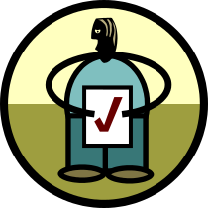 | What you must do as a worker  You must take care of your own health and safety.  You have to keep other people safe when you work.  You must keep the health and safety rules.
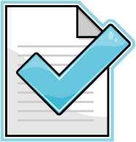 | Your employer must:  ✓ make sure they look at the risks of doing the job  ✓ tell employees what is done to protect their health and safety  ✓ tell you about any changes to the way things are done at work  ✓ tell you how to do your job safely  ✓ let employees know about things that may harm them  ✓ protect your health and safety  ✓ show you how to get first aid treatment  ✓ tell you what to do in an emergency.
You must do the job the way you are shown. You talk to your manager if you have any concerns.
Key words and what they mean
induction the training you get when you start work
manager the person in charge of people at work
worker a person who works or an employee
rules the way to do things that you must follow
risk something that might happen that could hurt someone
first aid treatment the care someone gets when they get hurt
emergency a sudden fire, explosion or accident

Task 1: Information in texts
Read the statements below. Use the text to find out if this is something the worker must do or something the employer must do. The first one is done for you.

 | Worker | Employer
Tell employees about risks to health and safety. |  | ✓
Take care of own health and safety.
Let employees know about things that may harm them.
Tell employees about what is done to protect their health and safety.
Keep the health and safety rules.
Tell how to do the job safely.
Show how to get first aid treatment.
Take care of other people’s health and safety.
Tell what has to be done in an emergency.
Tell people about any changes to the way things are done at work.
You must ......... means something you have to do.
You should........means something that it would be good to do.
Task 2: What do the words in the text mean?
Can you remember what the words in the text meant? Match the words to the meaning. The first one is an example.

 |  | 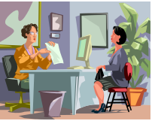 |  | 
rules |  | employer |  | induction |  | manager
the right way to do things |  | the training you get when you start work |  | the person in charge of people at work |  | the person or firm that gives you the job

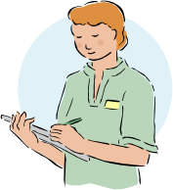 |  |  |  | 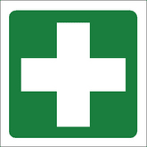 |  | 
worker |  | risk |  | first aid treatment |  | emergency
something that might happen that could hurt someone |  | a sudden fire, explosion or accident |  | a person who works or an employee |  | the care someone gets when they get hurt
Task 3: Fill in the gaps
Aim: We are learning the meaning of words in the text.
This text has some gaps. Put the words in the right place. The first one is done for you.

induction | people | manager | risks | person
emergency | worker | employer | safety | first aid

What you must do and what your employer must do
Your employer is the firm or ______________ who gives you a job. The employer must make sure you are safe at work. You find out about health and safety during your _________________ training. You should talk to your _________________ if there is anything you do not understand.
What you must do as a _________________
You must take care of your own health and safety.
You have to keep other _____________ safe when you work.
You must keep the health and _____________ rules.
Your employer must:
✓ make sure they look at the ____________ of doing the job
✓ tell employees what is done to protect their health and safety
✓ tell you about any changes to the way things are done at work
✓ tell you how to do your job safely
✓ let employees know about things that may harm them
✓ protect your health and safety
✓ show you how to get ____________ _______ treatment;
✓ tell you what to do in an ______________________ .
You must do the job the way you are shown. You talk to your manager if you have any concerns.


Working for a gangmaster
If you work on the land, you may work for a gangmaster. A gangmaster is a labour provider. That means a person or company that gives you the work. A labour provider must have a licence. They must show that they look after their workers to get a licence.

What work sectors are covered?
These sectors are covered by the licence scheme:

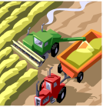 | agriculture |  | horticulture
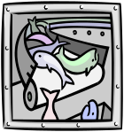 | fish monger |  | gathering shellfish
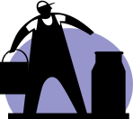 | dairy farming
The scheme makes sure that labour providers do what the law says they must do. You can check if your labour provider has a licence. Look at this website: http://www.gla.gov.uk and it will show you what to do. Also, you can phone the helpline 0845 602 5020 and someone will help you to check.

What you must do
✓ You must be allowed to work in the United Kingdom (UK).
✓ You should have a national insurance (NI) number.

Your rights
You have rights at work, for instance:
✓ You are paid at least the national minimum wage
✓ You have a right to at least four weeks paid holiday a year
✓ You must have weekly and daily rest breaks from work
✓ You should not work more than 48 hours a week and should take at least one day off each week
✓ If you work for more than six hours a day, you must have a 20-minute break.
If you think that you do not get your rights at work, you can phone 0845 602 5020 for help.
Task 4: Match the word to its meaning
What do you think some of the words in this text mean? Match the word to its meaning. Underline the answer. The first one is done for you.
gangmaster | a person or firm that works in horticulture  a person or firm that checks on labour providers  a person or firm with a licence to give people work  a person or firm that sorts out workers’ problems
licence | workplace  legal permit  training session  induction
scheme | check  permit  law  plan
allow | let or permit  plan or scheme  work or employ  stop or halt
national | covering the whole region  covering the whole world  covering the whole country  covering the whole area
minimum | the biggest  the greatest  the slowest  the smallest
least | the biggest  the greatest  the slowest  the smallest
weekly | each day  each year  each week  each hour
daily | each day  each year  each week  each hour
Word check
Adjectives are used to describe other words, for instance: dark.
If you want to compare one thing with another, the adjective is called a comparative adjective. We add er to the end of the adjective: darker.
dark darker
If we want to compare one thing with everything else, the adjective is called a superlative adjective. We add est to the end of the word: darkest.
dark darker darkest
There are some words that do not follow the rules.
comparative superlative
little less least
good better best
much more most
bad worse worst
Task 5: Right or wrong?
Aim: We are reading text to show we understand it.
Read the text called Working for a gangmaster. Look at the sentences below. Use the text to find out if these sentences are right (✓) or wrong (✗). The first one is done for you.

 | Right | Wrong
If you work on the land, you may work for a gangmaster. | ✓
A gangmaster is a person or firm with a licence to give people work.
They do not have to show anything to get a licence.
The licence scheme makes sure that labour providers do as the law says.
There are five sectors covered by the licence scheme.
You cannot check if your labour provider has a licence.
There is a helpline for workers.
Workers must be allowed to work in the UK.
Workers do not have to get a national insurance number.
You have the right to get the national minimum wage.
You have a right to at least three weeks paid holiday.
If you work for six hours, you must have a 20-minute break.

Aim: We are learning the meaning of words to do with lifting and carrying things.
Read the text about lifting things at work.

Manual handling

More injuries at work are from manual handling than anything  else. Manual handling covers lifting, lowering, pushing, pulling  or carrying. | 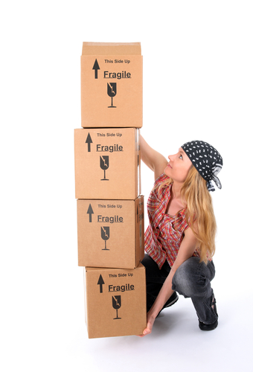
The load may be a box, a person or even an animal. It is  important that you know how to lift things correctly so that you  do not hurt yourself. Manual handling injuries happen wherever  people work, in factories, offices or warehouses. | 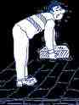
There are things that your employer should do to at work. There  are things that workers should do. These are called duties. | 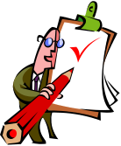
Employers have duties to:
- sort out the job so that workers do not lift loads
- look at the risk to workers if they do have to lift loads
- reduce the risk of injury to workers from lifting loads.
Workers have duties. They should:  - follow the rules they have been given for doing the job  - use the things they have been given for lifting correctly  - work with their employer on health and safety  - tell their employer about lifting jobs that could hurt someone  - take care not to hurt anyone else. | 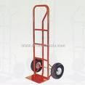
Key words and what they mean
manual handling lifting things by hand
lowering putting something down
employer the person or firm that gives you the job
reduce make less or lower
risk something that might happen
worker a person who works or an employee
duty something you should do
Task 6: Manual Handling
Look at the sentences below. Use the text on Manual handling to find out if this is something an employer should do or if it is the worker? The first one is done for you.

 | Worker | Employer
Sort out the job so that loads are not lifted. |  | ✓
Work with the employer on health and safety.
Take care not to hurt anyone else.
Look at the risk to employees from lifting.
Follow the rules for doing the job.
Use things they have been given for lifting.
Reduce the risk of injury from lifting loads.
Tell the employer about lifting jobs that could hurt someone.

 | lift | 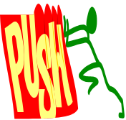 | push
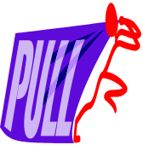 | pull | 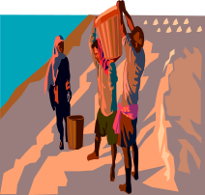
Task 7: Fill in the gaps
This text has some gaps. Put the word in the right place so the text makes sense. The first one is done for you.
reduce | hurt | correctly | risk | offices
duties | rules | handling | pushing | safety

Manual handling

More injuries at work are from manual handling than anything
else. Manual handling covers lifting, lowering, __pushing__,
pulling or carrying.
The load may be a box, a person or even an animal. It is
important that you know how to lift things correctly so that you
do not hurt yourself. Manual _________________ injuries
happen wherever people work, in factories, ______________ or
warehouses.
There are things that your employer should do to at work. There
are things that workers should do. These are called duties.
Employers have _________________ to:
- sort out the job so that workers do not lift loads
- look at the _____________ to workers if they do have to
lift loads
- ________________ the risk of injury to workers from lifting loads.
Workers have duties. They should:
- follow the ________ they have been given for doing the job
- use the things they have been given for lifting ____________
- work with their employer on health and _____________
- tell their employer about lifting jobs that could hurt someone
- take care not to ______________ anyone else.

How did you get on?

Module 2: Duties at work answers

Task 1 answers

 | Worker | Employer
Tell employees about risks to health and safety |  | ✓
Take care of own health and safety | ✓
Let employees know about things that may harm them |  | ✓
Tell employees about what is done to protect their health and safety |  | ✓
Keep the health and safety rules | ✓
Tell how to do the job safely |  | ✓
Show how to get first aid treatment |  | ✓
Take care of other people’s health and safety | ✓
Tell what has to be done in an emergency |  | ✓
Tell people about any changes to the way things are done at work |  | ✓

Task 2 answers

rules |  | employer |  | induction |  | manager
the right way to do things |  | the person or firm that gives you the job |  | the training you get when you start work |  | the person in charge of people at work

worker |  | risk |  | first aid treatment |  | emergency
a person who works or an employee |  | something that might happen that could hurt someone |  | the care someone gets when they get hurt |  | a sudden fire, explosion or accident

Task 3 answers

What you must do and what your employer must do
Your employer is the firm or person who gives you a job. The employer must make sure you are safe at work. You find out about health and safety during your induction training. You should talk to your manger if there is anything you do not understand.
What you must do as a worker
You must take care of your own health and safety.
You have to keep other people safe when you work.
You must keep the health and safety rules.
Your employer must:
✓ make sure they look at the risks of doing the job
✓ tell employees what is done to protect their health and safety
✓ tell you about any changes to the way things are done at work
✓ tell you how to do your job safely
✓ let employees know about things that may harm them
✓ protect your health and safety
✓ show you how to get first aid treatment;
✓ tell you what to do in an emergency .
You must do the job the way you are shown. You talk to your manager if you have any concerns.

Task 4 answers

licence | workplace  legal permit  training session  induction
scheme | check  permit  law  plan
allow | let or permit  plan or scheme  work or employ  stop or halt
national | covering the whole region  covering the whole world  covering the whole country  covering the whole area
minimum | the biggest  the greatest  the slowest  the smallest
least | the biggest  the greatest  the slowest  the smallest
weekly | each day  each year  each week  each hour
daily | each day  each year  each week  each hour

Task 5 answers

 | Right | Wrong
If you work on the land, you may work for a gangmaster. | ✓
A gangmaster is a person or firm with a licence to give people work. | ✓
They do not have to show anything to get a licence.  They must show that they look after their workers to get a licence. |  | ✓
The licence scheme makes sure that labour providers do as the law says. | ✓
There are five sectors covered by the licence scheme. | ✓
You cannot check if your labour provider has a licence.  You can check if your labour provider has a licence at http://www.gla.gov.uk and you can phone the helpline 0845 602 5020. |  | ✓
There is a helpline for workers. | ✓
Workers must be allowed to work in the UK. | ✓
Workers do not have to get a national insurance number.  You should have a national insurance (NI) number. |  | ✓
You have the right to get the national minimum wage. | ✓
You have a right to at least three weeks paid holiday.  You have a right to at least four weeks paid holiday a year. |  | ✓
If you work for six hours, you must have a 20-minute break. | ✓

Task 6 answers

 | Worker | Employer
Sort out the job so that loads are not lifted. |  | ✓
Work with the employer on health and safety. | ✓
Take care not to hurt anyone else. | ✓
Look at the risk to employees from lifting. |  | ✓
Follow the rules for doing the job. | ✓
Use things they have been given for lifting. | ✓
Reduce the risk of injury from lifting loads. |  | ✓
Tell the employer about lifting jobs that could hurt someone. | ✓
Task 7 answers

More injuries at work are from manual handling than anything
else. Manual handling covers lifting, lowering, pushing
pulling or carrying.
The load may be a box, a person or even an animal. It is
important that you know how to lift things correctly so that you
do not hurt yourself. Manual handling injuries happen wherever
people work, in factories, offices or
warehouses.
There are things that your employer should do to at work. There
are things that workers should do. These are called duties.
Employers have duties to:
- sort out the job so that workers do not lift loads
- look at the risk to workers if they do have to
lift loads
- reduce the risk of injury to workers from lifting loads.
Workers have duties. They should:
- follow the rules they have been given for doing the job
- use the things they have been given for lifting correctly
- work with their employer on health and safely
- tell their employer about lifting jobs that could hurt someone
- take care not to hurt anyone else.

