
Level 1: Reading
Agriculture

Module: Health and hygiene

Module aims

Main aim
We are learning the meaning of some key words from the induction slides.

Other learning aims
We are learning:
- To read for detail from the health and hygiene slides
- Looking at the phrases and expressions used in the text to understand the
meaning
- Using the headings to find information in the text
- About hazard signs for dangerous goods

Module: Health and hygiene
Aim: We are learning the meaning of some key words from the induction slides.


When Ivana started work for Better Farms Ltd, she had an induction. The induction included training about health, hygiene and the work environment. Read the induction slides.
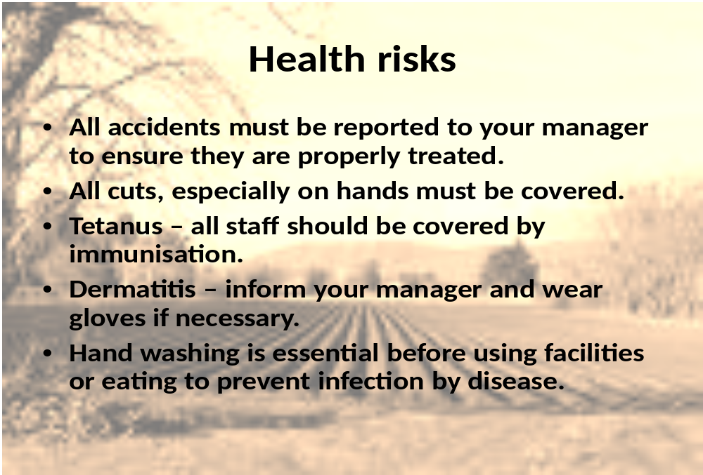
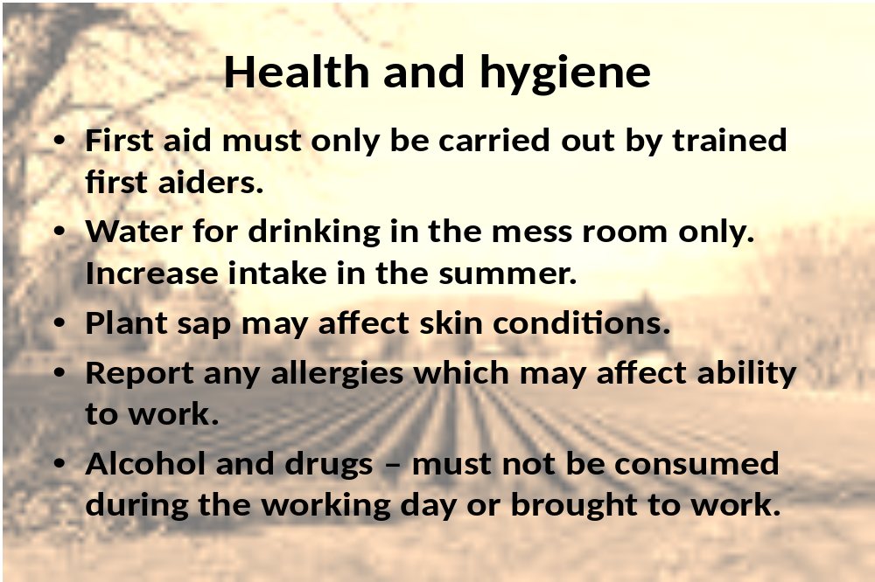
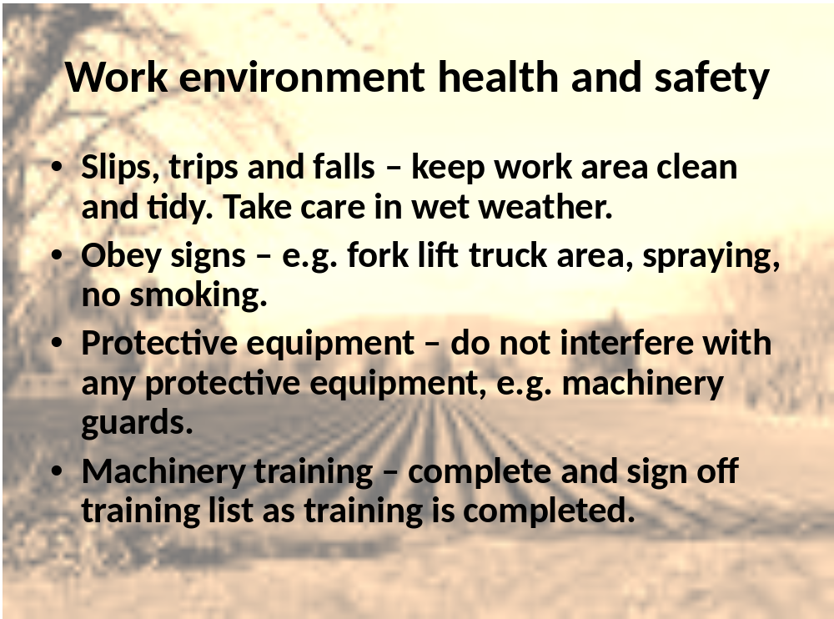
Abbreviations ore shortened words
e.g. means for example
It comes from two Latin words that mean for example.
Word check
There are a variety of words you will see on notices at work that are used to talk about what we can do and what we can’t do. The positive words are used for signs that tell us what we can do and the negative words tell us what we can’t do. Look at these positive words with their opposites.
positive negative
permitted not permitted or prohibited
allowed not allowed
authorised unauthorised or not allowed
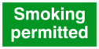

Task 1: Word check
Read the slides and check any words or phrases (groups of words) that you do not understand. Sometimes, the other words in the sentence can give you an idea about what the word means. Here are some of the words from the slides. Put the number of the word or words next to what you think it means (the definition). The first one is done for you.

1. properly treated |  | areas for staff use

2. tetanus |  | raining

3. immunisation |  | stop disease spreading

4. dermatitis |  | illness

5. facilities | 1 | looked after correctly

6. prevent infection |  | keeping something safe

7. disease |  | bacteria found in soil and animal manure

8. intake |  | eat and drink

9. consume |  | protection against disease

10. wet weather |  | take in

11. interface |  | skin rash

12. protective |  | alter or temper with something

Task 2: Getting information
Aim: We are learning to read for detail from the health and hygiene slides.
Writing on slides is often shortened to give the message quickly rather than writing in full sentences. For instance:
Report any allergies which may affect ability to work could be written as
(You should) report any allergies which may affect (your) ability to work.
Use the information from the health and hygiene slides to answer these questions about working for Better Farms Ltd.

Why is it important to report all accidents to your manager?

Who should carry out any first aid treatment?

What should you do if you have a small cut on your hand?

Where should you go to have a drink?

Why is it important to be immunised?

Why do you need to be careful about plant sap?

What two things should you do if you have dermatitis?

Why do you need to take care in wet weather?

What substances must not be brought to work?

What happens at each stage of your machinery training?
Skin at work: Outdoor workers and sun exposure

Who is at risk?
Outdoor workers that could be at risk include farm or construction workers, market gardeners, outdoor activity workers and some public service workers. If you have naturally brown or black skin, you are less at risk of developing skin cancer, although cases do occur.
When the sun is intense, it is sensible to follow guidance to protect yourself. The SunSmart website http://infor.cancerresearchuk.org/healthyliving/sunsmart/ gives advice on how to assess the risk.
You should take particular care if you have:
- fair or freckled skin that doesn’t tan, or goes red before it tans
- red or fair hair and light coloured eyes
- a large number of moles.
What are the harmful effects?
In the short term, even mild reddening of the skin from sun exposure is a sign of damage. Sunburn can blister the skin and make it peel.
Longer term problems can arise. Too much sun speeds up ageing of the skin, making it leathery, mottled and wrinkled. The most serious effect is an increased chance of developing skin cancer.
What can you do to protect yourself
- Keep your top on.
- Wear a hat with a brim or a flap that covers the ears and the back of the neck.
- Stay in the shade wherever possible, during your breaks and especially at lunch time.
- Use a high factor sunscreen of at least SPF15 on any exposed skin.
- Drink plenty of water to avoid dehydration.
- Check your skin regularly for any unusual moles or spots. See a doctor
promptly if you find anything that is changing in shape, size or colour, itching or bleeding.
Remember the SunSmart messages
Spend time in the shade between 11 and 3.
Make sure you never burn.
Aim to cover up with a t-shirt, hat and sunglasses.
Remember to take extra care with young people and children.
Then use factor 15+ sunscreen.
Report any mole changes or unusual skin growths promptly to your doctor.
Task 3: Word check
Aim: We are looking at the phrases and expressions used in the text to understand
the meaning.
Read the text Skin at work: Outdoor workers and sun exposure and check that you understand some of the words and phrases used in it. Look at the words or phrases below. Underline the correct meaning. The first one is done for you.
Outdoor workers that could be at risk include farm or construction workers.
shop | building | office

Outdoor workers that could be at risk include some public service workers.
people who deliver government services | people who transport loads | people who build houses

If you have naturally brown skin, you are at less risk of skin cancer, although cases do occur.
exist | stop | happen

You should take particular care if you have fair or freckled skin.
small bumps | small spots | small cuts

Even mild reddening of the skin is a sign of damage.
going blue | going brown | going red

Even mild reddening of the skin from sun exposure is a sign of damage.
being open to | being afraid of | being closed to
Sunburn can blister the skin and make it peel.
itchy spots | small cuts | watery lumps

Sunburn can blister the skin and make it peel.
tan | flake off | go red

Too much sun speeds up.
makes faster | makes slower | makes older

Too much sun speeds up ageing of the skin.
making younger | making smoother | making older

Too much sun speeds up ageing of the skin, making it leathery, mottled and wrinkled.
blotchy | smooth | tanned

The most serious effect is an increased chance of developing skin cancer.
lower | even | higher

Drink plenty of water to avoid dehydration.
lack of water | lack of sunscreen | lack of shade

Task 4: Skin at work
Aim: We are using the headings to find information in the text.
Use the text Skin at work: Outdoor workers and sun exposure to show if these items are people at risk, harmful effects or things you can do to protect yourself. Put a tick in the column. The first one is done for you.

 | People at risk | Harmful effects | Protect yourself
Work in construction | ✓
Blisters on the skin
Having fair skin
Stay in the shade when possible
Reddening of the skin
Skin that goes red before it tans
Check skin for unusual moles or spots
Wear a hat with brim
Work as a market gardener
Use a high factor sun screen
Ageing of the skin making it wrinkled
Keep top or t-shirt on
Increased chance of skin cancer
Drink plenty of water

Hazard diamonds
Aim: We are learning about hazard signs for dangerous goods.
When you work in manufacturing, you will sometimes store and handle goods that are marked with hazard diamonds. These are to show everyone what kind of materials the package contains.
The people who pack and transport the goods have a duty to identify the hazards of the goods they intend to transport. There are nine classes, some with divisions, as shown below:

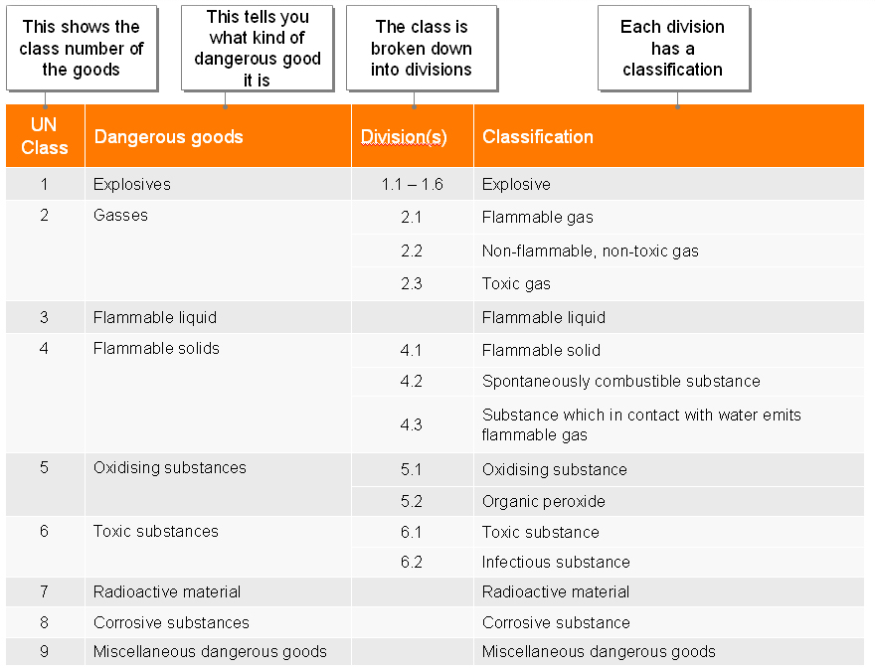

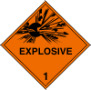 | The hazard diamond tells about the class of material. This diamond shows you the sign for explosive material, a written description and the class number.  Explosive material can blow up.

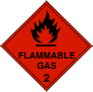 |  | 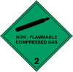 |  | 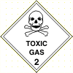 |  | 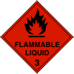 |  | 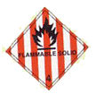
When you see this sign, it means that the substance is flammable. This means that it is very likely to catch fire or ignite. |  | Non-flammable means that this compressed gas will not catch fire. |  | This sign shows that the gas is toxic. This means that it could kill you if you breathe it in. |  | Flammable means that this is a liquid that can catch fire. |  | Flammable means that this is solid matter that can catch fire.

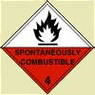 |  | 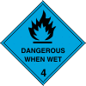 |  | 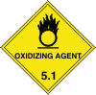 |  | 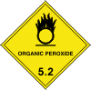 |  | 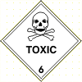
The substance has a low temperature when it can catch fire on contact with oxygen. |  | This substance can give off a flammable gas (it can catch fire) on contact with water. |  | Oxidising means something that can join (combine) with oxygen on contact with the air. |  | An organic peroxide is a compound from natural sources containing a single bond of oxygen. |  | When you see this sign, it means that the substance is toxic. This means that it is deadly: it can kill you.

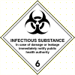 |  | 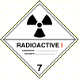 |  | 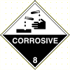 |  | 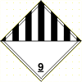
Infectious substances are those that can cause disease in humans or animals. |  | This sign shows that the substance is radioactive. |  | When you see this sign, it means that the substance is corrosive. This means that it could irritate your skin or burn your skin very badly. |  | Class 9 is miscellaneous. This is a word that means mixed and is used for everything else that does not have a class description.

Task 5: Test yourself
Use the information about hazard diamonds to find out what these signs mean.
Which sign means flammable substance?
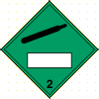 |  | 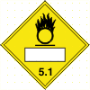 |  | 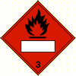 |  | 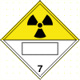
 |  |  |  |  |  | 
This sign means:
 compressed gas
 radioactive material
 infectious substance
 toxic gas
Which sign means toxic substance?
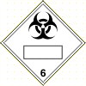 |  | 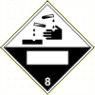 |  |  |  | 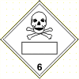
 |  |  |  |  |  | 
This sign means:
 compressed gas
 radioactive material
 infectious substance
 oxidising agent
Which sign means corrosive substance?
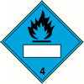
 |  |  |  |  |  | 
This sign means:
 compressed gas
 radioactive material
 flammable substance
 corrosive material
Which sign means oxidising substance?
 |  |  |  |  |  | 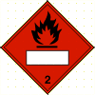
 |  |  |  |  |  | 

How did you get on?

Module 2: Health and hygiene answers

Task 1 answers

1. properly treated | 5 | areas for staff use

2. tetanus | 10 | raining

3. immunisation | 6 | stop disease spreading

4. dermatitis | 7 | illness

5. facilities | 1 | looked after correctly

6. prevent infection | 12 | keeping something safe

7. disease | 2 | bacteria found in soil and animal manure

8. intake | 9 | eat and drink

9. consume | 3 | protection against disease

10. wet weather | 8 | take in

11. interface | 4 | skin rash

12. protective | 11 | alter or temper with something

Task 2 answers

Why is it important to report all accidents to your manager?
It is important because the accidents should be treated properly.

Who should carry out any first aid treatment?
Only trained first aiders should provide first aid.

What should you do if you have a small cut on your hand?
If you have a small cut on your hand, you should make sure it is covered.

Where should you go to have a drink?
You should go to the mess room.

Why is it important to be immunised?
Immunisation protects against diseases like tetanus.

Why do you need to be careful about plant sap?
Plant sap may affect skin conditions.

What two things should you do if you have dermatitis?
If you have dermatitis, you should inform your manger and wear gloves.

Why do you need to take care in wet weather?
You need to take care you do not slip, trip or fall.

What substances must not be brought to work?
You must not bring alcohol or drugs to work.

What happens at each stage of your machinery training?
At each stage of machinery training, you are signed off on the training list as the training is completed.

Task 3 answers

Outdoor workers that could be at risk include farm or construction workers.
shop | building | office

Outdoor workers that could be at risk include some public service workers.
people who deliver government services | people who transport loads | people who build houses

If you have naturally brown skin, you are at less risk of skin cancer, although cases do occur.
exist | stop | happen

You should take particular care if you have fair or freckled skin.
small bumps | small spots | small cuts

Even mild reddening of the skin is a sign of damage.
going blue | going brown | going red

Even mild reddening of the skin from sun exposure is a sign of damage.
being open to | being afraid of | being closed to

Sunburn can blister the skin and make it peel.
itchy spots | small cuts | watery lumps

Sunburn can blister the skin and make it peel.
tan | flake off | go red

Too much sun speeds up.
makes faster | makes slower | makes older

Too much sun speeds up ageing of the skin.
making younger | making smoother | making older

Too much sun speeds up ageing of the skin, making it leathery, mottled and wrinkled.
blotchy | smooth | tanned

The most serious effect is an increased chance of developing skin cancer.
lower | even | higher

Drink plenty of water to avoid dehydration.
lack of water | lack of sunscreen | lack of shade

Task 4 answers

 | People at risk | Harmful effects | Protect yourself
Work in construction | ✓
Blisters on the skin |  | ✓
Having fair skin | ✓
Stay in the shade when possible |  |  | ✓
Reddening of the skin |  | ✓
Skin that goes red before it tans | ✓
Check skin for unusual moles or spots |  |  | ✓
Wear a hat with brim |  |  | ✓
Work as a market gardener | ✓
Use a high factor sun screen |  |  | ✓
Ageing of the skin making it wrinkled |  | ✓
Keep top or t-shirt on |  |  | ✓
Increased chance of skin cancer |  | ✓
Drink plenty of water |  |  | ✓

Task 5 answers

 |  |  |  |  |  | 
This sign means:
 compressed gas
 radioactive material
 infectious substance
 toxic gas
Which sign means toxic substance?
 |  |  |  |  |  | 
This sign means:
 compressed gas
 radioactive material
 infectious substance
 oxidising agent
Which sign means corrosive substance?
 |  |  |  |  |  | 
This sign means:
 compressed gas
 radioactive material
 flammable substance
 corrosive material
Which sign means oxidising substance?
 |  |  |  |  |  | 

