
Level 1: Reading
Agriculture

Module: Health and safety information at work

Module aims

Main aim
We are learning how headings help us find information from the text.

Other learning aims
We are learning:
- The meaning of some key words from the health and safety leaflet
- To read for detail from an information leaflet
- Reading the health and safety text to show we understand the text

Module: Health and safety information at work
Aim: We are learning how headings help us find information from the text.

Task 1
Headings in written texts help us to find bits of information quickly. They give an idea of what the paragraph is about. Look at this leaflet about health and safety at work. It is missing its headings. Match the headings in the table to the number of the paragraph in the text below. The first one is done for you.

Your employer’s duties to you | 
What to do if there’s a problem | 
Introduction | 
Your duties as an employee | 

A guide for workers
If you are an employee, this information explains what your rights are, what you should expect from your employer, what your responsibilities are and where you should go for help. If you are a temporary, casual or agency worker, the employment agency, gangmaster, contractor or hirer you are working for has a legal duty to ensure you receive the rights set out here.
Your employer has a duty to ensure, so far as is reasonably practicable, your health, safety and welfare at work, including:
- making the workplace safe and without risks to health
- ensuring machines are safe and safe systems of work are set and followed
- ensuring articles and substances are moved, stored and used safely
- providing adequate welfare facilities and first aid treatment
- providing health and safety training for employees
- providing necessary protection at work (such as clothing, shoes or boots, eye protection, gloves, masks, etc.)
You have legal duties at work, too. They include:
- taking reasonable care for your own health and safety and that of others who may be affected by what you do or do not do
- co-operating with your employer on health and safety including following risk assessments and method statements
- using work items correctly, including personal protective equipment
- not interfering with or misusing anything provided for your health and safety.
If you think there’s a problem or hazard in the workplace, you should discuss it first with your manager or supervisor. If you are not happy with the response, discuss it with your safety representative. Also, you can get further information on health and safety at the following website:
http://www.hse.gov.uk The Health and Safety Executive
If you want to speak to someone in your home language, call 08701 545 500 and tell the operator which language.
Health and safety at work
Aim: We are learning the meaning of some key words from the health and safety
leaflet.

Now the leaflet has its headings in place, it looks like this. Some of the words in the leaflet are quite difficult. This activity will help you to understand them. We have underlined some of the words and phrases that you may not know.
A guide for workers
Introduction
If you are an employee, this information explains what your rights are, what you should expect from your employer, what your responsibilities are and where you should go for help. If you are a temporary, casual or agency worker, the employment agency, gangmaster, contractor or hirer you are working for has a legal duty to ensure you receive the rights set out here.
Your employer’s duties to you
Your employer has a duty to ensure, so far as is reasonably practicable, your health, safety and welfare at work, including:
- making the workplace safe and without risks to health
- ensuring machines are safe and safe systems of work are set and followed
- ensuring articles and substances are moved, stored and used safely
- providing adequate welfare facilities and first aid treatment
- providing health and safety training for employees
- providing necessary protection at work (such as clothing, shoes or boots, eye protection, gloves, masks, etc.)
Your duties as an employee
You have legal duties at work, too. They include:
- taking reasonable care for your own health and safety and that of others who may be affected by what you do or do not do
- co-operating with your employer on health and safety including following risk assessments and method statements
- using work items correctly, including personal protective equipment
- not interfering with or misusing anything provided for your health and safety.
What to do if there’s a problem
If you think there’s a problem or hazard in the workplace, you should discuss it first with your manager or supervisor. If you are not happy with the response, discuss it with your safety representative. Also, you can get further information on health and safety at the following website:
http://www.hse.gov.uk The Health and Safety Executive
If you want to speak to someone in your home language, call 08701 545 500 and tell the operator which language.
Abbreviations are shortened words
etc means and so on
It comes from a Latin phrase et cetera.
Task 2: Health and safety at work word check
Here are the words from the leaflet. Put the number of the word next to what you think it means (the definition). The first one is done for you.

1. responsibilities |  | good enough

2. ensure |  | answer

3. reasonably practicable |  | needed

4. article | 1 | duties

5. substances |  | as much as could be expected

6. adequate |  | meddling with or altering

7. facilities |  | something that poses a health risk

8. necessary |  | not using in the correct way

9. co-operating |  | an agent or spokesperson

10. interfacing |  | doing as you have been told

11. misusing |  | items

12. hazard |  | make sure or certain

13. response |  | matter or materials

14. representative |  | places for use by staff
Word check
mis is an element added to the front of a base word to add to the meaning. It is a prefix.
mis means wrong or bad
mis + use means bad use
mis + deed means bad action
mis+ advise means to advise wrongly or badly
mis+ conduct means bad conduct (or behaviour)
Task 3: Health and safety at work word grid
Here are the meanings of the words from the last task. Work out the word. Write it in the word grid. There are some letters in the grid to help you.

doing as you have been told |  |  |  | an agent or spokesperson
items | places for use by staff |  |  | good enough |  |  | duties
meddling with or altering |  | matter or materials |  |  |  | needed
As much as could be expected |  |  | answer |  | Not using in the correct way

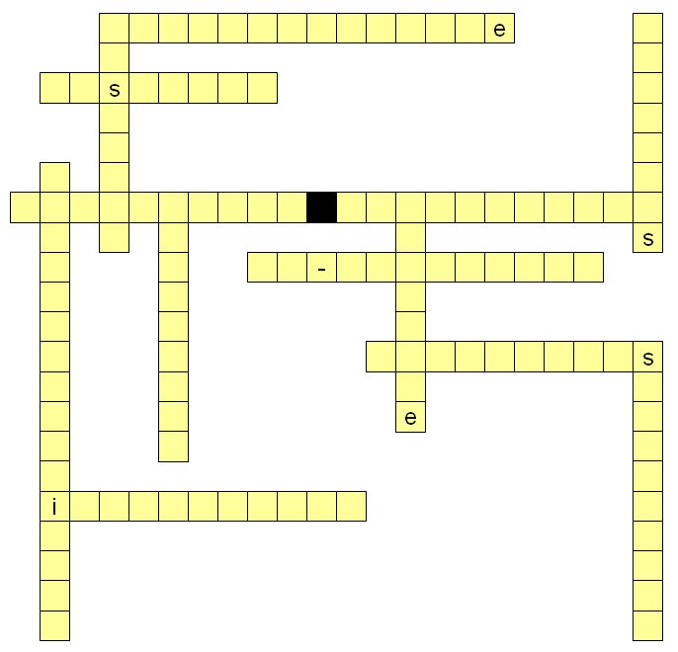
Task 4: Health and safety responsibilities at work
Aim: We are learning to read for detail from an information leaflet.
Read A guide for workers. Can you tell if these duties are the responsibility of the employer or the employee? Put a tick in the column. The first one is done for you.
Duties | Responsibility
Duties | employer | employee
Ensure health, safety and welfare at work | ✓
Co-operate with employers on health and safety
Make sure that articles and substances are stored safely
Take care of own health and safety
Not interfere with anything provided for health and safety
Provide health and safety training
Provide adequate welfare facilities
Use personal protective equipment correctly
Make the workplace safe
Provide protective clothing and equipment
Report a health and safety problem
Make sure safe systems of work are set and followed
Make sure that machines are safe to use

Task 5: Health and safety at work
Aim: We are reading the health and safety text to show we understand the text.
The text is about responsibilities under the Health and Safety at Work Act. An Act is an Act of Parliament. When you see Act in a title, it means that it is the law.
Look at the leaflet and use the information to answer the questions that follow.
A guide for workers
Introduction
If you are an employee, this information explains what your rights are, what you should expect from your employer, what your responsibilities are and where you should go for help. If you are a temporary, casual or agency worker, the employment agency, gangmaster, contractor or hirer you are working for has a legal duty to ensure you receive the rights set out here.
Your employer’s duties to you
Your employer has a duty to ensure, so far as is reasonably practicable, your health, safety and welfare at work, including:
- making the workplace safe and without risks to health
- ensuring machines are safe and safe systems of work are set and followed
- ensuring articles and substances are moved, stored and used safely
- providing adequate welfare facilities and first aid treatment
- providing health and safety training for employees
- providing necessary protection at work (such as clothing, shoes or boots, eye protection, gloves, masks, etc.)
Your duties as an employee
You have legal duties at work, too. They include:
- taking reasonable care for your own health and safety and that of others who may be affected by what you do or do not do
- co-operating with your employer on health and safety including following risk assessments and method statements
- using work items correctly, including personal protective equipment
- not interfering with or misusing anything provided for your health and safety.
What to do if there’s a problem
If you think there’s a problem or hazard in the workplace, you should discuss it first with your manager or supervisor. If you are not happy with the response, discuss it with your safety representative. Also, you can get further information on health and safety at the following website:
http://www.hse.gov.uk The Health and Safety Executive
If you want to speak to someone in your home language, call 08701 545 500 and tell the operator which language.
The Health and Safety at Work Act places legal duties on:
 employers only.
 operatives (employees) only.
 all people at work.
 visitors to the factory.
As an employee you do not have a legal duty to:
 use all equipment safely and as instructed.
 provide your own protective clothing.
 speak to your supervisor if you are worried about safety.
 report any equipment that is damaged or defective.
You will often hear the word hazard during safety training. What does it mean?
 Anything that can harm you?
 The industry accident rate.
 A type of barrier or machine guard.
 All of the other answers.
Why is the Health and Safety at Work Act important to you?
 It tells you which parts of the workplace are dangerous.
 It must be learnt before starting work.
 It requires your employer to provide a safe place to work.
 It tells you how to do your job.
You find that you cannot do your job as the work system says you should. What should you do?
 Make up your own way of doing the job.
 Do not start work until you have talked with your supervisor.
 Ask your workmates how you think they should do the job.
 Contact the Health and Safety Executive.
Why do you need to know the health and safety regulations?
 They tell you how to write risk assessments.
 They explain how health and safety is managed at work.
 They tell you when Health and Safety Executive inspections will take place.
 They place legal duties on you.

How did you get on?

Module 1: Health and safety information answers

Task 1 answers

Introduction
Your employer’s duties to you
Your duties as an employee
What to do if there’s a problem

Task 2 answers

1. responsibilities | 6 | good enough

2. ensure | 13 | answer

3. reasonably practicable | 8 | needed

4. article | 1 | duties

5. substances | 3 | as much as could be expected

6. adequate | 10 | meddling with or altering

7. facilities | 12 | something that poses a health risk

8. necessary | 11 | not using in the correct way

9. co-operating | 14 | an agent or spokesperson

10. interfacing | 9 | doing as you have been told

11. misusing | 4 | items

12. hazard | 2 | make sure or certain

13. response | 5 | matter or materials

14. representative | 7 | places for use by staff

Task 3 answers

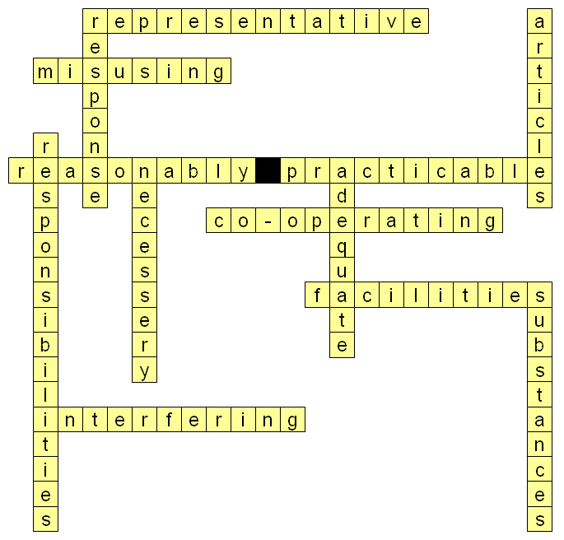
Task 4 answers

Duties | Responsibility
Duties | employer | employee
Ensure health, safety and welfare at work | ✓
Co-operate with employers on health and safety |  | ✓
Make sure that articles and substances are stored safely | ✓
Take care of own health and safety |  | ✓
Not interfere with anything provided for health and safety |  | ✓
Provide health and safety training | ✓
Provide adequate welfare facilities | ✓
Use personal protective equipment correctly |  | ✓
Make the workplace safe | ✓
Provide protective clothing and equipment | ✓
Report a health and safety problem |  | ✓
Make sure safe systems of work are set and followed | ✓
Make sure that machines are safe to use | ✓

Task 5 answers
The Health and Safety at Work Act places legal duties on:
 employers only.
 operatives (employees) only.
 all people at work.
 visitors to the factory.
As an employee you do not have a legal duty to:
 use all equipment safely and as instructed.
 provide your own protective clothing.
 speak to your supervisor if you are worried about safety.
 report any equipment that is damaged or defective.
You will often hear the word hazard during safety training. What does it mean?
 Anything that can harm you?
 The industry accident rate.
 A type of barrier or machine guard.
 All of the other answers.
Why is the Health and Safety at Work Act important to you?
 It tells you which parts of the workplace are dangerous.
 It must be learnt before starting work.
 It requires your employer to provide a safe place to work.
 It tells you how to do your job.
You find that you cannot do your job as the work system says you should. What should you do?
 Make up your own way of doing the job.
 Do not start work until you have talked with your supervisor.
 Ask your workmates how you think they should do the job.
 Contact the Health and Safety Executive.
Why do you need to know the health and safety regulations?
 They tell you how to write risk assessments.
 They explain how health and safety is managed at work.
 They tell you when Health and Safety Executive inspections will take place.
 They place legal duties on you.

