Outstanding teaching, learning and assessment: case study on operational project led by Barking & Dagenham College

Using Google for outstanding teaching, learning & assessment
Introduction
This project highlighted the impact on outstanding teaching, learning and assessment offered by incorporating widely available, free online tools – Google Apps, Google Classroom and others – into strategies to engage vocational 16 to 19-year-old students to become enthusiastic, independent learners, ready for work or progression.
The project partners Barking and Dagenham College and Redbridge College are neighbouring general further education (GFE) colleges with a strong record in developing entrepreneurial and employability skills in an East London area with high unemployment and a low rate of formal qualifications, even lower for white working class males.
Project partner | Profile | Course groups engaged | Tutors | Students | Managers
Barking & Dagenham College | Large GFE | Level 2 first certificate in creative digital media production  Cskills awards level 1 diploma in painting & decorating | 8 | 32 | 2
Redbridge College | Medium FE | Level 1 professional cookery  Level 1 hospitality & catering multi-skills  Level 2 professional cookery | 4 | 72 | 1

Barking & Dagenham College has developed its teaching, learning and assessment strategies to be innovative and creative, working with Professor Sugatra Mitra to embed the ‘Self Organised Learning Environment’ concept, a holistic approach to skills development using available technology, alongside the college’s vision for ‘T shaped’ capabilities combining core subjects with enterprise, self-efficacy, functional and social skills. The project followed the progress of offering successful approaches to tutors with groups whose engagement and performance needed improving in digital media, painting & decorating and at Redbridge College, hospitality and catering.
“I enjoy Quizlet, it’s a very easy and fun way to help me revise even when I am not at college. I have completed 7 out of 8 exams and had a few 100% thanks to Quizlet and hopefully pass all my exams by next week.”
Level 1 student, painting & decorating, Barking & Dagenham College

Approach
Advanced practitioner support helped each tutor to plan the introduction of new activities according to student profile, for example:
- Online quizzes motivated level 1 painting & decorating students from the moment they arrived in class, and they became eager to compete, share, peer review, tackle English and maths tasks, and go on to select their own activities and complete them outside class. Relevant YouTube videos were used to acquire and practice difficult techniques, research the implications of materials used before starting practical work and to find real world examples to test and justify their decisions enabling the tutor to develop a facilitative role channelling each learner’s interests.
- Managing the class using an onscreen avatar for each level 2 digital media student proved a highly inclusive, visual method that promoted an equal, unbiased share in classroom activities; praise and rewards; allocation of tasks; even a fun way of taking the register, and created classroom participation reports that were later shared and discussed with the student and parents.
- Enabling level 1 hospitality & catering students, many with additional learning needs, to have their work photographed in the kitchen environment and uploaded directly and accurately for later use improved the opportunity for every learner to calmly reflect on the evidence – especially if assignments had gone wrong – but also take pride in their work, peer review, assess safe working practices and make statements for their portfolio.
“I have noticed that my work is better with pictures to actually prove what I have done”
Level 1 hospitality & catering multi-skills student
Getting students involved in how they would like to see their learning develop using online tools generated a high interest, which increased the more they saw what was available to them.

Before Google |  | After Google |  | Students’ perspective on impact on learning
Mostly  % | Definitely  % | Mostly  % | Definitely  %
26 | 73 | 15 | 84 | I feel confident that I can successfully complete my course
35 | 45 | 32 | 64 | I like to learn from videos, e.g. YouTube.
39 | 42 | 34 | 61 | I like to use digital technology to present my work to other people
41 | 59 | 24 | 76 | Digital technology is useful and relevant to my lessons.

Outcomes and impact
Course leaders in hospitality and catering strongly link the development of practice using free online tools with improved student retention, punctuality and attendance for the 2014/15 level 1 hospitality and catering multi-skills group, after introduction around week 17.
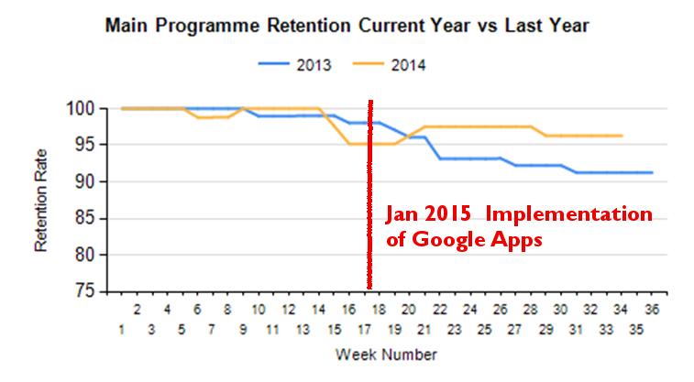 | 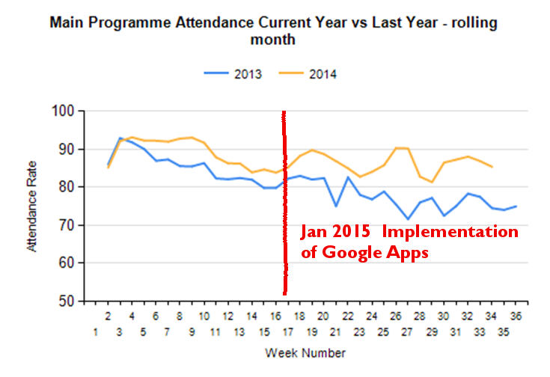

Everyone in this group was also progressing this year, showing an increase in work completed outside of class, with no permanent loss of work or evidence rejected. The students were showing a significant improvement in meeting deadlines and, through logging in at home, an increase in parental involvement.
“The past few weeks has helped me realise how much we learn digitally.”
Level 2 creative digital media student
The other areas also experienced positive results with higher performance expected across all groups by the end of the year. The Head of Learning for cultural and creative industries attributes success to increased organisation and accessibility of key support documents being in one place online. For example one digital media learner, with an additional learning need and predicted to fail her core subject, English and maths, found the ‘one stop shop’ structure provided by tutors using Google Classroom helped her manage her difficulties over where and how to engage with feedback and support, and is now on-track to pass her core subject and English and maths.
The painting and decorating group, a majority of which are white working class males, demonstrated improved engagement, no further drop in retention, considerable increase in independent learning and a professional attitude to collecting photographic evidence for portfolios.
Feedback from selected employers recognised the impact of improving students’ ability and responsibility to capture evidence of their work. Similarly with awarding bodies during external verification as evidenced by this commendation from City & Guilds:
“The evidence is both reliable and authentic as it is gathered during assessment and stored in a way that can be easily used by students of all ability.”
Aligned with the Professional Standards, teachers felt they significantly developed their practice, strengthening the professional values of building positive and collaborative relationships with colleagues and learners. Advanced practitioners helped them evaluate their professional understanding of how methods impacted on each student and what to try next. Ongoing development will target building skills to promote the benefits of technology and support learners in its use.
“We are a 5* Hotel, and visual evidence of the standard of work that the students are already producing at the college can aid us in supporting their progression. It is a practice I would like implemented on every work placement prior to start”.
Hotel Cafe Royal

Lessons learned
Risk taking and problem solving was genuinely encouraged ‘blame free’ to reinvigorate professional practice and relationships. The tutors, new to technology for teaching and learning, collaborated with online teachmeets between the two colleges. A typical experience was the example of a tutor who had low morale at the beginning of the year but quickly became an expert in engaging classes using these tools. As a result he significantly improved his observation grades and made a great impact on the learning taking place.

Quick to start up, tablets and phones ensured no drop in concentration, overcoming the delays and interruptions of waiting for computers to start up and log in.
A catalyst for accelerating change and getting traction proved to be identifying an advocate at lecturer level, passionate and supportive, to promote innovations that align college strategy with individual practice.
“These projects created a real buzz and made teaching sexy again which drew in more interested tutors. You get change by doing it with staff and not to staff, by visibly supporting them.”
Demi Stylianou, Quality & Transforming Learning Manager, Barking & Dagenham College

Sustainability and transferability
Growing staff confidence by using digital tools to impact on learning is a strategic aim at both colleges. At Barking & Dagenham College, expanding the impact of information and learning technologies for outstanding teaching, learning and assessment is a key aim. It is a component of the strategic drive for the college’s target improvements in English and maths, equality and diversity, checking understanding, and attendance and punctuality. Google Classroom, piloted in one course in creative media, will run in 35 courses next year, with similar expansions planned across other curriculum areas. Best practice ‘show and tell’ carousel sessions at all-staff development days will cascade successful methods across Redbridge College.
Collaboration between the two colleges has become known informally as the ‘virtual skills exchange’, which has accelerated developments that benefit learning arising from the use of information and learning technologies, has pooled effort and widened the curriculum-specific stock of exemplars.

Case study written by Julian Bream, Peer Advisor, supported by Demi Stylianou, Barking & Dagenham College
Appendix 1 Resources to share
 | Andy Duffy, Advanced Practitioner for Teaching, Learning and Assessment, Barking & Dagenham College, explaining how using Google Apps can bring outstanding teaching, learning and assessment to other tutors. | https://www.youtube.com/watch?v=r-pXwplNvTw&feature=youtu.be
 | Media Tutor, Ewan Bruce, Barking & Dagenham College, evaluates the use of Google Classroom and ClassDojo for learners. | https://youtu.be/BEoQqOvdmCs

