Outstanding teaching, learning and assessment: case study on operational project led by Lambeth Adult Learning Services

Introduction
This project has been driven by Morley College, who very successfully participated in the 2013-14 joint practice development (JPD) projects funded by the Education and Training Foundation, working with City Lit to better embed literacy and English for Speakers of Other Languages (ESOL) into a range of vocational courses. This project effectively continued that work, the emphasis being on cross-vocational / literacy/ESOL sharing of practice, along with collaborating with Lambeth Adult Learning Services to develop links with local employers to feed into the literacy for employability focus.

Approach
This project arose from a concern that lack of confidence and skills with English, literacy and ESOL are significant barriers to learners in finding employment or beginning their own enterprise. The project aimed to address the following priority areas:
- Development of English, literacy and ESOL skills
- Supporting learners with learning difficulties and/or disabilities
- Employability
- Employer engagement
A pilot group of five teachers currently delivering employability and enterprise courses for Lambeth Adult Learning Services worked to identify learners’ needs around English, literacy and ESOL through interviews, surveys and initial assessments. The project also involved consultation with local employers to determine their expectations of language and literacy. The stages of the project were planned as follows
- An initial meeting to share current practice and develop strategies.
- Consultations with employers
- A five-month period experimenting with teaching, learning and assessment strategies in their classes, recording outcomes and impact on learners in reflective diaries
- Producing case studies with learners
- A final session where participants will reflect on and share their experiences. This will also enable the reviewing and evaluating of the project.
English, literacy and ESOL specialists provided mentoring support, including reviewing current course content and jointly developing activities and resources.
Building on the success of the JPD project last year, this was very much a ‘ground up’ approach to collaboration. Each teacher in the project ran mini-projects tailored to their individual groups. In term 2, the focus was on developing formal communication skills through team work and presentations. In term 3, the focus was on contextualising reading and writing skills in work-based scenarios. The teachers met regularly to share ideas and practice in relation to notions of outstanding, and to relate these to the new professional standards (see below).
Although teachers were working with a similar focus each term, the project took a highly focused and contextualised approach to embedding in different subject areas – this may not seem particularly innovative, but it is unusual to see this actually happen in practice (i.e. there’s often a tendency for the literacy/language to become quite generic in application, with little sensitivity to the actual language/literacy practices of the vocational area). The project involved a team of 10 tutors and 75-100 learners.

Outcomes and impact
From the very start of this project there was a focus on classroom activity and sharing of practice between the participating teachers. Some of the teacher/student group had already taken part in a similar JPD activity during 2014-15, seen the benefits of this, and were highly motivated to use another opportunity for developing practice with colleagues. It was therefore no surprise to see the project already reporting increased confidence with embedding at the halfway point in March. By then, two teachers had already achieved higher internal observation grades and learner attendance rates had improved.
At the end of the project all teachers in the project have been graded ‘good’ or ‘outstanding’. Two were formerly graded 3 and two have progressed from 2 to 1. One is consistently ‘outstanding’ and wants to improve further by gaining a level 5 certificate in supporting adult literacy.
The project has been collecting various outputs in terms of monitoring and recording, including activity logs, group profiles, and visuals, e.g. student presentations.
At first I was not sure about my goals. I practised what I learnt. I am more motivated and confident…I see positive things for my future

Learner B
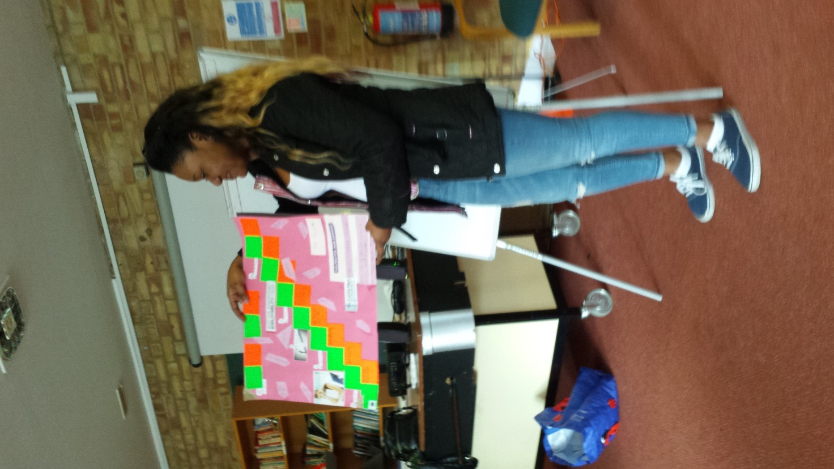

Teachers have met regularly with the project coordinator to share ideas, develop resources and assess their development against professional standards for teaching.
Resources produced during the first two months of the project have already been shared with other organisations delivering operational projects. As they are electronic, they can be adapted and contextualised according to different organisational needs.
Short-term outcomes:
- Five tutors trained to develop their learners’ English, literacy and ESOL skills for employability and enterprise. Impact will be recorded in their personal diaries, learner case studies, mentoring records and the report on the final evaluation session
- Online materials developing English, ESOL and literacy skills for employability and enterprise will be disseminated to all Lambeth Adult Learning Services community based tutors
- Improved employer engagement
Success data for term 2:
- NCFE childcare 95%
- NCFE employability (office and reception skills, confidence for work) 100%
- NCFE enterprise (sewing and enterprise) 100%
Additionally, the majority of students who passed level 1 childcare are progressing to level 2 and/or GCSE English. Four students from office and reception skills applied for voluntary placements at Guy’s Hospital and two are working as volunteers at Morley. Students from the sewing and enterprise course are preparing crafts for a summer fair stall in Brixton and one of the students has progressed to a dressmaking course at Morley College. Three students on the confidence for work course have started to apply for jobs and one has had a successful interview. Others are enrolling on ESOL, English and pay roll courses to improve their chances of employment in the future.
Aside from the impact on learners evidenced by the exam results and progression routes above, learners have been consulted throughout, and have played a very active role in this project in terms of continuous feedback and evaluation. Comments from learners evidence the impact that the teachers’ collaborative approach has had on their own learning:
“I am more motivated and confident…I see positive things for my future.”
“I have an excellent tutor who always explains things very well. I was scared of doing presentations but because my teacher helped me so much, I did a presentation to my group and I was so happy."
“My teacher is fabulous…really great at teaching and the lessons are so much fun. Some questions can be quite difficult to understand and our teacher helped us to realise how important it is to read the questions carefully. Often, it’s not the calculations that are hard but the way you’re asked.”
Some comments also evidence impact on particular target groups:
“Learning helps to takes off the layers you put on due to the stigma of mental health and allows you to blossom.”
“I’m dyslexic so it’s great that my lovely teacher makes tasks easier by breaking them down into stages. She also writes instructions in plain English.”
There have been many comments from the teachers which support the value of joint practice development:
“I’m really excited to work with my groups – it’s great how they motivate each other and how they are enthusiastic about their group project. They’ve even designed their own business cards which is an excellent way of practising literacy skills.”
“The project has given me the confidence to try out new ideas and reflect on what works and what doesn’t.”
“I’m more willing to acknowledge and use students’ experiences instead of slavishly sticking to my lesson plan.”
“I now have the confidence to deal with aggressive students without being someone I’m not.”
“I’m much more aware of how important it is to support the development of literacy skills – probably just as important as the vocational input. And students enjoy the vocabulary ice-breakers we use at the beginning of the class – they get quite competitive. »
In their regular discussions reflecting on the project and the Professional Standards, the teaching team singled out key areas that they felt were particularly relevant to their development. Here is how they related and contextualised some of their practical strategies and approaches in relation to relevant standards:
Be creative and innovative in selecting and adapting strategies to help learners to learn
- Focus groups – what works well for them (or otherwise)? Where would they like to progress? How can we help them get there?
- Facilitating independent learning through group projects: discussion, individual research, communication and presentation skills, problem-solving
- Reflections – what have they learned today? About the topic? About themselves? About English skills?
Value and promote social and cultural diversity, equality of opportunity and inclusion

- Ensuring everyone has a valuable role within the group or project which plays on their strengths and develops their potential
- Embed the challenging of stereotypes, prejudice and discrimination in course materials, class discussions and role plays
- Use opportunities to raise awareness of issues such as homelessness, mental health, physical disabilities and LGBT
Motivate and inspire learners to promote achievement and develop their skills to enable progression
- Arrange motivational speakers (Access tutors, information, advice and guidance specialists, professionals)
- Encourage students to identify own skills and qualities and how they can be transferred to the workplace, volunteer positions and personal/social life
- Promote effective study skills: remembering equipment, making notes, keeping glossaries, hole-punching and filing handouts logically, meeting deadlines, research skills, skim and scan reading, using libraries and searching the internet
Address the maths and English needs of learners and work creatively to overcome individual barriers to learning
- Survey employers to determine their expectations of literacy and numeracy for employability
- Produce activity packs in which literacy, ESOL and numeracy are contextualised in different vocational areas
- Produce SMART board games, for example: alphabetical order; subject-verb agreement, spelling, use of capital letters, cloze activities
- Create role plays that encourage confidence with assertiveness and formal speaking and listening

Lessons learned
One early issue encountered meant that the original collaborative focus changed – a key staff member at Lambeth Adult Learning Services left her post (her role was to have been to make links with local employers to feed into the literacy for employability focus). The project lead took this role on and talked to local employers, with their input being fed into teaching, learning and assessment aspects of the project; yet inevitably, given her already busy role as project lead, this meant that collaboration with employers became a smaller focus of the project, with the main collaborative development taking place between the Morley College teachers (and their learners, who fed into the project throughout). Perhaps a ‘lesson learnt’ here for future projects might be to be sure not to rely on particular individuals in an organisation for key aspects of a project, but to develop more flexible team approaches.
Another key lesson learnt from this project is the importance of context and continuity. The significance of a dynamic and committed project lead already enthusiastic for JPD approaches, and a team of teachers who had already participated in a similar project, and who also very much welcomed the opportunity to share practice, (and had already developed team skills to do this) – these factors together created a climate very favourable to quick progress and opportunities taken. This is particularly important in such a short-term project, where time can be easily lost just establishing initial collaborative relationships and boundaries, or the ‘ethos’ and day to day working practices of the project.
Overall tutors have been given – and taken advantage of – many opportunities to share/collaborate: these opportunities have resulted in a very much reinforced ethos of collaboration which is likely to extend beyond the life of the project, and which will also be likely to produce many of the ‘hidden’ benefits of collaboration, such as better sharing of ideas and innovative and outstanding practice, the passing of expertise, and ‘unofficial’ mentoring activity.
The team would very likely welcome future opportunities to transfer / share this practice, and to increase the level of cross-organisation collaborative practice.

Sustainability and transferability
Given that that this project has resulted in a teaching team working together very collaboratively, and seeing the benefits of this to themselves and their learners, it is to be expected that this will continue as a default approach - assuming of course that timetabling allows teachers the opportunity to continue to share practice. The strong collaborative ‘ethos’ of this project could certainly be shared with other organisations, - yet it is individual institutional contexts and conditions that will determine whether such a collaborative ‘ethos’ can be transferred. Certainly the Lambeth Adult Learning Services /Morley College team that took part in the project would all make good ‘champions’ for JPD type approaches.
In order to sustain the positive outcomes from this project, Lambeth Adult Learning Services have proposed forming a working group in which students and teachers can meet to share ideas, expectations and resources in order to create courses that meet the changing and diverse needs of people taking the first steps towards transforming their lives. Potentially, this could include students and teachers from all organisations delivering the London projects. Teachers from other organisations will be invited to join this group.
Case study written by John Sutter, Peer Advisor, supported by Alison Creedon, Morley College

