Outstanding teaching, learning and assessment: case study on operational project led by Redbridge Institute
East London Quality Partnership

Introduction
This project focussed on the core theme of English and Literacy, including ESOL. The lead partner was Redbridge Institute of Adult Education and the project was delivered through the East London Quality Partnership (ELQP). ELQP is made up of five partner organisations including four directly delivered local authority adult community learning services: Redbridge Institute; The Adult College of Barking and Dagenham (LBBD); Lifelong Learning; Idea Store Tower Hamlets (TH), London Borough of Waltham Forest Adult Learning Service (LBWF) and a special designated institution, City Lit.
The ELQP was established as a sub-regional London partnership in North East London in 2001 (but has increased in partners since that time) and previously delivered two successful projects which served as a building block for this project – Peer Review of the Learner Journey (2008-2010) and Peer Review of Community Development in ESOL Provision (2010-2011).
The aim of the project was to create an opportunity for organisational culture change in all five organisations, with regard to continuous professional development (CPD) for teachers in ESOL and English. The project used the catalyst of undertaking collaborative, ungraded paired peer observations across the five partner organisations. This provided opportunities for the teachers to undertake self-reflection and take responsibility for identifying their own CPD needs and requirements, as well as empowering them to develop their own judgements on excellence in teaching, learning and assessment and to identify excellent practice which inspires and challenges ESOL and English learners.

Approach
The already established ELQP partnership approach of professional dialogue and discussion (teachers, managers, and learners) was a feature at all stages of the project development, implementation, and completion and in planning for the sustainability of the project. This collaborative partnership approach underpinned the project and also developed the following new and different working practices:
- The project introduced the idea of a ‘bottom up approach’ to observation of teaching and learning and teachers taking responsibility for their own CPD needs.
- English and ESOL teachers informed their own judgements of what works in developing outstanding teaching, learning and assessment through ungraded paired peer visiting of classes and post visiting self-reflection.
- Teachers and managers developed skills to enable and empower learners to become involved in the learning process and to contribute to the debate of what is outstanding teaching, learning and assessment.
- Teachers developed their own personal CPD e-portfolios which were mapped against nine of the Professional Standards. The project partners and participants discussed and agreed the nine Professional Standards at the start of the project.
- Learners were trained and undertook ‘learning walks’ which empowered them develop their own skills (professional, employability, vocational) in their role as learning ambassadors.

Outcomes and impact
Outcomes
- Improved staff morale and motivation. In their own words practitioners found that:
“[The project has] challenged me to take a look at how often I inspire and motivate my learners and to constantly review my own teaching methods.”
“My beliefs and assumptions were challenged in a positive way. It didn’t feel threatening as in an observation of the lesson.”
“I saw a lot of evidence of collaborative learning. Learner-led activities with students working together – the tutor as facilitator…learners are being led to take responsibility for their own learning…resulting in learner motivation.”
“I watched a class dedicated to spelling and vocabulary. The full engagement of the learners made me evaluate the pace I set in class and challenged my idea of how much I should push learners.”
“I have challenged my understanding of movement in the classroom after seeing a session where students could freely stand up, walk around, and swap groups.”
“It has helped me realise that sharing experiences with other tutors face-to-face is a useful tool of self-reflection and professional development. It makes a bigger difference than staff meetings.”
- Development of the notion of e-portfolios for teachers to record their CPD needs and learning.
- An awareness and deeper understanding of the Professional Standards by all teachers and managers engaged in the project – particularly the power and value of self-reflection in stimulating willingness to change professional practice adopting new strategies and approaches.
- Working practice developed within each partner organisation and cross partnership (paired observation self-refection and e-portfolios for CPD) during the project which is embedded into ESOL and English teams from September 2015.
- Working practice framework (paired observations, self-refection and e-portfolios for CPD) is shared with other staff teams across all partners and rolled out to other curriculum areas 2015-2016.
- Action learning sets were used in the final project CPD event and the partnership has agreed to establish action learning sets across the ELQP partnership to take forward aspects of the project into working practice post project.
- Teachers have been proactive in evaluating the peer observation model and protocols developed in this pilot and how they could gain even more from the process. On the basis of this feedback going forward ELQP will make changes which include:
- ensuring the observed teachers are fully involved in the process by building in more time for collaborative debriefing and discussion between peers
- creating more flexibility and freedoms enabling tutors to create their own CPD opportunities by ‘buddying’ with peers, making their own visit arrangements throughout an academic year and enabling them to focus on specific subject related context and/or delivery to particular levels of learners
Impact
- Anticipated improved learner outcomes in all areas of learning across all partners – participation, retention and success data improved 2016-2017.
- Anticipated improved learner satisfaction rates 2015-2017.
- By adopting the recommended changes to the peer observation model used in the project, it will ensure ownership and value in the process as it is implemented more widely. Peer observation will be embedded as working practice in all 5 organisations rolled out across maths and one other curricula area in the academic year 2015 - 2016.

Lessons learned
The strength of building on an existing and mature partnership based on trust, openness, shared vision and engagement together with a strong and enthusiastic lead and head of service was the key to the successful engagement of the participants in this project and the delivery of the outcomes.
Discussions remain ongoing within the project’s professional learning community about what is outstanding teaching and learning practice. It is clearly important to have an understanding of learners’ primary and secondary motivations and motivators to inform teaching methodology. Although the project has not come up with a definitive answer, it has established some key and common elements which must be present to ensure an outstanding learning experience. Teachers and learners all identified the key importance of the following:
- Ensuring every learner in the class is included through well-constructed and managed learning activities.
- Contextualising resources and using materials which are relevant to the learners.
- Stimulating physical movement and activity through a lesson making learning motivating and enjoyable.
- Developing a supportive learning community within the classroom both teachers and learners, learners and learners.
- Stretching learners enabling them to make more rapid progress and achieve.
- Trust in and support of knowledgeable tutors.
The importance of teacher reflective practice to encourage innovation, exploration, creativity in the teaching environment in order to maximise all learners’ potential cannot be underestimated. The challenge is where and how can that reflection time be built into working practice so that it is not forgotten or at risk of being marginalised by other day to day and operational pressures.
There is added value to the traditional and formal observation of teaching, learning and assessment processes in providing opportunities for teachers to undertake developmental self-reflection and sharing practice outside/ alongside/ in tandem with performance management processes and systems. 100% of practitioners evaluated the paired observation experience in partner services as most useful/useful with 55% rating the experience as most useful. One of the most important benefits and impacts from the project for teachers occurred when a good range of visits was undertaken and there was time for debrief with the observed tutor after the class. The teachers welcomed the opportunity for taking individual ownership and accountability of their professional development needs.
In the lesson visit evaluations, participants made a number of very valuable suggestions for improving the model and there was an appetite for education research to support the principle of peer observation and its impact on improving professional practice.

Sustainability and transferability
The final project steering group meeting minuted a number of key actions which indicated the ELQP commitment to sustaining and developing the project in the coming year and positive feedback form steering group members included:
“This project has been so worthwhile. There was one particular teacher who had been coasting at a grade 3 and is now so motivated to change and develop his working practice that he has moved to grade 1, wants to be a mentor to other teachers and is developing his resources to embrace digital and eLearning.”
“The project has stimulated interest across the college, we now have teachers from all areas of learning asking how they can be involved in peer visiting and sharing of practice.”
“It has been fantastic for engaging learners. The learning ambassadors have really enjoyed the experience, gained new skills and are now inspiring other learners to become actively involved in any future opportunities.”
Many of the outcomes from the project will be sustained through the following practices:
- The dissemination and participation in the end of project meeting indicated that staff are committed to the principles of reflective practice, peer observation and action learning sets as way of working together in the future and their evaluation forms have indicated a desire to be engaged and to be a part of the ‘organisational whole’.
- All providers found value in identifying, training and deploying learning ambassadors and will offer further opportunities to other learners to access the programme to ensure a strong learner voice in quality improvement processes.
- The framework used for observation during this project will be modified and changed to take account of the learning from this project (which staff members are encouraged to participate; timing and numbers of visits and building in adequate reflection time in between visits; staff to take ownership of how they would adapt the model to suit their CPD needs and requirements).
- The project’s professional learning community (ungraded peer observation) will remain in place for English and ESOL tutors across the five partners from September 2015. The ELQP is committed to rolling out the model for other curriculum areas during the academic year 2015-16.
- E-portfolios for CPD to be developed and become central to each provider’s staff development plan.
- Dissemination of the project and findings through London ESOL, London LEAFEA (network of local authority lead officers for adult and community learning) and nationally through HOLEX (national network of local adult learning providers) and national LEAFEA frameworks.
An organisational framework for undertaking peer observation and visiting:
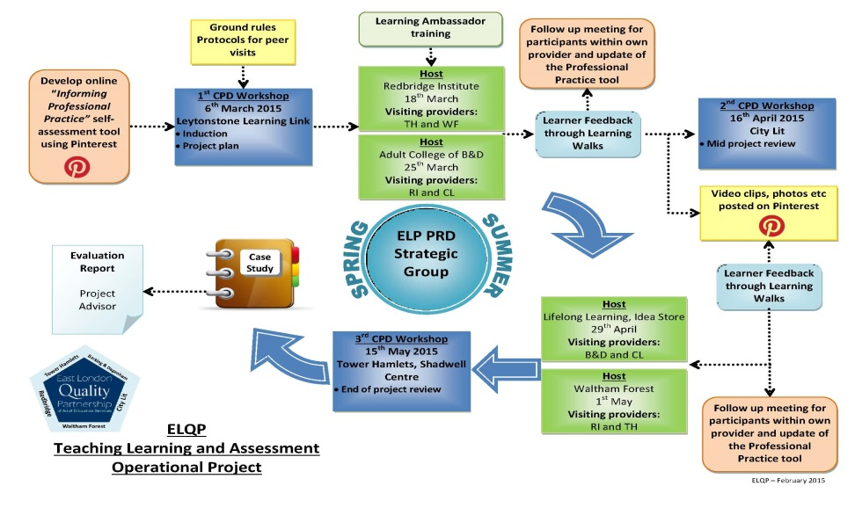
Aspects of the project which could be transferred, developed and made ‘fit for purpose’ across different contexts and organisations include:
- The framework above could be used for peer visiting and developed within departments, within one organisation or across organisations and whatever model is adopted. However, it needs to adapted and made to be fit for purpose and cost effective for the organisation and its staff.
- A toolkit for learners to be engaged in ‘learning walks’ or lesson observation.
- A set of protocols for undertaking peer observation/visiting.
- A CPD training programme for staff to support introduction of peer lesson visiting.

Case study written by Rosemary Sloman, Peer Advisor, supported by Joni Cunningham, Redbridge Institute

