
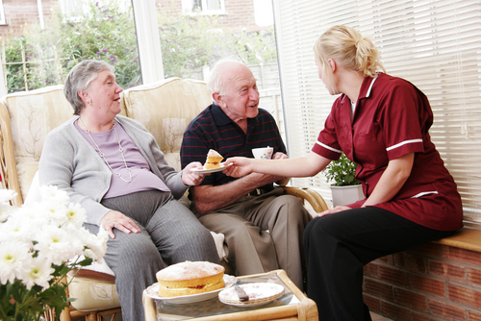
Entry 2: Reading
Care

Module: Duties at work

Module aims

Main aim
We are learning about the things that you must do at work. You will find out the meaning of words in the text.

Other learning aims
We are learning:
- The meaning of words we use at work

Module: Duties at work

Aim: We are learning about the things that you must do at work. You will find out the meaning of words in the text.
You must know about health and safety rules when you work in care. These rules are important for you and for the people you look after.

Read the text about rules at work

 | What you must do and what your employer must do  Your employer is the firm or person who gives you a job. The employer must make sure you are safe at work. You find out about health and safety during your induction training. You should talk to your manager if there is anything you do not understand.
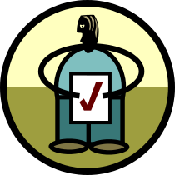 | What you must do as a worker  You must take care of your own health and safety.  You have to keep other people safe when you work.  You must keep the health and safety rules.
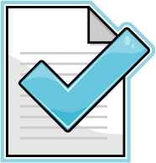 | Your employer must:  ✓ make sure they look at the risks of doing the job  ✓ tell employees what is done to protect their health and safety  ✓ tell you about any changes to the way things are done at work  ✓ tell you how to do your job safely  ✓ let employees know about things that may harm them  ✓ protect your health and safety  ✓ show you how to get first aid treatment  ✓ tell you what to do in an emergency.
You must do the job the way you are shown. You talk to your manager if you have any concerns.

Key words and what they mean
induction the training you get when you start work
manager the person in charge of people at work
worker a person who works or an employee
rules the way to do things that you must follow
risk something that might happen that could hurt someone
first aid treatment the care someone gets when they get hurt
emergency a sudden fire, explosion or accident

Task 1

Read the statements below. Use the text to find out if this is something the worker must do or something the employer must do. The first one is done for you.

 | Worker | Employer
Tell employees about risks to health and safety |  | ✓
Take care of own health and safety
Let employees know about things that may harm them
Tell employees about what is done to protect their health and safety
Keep the health and safety rules
Tell how to do the job safely
Show how to get first aid treatment
Take care of other people’s health and safety
Tell what has to be done in an emergency
Tell people about any changes to the way things are done at work

You must ......... means something you have to do.
You should........means something that it would be good to do

Task 2: What do the words in the text mean?
Can you remember what the words in the text meant? Match the words to the meaning. The first one is an example.

 |  |  |  |  |  | 
rules |  | employer |  | induction |  | manager
the right way to do things |  | the training you get when you start work |  | the person in charge of people at work |  | the person or firm that gives you the job

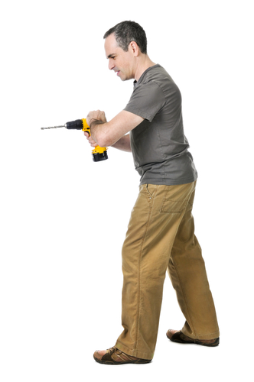 |  |  |  | 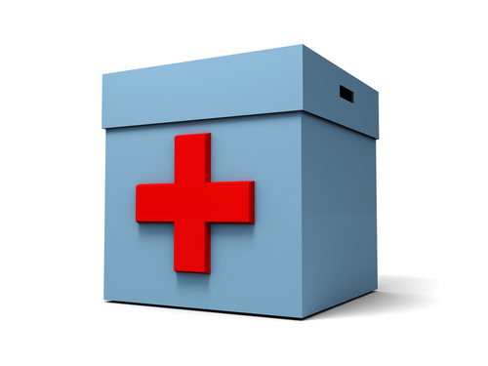 |  | 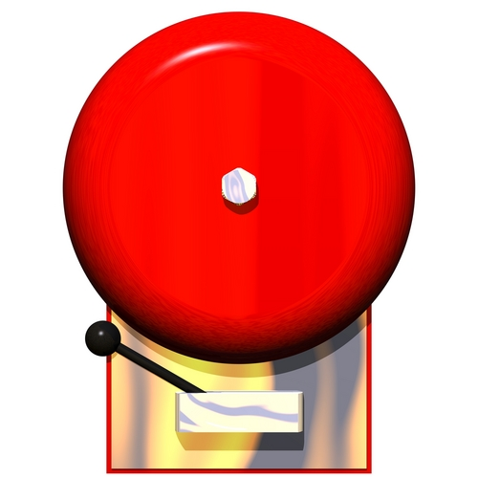
worker |  | risk |  | first aid treatment |  | emergency
something that might happen that could hurt someone |  | a sudden fire, explosion or accident |  | a person who works or an employee |  | the care someone gets when they get hurt

Task 3: Fill in the gaps
Aim: We are learning the meaning of words in the text.
This text has some gaps. Put the words in the right place. The first one is done for you.

What you must do and what your employer must do
Your employer is the firm or ______________ who gives you a job. The employer must make sure you are safe at work. You find out about health and safety during your _________________ training. You should talk to your _________________ if there is anything you do not understand.
What you must do as a _________________
You must take care of your own health and safety.
You have to keep other _____________ safe when you work.
You must keep the health and _____________ rules.
Your employer must:
✓ make sure they look at the ____________ of doing the job
✓ tell employees what is done to protect their health and safety
✓ tell you about any changes to the way things are done at work
✓ tell you how to do your job safely
✓ let employees know about things that may harm them
✓ protect your health and safety
✓ show you how to get ____________ _______ treatment;
✓ tell you what to do in an ______________________ .
You must do the job the way you are shown. You talk to your manager if you have any concerns.

induction | people | manager | risks | person
emergency | worker | employer | safety | first aid

Working in social care
Aim: We are learning the meaning of words we use at work.

Read this text.

In social care, services help people with daily living tasks such as:  - dressing  - washing  - going to the toilet  - help with eating  - preparing drinks and snacks  - shopping. | 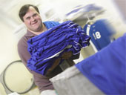
People may need help like this because they:  - have a disability  - have mental health problems  - are very weak or frail  - are ill or are still getting over an illness. | 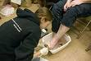
Service users need help so that they can live in their own home.

Task 4: Match the word to its meaning
What do you think the words in the text mean? Match the word to its meaning. The first one is an example.
dressing | helping someone to go to the toilet  helping with eating  helping with putting on clothes  helping with shopping
preparing | getting ready  going out  helping  dressing
snack | a little bit of washing  a little bit of shopping  a little bit to eat  a little illness
disability | not being able to do your shopping  not being able to do your washing  not being able to dress yourself  not being able to use your body fully
mental health problems | problems with how you read and write  problems with how you dress  problems with how you feel about yourself and life  problems with moving about
illness | something that makes you happy  something that makes you unwell  something that makes you sad  something that makes you hungry

Helping other people with their daily activities
There are many ways to help other people with their daily activities. You may work with them in their own homes. You may look after them in a care home. Let’s look at some of the things you may be asked to do.
She is putting the dentures in a glass of water.  Dentures are false teeth | 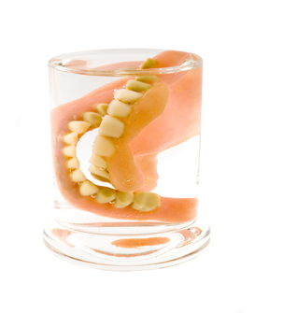
He is dressing the woman. | 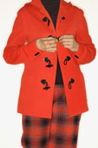
She is reading the letter to the man. | 
He is writing a letter for the service user. | 
She is shopping for the man. | 

Grammar check
She is shopping.....
He is writing..........
These are both ways of using the present tense to show that something is happening at that moment.
This is called the present continuous tense.

Task 5: What is the right verb?

You write a sentence in the order of:
subject verb object
You use the present tense to show something is happening now.
He drinks a cup of tea.
You use the present continuous form to show something that is in the process of happening.
He is drinking a cup of tea.
Match the present continuous to the action in the picture. Write the verb in the gap. The first one is an example.
 | She __ is shopping___ for her groceries. | is helping  is washing  is shopping  is cleaning
 | She _______________ her letter. | is writing  is reading  is shopping  is lifting
 | He _______________ his shopping list. | is cleaning  is washing  is reading  is writing
 | She _______________ herself. | is dressing  is writing  is reading  is cleaning
 | She ____________ their lunch. | is cleaning  is serving  is lifting  is writing
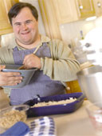 | He ____________his meal. | is cleaning  is reading  is shopping  is cooking
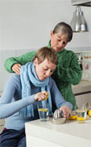 | She ____________some water. | is cleaning  is drinking  is cooking  is reading

When do you wash your hands?
You should wash our hands before you:

Prepare, serve or eat food | 
Treat a cut or care for someone who is sick | 
Put in or take out contact lenses. | 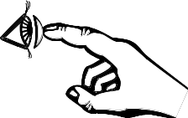
You should wash your hands after you: | 
Go to the toilet | 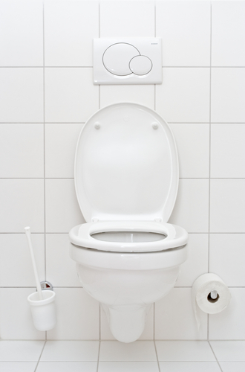
Handle uncooked food, e.g. raw meat, poultry or fish | 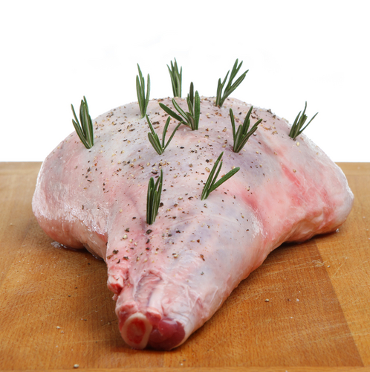 | 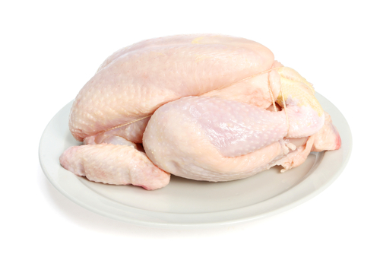 |  | 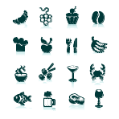
Change a nappy |  |  | 
Blow your nose, cough or sneeze |  |  | 
Handle rubbish |  |  | 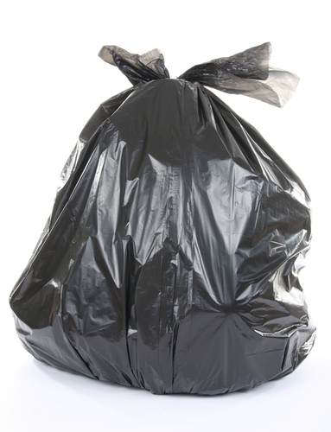
tend to someone who is sick or injured |  |  | 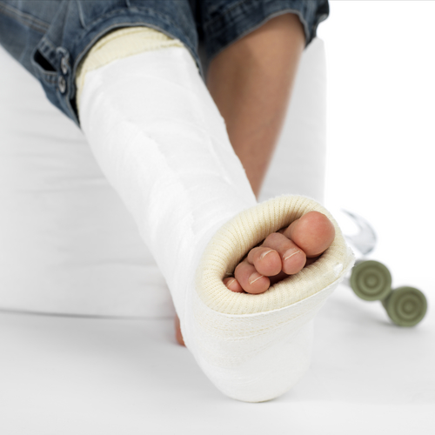
Handle an animal or animal waste. |  |  | 

Task 6: What is the right verb?

Tick to show if you should wash your hands before or after you do these things:

Put in or take out contact lenses. | 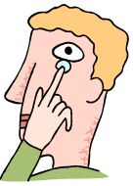
  before
  after
Blow your nose, cough or sneeze | 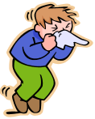
  before
  after
Treat a cut or care for someone who is sick | 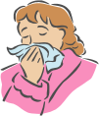
  before
  after
Handle an animal or animal waste | 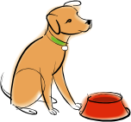
  before
  after
Handle rubbish | 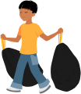
  before
  after
Go to the toilet | 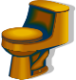
  before
  after
Prepare, serve or eat food | 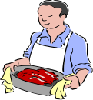
  before
  after
Change a nappy | 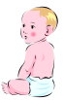
  before
  after

Reading instructions: How should we wash our hands?
We should wash our hands properly to get rid of germs.
We just need soap and water.
When you wash your hands you should:

1. Use soap |  | and warm, running water. | 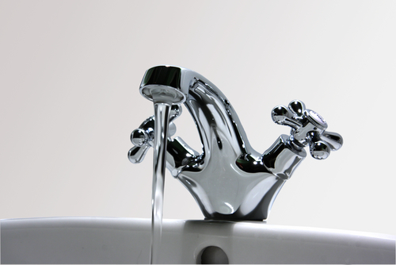
2. Wash all parts of your hands thoroughly, including wrists, palms, backs of hands, between fingers and under fingernails.
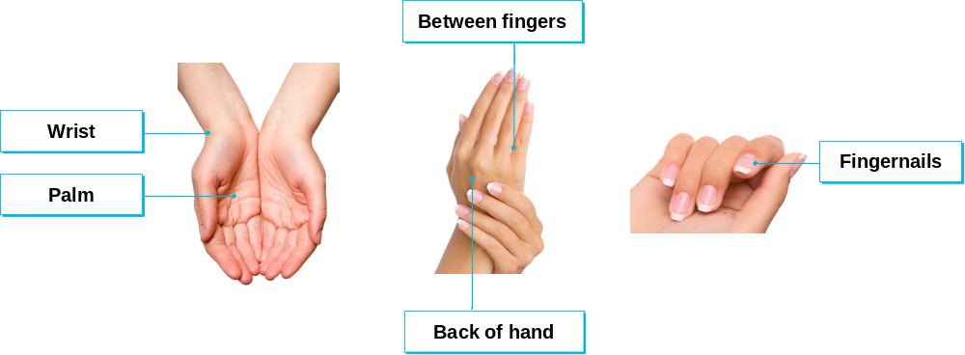
3. Rub hands together with the soap for 20 seconds. |  |  | 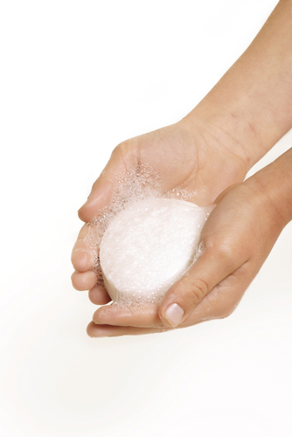
4. Rinse away all soap. |  |  | 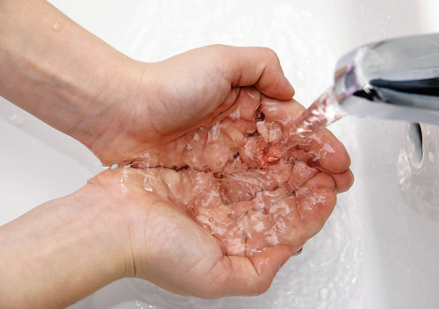
5. Dry hands with a paper towel, clean towel or warm air dryer. |  |  | 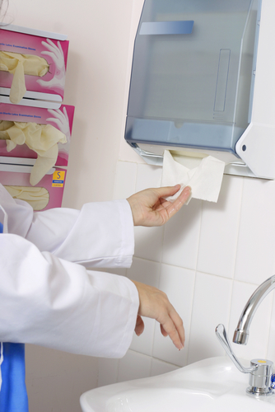
6. Pat the skin dry. |  |  | 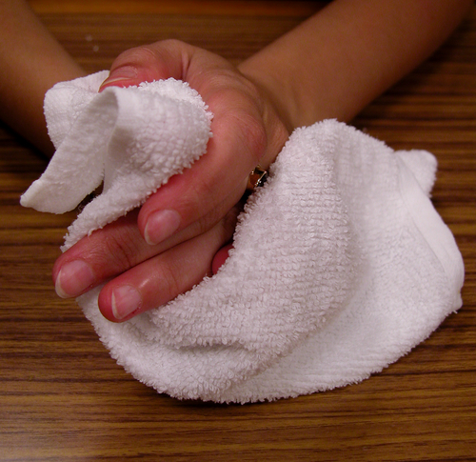

Reading instructions

Instructions tell you how to do something. The instructions above tell you how to wash your hands properly.
You write instructions as an order or command. This tells you something you must do.
Use soap and water could be written as You must use soap and water.

Task 7: Ordering instructions
Look at the set of instructions on washing your hands. Put the instructions in the correct order. Use the complete set to help you. The first one is done for you.

Rinse away all soap.
Wash all parts of your hands thoroughly, including wrists, palms, backs of hands, between fingers and under fingernails. | 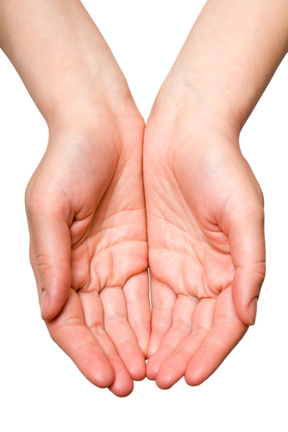
Pat the skin dry.
Rub hands together with the soap for 20 seconds.
Use soap and warm, running water. |  | 1
Dry hands with a paper towel, clean towel or warm air dryer.

How did you get on?

Module 2: Duties at work answers

Task 1 answers

 | Worker | Employer
Tell employees about risks to health and safety |  | ✓
Take care of own health and safety | ✓
Let employees know about things that may harm them |  | ✓
Tell employees about what is done to protect their health and safety |  | ✓
Keep the health and safety rules | ✓
Tell how to do the job safely |  | ✓
Show how to get first aid treatment |  | ✓
Take care of other people’s health and safety | ✓
Tell what has to be done in an emergency |  | ✓
Tell people about any changes to the way things are done at work |  | ✓

Task 2 answers

rules |  | employer |  | induction |  | manager
the right way to do things |  | the person or firm that gives you the job |  | the training you get when you start work |  | the person in charge of people at work

worker |  | risk |  | first aid treatment |  | emergency
a person who works or an employee |  | something that might happen that could hurt someone |  | the care someone gets when they get hurt |  | a sudden fire, explosion or accident

Task 3 answers

What you must do and what your employer must do
Your employer is the firm or person who gives you a job. The employer must make sure you are safe at work. You find out about health and safety during your induction training. You should talk to your manger if there is anything you do not understand.
What you must do as a worker
You must take care of your own health and safety.
You have to keep other people safe when you work.
You must keep the health and safety rules.
Your employer must:
✓ make sure they look at the risks of doing the job
✓ tell employees what is done to protect their health and safety
✓ tell you about any changes to the way things are done at work
✓ tell you how to do your job safely
✓ let employees know about things that may harm them
✓ protect your health and safety
✓ show you how to get first aid treatment;
✓ tell you what to do in an emergency .
You must do the job the way you are shown. You talk to your manager if you have any concerns.

Task 4 answers

preparing | getting ready  going out  helping  dressing
snack | a little bit of washing  a little bit of shopping  a little bit to eat  a little illness
disability | not being able to do your shopping  not being able to do your washing  not being able to dress yourself  not being able to use your body fully
mental health problems | problems with how you read and write  problems with how you dress  problems with how you feel about yourself and life  problems with moving about
illness | something that makes you happy  something that makes you unwell  something that makes you sad  something that makes you hungry

Task 5 answers

 | She __ is reading___ her letter. | is writing  is reading  is shopping  is lifting
 | He ___is writing___ his shopping list. | is cleaning  is washing  is reading  is writing
 | She ___is dressing___ herself. | is dressing  is writing  is reading  is cleaning
 | She __ is serving___ their lunch. | is cleaning  is serving  is lifting  is writing
 | He ___is cooking___ his meal. | is cleaning  is reading  is shopping  is cooking
 | She ___is drinking___ some water. | is cleaning  is drinking  is cooking  is reading

Task 6 answers

Put in or take out contact lenses.
  before | ✓
  after | ✓
Blow your nose, cough or sneeze
  before
  after | ✓
Treat a cut or care for someone who is sick
  before | ✓
  after | ✓
Handle an animal or animal waste
  before
  after | ✓
Handle rubbish
  before
  after | ✓
Go to the toilet
  before
  after | ✓
Prepare, serve or eat food
  before | ✓
  after
Change a nappy
  before
  after | ✓

Task 7 answers

Rinse away all soap. |  | 4
Wash all parts of your hands thoroughly, including wrists, palms, backs of hands, between fingers and under fingernails. |  | 2
Pat the skin dry. |  | 6
Rub hands together with the soap for 20 seconds. |  | 3
Use soap and warm, running water. |  | 1
Dry hands with a paper towel, clean towel or warm air dryer. |  | 5

