
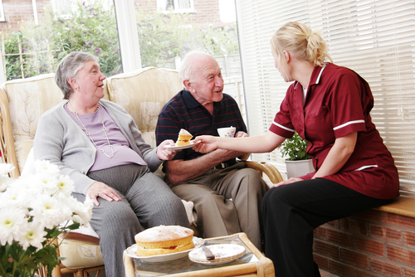
Entry 2: Reading
Care

Module: Health and safety signs

Module aims

Main aim
We are learning about health and safety.

Other learning aims
We are learning:
- The meaning of words and symbols used on the health and safety signs

Module: Health and safety signs

Aim: We are learning what health and safety signs mean.

There are different kinds of safety signs.

Blue circles tell you what you must do.
They are called mandatory signs.
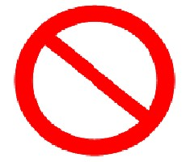 | Red circles with a line tell you what you must not do.  They are called prohibitive signs.
Black and Yellow triangles tell you to be careful.
They are called warning signs.
 | Green and white squares or rectangles give you information about first aid, fire escape or safe conditions.
 | Red squares or rectangles give you information about fire equipment.


Task 1: Match the colour
What does the colour of the sign mean? Draw a line to match the colour to the meaning. The first one is an example.

warning |  | fire equipment |  | you must do something |  | you must not do or use something |  | first aid, fire escape or safe condition

Blue signs

They are mandatory signs because you must do what they show.
They are mandatory signs because you must use what they show.

Blue signs show what you must do.
Blue signs show what you
must use.

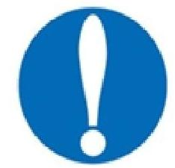 | This sign tells you something. It shows there is something you must read. The signs tells you what you must do.
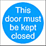 | This signs shows a door that must be closed after you use it.
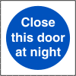 | This sign shows a door that must be closed at night.
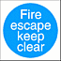 | This sign shows a fire escape that must be kept clear.
When you work in care, you must help to keep the fire safety rules.
These rules help to stop fires starting.
• Make sure there is nothing in the way of fire doors.
• Do not leave things in front of fire doors.
• Make sure that everyone can see signs like these.
• Put any waste paper in the rubbish bin.
• Make sure that cigarettes are put out.

Look at these signs.
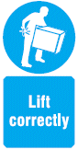 | This sign tells you that you must lift things in the right way.  Lift correctly is an order.  It means the same as:  You must lift correctly.
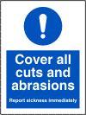 | This sign means that if you have a cut, you must cover it before you work.  You cover it with a plaster to stop germs spreading.  An abrasion is when something has rubbed your skin. Your skin is sore.
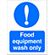 | This sign will be above a kitchen sink.  It means that you must wash only things used to prepare food in the sink.  You cannot use this sink to wash anything else.
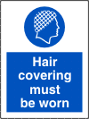 | This sign means the same as:  You must cover your hair.  You will see this sign if you prepare food for service users.
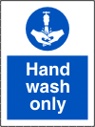 | This sign will be above a basin.  It means that this is a basin where  you can wash your hands.  These signs are both to do with washing your hands.  They do not mean the same thing.
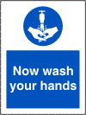 | This sign tells you that you must  wash your hands. You will see it  in the toilet. It reminds you that  you must wash your hands  after you use the toilet.

Task 2: Test yourself
Look at the signs. What do they mean?
Blue signs mean:
 you must do something
 warning
 you must not do something
 a fire exit
This sign means:
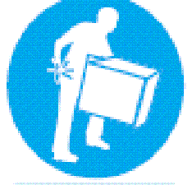 |  heavy boxes around
 |  watch your step
 |  lift carefully
 |  storage area
This sign means:
 |  food preparation area
 |  you must cover your hair
 |  warning - dusty area
 |  cover your hair if you like
This sign means:
 you must close the door during the day
 do not put things in front of the door
 close the door if you want to
 you must close this door at night

Red and white signs
Red and white signs show what you must not do.

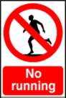 | 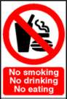 |  | 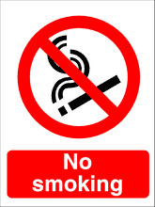 |  | No  Sometimes signs say:  No smoking  No running  This is another way saying:  You must not smoke here.  You must not run here.
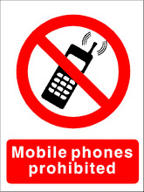 |  |  |  | Some signs use the word: prohibited.  If something is prohibited, you cannot use it.  This sign means:  You cannot use a mobile phone.
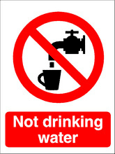 |  |  |  | This sign is telling you about something you cannot use.  It means that you must not drink the water from this tap.  Remember some signs leave words out.  It could say:  This is not drinking water.
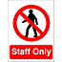 |  | 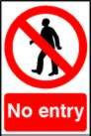 |  | These signs have the same picture. They mean different things.  Staff only means that only people who work there can go in.  No entry means that no one can go in.

Task 3: Test yourself
Look at these signs. What do they mean?
Red and white signs mean:
 warning – take care
 you must do or use something
 you must not do or use something
 first aid or safe condition
This sign means:
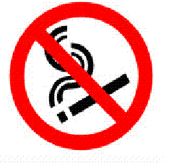 |  smoking area
 |  no smoking
 |  you can smoke
 |  smokers only
This sign means:
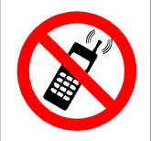 |  no mobile phones
 |  mobile phone area
 |  warning – people using phones
 |  emergency phone here
This sign means:
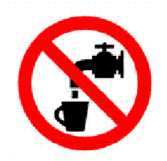 |  fresh drinking water
 |  water tap here
 |  not drinking water
 |  take care – running water

This sign means:
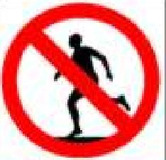 |  exercise area
 |  no eating
 |  fire route
 |  no running
Black and yellow signs
Another name for black and yellow signs are hazard signs.

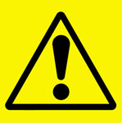 |  | Black and yellow signs are warning signs. They tell you to be careful.
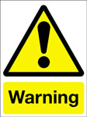 | 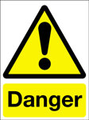 | Warning signs may say Caution, Danger or Warning.  They all mean that you must be careful.
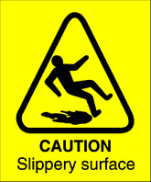 |  |  | 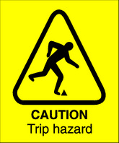 | 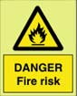
You might see this sign if the floor is wet. It tells you to take care. You could slip. |  |  | This sign tells you to take care. You could trip over something. | This sign tells you that there is something that could catch fire easily. You must take care.
These signs tell you why you must be careful.

Task 4: Test yourself
Put a ✓ in the box next to the meaning. The first one is an example.
This sign means:
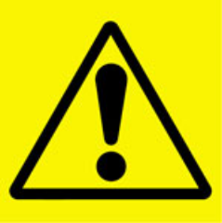 |  you must not do something
 |  you must do something
 |  hazard or danger
 |  safe condition
This signs means:
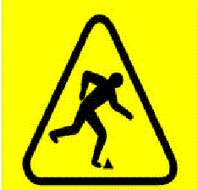 |  you must not run
 |  careful – you may trip
 |  fire route this way
 |  you may use these steps
This signs means:
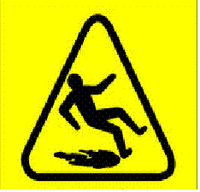 |  take care – slippery surface
 |  you must not run
 |  wear your safety shoes
 |  staff rest area
This signs means:
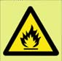 |  no smoking
 |  fire equipment
 |  fire escape route
 |  danger – fire risk

How did you get on?

Module 2: Rules at work answers

Task 1 answers

first aid, fire escape or safe place |  | warning |  | you must do something |  | you must not do or use something |  | fire equipment
When you see red and white signs, you may see these words on the sign.
no not
It means you must not do or use something.

Task 2 answers

 you must do something
 warning
 you must not do something
 a fire exit
This sign means:
 heavy boxes around
 watch your step
 lift carefully
 storage area
This sign means:
Remember: Sometimes a sign says:
Hair covering must be worn.
It means the same as:
You must wear hair covering.
 food preparation area
 you must cover your hair
 warning - dusty area
 cover your hair if you like
This sign means:
 you must close the door during the day
 do not put things in front of the door
 close the door if you want to
 you must close this door at night

Task 3 answers

 warning – take care
 you must do or use something
 you must not do or use something
 first aid or safe condition
This sign means:
 smoking area
 no smoking
 you can smoke
 smokers only
This sign means:
 no mobile phones
 mobile phone area
 warning – people using phones
 emergency phone here
This sign means:
 fresh drinking water
 water tap here
 not drinking water
 take care – running water
This sign means:

 exercise area
 no eating
 fire route
 no running

Task 4 answers

This sign means:
 you must not do something
 you must do something
 hazard or danger
 safe condition
This signs means:
 you must not run
 careful – you may trip
 fire route this way
 you may use these steps
This signs means:
 take care – slippery surface
 you must not run
 wear your safety shoes
 staff rest area
This signs means:
 no smoking
 fire equipment
 fire escape route
 danger – fire risk

