
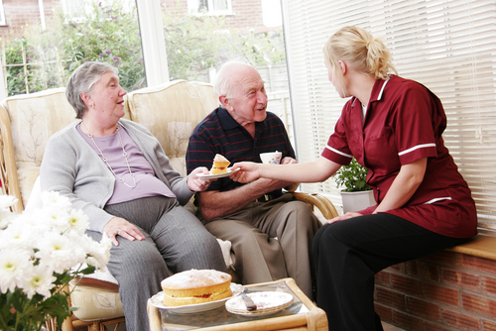
Entry 2: Reading
Care

Module: Words at work

Module aims

Main aim
We are learning to name some tools and equipment that you may use at work.

Other learning aims
We are learning:
- Alphabetical order
- The names of clothes

Module: Words at work

Aim: We are learning to name some tools and equipment that you may use at work.

Task 1: Find the letter
Find and underline the word that starts with the letter shown. The first one is an example.
Find the word that starts with w.

lifting hoist | tumble dryer | hearing aid | walking stick
Find the word that starts with i.

ironing board | washing machine | lifting hoist | hearing aid
Find the word that starts with w.

lifting hoist | walking frame | ironing board | hearing aid
Find the word that starts with t.

washing machine | ironing board | tumble dryer | lifting hoist
Find the word that starts with h.

hearing aid | walking stick | tumble dryer | ironing board
Find the word that starts with l.

wheelchair | lifting hoist | hearing aid | ironing board
Find the word that starts with i.

tumble dryer | walking stick | iron | walking frame
Find the word that starts with w.

lifting hoist | ironing board | hearing aid | washing machine

Task 2: Alphabetical order
Sometimes you put words in order. When the order uses the order of the alphabet, it is called alphabetical order.
Look at these words:
then | and | must
If they are put in order of the alphabet using the first letter, the order is:
and | must | then
This task uses the first letter of the word.
Put the words in the order of the alphabet by the first letter. Here is the alphabet to help you.
a b c d e f g h i j k l m n o p q r s t u v w x y z
The first one is done for you.

blouse |  | jumper
 |  | pyjamas
 |  | blouse
 |  | dressing gown
 |  | socks
 |  | cardigan
 |  | trousers
 |  | nightdress
 |  | knickers

Task 3: Word grid
Here are some things you see at work. Write the name in the grid. Use the words from the last task to help you. There are letters in the grid to help you.

washing machine | walking stick |  | lifting hoist |  | wheelchair |  | iron
tumble dryer |  | ironing board |  | walking frame |  | hearing aid

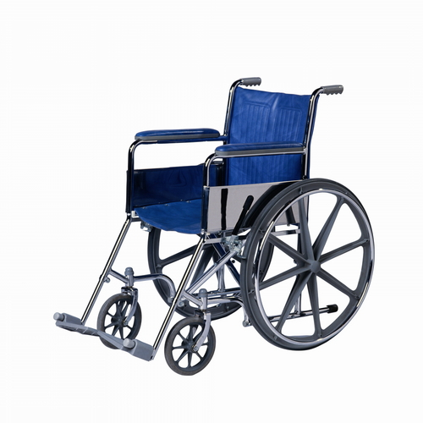 |  | 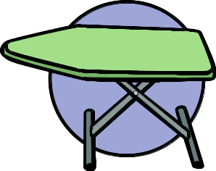 |  | 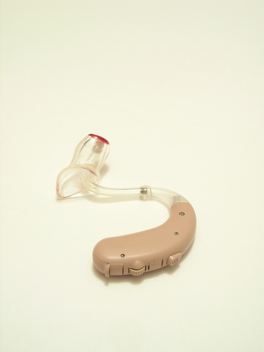

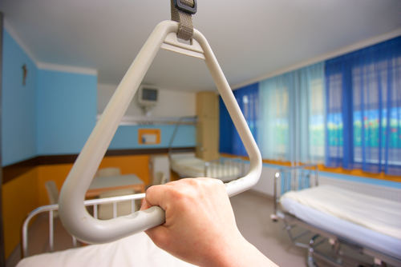 |  | 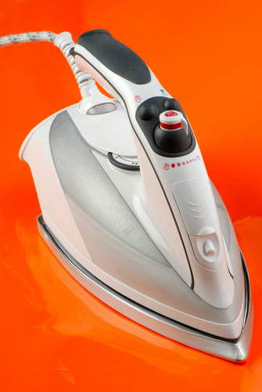 |  | 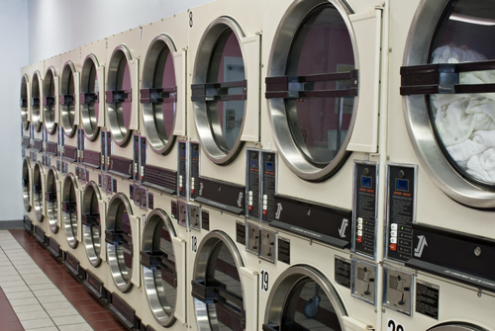

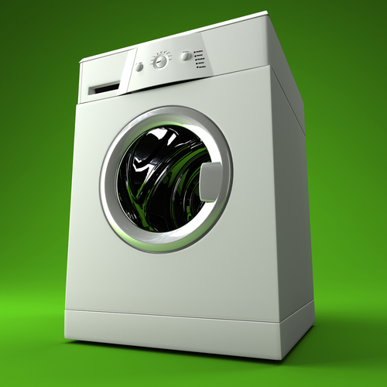 |  | 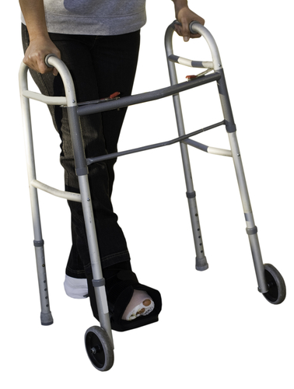 |  | 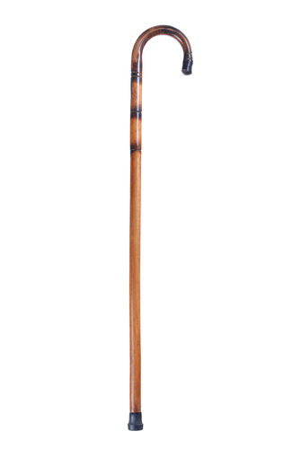

Task 4: Word grid
We are learning the names of some of the jobs you do at work.

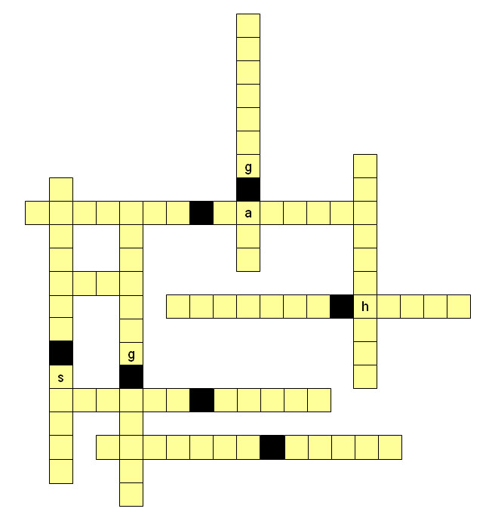

Task 5: Fill in the words
These are words for some of the things you see at work. Put the correct word in the sentence. The first one is done you.

Jojo puts the clothes in the __ washing machine___  to get clean. | walking frame  hearing aid  washing machine  lifting hoist
Lech wears a ___________ _____ to hear people speak. | lifting hoist  hearing aid  walking stick  walking frame
Doris uses a _____________ __________ to get around the house. | hearing aid  walking frame  ironing board  tumble dryer
Ewa puts the clothes in the _______________ ____________ to dry. | washing machine  ironing board  tumble dryer  walking frame
Stan uses a ____________ ___________for walking when he goes to the shops. | walking stick  hearing aid  ironing board  lifting hoist
Ahsa helps Azi to use the ____________ ___________ to get Winnie out of bed. | hearing aid  lifting hoist  ironing board  tumble dryer
Joe finds it hard to walk far, so Talia pushes him in a ____________ when they go out. | walking stick  hearing aid  wheelchair  lifting hoist
Tran irons the clothes on the ____________ _________. | hearing aid  lifting hoist  walking frame  ironing board

Task 6: Helping people to dress

Aim: We are learning the names of clothes.
Here are some clothes you might see at work when you help people to dress. Write the name under the picture.

cardigan | trousers |  | nightdress |  | skirt
blouse |  | knickers |  | shirt

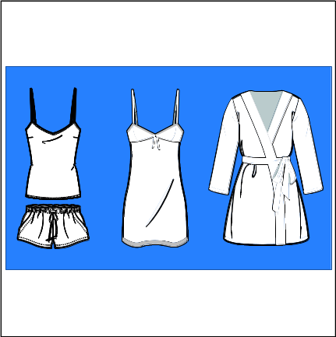 |  |  |  | 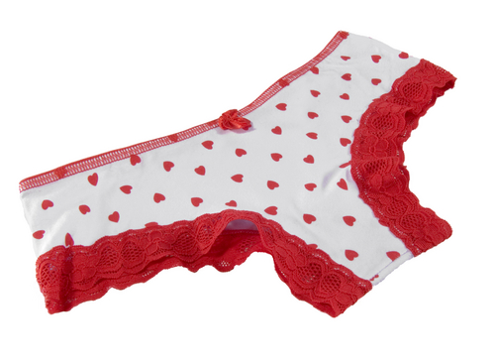

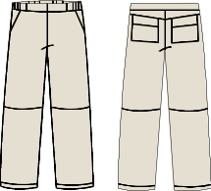 |  | 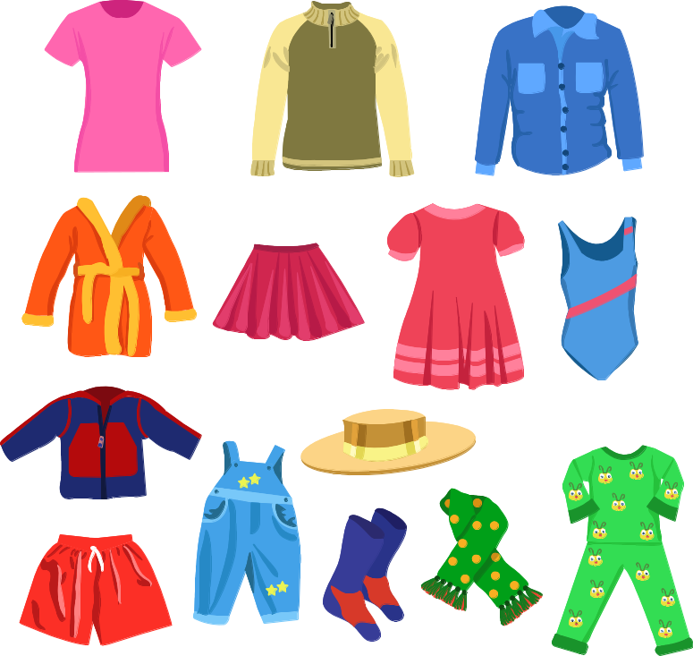 |  | 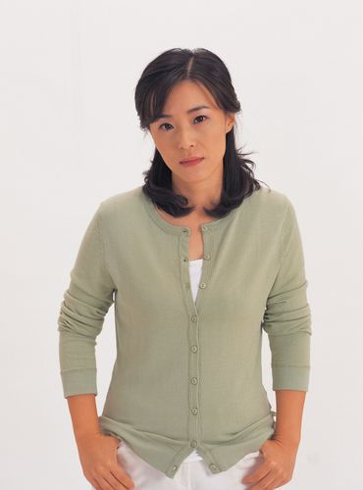 |  | 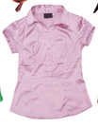

t-shirt | jumper |  | dressing gown |  | slippers
socks |  | pyjamas |  | jacket

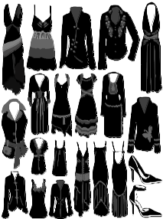 |  | 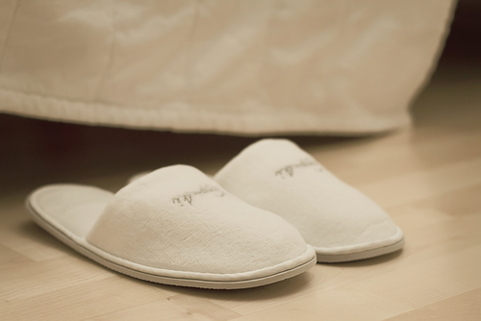 |  | 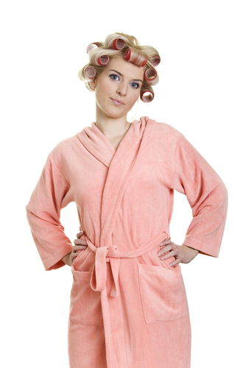

 |  | 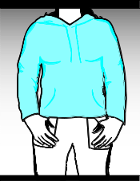 |  |  |  | 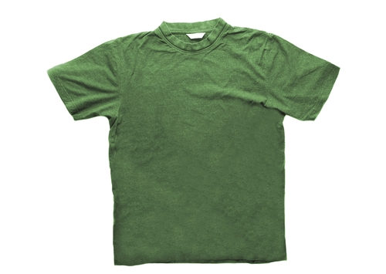

Task 7: Clothes
Find the word in the sentence that matches the picture at the side. Underline it. The first one is an example. You will give personal care to the people you work with. You could:

Do you want your dressing gown?
Pass me my slippers, please.
I would like some clean pyjamas.
I will wear my jacket today.
Ivy wants her cardigan.
Put that blouse in the laundry.
Stan needs help with putting his socks on.
Doris wants her blue skirt today.
Joe wants his jumper.

How did you do?
Module 1: Words for work answers

Task 1 answers

Find the word that starts with i.

ironing board | washing machine | lifting hoist | hearing aid
Find the word that starts with w.

lifting hoist | walking frame | ironing board | hearing aid
Find the word that starts with t.

washing machine | ironing board | tumble dryer | lifting hoist
Find the word that starts with h.

hearing aid | walking stick | tumble dryer | ironing board
Find the word that starts with l.

wheelchair | lifting hoist | hearing aid | ironing board
Find the word that starts with i.

tumble dryer | walking stick | iron | walking frame
Find the word that starts with w.

lifting hoist | ironing board | hearing aid | washing machine

Task 2 answers

blouse
cardigan
dressing gown
jumper
knickers
nightdress
pyjamas
socks
trousers

Task 3 answers

wheelchair |  | ironing board |  | hearing aid

lifting hoist |  | iron |  | tumble dryer

washing machine |  | walking frame |  | walking stick

Task 4 answers

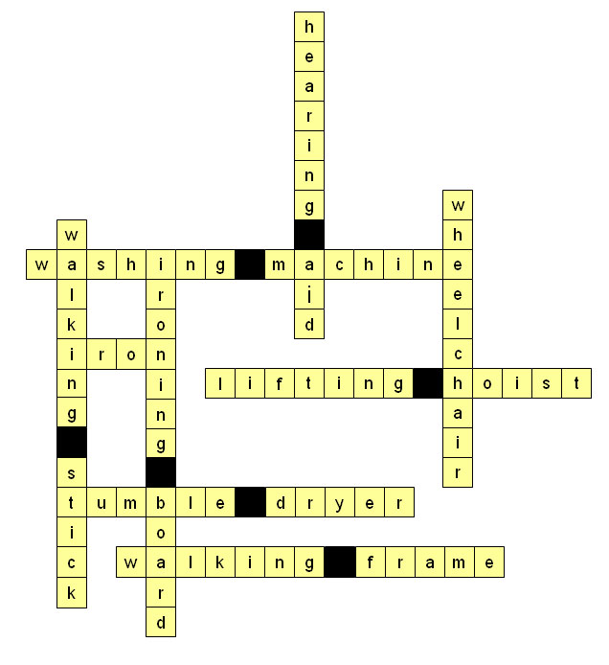

Task 5 answers

Lech wears a __hearing__ __aid__ to hear people speak. | lifting hoist  hearing aid  walking stick  walking frame
Doris uses a __walking__ __frame__ to get around the house. | hearing aid  walking frame  ironing board  tumble dryer
Ewa puts the clothes in the __tumble__ __dryer__ to dry. | washing machine  ironing board  tumble dryer  walking frame
Stan uses a __walking___ __stick__ for walking when he goes to the shops. | walking stick  hearing aid  ironing board  lifting hoist
Ahsa helps Azi to use the ___lifting___ ___hoist___ to get Winnie out of bed. | hearing aid  lifting hoist  ironing board  tumble dryer
Joe finds it hard to walk far, so Talia pushes him in a ___wheelchair___ when they go out. | walking stick  hearing aid  wheelchair  lifting hoist
Tran irons the clothes on the __ironing___ __board__. | hearing aid  lifting hoist  walking frame  ironing board

Task 6 answers

nightdress |  | blouse |  | knickers

 |  |  |  |  |  | 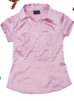
trousers |  | skirt |  | cardigan |  | shirt

Remember
You do not sound the k in knickers.
We always say trousers and knickers not trouser and knicker because they have two legs. If you are talking about one leg, you can say: Put your foot into the trouser leg.
jacket |  | slippers |  | dressing gown

socks |  | jumper |  | pyjamas |  | t-shirt

Task 7 answers

Pass me my slippers, please.
I would like some clean pyjamas.
I will wear my jacket today.
Ivy wants her cardigan.
Put that blouse in the laundry.
Stan needs help with putting his socks on.
Doris wants her blue skirt today.
Joe wants his jumper.

