
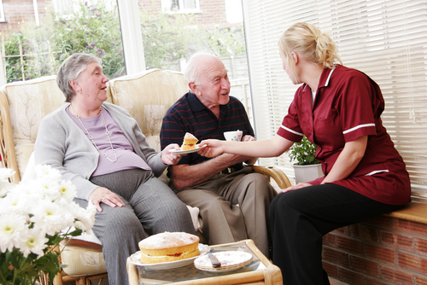
Entry 3: Reading
Care

Module: Code of practice for health and social care workers

Module aims

Main aim
We are learning about the meaning of words and expressions used in induction training.

Other learning aims
We are learning:
- About the meaning of words and expressions used in care
- To read a text and show we understand what it means


Module: Code of practice for health and social care workers
Aim: We are learning about the meaning of words and expressions used in induction training.
Lech has arrived for his first day at work with Great Days Caring. During his induction training, the manager shows these slides in the presentation. Read them.

Code of practice for social care workers
Social care workers must:
- Protect the rights and promote the interests of service users and carers
- Strive to establish and maintain the trust and confidence of service users and carers
- Promote the independence of service users while protecting them as far as possible from danger or harm
Code of practice for social care workers
- Respect the rights of service users while making sure that their behaviour does not harm themselves or other people
- Uphold public trust and confidence in social care services
- Take responsibility for the quality of their work and for maintaining and improving their knowledge and skills

Some industries have a code of practice. Health and social care has a code of practice that workers have to follow. A code of practice tells workers how to behave at work.
Let’s look at some of the phrases (or expressions) Lech saw on the slides.


Task 1: What do you think the phrases mean?
Look at some of the expressions used in the slides. Match the phrase in bold to its meaning. The first one is done for you.

1. protect the rights |  | belief in someone or something else

2. promote the interests |  | people who look after other people

3. service users | 1 | take care of the rights

4. carers |  | encourage service users to do things themselves

5. strive to establish and maintain |  | support and encourage the interests

6. trust and confidence |  | people who use the care service

7. promote the independence |  | keep service users safe from things that could hurt them

8. protect from danger or harm |  | work hard to develop and keep

9. respect the rights of service users |  | have a duty to do something

10. uphold public trust and confidence |  | hold in high esteem

11. quality of work |  | keep on doing and getting better at

12. take responsibility |  | high standard

13. maintaining and improving |  | support and keep the good name of the service

When you have checked your answers, go back and read the slides again. Make sure you understand all the information.
If you want a code of practice translated into your own language go to: http://www.gscc.org.uk/codes/Get+copies+of+our+codes/
to download one.

Risk assessment
Your employer has a duty to carry out a risk assessment on the tasks you have to do at work. Your employer has to write a method statement for the task. The method statement shows the hazards or risks that might come from carrying out the task. If there is a risk to doing the task, your employer must put control measures in place. The control measures show how the work should be carried out safely.

Word check
risk assessment looking at a task to work out what the dangers are
hazard or risk something that might happen that could hurt someone
control measures instructions on how to do the task safely – this includes providing equipment

It is different if you work at a service user’s home. Your employer will carry out risk assessments and put control measures in place. They cannot remove all the risks such as frayed carpets or cables across the floor. You can tell the service user what to do about it but you cannot make them do it. You need to take care!

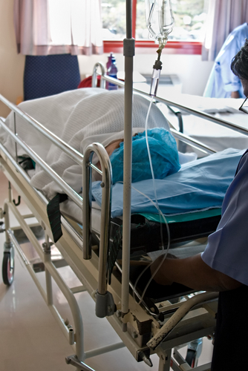
Case study
The problem

Mr H has multiple sclerosis and is cared for by two workers. He can use his arms and hands fully. He has little strength in his legs and feet. He weighs 12 stone or 75kg. The care workers have to wash Mr H while he is in bed. One care worker rolled Mr H towards her and the second washed his back. This task was uncomfortable for the worker and caused lower back pain.

The occupational therapist had another look at the risk assessment and identified the task of holding Mr H as a manual handling risk.

The action

To make best use of Mr H's strength in his arms, the service
installed bed rails. The rails were screwed to the floor and
were above the height of the bed. This allowed Mr H to reach
across with his opposite arm and use the rails to roll and
support himself in that position. The cost of the bed rails
was £70 and installation was £40.

Advice

The action taken was good for everyone. It reduced the manual handling risk to the care workers. The rail helped Mr H to use the strength in his arms. This helped him to move more. He liked being able to help his care workers.

Task 2: Words and expressions used in care

Aim: We are learning about the meaning of words and expressions used in care.
Sometimes, you can work out the meaning of a word from the way it is used in a sentence. See if you can work out the meaning of the underlined words from the way they have been used in the text. Underline the word or words that mean the same.

Mr H has multiple sclerosis.
a condition that affects all the body | a condition that affects the eyes | a condition that affects the spine

He can use his arms and hands fully.
sometimes | completely | slowly

He has little strength in his legs and feet.
a lot of strength | not much strength | a great deal of strength

This task was uncomfortable for the worker.
very easy | slightly difficult | slightly painful

The occupational therapist identified the task of holding Mr H as a manual handling risk.
to do with hands | to do with feet | to do with the back

The service installed bed rails.
put out | put in | put under

It reduced the manual handling risk.
made greater | made easier | made smaller
Task 3: Reading for meaning
Aim: We are learning to read a text and show we understand what it means.
Read the case study and read the statements. Tick whether the statements are right, wrong or you can’t tell.

 | True | False | Can’t tell
Mr H is cared for by a group of five workers.
The carers work in different shifts to look after Mr H.
Mr H has little strength in his arms.
The care workers can wash Mr H in the bathroom.
The care worker was having difficulty washing Mr H’s back.
The care workers prepared Mr H’s lunch for him.
The task caused the care worker pain in her legs.
The assessment was done by the occupational therapist who did the first assessment.
The occupational therapist identified the task of holding Mr H as a manual handling risk.
The care service had bed rails put in Mr H’s home.
Mr H was able to use the rails to roll over in bed.
Mr H could use the rails to sit up in bed.
The action taken did not help anyone in the case study.
Mr H liked being able to help his care workers.
The rail helped Mr H use the strength in his legs.

Task 4: Getting information from a diagram
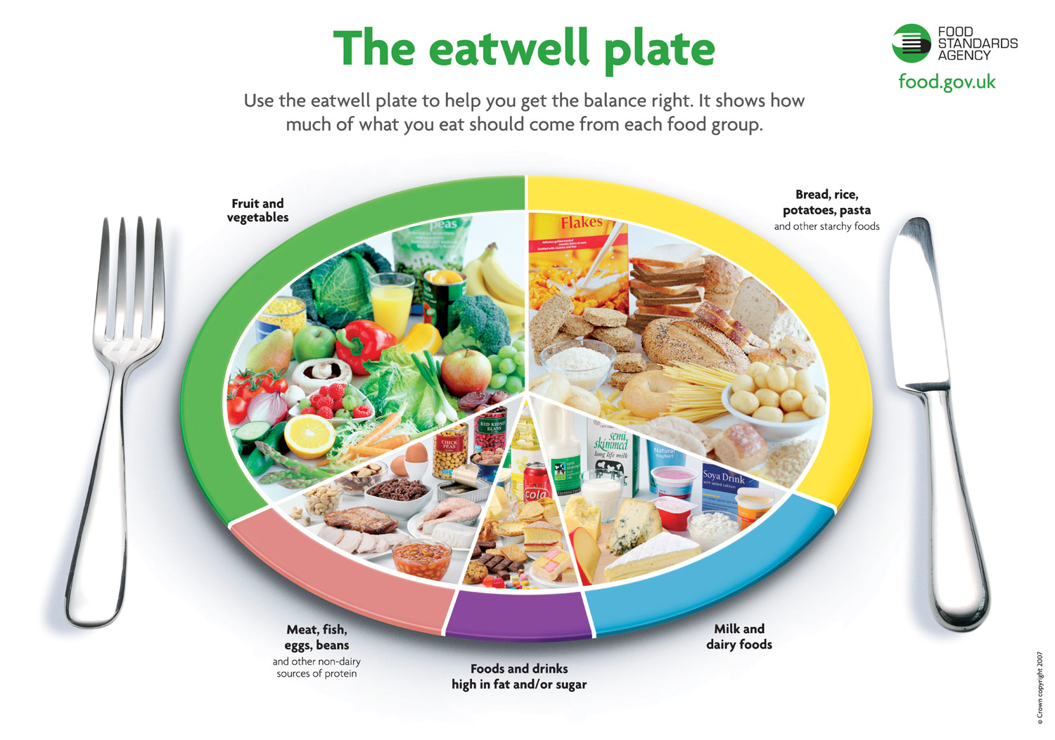

This is the eatwell plate from the Food Standards Agency. It shows the proportion of food from each of the food groups that people should eat to stay healthy.
Answer the questions by getting the information from the diagram.

1. What kind of food or drinks should you eat most during the day?
2. What should you eat more of during the day, protein or starchy foods?
3. What kind of food is pasta?
4. What should you eat or drink least during the day?
5. What kind of food is cheese?

How did you get on?

Module 3: Code of practice for health and social care workers answers

Task 1 answers
1. protect the rights | 6 | belief in someone or something else

2. promote the interests | 4 | people who look after other people

3. service users | 1 | take care of the rights

4. carers | 7 | encourage service users to do things themselves

5. strive to establish and maintain | 2 | support and encourage the interests

6. trust and confidence | 3 | people who use the care service

7. promote the independence | 8 | keep service users safe from things that could hurt them

8. protect from danger or harm | 5 | work hard to develop and keep

9. respect the rights of service users | 12 | have a duty to do something

10. uphold public trust and confidence | 9 | hold in high esteem

11. quality of work | 13 | keep on doing and getting better at

12. take responsibility | 11 | high standard

13. maintaining and improving | 10 | support and keep the good name of the service

Task 2 answers

Mr H has multiple sclerosis.
a condition that affects all the body | a condition that affects the eyes | a condition that affects the spine

He can use his arms and hands fully.
sometimes | completely | slowly

He has little strength in his legs and feet.
a lot of strength | not much strength | a great deal of strength

This task was uncomfortable for the worker.
very easy | slightly difficult | slightly painful

The occupational therapist identified the task of holding Mr H as a manual handling risk.
to do with hands | to do with feet | to do with the back

The service installed bed rails.
put out | put in | put under

It reduced the manual handling risk.
made greater | made easier | made smaller

Task 3 answers

 | True | False | Can’t tell
Mr H is cared for by a group of five workers. |  | ✓
The carers work in different shifts to look after Mr H. |  |  | ✓
Mr H has little strength in his arms. |  | ✓
The care workers can wash Mr H in the bathroom. |  |  | ✓
The care worker was having difficulty washing Mr H’s back. |  | ✓
The care workers prepared Mr H’s lunch for him. |  |  | ✓
The task caused the care worker pain in her legs. |  | ✓
The assessment was done by the occupational therapist who did the first assessment. |  |  | ✓
The occupational therapist identified the task of holding Mr H as a manual handling risk. | ✓
The care service had bed rails put in Mr H’s home. | ✓
Mr H was able to use the rails to roll over in bed. | ✓
Mr H could use the rails to sit up in bed. |  |  | ✓
The action taken did not help anyone in the case study. |  | ✓
Mr H liked being able to help his care workers. | ✓
The rail helped Mr H use the strength in his legs. |  | ✓

Task 4 answers

1. What kind of food or drinks should you eat most during the day?
You should eat fruit and vegetables most during the day.
2. What should you eat more of during the day, protein or starchy foods?
You should eat more starchy foods.
3. What kind of food is pasta?
Pasta is a starchy food.
4. What should you eat or drink least during the day?
You should have less food and drinks that are high in fat or sugar.
5. What kind of food is cheese?
Cheese is milk or dairy food.

