

Entry 3: Reading
Care

Module: Reading workplace information

Module aims

Main aim
We are learning to read a range of texts for meaning using headings to locate information.

Other learning aims
We are learning:
- Using headings in text to locate information
- Working out the meaning of words from the way they are used in the text
- About the present and future tenses
- To read a text and show we understand what it means

Module: Reading workplace information

There are different kinds of safety signs.

This is a first aid poster that you might see at work. Look at the way it has been set out to help you find information quickly.

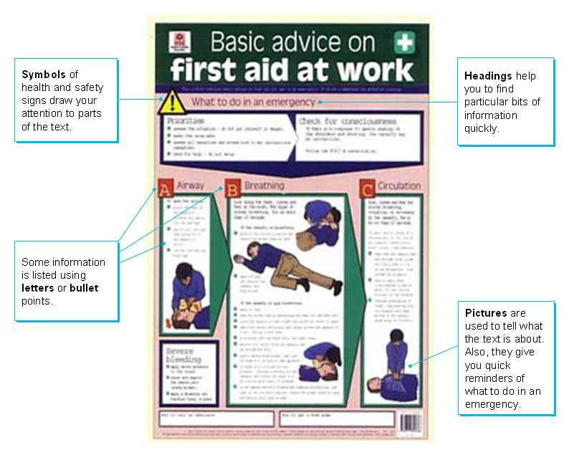
Read this leaflet.


Respecting different cultures and values in care work

Introduction
What we say and how we act can affect how other
people respond to us. You should consider the following
information when you work with other people. They can be
people you look after or people you work with.

Do
✓ Take care about using jargon or slang when speaking to people from other ethnic groups. What you say may have a different meaning to the person listening to you.
✓ Be careful how you use gestures or body language. They might have another meaning to other people. They might understand them in a different way.
✓ Be sensitive when using terms of endearment like love and my dear. You might think you are being friendly. Other people might find it rude.
✓ Be aware that in some communities physical contact between people of different sexes is not common. A handshake is not always the custom to greet people.
✓ Be aware that in some communities, a woman may not be comfortable or wish to be in a room with a man who is not a relative.
Don’t
✗ Don’t ask for a Christian name or surname. Ask for a person’s first, personal or family name instead. Don’t think that if a person answers in English, they understand everything you say.
✗ Don’t think that not keeping eye contact in conversation is a sign of dishonesty or disrespect. In some communities, the opposite is true. Don’t think that just because voices are getting louder, a person is losing control or becoming aggressive. In some communities, it is common practice for people to speak loudly and become more active as their sense of personal space can be less than your own.
✗ Don’t raise your voice if a person does not understand you. Speak more slowly and clearly. Use language that is easier to understand.

Writing instructions
Instructions are written as orders or commands. They use the imperative form of the verb. This means you will read:
Take care instead of You must take care.
Don’t ask instead of You do not ask.

Task 1: Use the headings to find the missing word

Aim: We are using headings in text to locate information.
Use the headings in the text called ‘Respecting different cultures and values in care work’ to find the missing words in the sentences below. Fill in the words that are missing.

What we say and how we act can __________ how other people respond to us.
Take care about using ________ or ________when speaking to people from other ethnic groups.
Don’t ask for a Christian name or___________.
Be sensitive when using _________ of________________ like love and my dear.
Don’t ________ your voice if a person does not understand you.
Be aware that in some communities, a woman may not be __________ or wish to be in a room with a man who is not a _____________.
Be careful how you use ___________ or body language.
Don’t think that just because voices are getting louder, a person is _________ __________ or becoming _____________.
Be aware that in some communities _________ __________ between people of different sexes is not common.
Don’t think that if a person answers in English, they __________ everything you say.

Vocabulary

Read the text again and underline any words or phrases (small groups of words) you do not understand.

Respecting different cultures and values in care work
Introduction
What we say and how we act can affect how other
people respond to us. You should consider the following
information when you work with other people. They can be
people you look after or people you work with.
Do
✓ Take care about using jargon or slang when speaking to people from other ethnic groups. What you say may have a different meaning to the person listening to you.
✓ Be careful how you use gestures or body language. They might have another meaning to other people. They might understand them in a different way.
✓ Be sensitive when using terms of endearment like love and my dear. You might think you are being friendly. Other people might find it rude.
✓ Be aware that in some communities physical contact between people of different sexes is not common. A handshake is not always the custom to greet people.
✓ Be aware that in some communities, a woman may not be comfortable or wish to be in a room with a man who is not a relative.

You might have picked out:
jargon | words or terms used in a particular job
slang | informal words
gestures | movements that have a certain meaning | 
body language | when our movements show our feelings | 
terms of endearment | a loving name (usually for a member of your family)
physical contact | touching | 
different sexes | men and women
custom | a tradition or usual way to do something
not be comfortable | not feeling relaxed, being worried | 
relative | a member of the family
Vocabulary

Read the extract below and underline any words or phrases (small groups of words) you do not understand.

Don’t
✗ Don’t ask for a Christian name or surname. Ask for a person’s first, personal or family name instead. Don’t think that if a person answers in English, they understand everything you say.
✗ Don’t think that not keeping eye contact in conversation is a sign of dishonesty or disrespect. In some communities, the opposite is true. Don’t think that just because voices are getting louder, a person is losing control or becoming aggressive. In some communities, it is common practice for people to speak loudly and become more active as their sense of personal space can be less than your own.
✗ Don’t raise your voice if a person does not understand you. Speak more slowly and clearly. Use language that is easier to understand.

You might have picked out:
eye contact | looking at another person’s eyes when talking to them | 
conversation | talking to another person | 
losing control | not being in charge of your actions | 
aggressive | angry | 
common practice | something that is usually done | 
personal space | the distance that people like to keep between them | 
Word check
A prefix is an element added to the front of a base word.
We can add the prefix dis in front of some words to add to their meaning.
dis means not
dis + respect = disrespect not showing respect
dis + honest = dishonest not being honest

Task 2: Test your vocabulary
Read the sentences and look at the word or words that have been underlined. What do you think they mean? Look at the vocabulary check to help you.
Tick ✓one of the answers.

Some women may not be comfortable if the man is not a relative.
 feel worried
 feel silly
 feel aggressive
 feel tired

You should be careful about how you use body language because some people may be offended.
 movements that amuse people
 movements for exercise
 movements to dance music
 movements that show feelings

Do be sensitive if you use a term of endearment as some people find it rude.
 a family name
 a loving name
 a first name
 a work name

Don’t use workplace jargon others may not understand.
 work routine
 work signs
 work friends
 work terms

If you do not keep eye contact with someone when you talk to them, it does always mean you are being dishonest.
 looking at someone’s shoes
 looking at someone’s hands
 looking at someone’s eyes
 looking at someone’s feet

Just because some people raise their voices, it does not mean they are becoming aggressive.
 angry
 offended
 friendly
 comfortable

In some communities it is not common for people of different sexes to have physical contact.
 to laugh
 to relax
 to touch
 to speak

For some people a handshake is not the custom to greet another person.
 the gesture
 the contact
 the term
 the usual way

Task 3: Word grid
Here are the meanings of some words from the vocabulary list. Work out the word. Write it in the word grid. There are some letters in the grid to help you.

words or terms used in a particular job |  |  | a member of the family
a tradition or usual way to do something |  | movements that have a certain meaning
talking to another person | angry |  |  | informal words
looking at another person’s eyes when talking to them
the distance that people like to keep between them

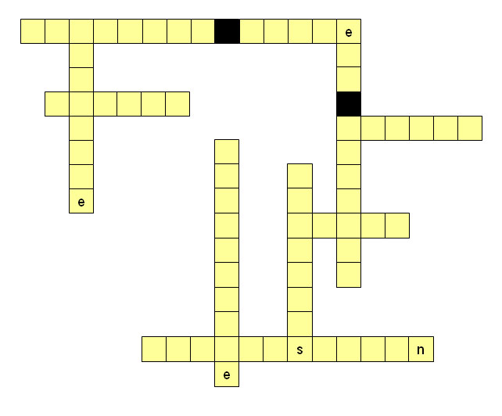
Task 4: Respecting different cultures and values in care work
Read the text Respecting different cultures and values in care work. Then read the statements.
Put a tick in the column to show if the statement is right or wrong.

 | Yes | No
You should take care about using jargon or slang.
You can ask people for their surname.
In some communities physical contact between people of different sexes is not common.
Some people might find a term of endearment rude.
If you do not keep eye contact it means you are being dishonest.
You can raise your voice if someone does not understand you.
Someone might understand your body language in a different way.
You should ask for a person’s personal or family name.
If someone speaks loudly it always means they are becoming aggressive.
If someone does not understand you, use language that is easier to understand.
If someone speaks loudly, it does not mean they are losing control.
A handshake is not always the custom to greet people in some communities.

Confidentiality
When you work in health and social care it is important that you can keep some information secret. This is keeping it confidential.
There are some laws about how you must keep information in social care confidential. These are:
The Access to Medical Reports Act 1988
Remember

An Act is an Act of Parliament. It means that something is the law.
The Access to Health Records Act 1990
The Data Protection Act 1998

The Data Protection Act 1998 gives all us all the right to privacy and to know what records are kept about us. It does not become an issue for us until we are in danger of losing our privacy. It is important that you know about the laws to ensure that you act correctly. | 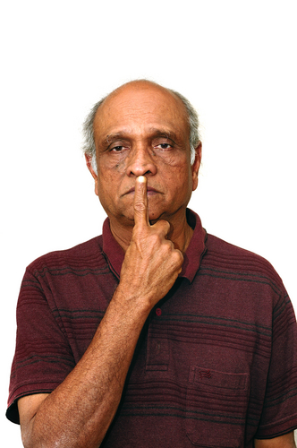
Sometimes, you might get information from a service user or from someone else. They ask you to keep it secret. However, you know that you must pass this information to your supervisor because someone else may be at risk. You tell the service user that you cannot do as they wish because of the risk to other people. You should tell them that you have to tell the supervisor because it is your duty to protect the health and safety of other people. | 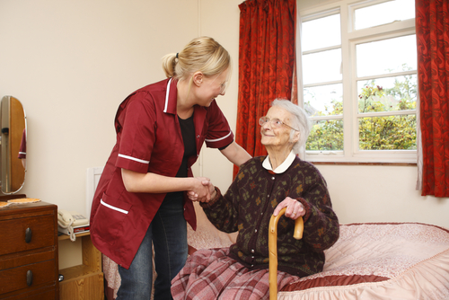
As a care worker, you will know information about the people you care for. This information is sensitive. The people you look after may watch you to make sure that you are careful about what you say about them. Your employer will have a Confidentiality Policy. You may need to sign a statement that says you will not tell anyone confidential information except the people in the caring team you work with. | 
It may be difficult at times to know what to do when people ask you for information. It’s best to say that the employer has a Confidentiality Policy and tell them to speak to your supervisor.  You should ask your supervisor if you are not sure what to do. | 
Remember

might and may are used in this text to show a possibility

should is used to give advice
Task 5: Words that mean the same thing

Aim: We are working out the meaning of words from the way they are used in the text.
The words used in written information at work can be quite difficult. Some of the words in the text Confidentiality have been underlined because you may not know what they mean. You might be able to work out what they mean by the way they are used in the text.
There are other words that mean the same thing. Tick the box that means the same as the new words. The first one is done for you.

confidential | means the same as |  open
 |  |  private
 |  |  shared
 |  |  written

privacy | means the same as |  keeping personal details to yourself
 |  |  sharing personal details
 |  |  personal care routine
 |  |  be looked after

ensure | means the same as |  make fair
 |  |  make comfortable
 |  |  make equal
 |  |  make certain

secret | means the same as |  public
 |  |  private
 |  |  open
 |  |  written

at risk | means the same as |  in danger
 |  |  kept safe
 |  |  kept busy
 |  |  in health

sensitive | means the same as |  public
 |  |  written
 |  |  shared
 |  |  private

except | means the same as |  including
 |  |  leaving out
 |  |  in addition to
 |  |  taking in
The present and future tenses

Aim: We are learning about the present and future tenses.
The verb tenses used in Confidentiality are the present and future tenses. The present tense shows something that is happening now. The future tense shows what will happen in the future.
There are some laws that are about............ present tense.
This is called keeping it confidential............. present tense.
You will know information............................. future tense.
Your employer will have .............................. future tense.

To write in the future tense you need to change the present tense from:
They ask you to keep it secret...
to They will ask you to keep it secret...
Will is a helping or auxiliary verb. It helps the main verb ask to show the future tense.

Task 6: Changing tenses
These sentences are taken from Confidentiality. They are written in the present tense. Write them in the future tense.

You know that you must pass it on.

You tell the service user that you cannot do as they wish.

You know that you must pass this information to your supervisor.

This information is sensitive.

People ask you for information.

You tell them to speak to your supervisor.

Task 7: Reading for meaning

Aim: We are learning to read a text and show we understand what it means.
Read through the Confidentiality text and then read these statements. Show if the sentences are true, false or you may not be able to tell from the text (can’t tell). Put a tick in the column.

 | True | False | Can’t tell
When you work in health and social care it is important to keep some information secret.
The Health and Safety at Work Act is a law that says you need to keep information confidential in health and social care work.
As a care worker, you do not have to know anything about confidentiality issues.
The Data Protection Act gives you a right to privacy.
If the person you look after tells you to keep something a secret, it is alright to promise you will.
It is your duty at work to protect the health and safety of other people.
As a care worker, you will know sensitive information about the people you look after.
Your employer may not have a Confidentiality Policy.
You can talk about sensitive information with anyone outside work if you want to.
There are a number of statements your employer will ask you to sign at work.

How did you get on?

Module 3: Reading workplace information answers

Task 1 answers

What we say and how we act can ___affect___ how other people respond to us.
Take care about using __jargon__ or __slang__ when speaking to people from other ethnic groups.
Don’t ask for a Christian name or __surname__.
Be sensitive when using ___ terms___ of __endearment__ like love and my dear.
Don’t __raise__ your voice if a person does not understand you.
Be aware that in some communities, a woman may not be __comfortable__ or wish to be in a room with a man who is not a ___relative___.
Be careful how you use __gestures__ or body language.
Don’t think that just because voices are getting louder, a person is __losing___ __control__ or becoming __aggressive__.
Be aware that in some communities __physical__ __control__ between people of different sexes is not common.
Don’t think that if a person answers in English, they _understand__ everything you say.

Task 2 answers

Some women may not be comfortable if the man is not a relative.
 feel worried
 feel silly
 feel aggressive
 feel tired

You should be careful about how you use body language because some people may be offended.
 movements that amuse people
 movements for exercise
 movements to dance music
 movements that show feelings

Do be sensitive if you use a term of endearment as some people find it rude.
 a family name
 a loving name
 a first name
 a work name

Don’t use workplace jargon others may not understand.
 work routine
 work signs
 work friends
 work terms

If you do not keep eye contact with someone when you talk to them, it does always mean you are being dishonest.
 looking at someone’s shoes
 looking at someone’s hands
 looking at someone’s eyes
 looking at someone’s feet

Just because some people raise their voices, it does not mean they are becoming aggressive.
 angry
 offended
 friendly
 comfortable

In some communities it is not common for people of different sexes to have physical contact.
 to laugh
 to relax
 to touch
 to speak

For some people a handshake is not the custom to greet another person.
 the gesture
 the contact
 the term
 the usual way

Task 3 answers

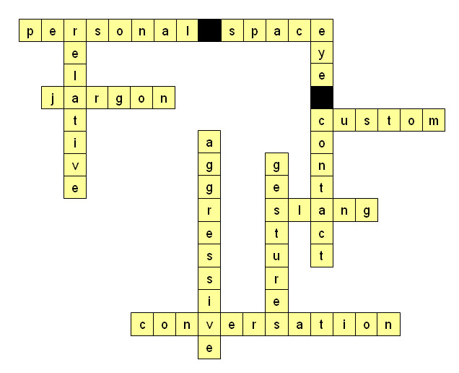

Task 4 answers

 | Yes | No
You should take care about using jargon or slang. | ✓
You can ask people for their surname. |  | ✓
In some communities physical contact between people of different sexes is not common. | ✓
Some people might find a term of endearment rude. | ✓
If you do not keep eye contact it means you are being dishonest. |  | ✓
You can raise your voice if someone does not understand you. |  | ✓
Someone might understand your body language in a different way. | ✓
You should ask for a person’s personal or family name. | ✓
If someone speaks loudly it always means they are becoming aggressive. |  | ✓
If someone does not understand you, use language that is easier to understand. | ✓
If someone speaks loudly, it does not mean they are losing control. | ✓
A handshake is not always the custom to greet people in some communities. | ✓

Task 5 answers

privacy | means the same as |  keeping personal details to yourself
 |  |  sharing personal details
 |  |  personal care routine
 |  |  be looked after

ensure | means the same as |  make fair
 |  |  make comfortable
 |  |  make equal
 |  |  make certain

secret | means the same as |  public
 |  |  private
 |  |  open
 |  |  written

at risk | means the same as |  in danger
 |  |  kept safe
 |  |  kept busy
 |  |  in health

sensitive | means the same as |  public
 |  |  written
 |  |  shared
 |  |  private

except | means the same as |  including
 |  |  leaving out
 |  |  in addition to
 |  |  taking in
Remember
When you read:
...you might get information... might is used to show possibility.
For instance:
If it is sunny tomorrow, I might go to the park.
If you do not wear a tabard, you might get your clothes dirty.

Task 6 answers

You know that you must pass it on.
You will know that you must pass it on.

You tell the service user that you cannot do as they wish.
You will tell the service user that you cannot do as they wish.

You know that you must pass this information to your supervisor.
You will know that you must pass this information to your supervisor.

This information is sensitive.
This information will be sensitive.

People ask you for information.
People will ask you for information.

You tell them to speak to your supervisor.
You will tell them to speak to your supervisor.
Remember
When the verb is to be:
The present is.........he is.
The future is............he will be.

Task 7 answers

 | True | False | Can’t tell
When you work in health and social care it is important to keep some information secret. | ✓
The Health and Safety at Work Act is a law that says you need to keep information confidential in health and social care work. |  |  | ✓
As a care worker, you do not have to know anything about confidentiality issues.  It is important that you know about the laws to ensure that you act correctly. |  | ✓
The Data Protection Act gives you a right to privacy. | ✓
If the person you look after tells you to keep something a secret, it is alright to promise you will.  You tell the service user that you cannot do as they wish because of the risk to other people. |  | ✓
It is your duty at work to protect the health and safety of other people. | ✓
As a care worker, you will know sensitive information about the people you look after. | ✓
Your employer may not have a Confidentiality Policy.  Your employer will have a Confidentiality Policy. |  | ✓
You can talk about sensitive information with anyone outside work if you want to.  When you work in health and social care it is important that you can keep some information secret. You may need to sign a statement that says you will not tell anyone confidential information except the people in the caring team you work with. |  | ✓
There are a number of statements your employer will ask you to sign at work. |  |  | ✓

