
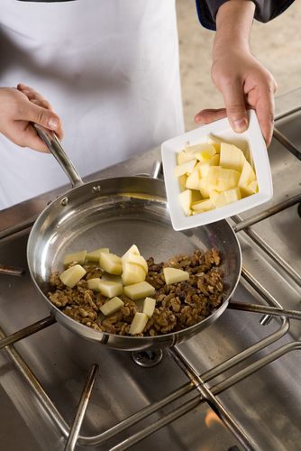
Entry 1: Reading
Catering

Module: Learning about your job

Module aims

Main aim
We are learning about induction training. You will find out the meanings of some of the words used in the text.

Other learning aims
We are learning:
- To read for meaning
- To read for detail
- About plurals
- Verbs we use at work
- Words for telling the time
- Words that tell us the order to do things

Module: Learning about your job
Aim: We are going to learn about induction training. You will find out the meanings
of some of the words used in the texts.

Task 1: Starting a new job
Read the text about induction. Find these words in the text:

in charge | names |  | keep safe |  | training
rules |  | work |  | clothes
Underline them. The first one is an example.

Induction

Induction is training for people starting a new job. One of the people in charge gives a talk. | 
The talk tells you about the work you do.
You learn the names of people who tell you what to do. | 
You learn to work safely. You learn the health and safety rules. | 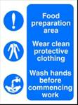
You find out about the clothes you wear to keep safe. | 
What do the words in the text mean?
induction training for people starting a new job
in charge leading the work
safely not in danger

Task 2
Find these words in the text. Draw a line under them.

first aid | emergency | things | fire | person
Underline them. The first one is an example.

Induction

You need to know where things are. | 
You learn where to go if you need first aid. | 
You find out what to do if there is an emergency. A fire is an emergency. | 
You must tell the person in charge if you do not understand something. | 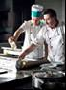
Ask the person to say it again or say it in another way. | 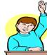
What do the words in the text mean?
first aid for people who are hurt or ill
emergency something that people do not expect to happen – a fire or accident is an emergency

Word check
We call the letters a, e, i, o, u vowels. Other letters are called consonants.
When a word starts with a vowel we use an before it. For other words we use a.
a chef, a waiter, an induction talk, an emergency


Now read the whole text:

Induction

Induction is training for people starting a new job. One of the people in charge gives a talk.
The talk tells you about the work you do.
You learn the names of people who tell you what to do.
You learn to work safely. You learn the Health and Safety rules.
You find out about clothes you wear to keep safe.
Word check
You see the words health and safety at work. You see these words together because they have a special meaning. They are a short form for the Health and Safety at Work Act. This is a law to keep you safe at work.

Ask if you do not understand. You can say:
Sorry I don’t understand.
Please say that again.
I don’t know what you mean. Can you explain?
Excuse me, can you say that again? I don’t understand.

Task 3
These sentences have a gap. Use the words to fill in the gap.
Here is an example:
I go to the store room to get some flour. |  |  |  | 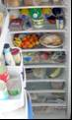
office | reception | store room | canteen
Now you try
Report to the person ________________ of the team. |  |  |  | 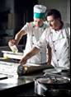
at home | in charge | in leave | at work

The _____________ talk for new people is in the training room. |  |  |  | 
work | induction | training room | office

The alarm rings when there is an __________________. |  |  |  | 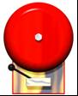
emergency | election | emission | erosion

Go to ______________ if you cut yourself. |  |  |  | 
eye wash | the assembly point | first aid | the kitchen

Work ________ and take care all the time. |  |  |  | 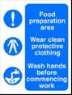
swiftly | slowly | softly | safely

Task 4: Marco’s first day at work
Read this text about Marco. It has some gaps. Write a word in the gap to complete the sentences.

aid | names | charge | induction
clothes | new job | rules | understand

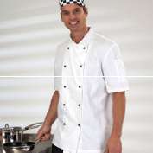 |  | This is Marco. He is starting a new job. He is a kitchen assistant in a restaurant.
He meets Olenka. She is his line manager. She is the person in __________.
Olenka tells Marco what he has to do. She tells him what he has to do. This is called an _______________ talk.
She tells him to work safely. She tells him the ___________ to wear to keep safe.
She tells him where to go for first ____________. She tells him where to go if there is a fire.
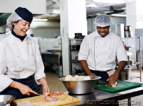 | He must follow the health and safety _____________.
 | He meets the waiters. He learns the ___________ of the chef and the kitchen staff. They are all friendly and helpful.
Olenka tells him to ask her if he does not _____________. She is happy to tell him again.
Another name for your line manager is your boss.
Another name for a kitchen assistant is a kitchen porter.
A fire is an emergency.
An accident is an emergency.
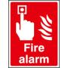

Duties at work
Olenka tells Marco about the clothes he has to wear to work safely. She tells him about his duties. He has to:
- do the washing up
The word duties is the plural of duty. 1 duty, 2 duties. When a word ends in a consonant + y the plural is – ies.
an emergency
many emergencies

- load the dishwasher
- clear tables
- help to prepare food
- help with deliveries
- clean the kitchen at end of day
She gives him a uniform and gloves.
Task 5
Here are some of Marco’s duties. Put a ✓ by the text that says what the picture shows. The first one is an example.
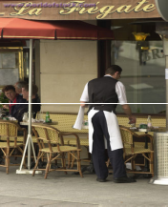 |  Do the washing up
 |  Clear tables
 |  Help with deliveries
 |  Clean the kitchen

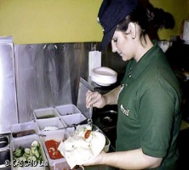 |  Help with deliveries
 |  Clear tables
 |  Prepare food
 |  Load the dishwasher

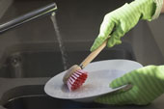 |  Do the washing up
 |  Clear tables
 |  Help with deliveries
 |  Clean the kitchen

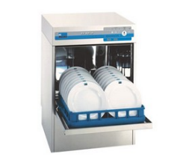 |  Load the dishwasher
 |  Clear tables
 |  Help with deliveries
 |  Clear tables

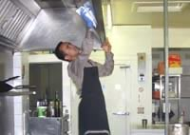 |  Do the washing up
 |  Clear tables
 |  Load the dishwasher
 |  Clean the kitchen

Verbs
We are learning about verbs. Verbs tell you about actions. Do, cook, take are verbs.

 |  | 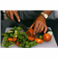 |  | 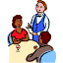
The chef cooks. |  | I slice tomatoes. |  | The waiter takes the order.

Task 6
Can you put these verbs in the sentences? The first one is an example.

prepare | clear | wash | give
is | does | helps | wears

 | Chefs in uniform  We call a chef’s uniform whites.
1. The waiter helps Marco to bring in the deliveries.
2. The chef __________ a clean uniform.
3. The kitchen staff __________ their hands.
4. Marco __________ the washing up every day.
5. The waiters __________ the tables.
6. The kitchen assistant __________ the vegetables for the chef.
7. Olenka ________ Marco’s boss.
8. She __________ him gloves.
A working day
Olenka writes down what Marco has to do each day. Read what she writes:
You are on the early shift this week. You start work at 6 am. This is your timetable.

6 to 7.30am | Help with the deliveries  Help the waiters set tables for breakfast
7.30 to 9am | Do the washing up
9 to 9.15am | Break
9.15 to 11am | Help prepare food for lunch  Wash up
11 to 11.45am | Lunch break
11.45am to 1.30pm | Washing up and cleaning
1.30 to 1.45pm | Break
1.45 to 3pm | Training
3pm | Go home
12 o’clock or 12:00
Other words for 12 are noon or midday.
Another word for 12 o’clock at night or 24:00 hours is midnight.
am means in the morning before 12
pm means after 12 in the afternoon
Task 7
Look at the sentences below. Put a tick ✓ to say if the answer is yes or no. The first one is an example.

 | Yes | No
A break is the time when you do not work. | ✓
Marco starts work at 7.30 in the morning.
Marco helps the waiters talk to customers.
Marco goes home at 3 pm in the afternoon
The training is before lunch.

Doing things in order

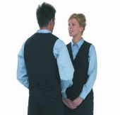 |  |  |  | 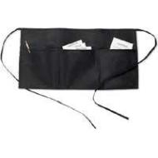
Uniforms are clothes you wear for work |  | order pad |  | Apron with pockets

Olenka tells him what to do. Read what she says.
1. Before you start you must wash your hands.
2. First you greet customers. You call men ‘Sir’ and women ‘madam’.
3. Then you take them to a table.
4. Next you give them a menu and take their order.
5. Then you bring them their order.
6. After they finish you clear and wipe the table.
7. Finally you prepare the table for the next customers.
Look at the words in bold: before, first, then, next, after, finally. These words tell you the order to do things.
Task 8: Putting sentences in order
This is what Marco does. Put in the numbers 1 2 3 4 5 6 7 to show the order. The first one is an example.

Then he takes the customer to a table.

After the customer finishes he clears and wipes the table.

1 | Before he starts Marco puts an order pad in his pocket.

Next he gives him a menu and takes his order.

Finally he prepares the table for the next customer.

First he greets a customer.

Then he brings the order.

How did you get on?

Module 2: Learning about your job answers

Task 1 answers

Induction is training for people starting a new job. One of the people in charge gives a talk.
The talk tells you about the work you do.
You learn the names of people who tell you what to do.
You learn to work safely. You learn the health and safety rules.
You find out about the clothes you wear to keep safe.

Task 2 answers

You need to know where things are.
You learn where to go if you need first aid.
You find out what to do if there is an emergency. A fire is an emergency.
You must tell the person in charge if you do not understand something.
Ask the person to say it again or say it in another way.

Task 3 answers

Report to the person in charge of the team.
at home | in charge | in leave | at work

The induction talk for new people is in the training room.
work | induction | training room | office

The alarm rings when there is an emergency.
emergency | election | emission | erosion

Go to first aid if you cut yourself.
eye wash | the assembly point | first aid | the kitchen

Work safely and take care all the time.
swiftly | slowly | softly | safely

Task 4 answers

This is Marco. He is starting a new job. He is a kitchen assistant in a restaurant.
He meets Olenka. She is his line manager. She is the person in charge.
Olenka tells Marco what he has to do. She tells him what he has to do. This is called an induction talk.
She tells him to work safely. She tells him the clothes to wear to keep safe.
She tells him where to go for first aid. She tells him where to go if there is a fire.
He must follow the health and safety rules.
He meets the waiters. He learns the names of the chef and the kitchen staff. They are all friendly and helpful.
Olenka tells him to ask her if he does not understand. She is happy to tell him again.

Task 5 answers

 Do the washing up
 Clear tables
 Help with deliveries
 Clean the kitchen

 Help with deliveries
 Clear tables
 Prepare food
 Load the dishwasher

 Do the washing up
 Clear tables
 Help with deliveries
 Clean the kitchen

 Load the dishwasher
 Clear tables
 Help with deliveries
 Clear tables

 Do the washing up
 Clear tables
 Load the dishwasher
 Clean the kitchen

Task 6 answers

1. The waiter helps Marco to bring in the deliveries.
2. The chef wears a clean uniform.
3. The kitchen staff wash their hands.
4. Marco does the washing up every day.
5. The waiters clear the tables.
6. The kitchen assistant prepares the vegetables for the chef.
7. Olenka is Marco’s boss.
8. She gives him gloves.

Task 7 answers

 | Yes | No
A break is the time when you do not work. | ✓
Marco starts work at 7.30 in the morning. |  | ✓
Marco helps the waiters talk to customers. |  | ✓
Marco goes home at 3 pm in the afternoon | ✓
The training is before lunch. |  | ✓

Task 8 answers

3 | Then he takes the customer to a table.

6 | After the customer finishes he clears and wipes the table.

1 | Before he starts Marco puts an order pad in his pocket.

4 | Next he gives him a menu and takes his order.

7 | Finally he prepares the table for the next customer.

2 | First he greets a customer.

5 | Then he brings the order.
Remember
Look at the verbs. When the verb goes with he, she or it, it ends in s or es.
The customer finishes
You finish
They finish

Here are the sentences in the right order:
Before he starts Marco puts an order pad in his pocket.
First he greets a customer
Then he takes the customer to a table.
Next he gives him a menu and takes his order.
Then he brings the order.
After the customer finishes he clears and wipes the table.
Finally he prepares the table for the next customer.

