
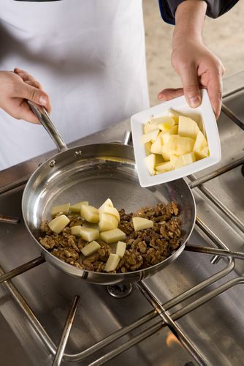
Entry 2: Reading
Catering

Module: Rules at work

Module aims

Main aim
We are learning about the things that you must do at work.

Other learning aims
We are learning:
- To read a text to show we understand it
- The meaning of words in the text
- About plurals
- About health and safety signs at work
- To use must/must not and have to

Module: Rules at work
Aim: We are learning about the things you and your employer must do at work. You
will find out the meaning of words used in this module.

Read the text about rules at work.

What you must do and what your employer must do
The law tells employers and employees what they must do to stay safe at work.
Employers must provide:
- a safe and healthy workplace
- safe equipment and protective clothing
- good supervision
- training on how to work safely
- toilets and a place to wash.
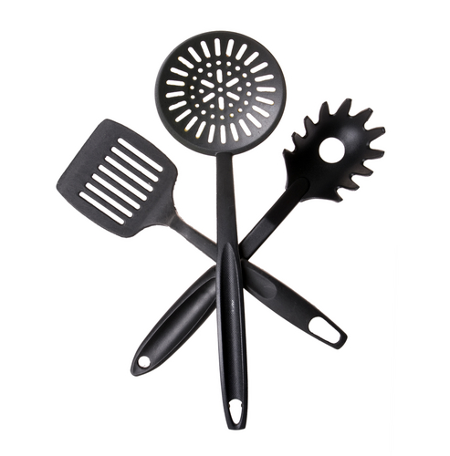 |  | 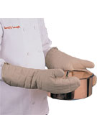 |  |  |  | 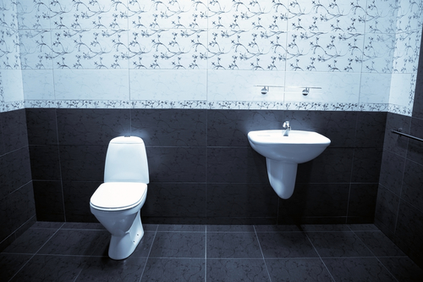
equipment |  | protective clothing |  | training |  | toilets and a place to wash
Employers must:
- follow the rules
- use safety equipment
- wear protective clothing
- work safely and carefully.
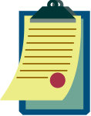 |  | 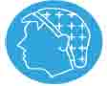 |  | 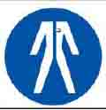 |  | 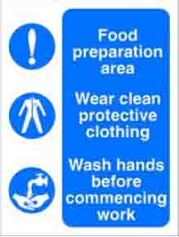
rules |  | use safety equipment |  | wear protective clothing |  | work safely and carefully


Task 1: What are your duties? What are you employer’s duties?
Put a tick ✓ in the right box. The first one is an example.

 | You | Your employer
Provide a safe and healthy workplace |  | ✓
Training on how to work safely
Work safely and carefully
Toilets and a place to wash
Follow the rules

Task 2: Plurals
The plural of duty is duties. When a word ends with a consonant + y it changes to -ies for the plural.
Can you think of other words like this? Write them in the box. Use the pictures to help you.
1._____________________________________________________________

2._____________________________________________________________

3._____________________________________________________________

4._____________________________________________________________

5._____________________________________________________________

6._____________________________________________________________

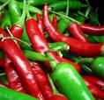 |  | 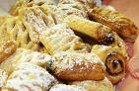 | 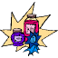 | 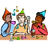

What do the words in the text mean?

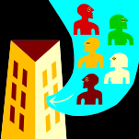 | employer |  | equipment
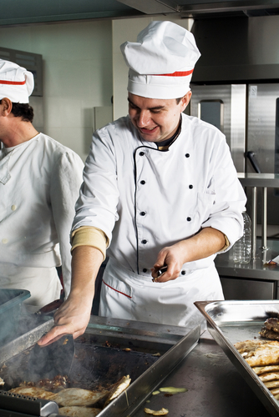 | employee |  | rules
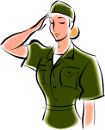 | duty | 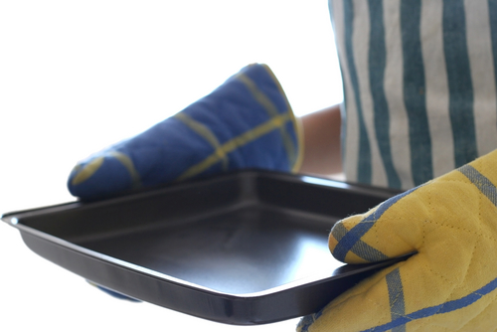 | protective clothing

Task 3: What do the words in the text mean?
Match the words to the meaning. The first one is an example.

the things you use at work – pans, knives, mixers |  | the things you have to follow at work |  | what you must do |  | the firm or person that gives the job

Task 4: Word grid
Here are some words from the text. Write them in the word grid. There are some letters in the grid to help you.

employer | duty |  | training |  | rules |  | explain
equipment |  | toilets |  | healthy |  | safely

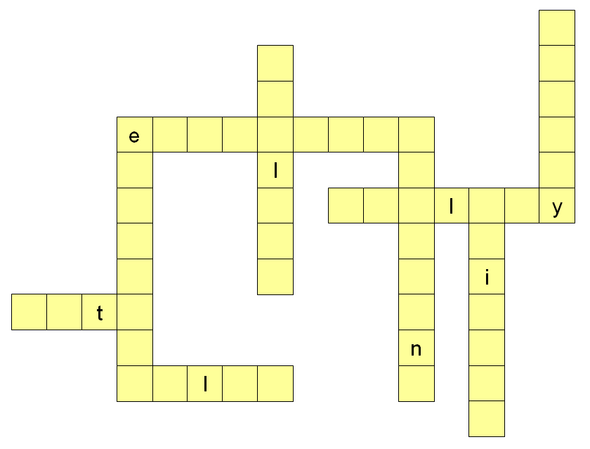

Health and safety signs
There are many health and safety signs in your workplace. They are different colours and shapes. This helps you understand what they mean. This table tells you the meaning of the shapes and colours.

Blue circles tell you what you must do.
They are called mandatory signs.
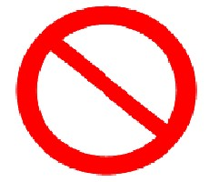 | Red circles with a line tell you what you must not do or use.  They are called prohibitive signs.
Black and Yellow triangles tell you to be careful.
They are called warning signs.
 | Green and white squares or rectangles give you information about first aid, fire escape or safe conditions.
 | Red squares or rectangles give information about fire equipment.
 | Orange signs on containers also tell you to be careful.
 | Yellow and black tape or signs tell you a place or thing is dangerous.

Task 5
What does the colour of the sign mean? Draw a line to match the colour to the meaning. The first one is an example.

fire equipment |  | you must do something |  | warning |  | you must not do or use something |  | first aid, fire escape or safe place

Blue signs

They are mandatory signs because you must do what they show.
They are mandatory signs because you must use what they show.

Blue signs show what you must do.
Blue signs show what you
must use.

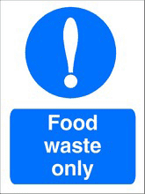 | Sometimes signs leave out words. This sign means:  You must only put food waste here.
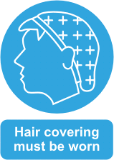 | This sign says the same thing in a different way. It means the same as:  You must wear hair covering.
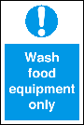  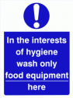 | Both these signs say you only wash equipment used to prepare, store or cook food in this sink.

Look at these signs.

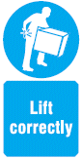 | This sign tells you that you must lift things in the right way.  Lift correctly is an order.  It means the same as:  You must lift correctly.
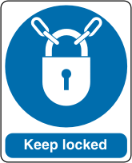 | There are places at work that must be locked.  Sometimes signs leave out words.  This sign means:  You must keep this door locked.
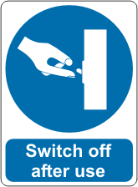 | You must make sure you turn equipment off when you have stopped using it.  This sign is an order, too. It means the same as:  You must switch this machine off after you use it.
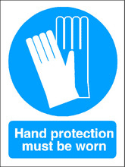 | Sometimes signs leave out words. This sign means:  You must wear hand protection.  You might see a sign that says:  Wear hand protection.  They mean the same thing.
Look out for safety signs in your workplace and make sure you know what they mean.
Task 6: Test yourself
Do you know what these signs mean? Test yourself. Tick the box next to the meaning. The first one is an example.
This sign means:
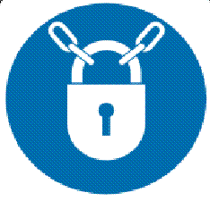 |  warning – locked door
 |  please shut the door
 |  do not keep locked
 |  must be kept locked
This signs means:
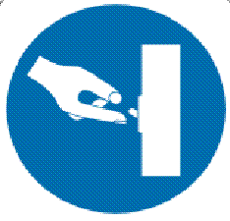 |  turn on equipment
 |  warning – switch here
 |  switch off after use
 |  switch is here
Blue signs means:
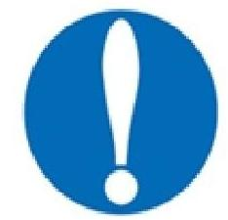 |  you must do something
 |  warning
 |  stop here
 |  a fire exit
This signs means:
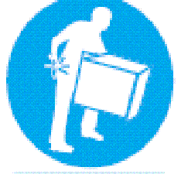 |  heavy boxes around
 |  watch your step
 |  lift carefully
 |  storage area

This signs means:
 hair nets kept here
 you must cover your hair
 warning – dusty area
 wear a hair next if you want

Red and white signs
Red and white signs show what you must not do.

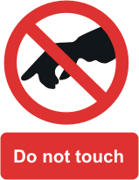 | Do not  This means the same as:  You must not.  When you see this sign on something you must not touch it.
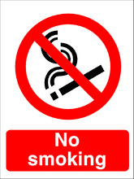 | No  Sometimes signs say:  No smoking  No running.  This is another way of saying:  You must not smoke here.
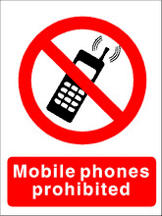 | Some signs use the word:  prohibited  If something is prohibited, you cannot use or do it.  This sign means:  You cannot use a mobile phone.
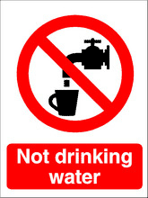 | This sign is telling you about something you cannot use.  It means that you must not drink the water from this tap.  Remember some signs leave words out.  It could say:  This is not drinking water.

Task 7
Do you remember what the signs mean? Test yourself. Put a ✓ in the box next to the meaning. The first one is an example.
This sign means:
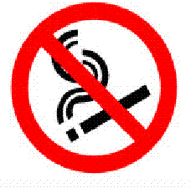 |  smoking area
 |  no smoking
 |  you can smoke
 |  smokers only
This signs means:
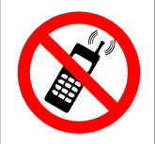 |  no mobile phones
 |  mobile phone area
 |  warning – people using phones
 |  emergency phone here
Red and white signs means:
 warning – take care
 you must do or use something
 you must not do or use something
 first aid or safe condition
This signs means:
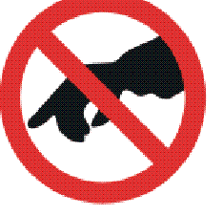 |  wear safety gloves
 |  take care of hands
 |  use with care
 |  do not touch

This signs means:
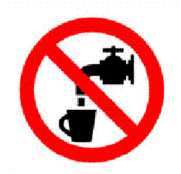 |  fresh drinking water
 |  water tap here
 |  not drinking water
 |  take care –running water
Black and yellow signs
Another name for black and yellow signs are hazard signs.

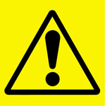 | Black and yellow signs are warning signs. They tell you to be careful.
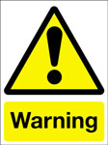  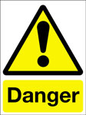 | Warning signs may say Caution, Danger or Warning.  They all mean that you must be careful.
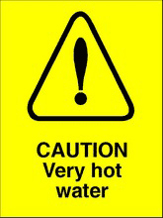  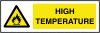 |  | 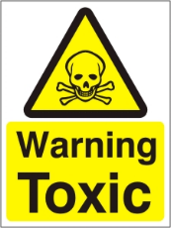  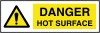 | 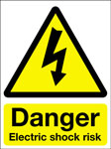  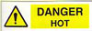
These signs tell you why you must be careful.

Task 8: Do you remember what the signs mean? Test yourself
Put a ✓ in the box next to the meaning. The first one is an example.
This sign means:
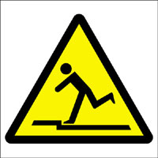 |  wet floor
 |  stairs this way
 |  you may trip
 |  you must use these steps
This signs means:
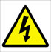 |  danger - electricity
 |  this way
 |  light switch
 |  exit
This signs means:
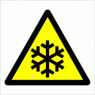 |  bad weather
 |  cold temperature
 |  plant area
 |  no entry
This signs means:
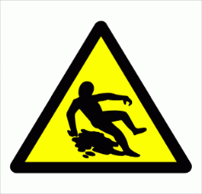 |  no running
 |  slippery surface
 |  someone is hurt
 |  wear safety shoes

How did you get on?

Module 2: Rules at work answers

Task 1 answers

 | You | Your employer
Provide a safe and healthy workplace |  | ✓
Training on how to work safely |  | ✓
Work safely and carefully | ✓
Toilets and a place to wash |  | ✓
Follow the rules | ✓

Task 2 answers
1. 1 berry many berries

2. 1 chilli many chillies

3. jelly jellies

4. quantity quantities

5. party parties

6. pastry pastries

Task 3 answers

what you must do |  | the firm or person that gives the job |  | the things you use at work – pans, knives, mixers |  | the things you have to follow at work

Task 4 answers

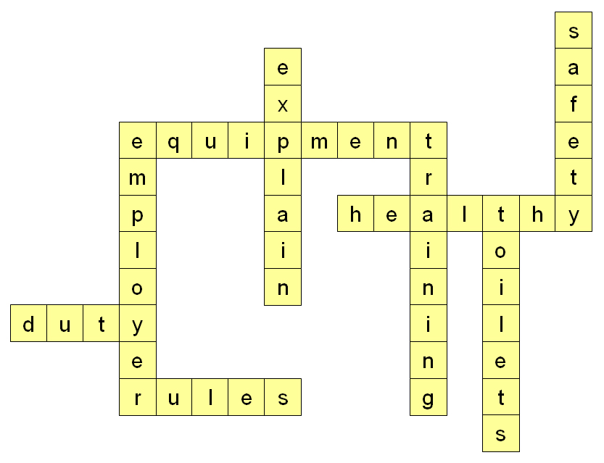

Task 5 answers

first aid, fire escape or safe place |  | warning |  | you must do something |  | you must not do or use something |  | fire equipment
When you see red and white signs, you may see these words on the sign.
no not
It means you must not do or use something.

Task 6 answers
This sign means:
 warning – locked door
 please shut the door
 do not keep locked
 must be kept locked
This signs means:
 turn on equipment
 warning – switch here
 switch off after use
 switch is here
Blue signs means:
 you must do something
 warning
 stop here
 a fire exit
This signs means:
 heavy boxes around
 watch your step
 lift carefully
 storage area
This signs means:
 hair nets kept here
 you must cover your hair
 warning – dusty area
 wear a hair next if you want

Task 7 answers
This sign means:
 smoking area
 no smoking
 you can smoke
 smokers only
This signs means:
 no mobile phones
 mobile phone area
 warning – people using phones
 emergency phone here
Red and white signs means:
 warning – take care
 you must do or use something
 you must not do or use something
 first aid or safe condition
This signs means:
 wear safety gloves
 take care of hands
 use with care
 do not touch
This signs means:
 fresh drinking water
 water tap here
 not drinking water
 take care –running water

Task 8 answers
This sign means:
 wet floor
 stairs this way
 you may trip
 you must use these steps
This signs means:
 danger - electricity
 this way
 light switch
 exit
This signs means:
 bad weather
 cold temperature
 plant area
 no entry
This signs means:
 no running
 slippery surface
 someone is hurt
 wear safety shoes

