
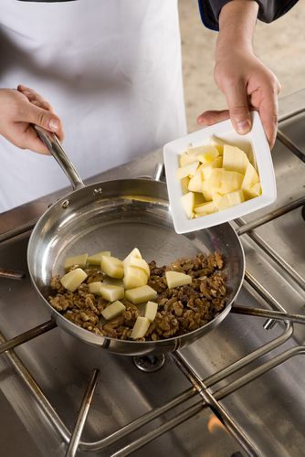
Entry 3: Reading
Catering

Module: Safety signs and symbols

Module aims

Main aim
We are learning about safety signs and symbols at work.

Other learning aims
We are learning:
- The names of parts of a fire extinguisher
- To read for understanding
- To obtain information from a table
- The meaning of hazard symbols

Module: Safety signs and symbols


Fire safety
The risk of fire is high in a busy kitchen. It is important to be very careful and to make sure you know how to use fire extinguishers.
There are four types of fire extinguisher:
- Water
- Foam
- CO₂ (carbon dioxide)
- Dry powder
They work in different ways. They all stop the fire from burning by either:
1. removing heat from the fire or
2. removing oxygen from the fire (oxygen is in the air).
Remember: removing means taking away.
They each have their benefits and problems.
If the extinguishers are new, they will be red with coloured handles or a coloured ‘shoulder’ or band. If they are older, the whole cylinder will be the colour that shows what kind fire the extinguisher can be used on.
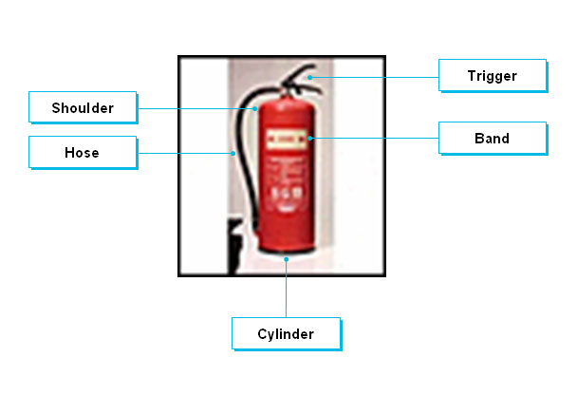

Task 1
Read these instructions for using a fire extinguisher. Write 1, 2, 3 and 4 in the box to show the order you think you should follow to use an extinguisher. The first one is an example.

Pull the trigger | 4

Pull out the pin

Take the extinguisher to where you will use it

Aim the hose or nozzle

Read this table about fire extinguishers.

Colour band and type | Best for: | Dangers | Puts out the fire by:
Red  Water | Solids - wood, cloth, paper, plastics | Do not use on burning fat or oil.  Do not use on electrical appliances. | cooling burning material
Blue  Dry Powder  Standard | Liquids - grease, fats, oil, paint, petrol  Electrical equipment | Do not use on chip or fat pan fires.  Does not easily penetrate equipment - fire may re-ignite. | knocking down flames and by smothering the fire  providing some cooling effect
Cream  AFFF  Multi-purpose  (Aqueous film-forming foam) | Solids - wood, cloth, paper, plastics, etc.  Liquids - grease, fats, oil, paint, petrol | Do not use on chip or fat pan fires.  Do not use on electrical appliances. | smothering fire with foam film on surface of burning liquid  having a cooling action with a wider extinguishing use than water on solids
Black  Carbon Dioxide CO₂ | Liquids - grease, fats, paint, petrol  Electrical equipment | Do not use on chip or fat pan fires.  Does not cool fire well - fire may re-ignite.  Fumes from CO₂ extinguishers can be harmful if used in confined spaces. | smothering the flames with a vaporising liquid gas which keeps out oxygen in the air

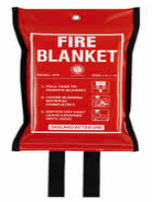 | If you have a chip or fat pan fire, use a fire blanket.

Task 2
Answer these questions using the information from the table about fire extinguishers. The first one is an example.
1. How does this type of extinguisher put out fires?
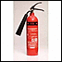 |  It gets rid of heat
 |  It keeps out oxygen
 |  It removes the fuel
 |  It makes the fire wet
2. This fire extinguisher contains:
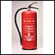 |  foam
 |  carbon dioxide (CO₂)
 |  water
 |  dry powder
3. To put out an oil fire, you must not use:
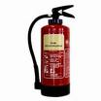 |  | 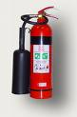 |  | 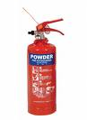 |  | 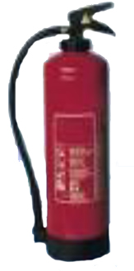
 |  |  |  |  |  | 

4. This extinguisher must not be used on:
 electrical fires
 wood fires
 burning furniture
 burning clothes
5. Which two extinguishers can be used on electrical fires?
 |  |  |  |  |  | 
6. If you discover a large fire, the first thing you should do is:
 put your tools away
 finish what you are doing
 try to put out the fire
 raise the alarm
7. If you have a chip pan fire which should you use?
 |  | 

8. Which two extinguishers can be used on oil fires?
 |  |  |  |  |  | 
9. This extinguisher can be used to put out:
 burning oil
 electrical fires
 wood fires
 burning petrol
10. This extinguisher must not be used on:
 electrical fires
 wood fires
 burning oil
 burning petrol
11. This fire extinguisher contains:
 water
 foam
 dry powder
 carbon dioxide (CO₂)

Warning signs on chemicals
Read the text about hazard symbols.
Cleaning products often contain harmful chemical substances.
They have to be used carefully and stored correctly. Look out for these symbols on product labels. They are there to warn you that these chemicals can harm you.

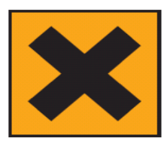  Irritant | You must:  - store away from food products  - avoid contact with eyes  - seek medical advice if anyone swallows it.
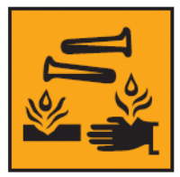  Corrosive | - Causes severe burns.  - Wear gloves, eye and face protection.  - In case of contact with eyes or skin, rinse immediately with water and seek medical advice.  - Do not breathe spray.  - Use only in well ventilated areas.  In case of means if something happens.
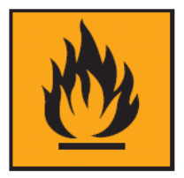  Flammable | - Do not expose to temperatures above 50ºC.  - Keep out of direct sunlight.  - Keep away from sources of ignition.  - Do NOT smoke.
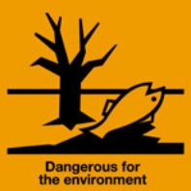 | - Use with care.  - Do not pour down the sink.  - Follow instructions for disposal.
Keep all substances with these labels away from children.

Task 3: Warning signs
Put a ✓  next to the right word or phrase. The first one is an example.
Flammable means:
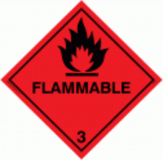 |  don’t touch, very hot
 |  can irritate your skin
 |  can catch fire very easily
 |  for putting out fire
Irritant means:
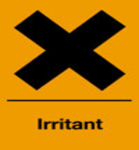 |  annoying
 |  can cause reddening, swelling, itching
 |  can catch fire very easily
 |  can harm plants and animals
Corrosive means:
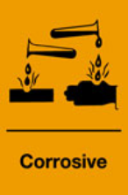 |  can kill you or make you very ill
 |  can dissolve your skin, metal and other substances
 |  can catch fire very easily
 |  very poisonous
Dangerous for the environment means:
 can kill you or make you very ill
 can burn your skin very badly
 can catch fire very easily
 can harm plants and animals

Task 4: Word grid
Here are some of the objects, signs and symbols from the tasks. Write what they are in the grid. There are some letters in the grid to help you.

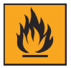 |  | 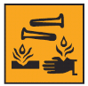 | 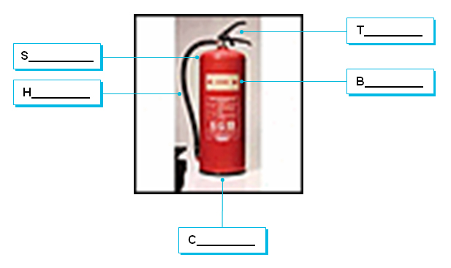
 | fire __________ | 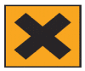

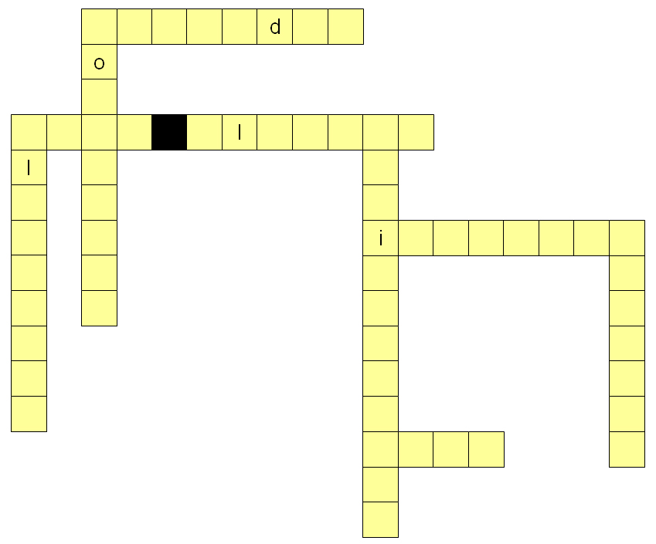

How did you get on?

Module 3: Safety signs and symbols

Task 1 answers

Pull the trigger | 4

Pull out the pin | 3

Take the extinguisher to where you will use it | 1

Aim the hose or nozzle | 2
Remember
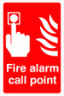 Only use an extinguisher after raising the alarm – letting other people know about the fire.

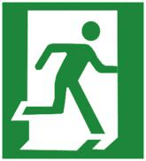 Make sure you have a means of escape – a way to leave the area safely.

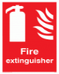 Use the right kind of extinguisher for the fire.

Task 2 answers
1. How does this type of extinguisher put out fires?
 It gets rid of heat
 It keeps out oxygen
 It removes the fuel
 It makes the fire wet
2. This fire extinguisher contains:
 foam
 carbon dioxide (CO₂)
 water
 dry powder
3. To put out an oil fire, you must not use:
 |  |  |  |  |  | 
4. This extinguisher must not be used on:
 electrical fires
 wood fires
 burning furniture
 burning clothes

5. Which two extinguishers can be used on electrical fires?
 |  |  |  |  |  | 
6. If you discover a large fire, the first thing you should do is:
 put your tools away
 finish what you are doing
 try to put out the fire
 raise the alarm
7. If you have a chip pan fire which should you use?
 |  | 
8. Which two extinguishers can be used on oil fires?
 |  |  |  |  |  | 

9. This extinguisher can be used to put out:
 burning oil
 electrical fires
 wood fires
 burning petrol
10. This extinguisher must not be used on:
 electrical fires
 wood fires
 burning oil
 burning petrol
11. This fire extinguisher contains:
 water
 foam
 dry powder
 carbon dioxide (CO₂)

Task 3 answers
Flammable means:
 don’t touch, very hot
 can irritate your skin
 can catch fire very easily
 for putting out fire
Irritant means:
 annoying
 can cause reddening, swelling, itching
 can catch fire very easily
 can harm plants and animals
Corrosive means:
 can kill you or make you very ill
 can dissolve your skin, metal and other substances
 can catch fire very easily
 very poisonous
Dangerous for the environment means:
 can kill you or make you very ill
 can burn your skin very badly
 can catch fire very easily
 can harm plants and animals
Look out for these signs in your workplace and think about the protective clothes or equipment you can you use to prevent harming yourself. Think also about what you must do to avoid harming anyone or anything else.
The signs with a fire symbol 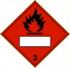 may say Fire risk or use the words flammable or inflammable. Flammable and inflammable both mean the same thing. They are adjectives that tell you something catches fire very easily.

Task 4 answers



