
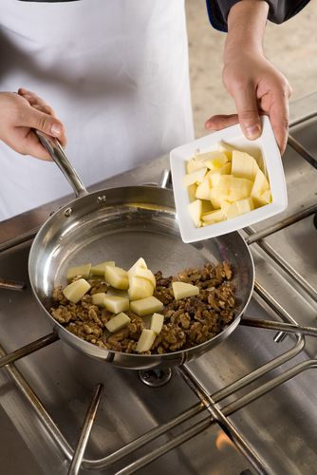
Level 1: Reading
Catering

Module: Food Hygiene

Module aims

Main aim
We are learning to read information about Food Hygiene for understanding and detail.

Other learning aims
We are learning:
- To read for detail from a food hygiene text
- Formal and informal words and phrases about food borne illness; to extract information from a poster
- To use passive and active forms in instructions

Module: Food hygiene

Millions of people in the UK suffer from food poisoning every year. Even in the most modern and hygienic of food premises just one mistake by an untrained food handler can cause a serious outbreak of food poisoning. Food poisoning is caused by types of bacteria. Food hygiene is intended to stop the bacteria from making staff and customers seriously ill. Food poisoning can kill.
Under food hygiene law in the UK, food handlers must receive adequate supervision, instruction and training in food hygiene for the work they do.
New employees who are just starting to work in a catering business must have ‘hygiene awareness instruction’ from a competent person within four weeks of starting work. The overall aim of ‘hygiene awareness instruction’ is to develop knowledge of the basic principles of food hygiene. The topics covered should include:

- temperature control  - food poisoning  - personal health and hygiene  - cross contamination  - food storage  - waste disposal  - foreign body contamination  - awareness of pests. | 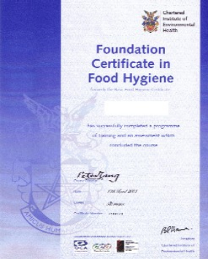
Good employers will send their employees to do a training course, take a test and, if they pass, get a certificate in Food Hygiene at the right level for their job.

Task 1: Food hygiene
Can you match the topics mentioned above with the pictures that are associated with, or linked to, them? Put a tick in the box next to the right answer. The first one is an example.

 |  Temperature control
 |  Food poisoning
 |  Awareness of pests
 |  Cross contamination

 |  Food storage
 |  Waste disposal
 |  Foreign body contamination
 |  Personal health and hygiene

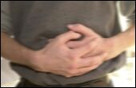 |  Food storage
 |  Food poisoning
 |  Awareness of pests
 |  Cross contamination

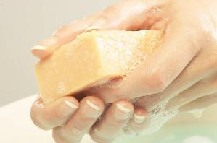 |  Cross contamination
 |  Foreign body contamination
 |  Personal health and hygiene
 |  Temperature control

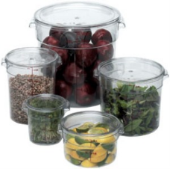 |  Food storage
 |  Waste disposal
 |  Awareness of pests
 |  Cross contamination

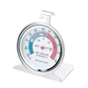 |  Personal health and hygiene
 |  Temperature control
 |  Food poisoning
 |  Awareness of pests

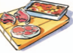 |  Cross contamination
 |  Foreign body contamination
 |  Temperature control
 |  Food poisoning

Now read this text.

What you learn on a food hygiene course
On a food hygiene course you will learn about the causes of food poisoning and how to avoid them. You will have to understand a lot of difficult words. You can look up the words in a dictionary or use the internet to find out more. It helps to write the words you learn in your own personal dictionary. You can arrange them in alphabetical order, by topics or in word families. Choose the method that suits you best.
Causes of food poisoning
We learnt that food poisoning is caused by types of bacteria. The bacteria that cause illness are tiny forms of life called pathogens. Another word for tiny forms of life is micro-organisms. These organisms are so small that you have to use a microscope to see them.
You will find out about the main food-poisoning bacteria – Bacillus cereus, Campylobacter, Escherichia coli (e-coli), Salmonella and Staphylococcus aureus. You will learn where they are found and the conditions they need to grow and spread. You will learn how long they take to make someone ill. Most importantly you will learn how to prevent them from spreading and getting into your body or your customers’ bodies.
The illnesses they cause are called food-borne diseases. Borne means carried. Illnesses you get from tiny droplets of water in the air are called air-borne illnesses. For example, colds and flu are air-borne illnesses caught by breathing in the micro-organisms spread by coughing and sneezing.
Micro is an element added to the front of a root word to add to the meaning. It is a prefix.
micro-organism a tiny form of life
or microbe
microscope an instrument for looking at microbes
When you add an element to the end of a word it is called a suffix
-let is a suffix. It means a small version of the root word.
droplet – a small drop
booklet – a small book
Think of three more examples of words ending in -let and write them below.
1. _____________________________________________________________

2. _____________________________________________________________

3. _____________________________________________________________
Bacteria that causes food poisoning

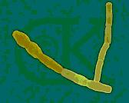  Bacillus cereus | What does it look like? It’s rod-shaped.  Where can you find it? Mostly it lives in the soil. You can find it a variety of dried and fresh food.  What does it do? One type gives you diarrhoea and another makes you vomit.
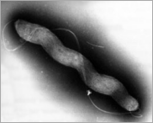  Campylobacter | What does it look like? Like curved rods.  Where can you find it? In meat, especially chicken, and unpasteurised milk.  What does it do? It gives you severe diarrhoea and abdominal pain.
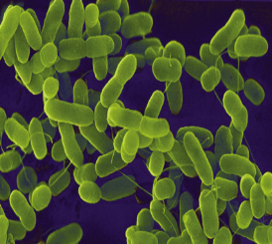  E-coli | What does it look like? It’s looks like a rod and can move.  Where can you find it? In the lower part of the intestine of warm blooded animals.  What does it do? Only 10 of one type of E-coli are needed to give you diarrhoea and make you vomit.
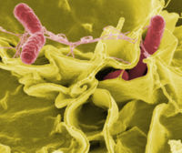  Salmonella | What does it look like? It’s a straight rod and can move.  Where can you find it? Sometimes you can find it in your gut but mostly it lives in chickens, pigs, water and soil.  What does it do? In large numbers it makes you vomit and gives you fever.
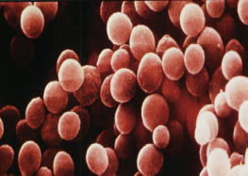  Staphylococcus aureus | What does it look like? Like a sphere. In clusters it looks like a bunch of grapes.  Where can you find it? On the skin, in infected cuts and boils and in the nose.  What does it do? It causes severe vomiting, stomach pains and diarrhoea.

Informal words
Aim: We are learning formal and informal words to do with food-borne illness.
When people talk about germs and illnesses they often use informal words and slang. Sometimes this is because they are too embarrassed to use the correct term, other times it is because the formal words are too long or unfamiliar.

Task 2
Can you write in the word from the list next to the informal words or phrases that mean the same thing. There is more than one informal word for each formal one. These are not rude words.

stomach | toilet | intestine
vomit | diarrhoea | nausea

Is another word for
be sick
gut
tummy bug
to have the runs
loo
throw up
WC
bowels
can’t keep food down
running to the loo
belly ache
loose bowel movement

People at work may use other words. Find out what they are and write

Stomach
Nausea
Vomit
Diarrhoea
Intestine
Toilet

Fighting food-borne disease
The most common food safety problems can be controlled by good food hygiene and the main things to remember are the ‘4 Cs’.
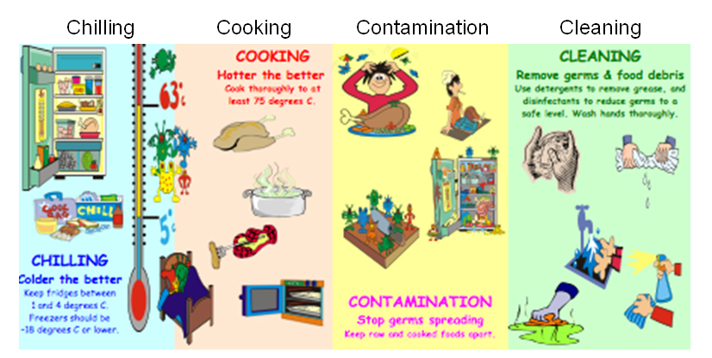

What is contamination? Contamination is when contaminants like germs, microbes, dirt or chemicals get into food. Anything harmful that should not be in food is a contaminant.
What is cross contamination? Cross contamination is when germs are carried from one type of food to another. Unwashed hands, used equipment and utensils, and raw food are full of germs.
To prevent cross contamination you must:
- wash your hands, equipment and surfaces thoroughly
- follow the colour coded system for preparing different kinds of food.

Task 3
Look at the poster above and complete the sentences.
Another method for preventing cross contamination is to ____________ raw and cooked foods ___________.
_______________ foods to stop germs from increasing.
The temperature of the fridge must be between _______ and _______
degrees centigrade. The temperature of the freezer should be ___________
than _______________ degrees.
______________ foods to kill germs.
You should cook foods to ______ _______ 75 degrees centigrade.

Now read the text on this poster.
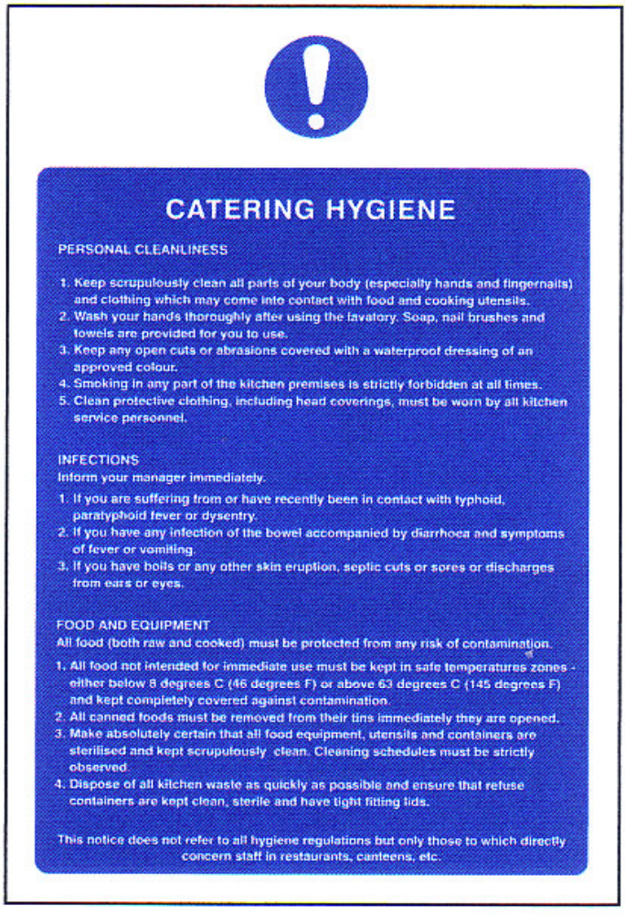
The instructions on the safety poster use the imperative or instruction verbs to tell you what do and passive voice to tell you what to do with something. This is common in instructions and text books.
A simple sentence is made up of a subject, a verb and an object
Una cooks the chicken is in the active voice. If we make the chicken the subject it becomes:
The chicken is cooked by Una. This is a passive sentence. In a passive sentence you do not always have to say who or what did something with or to the object:
The restaurant was opened in 2006.

Task 4: Catering hygiene
We have changed some of the sentences from the poster to an active form, can you complete them in the active form?
This one is an example:
Soap, nail brushes and paper towels are provided for you to use.
The restaurant provides soap, nail brushes and paper towels for you to use. or
We provide soap, nail brushes and paper towels for you to use.
1. Smoking is forbidden in any part of the restaurant.
You _______ ______ __________ in any part of the restaurant. (3 words)

2. Clean protective clothing must be worn.
You _________ ___________ clean protective clothing. (2 words)

3. All food must be protected from any risk of contamination.
You _______ __________ all food from any risk of contamination. (2 words)

4. Cleaning schedules must be strictly observed.
Make sure you ____________ cleaning schedules strictly. (1 word)

5. Ensure that refuse containers are kept clean, sterile and have tight fitting lids.
______________ refuse containers clean, sterile and tightly closed. (1 word)
Task 5: Hygiene quiz
1. Which one of these statements about bacteria is true?
 All types of bacteria cause food poisoning
 Freezing makes food last longer by killing bacteria
 Bacteria grow fastest when they are warm
 All bacteria need air to survive
2. The temperature inside your fridge should be less than:
 10°C
 4°C
 0°C
 -2°C
3. Which one of these foods is likely to contain the most bacteria?
 Cooked chicken
 Tinned cream
 Frozen raw chicken
 Bottled mayonnaise
4. Food poisoning bacteria will multiply best between:
 -18°C – 0°C
 0°C – 5°C
 5°C – 63°C
 63°C – 90°C
5. The temperature in your freezer should be:
 -2°C
 - 9°C
 -12°C
 -18°C
6. At work, the best way to dry your hands after washing is:
 Using a warm air dryer
 Giving them a shake
 Using a cotton towel
 Using a paper towel
7. Food contaminated with food poisoning bacteria would:
 Smell
 Change colour
 Look and taste normal
 Be slimy and bitter

How did you get on?

Module 2: Food hygiene answers

Task 1 answers

 Temperature control
 Food poisoning
 Awareness of pests
 Cross contamination

 Food storage
 Waste disposal
 Foreign body contamination
 Personal health and hygiene

 Food storage
 Food poisoning
 Awareness of pests
 Cross contamination

 Cross contamination
 Foreign body contamination
 Personal health and hygiene
 Temperature control

 Food storage
 Waste disposal
 Awareness of pests
 Cross contamination

 Personal health and hygiene
 Temperature control
 Food poisoning
 Awareness of pests

 Cross contamination
 Foreign body contamination
 Temperature control
 Food poisoning

Task 2 answers

 | Is another word for
be sick |  | vomit
gut |  | intestines
tummy bug |  | stomach
to have the runs |  | diarrhoea
loo |  | toilet
throw up |  | vomit
WC |  | toilet
bowels |  | intestines
can’t keep food down |  | vomit
running to the loo |  | diarrhoea
belly ache |  | stomach
loose bowel movement |  | diarrhoea
The bowel is a term for the lower intestine
Belly and tummy are informal words for the stomach.
Abdomen is a formal term for the stomach.
Belly ache, tummy ache, gut ache are all used to describe pains in the
abdominal area.
If you feel sick, vomit or have diarrhoea at work tell your line manager immediately and leave your place of work. If you are at home do not go to work. Phone your workplace and tell them your symptoms. Symptoms are the signs of your illness. A pain in the stomach is a symptom, vomiting is a symptom. A sore throat, coughing and sneezing are symptoms of a cold or influenza (flu). Do not go to work if you have a cold.

Task 3 answers

Another method for preventing cross contamination is to keep raw and cooked foods separate.
Chill foods to stop germs from increasing.
The temperature of the fridge must be between 1 and 4 degrees centigrade. The temperature of the freezer should be lower than -18 degrees.
Cook foods to kill germs.
You should cook foods to more than 75 degrees centigrade.
Another way to say - 18 degrees is 18 degrees below zero or below freezing.
Another way to write minus 18 degrees is -18o C

Task 4 answers

1. Smoking is forbidden in any part of the restaurant.
You must not smoke in any part of the restaurant.

2. Clean protective clothing must be worn.
You must wear clean protective clothing.

3. All food must be protected from any risk of contamination.
You must protect all food from any risk of contamination.

4. Cleaning schedules must be strictly observed.
Make sure you observe cleaning schedules strictly.

5. Ensure that refuse containers are kept clean, sterile and have tight fitting lids.
Keep refuse containers clean, sterile and tightly closed.

Task 5 answers
1. Which one of these statements about bacteria is true?
 All types of bacteria cause food poisoning
 Freezing makes food last longer by killing bacteria
 Bacteria grow fastest when they are warm
 All bacteria need air to survive
2. The temperature inside your fridge should be less than:
 10°C
 4°C
 0°C
 -2°C
3. Which one of these foods is likely to contain the most bacteria?
 Cooked chicken
 Tinned cream
 Frozen raw chicken
 Bottled mayonnaise
4. Food poisoning bacteria will multiply best between:
 -18°C – 0°C
 0°C – 5°C
 5°C – 63°C
 63°C – 90°C
5. The temperature in your freezer should be:
 -2°C
 - 9°C
 -12°C
 -18°C
6. At work, the best way to dry your hands after washing is:
 Using a warm air dryer
 Giving them a shake
 Using a cotton towel
 Using a paper towel
7. Food contaminated with food poisoning bacteria would:
 Smell
 Change colour
 Look and taste normal
 Be slimy and bitter
Remember
When you read:
Warm air dryers may not remove water from your hands.
may is used to show possibility. You use may when you are not sure if something will happen or will not happen.
For example:
There are dark clouds in the sky, it may rain or the sun may shine again.
If you do not wear a gloves when you wash up, you may get dermatitis. You may be lucky and not get dermatitis.
Another word you can use to show possibility is might.
If you cook food that has not been thoroughly defrosted the centre might not be cooked properly when the outside is ready.

