
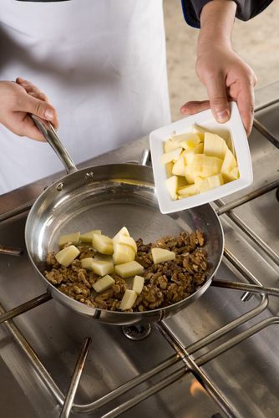
Level 1: Reading
Catering

Module: Health and safety at work

Module aims

Main aim
We are learning to read information about health and safety for understanding and detail.

Other learning aims
We are learning:
- To use headings to find information
- The meaning of some key words from the health and safety leaflet
- To read for detail from an information leaflet
- Reading the health and safety text to show we understand the text
- To obtain information from a graph
- Words about causes of injuries
- To use by + –ing participles to describe risk assessment

Module: Health and safety at work
Aim: We are learning how headings help us find information from the text.

Task 1
Headings in written texts help us to find bits of information quickly. They give an idea of what the paragraph is about. Look at this leaflet about health and safety. The headings are missing. Match the headings in the table to the number of the paragraph in the text below. The first one is an example.

Our duty to you | 
What to do if there’s a problem | 
Introduction | 
Your duties as an employee | 
Beston Catering Ltd
Health and safety at work
We take our responsibility as your employer seriously. This leaflet is a brief guide to health and safety law. It does not describe the law in detail but it lists the key points.
As your employer, we have a duty to ensure, so far as is reasonably practicable, your health, safety and welfare at work, including:
- making the workplace safe and without risks to health
- ensuring premises and equipment are safe and safe systems of work are set and followed
- ensuring articles and substances are moved, stored and used safely
- providing adequate welfare facilities
- giving employees information, instruction, training and supervision necessary for health and safety.
You have legal duties at work, too. They include:
- taking reasonable care for your own health and safety and that of others who may be affected by what you do or do not do
- co-operating with us on health and safety including following risk assessments and method statements
- using work items provided by us correctly, including personal protective equipment (PPE)
- not interfering with or misusing anything provided for your health and safety.
If you think there’s a problem or hazard in the workplace, you should discuss it first with your manager or supervisor. If you are not happy with the response, talk to a union health and safety representative. You can also get further information on health and safety from the following website:
http://www.hse.gov.uk The Health and Safety Executive
Any worker has the right to stop work if they feel their health or safety is at risk.

Health and safety at work wordcheck
Aim: We are learning the meaning of some key words from the health and safety

leaflet.
Read this text: Now the leaflet has its headings in place, it looks like this. Some of the words in the leaflet are quite difficult. This activity will help you to understand them.
We have underlined some of the words and phrases that you may not know.
Beston Catering Ltd
Health and safety at work
Introduction
We take our responsibility as your employer seriously. This leaflet is a brief guide to health and safety law. It does not describe the law in detail but it lists the key points.
Our duty to you
As your employer, we have a duty to ensure, so far as is reasonably practicable, your health, safety and welfare at work, including:
- making the workplace safe and without risks to health
- ensuring premises and equipment are safe and safe systems of work are set and followed
- ensuring articles and substances are moved, stored and used safely
- providing adequate welfare facilities
- giving employees information, instruction, training and supervision necessary for health and safety.
Your duties as an employee
You have legal duties at work, too. They include:
- taking reasonable care for your own health and safety and that of others who may be affected by what you do or do not do
- co-operating with us on health and safety including following risk assessments and method statements
- using work items provided by us correctly, including personal protective equipment (PPE)
- not interfering with or misusing anything provided for your health and safety.
What to do if there’s a problem
If you think there’s a problem or hazard in the workplace, you should discuss it first with your manager or supervisor. If you are not happy with the response, talk to a union health and safety representative. You can also get further information on health and safety from the following website:
http://www.hse.gov.uk The Health and Safety Executive
Any worker has the right to stop work if they feel their health or safety is at risk.

Task 2
Here are the words we underlined in the leaflet. Put the number of the word next to what you think it means (the definition). The first one is an example.

1. responsibilities |  | good enough

2. reasonably practicable |  | answer

3. equipment |  | needed

4. premises |  | as much as can be expected

5. articles | 1 | duty

6. substances |  | the building or other place where you work

7. adequate |  | meddling with or altering

8. facilities |  | utensils and machines you use at work

9. necessary |  | areas or places for use by staff

10. co-operating |  | items

11. interfering |  | an agent or spokesperson

12. misusing |  | doing as you have been told

13. response |  | not using in the correct way

14. representative |  | chemicals or materials

Grammar check
mis is an element added to the front of a root word to add to the meaning. It is a prefix.
mis means wrong or bad
mis + use means bad use or use wrongly
mis + deed means bad action
mis+ handle means to use something wrongly
mis+ conduct means bad conduct (or behaviour)
Task 3: Health and safety responsibilities at work
Aim: We are learning to read for detail from an information leaflet.
Read the Health and safety at work leaflet. Can you tell if these duties are the responsibility of the employer or the employee? Put a tick in the column. We have done the first one for you.

Duties | Responsibility
Duties | employer | employee
Ensure health, safety and welfare at work | ✓
Co-operate with employers on health and safety
Make sure that articles and substances are stored safely
Take care of own health and safety
Not interfere with anything provided for health and safety
Give information and training on health and safety
Provide adequate welfare facilities
Use personal protective equipment correctly
Make the workplace safe
Report a health and safety problem
Make sure safe systems of work are set and followed
Make sure that machines are safe to use

Task 4: Injuries at work
Every year many catering workers have accidents and are hurt at work. Employers have to report accidents to the Health and Safety Executive (HSE). The HSE leads campaigns to inform employers about accidents and how they can prevent them. The text below is from a report on injuries in catering in 2006. Use information from this graph to complete the text below.
30%

29%

16%

10%

4%

3%

1.80%

1.60%

0.50%

0.30%

0%

5%

10%

15%

20%

25%

30%

1

Causes of injuries

Slips and trips

Handling

Hazardous substances/hot surfaces

Struck by moving articles

Walking into objects

Machinery

Falls

Fire/explosion

Electric shock

Transport

Abbreviations
e.g. means for example.
etc means and so on.
Vocabulary
most highest number
least lowest number
per cent the number out of a hundred: 1 out of 100 is 1%; 2 out of 200 = 1% of 200
handling here it means lifting heavy objects or having sharp objects in your hand

Now fill in the gaps. The first one is an example.

Injuries at work
In 2006 slips and _______ made up 30% of all reported injuries, but 75% of all major injuries. Most of these were caused by spillage and contamination on the floor and spillages not cleared up. Wet cleaning without drying the floor afterwards caused about a third of the _____________. Around 7% of all reports were about ________, e.g. due to objects (buckets etc.) left in walkways and uneven floor surfaces.
____________ caused the next highest number of injuries. Around a third of these were caused by lifting heavy objects such as pans, trays, packs or tables. A similar number were caused by __________ sharp objects such as knives. Another third were caused by awkward lifts such as out of low ovens or off high positions. These made up _______% of injuries.
About 16% of injuries were caused by exposure to __________ ____________, ______ _____________ and steam.
In order of importance causes include:
- poor maintenance
- steam escaping from ovens, steamers etc
- carrying hot liquids etc.
- unsafe use of cleaning materials
- cleaning of fat fryers
- equipment failure
- horseplay.
Horseplay is also implicated in injuries caused by being _________ by _________ ______________. Around a third of these are from hand tools, a quarter from falling articles and a tenth from assault.

Most of the injuries caused by _________________ into ____________ involved _____________ into fixed ____________ as opposed to movable ones.
_______________ accidents (3%) were mainly caused by:
- slicers
- planetary mixers
- vegetable cutting machines
- catering attachments (slicing, mincing and grating attachments)
- pie and tart machines.
Although just 1.8% of the reports were about _________, these were the second most significant cause of major injuries after slips. About half the serious _______ occurred on stairs.

Task 5
Aim: We are learning vocabulary from the report on causes of injury at work.
These words are from the Injuries at work text above. Work out what they mean and write them next to their definition (meaning).

contamination | assault |  | exposure |  | major
fixed object | occurred |  | significant |  | horseplay
awkward |  | maintenance |  | spillage

a violent attack

a difficult position

the presence of unwanted or poisonous substances

coming into contact with something harmful

something that stays in one place or is attached to the wall or floor

rough noisy behaviour

the work that is done to keep something in good condition

more important or more serious than other things or people of a similar type

happened

important or noticeable

liquid dropped on the floor accidentally

Task 6
Using the words from Task 5, put them in these sentences.
A fire ______________ when the hot oil spilt on the gas flame.
A broken leg is a ______________ injury.
One of my _________________ tasks is to make sure that all the cutting machines are working properly.
Anna fell in an ________________ position and twisted her ankle.
______________ is forbidden in our kitchen. Radnan and Joven were sacked for mucking around with knives.

Preventing injury at work: Risk assessment
Aim: We are learning the language used to talk about risks and hazards in catering
workplaces.
Now read the text:
Key assessment: What your employer must do
By law all employers must carry out regular risk assessments. This means that they must identify any hazards a new substance, machine or tasks may cause. This is not as complicated as it sounds. We all carry out risk assessments every day. When crossing the road the hazard of being knocked down by a car is always there. For this reason you assess the risk of being run over before deciding to cross. If you think the risk is too great because there is too much traffic, you may decide to eliminate it by not crossing, or to reduce it to an acceptable level by waiting until there is a gap, or walking to a pedestrian crossing.
Health and safety laws work in a similar way. They require an employer to identify all the hazards in the premises, e.g. mincers, slicers, slippery floors etc. Any associated risks must then be assessed, i.e. are the hazards likely to cause harm to the employees? If the answer for any hazard is yes, then the employer needs to think of ways of eliminating it or reducing the risk to an acceptable level. Failure to do this can have the most tragic consequences.
Employers with five or more employees need to record the significant findings of the risk assessment. For the catering industry this will most probably include those associated with slips, trips and falls, manual handling, contact with hot surfaces or harmful substances, dermatitis, and upper limb disorders.
Look at the word by in the first paragraph. It has different uses in English.
By law means the law says that someone must do something.
You may see a sign that says something like:
By order of the management no smoking is allowed in working hours.
By can describe a cause: knocked down by a car
Splashed by hot sauce.
By can describe a method: mix the gravy by stirring it well.
Maintain the equipment by checking for faults and repairing them.
Listen for other uses of by in your workplace. Can you write down five sentences using by + a verb ending in -ing?
1._____________________________________________________________

2._____________________________________________________________

3._____________________________________________________________

4._____________________________________________________________

5._____________________________________________________________

Task 7
Complete these sentences by matching them with the correct ending.
Employees can reduce the risk of injury by

You can reduce the risk of slipping by

The cleaner warns staff about slipping hazards by

Employers minimise risks by

The waiter’s hand was cut by

You are not allowed to block or lock fire escape doors. It is prohibited by | 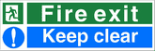

Oner has got dermatitis on his hands by

We avoid cross contamination by
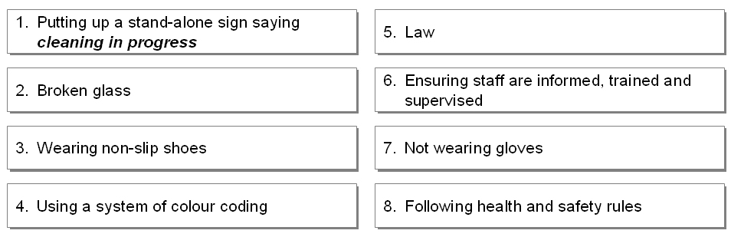
Tick ✓ the box with the sign that is a hazard warning
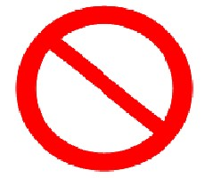 |  | 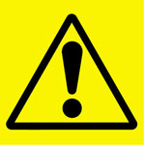 |  |  |  | 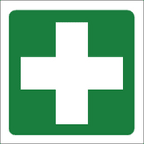
 |  |  |  |  |  | 

How did you get on?

Module 1: Health and safety at work answers

Task 1 answers

Introduction
Our duty to you
Your duties as an employee
What to do if there’s a problem

Task 2 answers

1. responsibilities | 7 | good enough

2. reasonably practicable | 13 | answer

3. equipment | 9 | needed

4. premises | 2 | as much as can be expected

5. articles | 1 | duty

6. substances | 4 | the building or other place where you work

7. adequate | 11 | meddling with or altering

8. facilities | 3 | utensils and machines you use at work

9. necessary | 8 | areas or places for use by staff

10. co-operating | 5 | items

11. interfering | 14 | an agent or spokesperson

12. misusing | 10 | doing as you have been told

13. response | 12 | not using in the correct way

14. representative | 6 | chemicals or materials

Task 3 answers

Duties | Responsibility
Duties | employer | employee
Ensure health, safety and welfare at work | ✓
Co-operate with employers on health and safety |  | ✓
Make sure that articles and substances are stored safely | ✓ | ✓
Take care of own health and safety |  | ✓
Not interfere with anything provided for health and safety |  | ✓
Give information and training on health and safety | ✓
Provide adequate welfare facilities | ✓
Use personal protective equipment correctly |  | ✓
Make the workplace safe | ✓
Report a health and safety problem |  | ✓
Make sure safe systems of work are set and followed | ✓
Make sure that machines are safe to use | ✓

Task 4 answers

Injuries at work
In 2006 slips and trips made up 30% of all reported injuries, but 75% of all major injuries. Most of these were caused by spillage and contamination on the floor and spillages not cleared up. Wet cleaning without drying the floor afterwards caused about a third of the slips. Around 7% of all reports were about trips, e.g. due to objects (buckets etc.) left in walkways and uneven floor surfaces.
Handling caused the next highest number of injuries. Around a third of these were caused by lifting heavy objects such as pans, trays, packs or tables. A similar number were caused by handling sharp objects such as knives. Another third were caused by awkward lifts such as out of low ovens or off high positions. These made up 29%% of injuries.
About 16% of injuries were caused by exposure to hazardous substances, hot surfaces and steam.
In order of importance causes include:
- poor maintenance
- steam escaping from ovens, steamers etc
- carrying hot liquids etc.
- unsafe use of cleaning materials
- cleaning of fat fryers
- equipment failure
- horseplay.
Horseplay is also implicated in injuries caused by being struck by moving articles. Around a third of these are from hand tools, a quarter from falling articles and a tenth from assault.

Most of the injuries caused by walking into objects involved walking into fixed objects as opposed to movable ones.
Machinery accidents (3%) were mainly caused by:
- slicers
- planetary mixers
- vegetable cutting machines
- catering attachments (slicing, mincing and grating attachments)
- pie and tart machines.
Although just 1.8% of the reports were about falls, these were the second most significant cause of major injuries after slips. About half the serious falls occurred on stairs.

Task 5 answers
assault | a violent attack

awkward | a difficult position

contamination | the presence of unwanted or poisonous substances

exposure | coming into contact with something harmful

fixed object | something that stays in one place or is attached to the wall or floor

horseplay | rough noisy behaviour

maintenance | the work that is done to keep something in good condition

major | more important or more serious than other things or people of a similar type

occurred | happened

significant | important or noticeable

spillage | liquid dropped on the floor accidentally
The answers are in alphabetical order to help you write them in your personal glossary more quickly.
You can group them by the word family:
spill (verb) to drop liquid.
spilt (past) I spilt the gravy (adjective) The spilt liquid made the floor slippery.
spillage (noun) Clear spillages quickly and safely.

Task 6 answers

A fire occurred when the hot oil spilt on the gas flame.
A broken leg is a major injury.
One of my maintenance tasks is to make sure that all the cutting machines are working properly.
Anna fell in an awkward position and twisted her ankle.
Horseplay is forbidden in our kitchen. Radnan and Joven were sacked for mucking around with knives.

Task 7 answers
Complete these sentences by matching them with the correct ending.
Employees can reduce the risk of injury by | 8

You can reduce the risk of slipping by | 3

The cleaner warns staff about slipping hazards by | 1

Employers minimise risks by | 6

The waiter’s hand was cut by | 2

You are not allowed to block or lock fire escape doors. It is prohibited by | 5

Oner has got dermatitis on his hands by | 7

We avoid cross contamination by | 4

 |  |  |  |  |  | 

