

Level 1: Reading
Catering

Module: Moving on

Module aims

Main aim
We are learning to read a range of texts for detail using text features to locate information.

Other learning aims
We are learning:
- To read information from websites to answer questions about the text


Module: Moving on
Aim: We are reading websites to find out about getting qualifications in the catering
sector.
There are different ways to find out about training. For instance if you are a member of a union there may be a union learning representative, also called a ULR, in your company who will advise you. Or you can use the internet to find about qualifications and training courses. If you do not have access to the internet at home or at work you can get free access at many public libraries, learning centres or pay to use a computer at an internet café.
There are several sites that can help you find out about training opportunities. We are going to look at one that belongs to a national organisation called People 1st. People 1st is the sector skills council for the Hospitality sector.
This is their website:
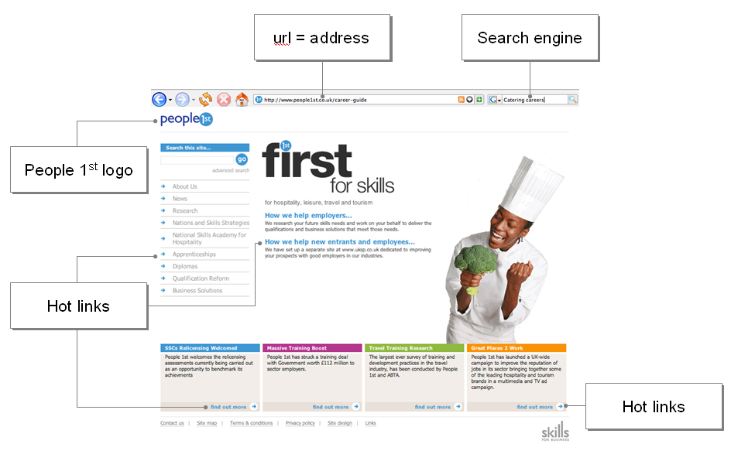
To find this website you can type www.people1st.co.uk/career-guide into the space for website addresses on the top. This is called an address bar and a website address is called an ‘url’. Companies change their websites so it may look different.
A logo is a design or symbol that represents a company.
If you click on a hot link it will take you to a new web page.

Task 1
Match the beginnings and ends of these sentences. The first one is an example.

If you are a member of a union |  | for the Hospitality sector.
You can use the internet to find out |  | into the address bar on a website.
People 1st is the sector skills council |  | you can ask a union learning representative.
You type a url |  | to use computers in an internet café.
You can get free access to the internet |  | about qualifications and training courses.
You have to pay |  | to go to a new web page.
Click on a hot link |  | at many public libraries.
Click on: place your cursor  on a hotlink and press a button on your mouse.
Task 2
Look at the verbs we have underlined above. They go with prepositions which change their meaning. For example:
find out click on
Can you think of other verbs + prepositions that are used in catering?
Here are some verbs and prepositions. Put them together in sentences.
Verbs: dry cash gone carry throw take
Prepositions: up off out on down
_________________________________________________________________
_________________________________________________________________
_________________________________________________________________
_________________________________________________________________
_________________________________________________________________
_________________________________________________________________

Finding out more
The People 1st website tells employees or people who want to work in catering to go to www.uksp.co.uk to find out more about opportunities.
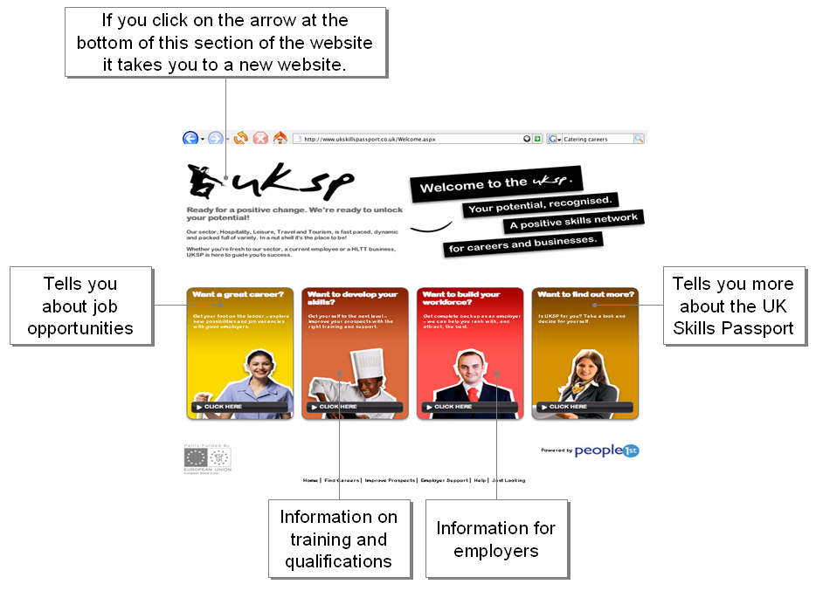

 | If you click on the link in the box that says Want to develop your skills? you will come to a page that has this picture.  This map has lots of different routes with boxes that tell you more about the many different jobs in hospitality, leisure and tourism.

Task 3: Reading a career map
This is part of the career map. It uses a system of colour coding. The colour of each line tells about a route in one type of job – cooking or bar work – or an area – working in fast food restaurants, hotels, or in tourism. The colours also tell you about the salary you earn in different types of jobs.
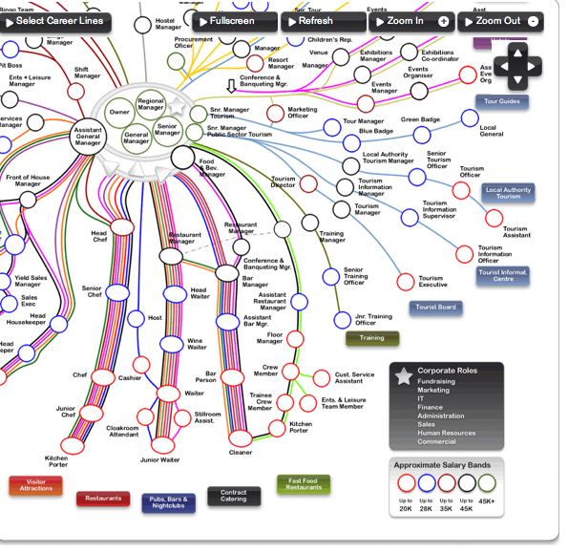
This map shows the route someone with no qualifications can take to get to the jobs with the highest pay and most responsibility in the centre circle. Use the colours and symbols to help you to answer these questions. Put a tick P in the box. The first one is an example.

 | Yes | No
A senior chef earns more than a bar person. |  | ✓
A wine waiter can earn as much as a head waiter.
Kitchen porters earn more than training officers.
A bar manager can become a restaurant manager.
A floor manager earns more than a crew member.
Human Resources is a corporate role.
A kitchen porter cannot train to be a chef.
A floor manager earns less than £20,000.
These salaries are what you can expect to earn. There will be places where you earn a lot more for the same job. In other places you will earn less but you should not be paid less than the minimum wage.
Visit the site and find out more.
Read this text on what you need to do to become a chef.
What is the work like
Chefs are responsible for preparing food using different cooking techniques. In large kitchens they will normally work as part of a team responsible for one particular area, such as bread and pastries, or vegetables. The head chef, or ‘maitre de cuisine’, is responsible for running the entire kitchen.
You would usually start as a trainee chef (or 'commis' chef), spending time in each area of the kitchen, learning a range of culinary skills and techniques, and how to look after kitchen equipment and utensils.
You could progress to section chef and be in charge of running an area of the kitchen. The next step would be sous chef (or under-chef) when you could be asked to run the entire kitchen on behalf of the head chef.
In smaller kitchens, you may also be responsible for cleaning the kitchen and serving customers.
What qualifications and experience will employers look for?
You may not need any specific academic qualifications to start work as a trainee (commis) chef. However, some employers will prefer you to have a good standard of general education.
Many trainee chefs start by taking a course that combines classroom-based study with practical experience and work placements, such as:
- Level 2 Diploma in Professional Cookery
- BTEC National Certificate/Diploma in Hospitality, or Hospitality Supervision
- BTEC HND in Professional Cookery
- Foundation degree in Culinary Arts Management.
If you have qualifications from your country, you may be able to convert these into UK equivalents. A national organisation called UK NARIC can help you with this. Their website address is www.naric.org.uk
What __________ and _____________ will I need?
- A keen interest in food and cooking
- Strong communication and leadership skills
- The ability to work under pressure
- High standards of cleanliness and hygiene
- The ability to manage multiple tasks
- The ability to work as part of a team
- Creativity and imagination for food presentation
- Good organisational skills
- The ability to manage a budget

Task 4: Reading job descriptions
Aim: We are reading the information on the Skills Passport to answer questions
about the text.
Use the text to find the information to help you answer these questions. Remember to use headings to help you find the information easily.

1. What is a chef responsible for?

2. What is another name for the ‘maitre de cuisine’?

3. When you have gained experience as a chef to what role can you progress?

4. What does a commis chef do?

5. If you study for a Diploma in Professional Cookery what level certificate can you achieve?

6. What is the name of the organisation which can help you work out which UK qualifications are equal to yours?

7. What is the name of the organisation which can help you work out which UK qualifications are equal to yours?
Joining a union
All employees in the UK have the right to join a union. The role of the union is to protect the rights of its members. Unions also help to make sure that workplaces are safe, support employees to get on at work, provide legal and other advice to members and their families.
Task 5
In the catering sector many union members belong to a union called Unison. On its website Unison has ten reasons why you should join. We have picked five. Match the number of the description with the right bullet point. The first one is an example.

4 | You can earn more |  | 1. UNISON provides courses to help you learn new skills, improve existing ones and develop your career. It has won agreements with employers to pay for courses and provide time off for employees to attend them.

 | You get more and better training |  | 2. UNISON campaigns to bring women's pay into line with men's. Workplaces with union recognition are 20% more likely to have an equal opportunities policy.

 | You’re less likely to be injured at work |  | 3. UNISON campaigns for stronger laws to make it illegal to discriminate on the basis of sex, race, age, disability or sexual orientation. Black and Asian trade unionists earn 32% more than non-unionised colleagues.

 | You’re less likely to be discriminated against |  | 4. Year on year, UNISON wins pay rises for its members. Average earnings are around 8% higher in unionised workplaces.

 | Your more likely to get equal pay |  | 5. UNISON health and safety stewards are trained to minimise the risk of workplace injuries and ensure that employers meet their legal obligations.
To find out about the other five reasons or to join Unison go to this website: http://www.unison.org.uk/join/reasons.asp or call 0845 355 0845.
% is the symbol for per cent
1/100 is 1%
50/100 is 50%
If you earn £100 and your pay goes up by 5% you will earn £105.

How unions organise
In UNISON you are always a member of a branch. Each branch is made up of employees who do similar kinds of work or face common issues in their workplaces.
Members elect workplace stewards and safety reps and vote for branch officers. Every branch is supported by its nearest UNISON regional centre where staff work with elected lay members.
Each UNISON branch elects its own reps to attend the UNISON national delegate conference and vote on behalf of all local branch members.
Members are also elected through an annual individual ballot to join UNISON's local government service group executive. This body helps decide policies and activities and works with UNISON staff to support members. Regional offices provide support for branches in local negotiations and representation of members.

Task 6
Read the text above and try and work out what the words in bold mean. Now put them in the right space in the sentences below. The first one is an example:

1. Every member of UNISON belongs to a local branch which is made up of people working for the same employer.
2. A group of workers had a meeting to talk about __________ ___________ like the hours they had to work and the training they needed.
3. Workplace representatives are also called ____________. They are organisers who recruit members, hold meetings and help to run ballots.
4. The _______ __________ has organised a course on the correct way to work at height.
5. We want to __________ for Ugo to become our union representative.
6. If you want Meena as your representative you must put a X next to her name and put the voting paper in the box. This is a secret____________.
7. The union representatives who are _________ to go to our national conference are called __________.
8. The discussions that union officials hold with employers in order to agree on issues are called ______________.
9. A _____________ is a set of ideas or a plan of what to do in particular situations that has been agreed officially by a group of people or organisation.
Rep is short for representative.
What unions offer their members
Unions offer many different services to their members. In your company you may have a steward, a health and safety rep and a union learning rep. These are some of the things they do:
Stewards are the main union representatives. They
- recruit and organise members
- talk to members about workplace problems and advise them
- represent members in the workplace.
Designated workplace area: the part of the workplace that the health and safety rep is responsible for.
Designated means chosen for a special purpose: e.g. The kitchen is designated for preparing food.
Health and safety reps work to make the workplace as safe as possible. They can:
- talk to the employer on behalf of members on any health, safety and welfare matter
- inspect designated workplace areas at least every three months
- investigate any potential hazards, complaints by members and causes of accidents, dangerous occurrences and diseases.

Union learning reps promote the collective and individual learning needs in their workplace. They may:
- negotiate with an employer for learning facilities
- negotiate for time off to learn
- help a member to find the right course for them
- support someone learning a new skill.
Unions also offer welfare advice and help. UNISON is a registered charity. It runs a confidential service offering advice and support just for UNISON members and their families. For example it offers:
- debt advice
- listening and support
- financial assistance
- breaks and holidays
- personal advice.
Task 7
Read the different issues some union members have. Which is the best service for them? They can go to more than one.
Katya’s contract has come to an end. She has found a new job but the hours and rate of pay are lower than before. She has not paid her rent or her gas bill. She has no money left in the bank. |  Debt advice
 |  Health and safety
 |  Financial assistance
 |  Union Learning rep

Sulee is a part-time casual worker. Her employer won’t give her a contract and says she cannot have any paid holidays. |  Union Learning rep
 |  Shop steward
 |  Financial assistance
 |  Health and Safety rep

Ben is a kitchen porter. He starts work before anyone else. Sometimes food deliveries arrive early and he has to carry them in by himself. He has been trained in manual handling but some bags are very heavy. He has begun to suffer from back ache |  Union Learning rep
 |  Listening and support
 |  Health and Safety rep
 |  Breaks and holidays

Bosaka came to England a few months ago. He is a trained chef but he speaks very little English. He is working as a cleaner in a fast food outlet. He wants to know if his qualifications are recognised. |  Debt advice
 |  Listening and support
 |  Union Learning rep
 |  Shop steward
Task 8: Your rights at work
Sulee’s shop steward tells her that it doesn't matter what your boss or your contract calls you, all workers still have a number of basic legal rights including:
- to be paid the minimum wage
- to get 24 days paid holiday (after you have worked for 13 weeks)
- to work in a safe environment
- to be protected from harassment or discrimination.
Her employer should give her a contract that includes:
- a job description that lists her duties and responsibilities
- details of her pay
- the hours she has to work
- how much notice she has to give if she wants to leave the job
- how much notice the employer has to give her to end the job
- her holiday entitlement
- what she has to do if she takes time off if she is sick
Contracts may also include other information such as:
- extra pay you get if you work extra hours (overtime) or if you work on public holidays
- parental leave
- training that you are expected to do
- training opportunities that you can take if you wish.
Here harassment means to annoy, bully or upset someone. This may include threatening someone, teasing someone because of the way they look, their sex or their race. Bullying at work is not acceptable.
Here discrimination means to treat someone badly because they are different from the majority in a group. It is against the law to discriminate against an employee because of their race, gender, sexual orientation, religion, disability or age.
Read the statements below and put a tick to say if they are true or false or you can’t tell.
 | True | False | Can’t tell
The minimum wage is the most your employer can pay you.
You must not do a task that is not in your job description.
By law all staff should have a contract.
A bartender tells his employer that he is gay. The employer tells him to leave. His employer has broken the law.
Eva speaks very little English and finds it difficult to understand Jo her supervisor. Jo gets impatient and repeats what she says more loudly. Eva thinks she is shouting at her. Jo is bullying Eva.
Omar has been in his job for two months. His sister is getting married in Dubai. He wants to take two weeks holiday to spend with his family. His employer says he will give him only one week paid holiday. His employer is breaking the law.
Shamma is pregnant and needs to take time off to see the doctor. Her friend tells her that she is entitled to paid time off.

How did you get on?

Module 3: Moving on answers

Task 1 answers

If you are a member of a union |  | you can ask a union learning representative.
You can use the internet to find out |  | about qualifications and training courses.
People 1st is the sector skills council |  | for the Hospitality sector.
You type a url |  | into the address bar on a website.
You can get free access to the internet |  | at many public libraries.
You have to pay |  | to use computers in an internet café.
Click on a hot link |  | to go to a new web page.
Some union learning representatives will advise you even if you are not a member of their union.
Sector skills councils work with employers to develop training and qualifications for employees.

Task 2 answers

gone off | This fish has gone off, throw it out.
carry on | Carry on stirring till the sauce is smooth.
cash up | Cash up and lock the takings in the safe.
dry off | Make sure you dry off the floor when you wash it.
throw out | Throw out food that is out of date.
take down | Marco took down the customer’s order.

Task 3 answers

 | Yes | No
A senior chef earns more than a bar person. |  | ✓
A wine waiter can earn as much as a head waiter. | ✓
Kitchen porters earn more than training officers. |  | ✓
A bar manager can become a restaurant manager. | ✓
A floor manager earns more than a crew member. | ✓
Human Resources is a corporate role. | ✓
A kitchen porter cannot train to be a chef. |  | ✓
A floor manager earns less than £20,000. | ✓

Task 4 answers

1. What is a chef responsible for?
Chefs are responsible for preparing food using a variety of cooking techniques.

2. What is another name for the ‘maitre de cuisine’?
Another name for the ‘maitre de cuisine’ is head chef.

3. When you have gained experience as a chef to what role can you progress?
When you have gained experience as a chef you can progress to section chef.

4. What does a commis chef do?
A commis chef spends time in each area of the kitchen, gaining a range of culinary skills and techniques, and learning how to look after kitchen equipment and utensils.

5. If you study for a Diploma in Professional Cookery what level certificate can you achieve?
If you study for a Diploma in Professional Cookery you can gain a Level 2 certificate.

6. What is the name of the organisation which can help you work out which UK qualifications are equal to yours?
The name of the organisation which can help you work out which UK qualifications are equal to yours is UK NARIC.

7. What is the name of the organisation which can help you work out which UK qualifications are equal to yours?
The two words that are missing from the heading of the last paragraph are
skills and knowledge or skills and qualities.

Task 5 answers

4 | You can earn more |  | 1. UNISON provides courses to help you learn new skills, improve existing ones and develop your career. It has won agreements with employers to pay for courses and provide time off for employees to attend them.

1 | You get more and better training |  | 2. UNISON campaigns to bring women's pay into line with men's. Workplaces with union recognition are 20% more likely to have an equal opportunities policy.

5 | You’re less likely to be injured at work |  | 3. UNISON campaigns for stronger laws to make it illegal to discriminate on the basis of sex, race, age, disability or sexual orientation. Black and Asian trade unionists earn 32% more than non-unionised colleagues.

3 | You’re less likely to be discriminated against |  | 4. Year on year, UNISON wins pay rises for its members. Average earnings are around 8% higher in unionised workplaces.

2 | Your more likely to get equal pay |  | 5. UNISON health and safety stewards are trained to minimise the risk of workplace injuries and ensure that employers meet their legal obligations.

Task 6 answers

1. Every member of UNISON belongs to a local branch which is made up of people working for the same employer.
2. A group of workers had a meeting to talk about common issues like the hours they had to work and the training they needed.
3. Workplace representatives are also called stewards. They are organisers who recruit members, hold meetings and help to run ballots.
4. The safety rep has organised a course on the correct way to work at height.
5. We want to vote for Ugo to become our union representative.
6. If you want Meena as your representative you must put a X next to her name and put the voting paper in the box. This is a secret ballot.
7. The union representatives who are elected to go to our national conference are called delegates.
8. The discussions that union officials hold with employers in order to agree on issues are called negotiations.
9. A policy is a set of ideas or a plan of what to do in particular situations that has been agreed officially by a group of people or organisation.

Task 7 answers

Katya’s contract has come to an end. She has found a new job but the hours and rate of pay are lower than before. She has not paid her rent or her gas bill. She has no money left in the bank. |  Debt advice
 |  Health and safety
 |  Financial assistance
 |  Union Learning rep

Sulee is a part-time casual worker. Her employer won’t give her a contract and says she cannot have any paid holidays. |  Union Learning rep
 |  Shop steward
 |  Financial assistance
 |  Health and Safety rep

Ben is a kitchen porter. He starts work before anyone else. Sometimes food deliveries arrive early and he has to carry them in by himself. He has been trained in manual handling but some bags are very heavy. He has begun to suffer from back ache |  Union Learning rep
 |  Listening and support
 |  Health and Safety rep
 |  Breaks and holidays

Bosaka came to England a few months ago. He is a trained chef but he speaks very little English. He is working as a cleaner in a fast food outlet. He wants to know if his qualifications are recognised. |  Debt advice
 |  Listening and support
 |  Union Learning rep
 |  Shop steward

Task 8 answers

 | True | False | Can’t tell
The minimum wage is the most your employer can pay you.  Minimum wage means the least your employer can pay you. |  | ✓
You must not do a task that is not in your job description.  Your employer cannot make you do a task that is not in your job description, but you can do it if it is not unreasonable or unsafe. |  |  | ✓
By law all staff should have a contract. | ✓
A bartender tells his employer that he is gay. The employer tells him to leave. His employer has broken the law. | ✓
Eva speaks very little English and finds it difficult to understand Jo her supervisor. Jo gets impatient and repeats what she says more loudly. Eva thinks she is shouting at her. Jo is bullying Eva.  Sometimes people feel harassed or bullied because of a lack of understanding. If this happens it is a good idea to talk to someone who can help you. |  |  | ✓
Omar has been in his job for two months. His sister is getting married in Dubai. He wants to take two weeks holiday to spend with his family. His employer says he will give him only one week paid holiday. His employer is breaking the law. |  | ✓
Shamma is pregnant and needs to take time off to see the doctor. Her friend tells her that she is entitled to paid time off. | ✓
If you need legal advice and there is no union at your workplace you can contact the Citizens Advice Bureau near where you live. You can find the address from a telephone directory, the library or from their website, www.citizensadvice.org.uk. It helps everyone not just UK citizens.
You can also contact an organisation called ACAS, www.acas.org.uk telephone: 08457 47 47 47. ACAS works with employers and employees to solve problems in the workplace.
Legal advice from both organisations is free and confidential.

