
Level 1 Reading
Construction

Module: Health and safety information

Module Aims

Main aim
We are learning how headings help us find information from the text.

Other learning aims
We are: learning the meaning of some key words from the health and safety leaflet; learning to read for detail from an information leaflet; reading the health and safety text to show we understand the text



Module: Health and safety information at work

Aim: We are learning how headings help us find information from the text.

Task 1

Headings in written texts help you to find bits of information quickly. They give you an idea what the paragraph is about. Look at this leaflet about health and safety at work. Its headings are missing. Match the headings in the table to the number of the paragraph in the text below.

The first one is done for you.

Our duty to you | 4  1  3  2
What to do if there’s a problem
Introduction
Your duties as an employee

1
2
3
4
Better Homes Ltd

Health and safety at work

Introduction
We take our responsibility as your employer seriously. This leaflet is a brief guide to health and safety law. It does not describe the law in detail but it lists the key points.

Our duty to you
As your employer, we have a duty to ensure, so far as is reasonably practicable, your health, safety and welfare at work. This includes:

- making the workplace safe and without risks to health
- ensuring plant and machinery are safe
- ensuring safe systems of work are set and followed
- ensuring articles and substances are moved, stored and used safely
- providing adequate welfare facilities
- giving employees information, instruction, training and supervision necessary for your health and safety.

Your duties as an employee
You have legal duties at work, too. They include:

- taking reasonable care for your own health and safety and that of others who may be affected by what you do or by what you do not do
- co-operating with us on health and safety including following risk assessments and method statements
- using work items provided by us correctly, including Personal Protective Equipment (PPE)
- not interfering with or misusing anything provided for your health and safety.

What to do if there’s a problem
If you think there’s a problem or hazard in the workplace, you should discuss it with your manager or supervisor first. If you are not happy with the response, discuss it with the site safety representative. You can get further information on health and safety at the following websites.

http://www.hse.gov.uk The Health and Safety Executive
http://www.cskills.org Construction Skills

Any worker has the right to stop work if they feel their health or safety is at risk.

Health and safety at work

Aim:
We are learning the meaning of some key words from the health and safety leaflet.

Now the leaflet has its headings it looks like this. Some of the words in the leaflet are quite difficult. This activity will help you to understand them. Some of the words and phrases that you may not know are underlined.

Better Homes Ltd

Health and safety at work

Introduction
We take our responsibility as your employer seriously. This leaflet is a brief guide to health and safety law. It does not describe the law in detail but it lists the key points.

Our duty to you
As your employer, we have a duty to ensure, so far as is reasonably practicable, your health, safety and welfare at work. This includes:

- making the workplace safe and without risks to health
- ensuring plant and machinery are safe
- ensuring safe systems of work are set and followed
- ensuring articles and substances are moved, stored and used safely
- providing adequate welfare facilities
- giving employees information, instruction, training and supervision necessary for your health and safety.

Your duties as an employee
You have legal duties at work, too. They include:

- taking reasonable care for your own health and safety and that of others who may be affected by what you do or by what you do not do
- co-operating with us on health and safety including following risk assessments and method statements
- using work items provided by us correctly, including Personal Protective Equipment (PPE)
- not interfering with or misusing anything provided for your health and safety.

What to do if there’s a problem
If you think there’s a problem or hazard in the workplace, you should discuss it with your manager or supervisor first. If you are not happy with the response, discuss it with the site safety representative. You can get further information on health and safety at the following websites.

http://www.hse.gov.uk The Health and Safety Executive
http://www.cskills.org Construction Skills

Any worker has the right to stop work if they feel their health or safety is at risk.

Task 2: Word check

Here are the words from the leaflet. Try to work out what the word means from the way it is used in the leaflet. Put the number of the word next to what you think it means (the definition). The first one is done for you.

1. responsibility |  | good enough
2. reasonably practicable |  | answer
3. plant |  | needed
4. machinery |  | as much as could be expected
5. articles | 1 | duty
6. substances |  | equipment with moving parts
7. adequate |  | meddling with or altering
8. facilities |  | items of large and heavy equipment
9. necessary |  | places for use by staff
10. co-operating |  | items
11. interfering |  | an agent or spokesperson
12. misusing |  | doing as you have been told
13. response |  | not using in the correct way
14. representative |  | matter or materials

Word check
mis is an element added to the front of a base word to add to the meaning. It is a prefix.
mis means wrong or bad
mis + use means bad use
mis + deed means bad action
mis + advise means to advise wrongly or badly
mis + conduct means bad conduct (or behaviour)

Task 3: Word grid

Here are the meanings of the words from the last task. Work out the word. Write it in the word grid. There are some letters in the grid to help you.

doing as you have been told |  |  | an agent or spokesperson
items | places for use  by staff |  | good enough |  | duty
meddling with or altering |  |  | items of large and heavy equipment
matter or materials |  | equipment with  moving parts |  | needed
as much as could be expected |  | answer |  | not using in the  correct way

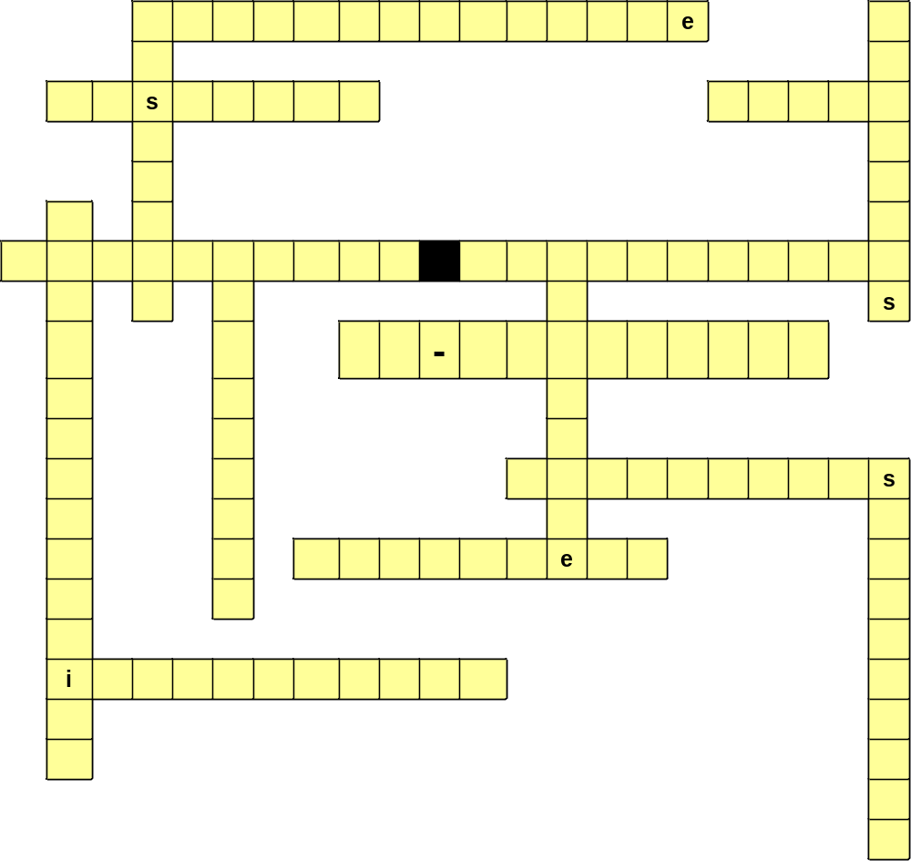
Task 4: Responsibilities at work

Aim: We are learning to read for detail from an information leaflet.

Read the Better Homes Health and safety at work leaflet. Can you tell if these duties are the responsibility of the employer or the employee? Put a tick in the right column. The first one is done for you.

Duties | Responsibility
Duties | employer | employee
Ensure health, safety and welfare at work. | 
Co-operate with employers on health and safety.
Make sure that articles and substances are stored safely.
Take care of own health and safety.
Not interfere with anything provided for health and safety.
Give information and training on health and safety.
Provide adequate welfare facilities.
Use Personal Protective Equipment correctly.
Make the workplace safe.
Report a health and safety problem.
Make sure safe systems of work are set and followed.
Make sure that machines are safe to use.

Task 5: Health and safety at work
Aim: We are reading the health and safety text to show we understand it.

If you work in construction, one of the qualifications you can take is the Health and Safety test. Some of the questions in the test are about responsibilities under the Health and Safety at Work Act. An Act is an Act of Parliament. When you see Act in a title, it means that it is the law.


Read the leaflet and use the information to answer the questions that follow.
Better Homes Ltd
Health and safety at work

Introduction
We take our responsibility as your employer seriously. This leaflet
is a brief guide to health and safety law. It does not describe the law
in detail but it lists the key points.

Our duty to you
As your employer, we have a duty to ensure, so far as is reasonably practicable, your health, safety and welfare at work. This includes:

- making the workplace safe and without risks to health
- ensuring plant and machinery are safe
- ensuring safe systems of work are set and followed
- ensuring articles and substances are moved, stored and used safely
- providing adequate welfare facilities
- giving employees information, instruction, training and supervision necessary for your health and safety.

Your duties as an employee
You have legal duties at work, too. They include:
- taking reasonable care for your own health and safety and that of others who may be affected by what you do or by what you do not do
- co-operating with us on health and safety including following risk assessments and method statements
- using work items provided by us correctly, including Personal Protective Equipment (PPE)
- not interfering with or misusing anything provided for your health and safety.

What to do if there’s a problem
If you think there’s a problem or hazard in the workplace, you should discuss it with your manager or supervisor first. If you are not happy with the response, discuss it with the site safety representative. You can get further information on health and safety at the following websites.

http://www.hse.gov.uk The Health and Safety Executive
http://www.cskills.org Construction Skills

Any worker has the right to stop work if they feel their health or safety is at risk.
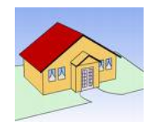
These are the kind of questions you will see in the Health and Safety test. They are about responsibilities under the Health and Safety at Work Act.

Who is responsible for reporting any unsafe conditions on site?

 the site manager only
 the client
 Health and Safety Executive inspectors
 everyone on site

A risk assessment tells you:

 how to report accidents
 the site working hours
 how to do the job safely
 where the first aid box is kept

The Health and Safety at Work Act places legal duties on:

 employers only
 operatives (employees) only
 all people at work
 self-employed people only

As an employee you do not have a legal duty to:

 use all equipment safely and as instructed
 write your own risk assessments
 speak to your supervisor if you are worried about safety on site
 report any equipment that is damaged or defective

You will often hear the word hazard mentioned on the site and during safety talks. What does it mean?

 anything at work that can harm you
 the site accident rate
 a type of barrier or machine guard
 all of the other answers

Why is the Health and Safety at Work Act important to you? Give two answers.

 it tells you which parts of the site are dangerous
 it must be learnt before starting work
 it requires your employer to provide a safe place of work
 it tells you how to do your job

Remember
Some questions in the test will ask you to find more than one correct answer.

You find that you cannot do your job as the method statement says you should. What should you do?

 make up your own way of doing the job
 do not start work until you have talked with your supervisor
 ask your workmates how you think they should do the job
 contact the Health and Safety Executive

Why do you need to know the health and safety regulations that deal with your type of work?

 they tell you how to write risk assessments
 they explain how health and safety is managed on your site
 they tell you when Health and Safety Executive inspections will take place
 they place legal duties on you

How did you get on?

Module: Health and safety at work answers

Task 1: answers

Our duty to you | 4  1  3  2
What to do if there’s a problem
Introduction
Your duties as an employee

Task 2: answers

1. responsibility | 7 | good enough
2. reasonably practicable | 13 | answer
3. plant | 9 | needed
4. machinery | 2 | as much as could be expected
5. articles | 1 | duty
6. substances | 4 | equipment with moving parts
7. adequate | 11 | meddling with or altering
8. facilities | 3 | large and heavy equipment
9. necessary | 8 | areas or places for use by staff
10. co-operating | 5 | items
11. interfering | 14 | an agent or spokesperson
12. misusing | 10 | doing as you have been told
13. response | 12 | not using in the correct way
14. representative | 6 | matter or materials

Task 3: answers

responsibility |  |  | representative
articles | facilities |  | good enough |  | duty
interfering |  |  | plant
substances |  | machinery |  | needed
adequate |  | response |  | misusing

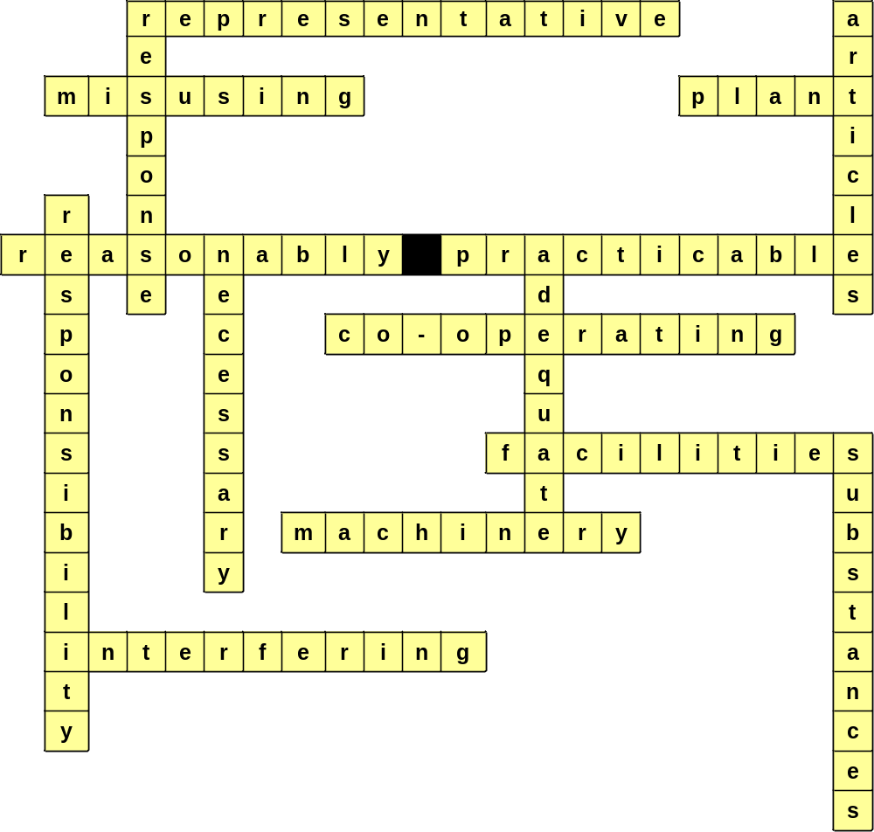

Task 4: answers

Duties | Responsibility
Duties | employer | employee
Ensure health, safety and welfare at work. | 
Co-operate with employers on health and safety. |  | 
Make sure that articles and substances are stored safely. | 
Take care of own health and safety. |  | 
Not interfere with anything provided for health and safety. |  | 
Give information and training on health and safety. | 
Provide adequate welfare facilities. | 
Use Personal Protective Equipment correctly. |  | 
Make the workplace safe. | 
Report a health and safety problem. |  | 
Make sure safe systems of work are set and followed. | 
Make sure that machines are safe to use. | 

Task 5: answers

Who is responsible for reporting any unsafe conditions on site?

 the site manager only
 the client
 Health and Safety Executive inspectors
 everyone on site

A risk assessment tells you:

 how to report accidents
 the site working hours
 how to do the job safely
 where the first aid box is kept

The Health and Safety at Work Act places legal duties on:

 employers only
 operatives (employees) only
 all people at work
 self-employed people only

As an employee you do not have a legal duty to:

 use all equipment safely and as instructed
 write your own risk assessments
 speak to your supervisor if you are worried about safety on site
 report any equipment that is damaged or defective

You will often hear the word hazard mentioned on the site and during safety talks. What does it mean?

 anything at work that can harm you
 the site accident rate
 a type of barrier or machine guard
 all of the other answers

Why is the Health and Safety at Work Act important to you? Give two answers.

 it tells you which parts of the site are dangerous
 it must be learnt before starting work
 it requires your employer to provide a safe place of work
 it tells you how to do your job

You find that you cannot do your job as the method statement says you should. What should you do?

 make up your own way of doing the job
 do not start work until you have talked with your supervisor
 ask your workmates how you think they should do the job
 contact the Health and Safety Executive

Why do you need to know the health and safety regulations that deal with your type of work?

 they tell you how to write risk assessments
 they explain how health and safety is managed on your site
 they tell you when Health and Safety Executive inspections will take place
 they place legal duties on you

