
Entry 3: Writing
Construction

Module: Workplace information

Module aims

Main aim
We are learning to write instructions for working in construction.

Other learning aims
We are learning to:
- Write instructions for the construction industry
- Use auxiliary and modal verbs to show different meanings and verb forms.

Module: Workplace information
Main aim: We are learning to write instructions for working in construction.
Aim: We are learning to write instructions for the construction industry.

Instructions are a way of telling someone to do something. They are written as orders or commands. There are many ways you can tell someone to do something.
Here are some of them.

instructing | Put on your hard hat. | 
warning | Watch out! | 
advising | Take care with the ladder. | 
These sentences are all made the same way. The verb is in the basic form without an ending and there is no subject.
You can write:

verb | object |  | subject | verb | object
Take | care! | instead of | You | take | care!
Don’t ask | me! | instead of | You | don’t ask | me!
Remember
The subject is what the sentence is about.
The verb is the action that happens.
The object shows what the action is about.
Commands can be written with just a verb.
Help! Stop! Go! Walk! Duck!
Task 1: Find the instruction or command

Read this text and find the instructions. Underline them. The first one is an example.
Ladder safety
Ladders should be used for short term work or light work only. Make sure the work needs only one hand to be used. You should check that there is a good handhold.
Before you use a ladder, check it for splits or cracks in the stiles and rungs. Do not use a painted ladder. You cannot see any damage if the ladder is painted. Ensure that none of the rungs is missing. Report any defects to your supervisor.
Set the ladder on a firm base. Ladder safety posters tell you to set the ladder one unit out to four units up. For instance, you set the ladder one metre out for four metres up. Make sure your boots are clean and you do not have any mud or grease on them. Use both hands on the stiles when you climb up and down the ladder.
Do not stand the ladder on a drum, box or other unstable base and never carry a load up it.

Task 2: Write instructions
Look at these sentences. Write them as instructions. The example shows you what to do.
You set the ladder on a firm base.
Set the ladder on a firm base.
1. You use both hands on the stiles.
2. You make sure your boots are clean.
3. You report any defects.
4. You do not carry loads up a ladder.
There are ways that you can change the sentence order for instructions.
You can add a subject to stress something.
Everyone pay attention.
David, stop messing around on site.
Sir, stand behind the yellow line.
You can begin a sentence with do, don’t or do not.
Do turn off the machine first.
Don’t panic and don’t run.
Do not go off shift without seeing me.

When you talk about yourself as part of a group, you can start the sentence with let. In speech, let us is shortened to let’s.

It’s lunch time, so let’s go to the canteen.

You can soften the instruction with please.
Sign in, please.
Please shut the office door.
Please keep the site rules.

Writing instructions in order
You can write a set of instructions for something that need to be done in a certain order. There are words that can help you. For instance:
before | when | after | while
next | then | finally | firstly

Needlestick injuries
It is possible that you will find a syringe or needle on site at some time.
You must take care that you do not prick your skin. It could become infected.
If you find a needle, do not touch or move it. Leave a responsible person to safeguard it while you report it to your supervisor. Then inform the site nurse if you have one. If you must move the syringe, carry it pointing downwards. Dispose of it safely through the site nurse, local hospital or Environmental Health Department.
If you do prick your skin, do not panic. Firstly, squeeze the area around the wound to make it bleed. Then wash the injury with soap and water as soon as you can. Then get medical help from the site nurse or the local hospital. Finally, take the syringe with you if it is safe to do so.

Task 3: Write a set of instructions
Look at the pictures showing how to use a fire extinguisher.
 |  | 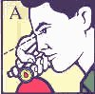 |  | 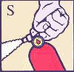 |  | 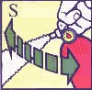
Write a set of instructions to tell someone else how to use a fire extinguisher in an emergency situation. Here are some words to help you.
before | then | pull | pin | seal
when | finally | aim | point | nozzle
after | firstly | squeeze | lever | sweep
while | fire | carefully | flames | release
next | re-ignite | repeat | process | unlock
Using a fire extinguisher
_________________________________________________________________

_________________________________________________________________

_________________________________________________________________

_________________________________________________________________

_________________________________________________________________

_________________________________________________________________

_________________________________________________________________

_________________________________________________________________

_________________________________________________________________

Task 4: Word grid
Here are the useful words for writing instructions. You can use these words in longer pieces of text to show the order of information you present. Use the words to complete the word grid. There are some letters in the grid to help you.

before | when | after | while
next | then | finally | firstly
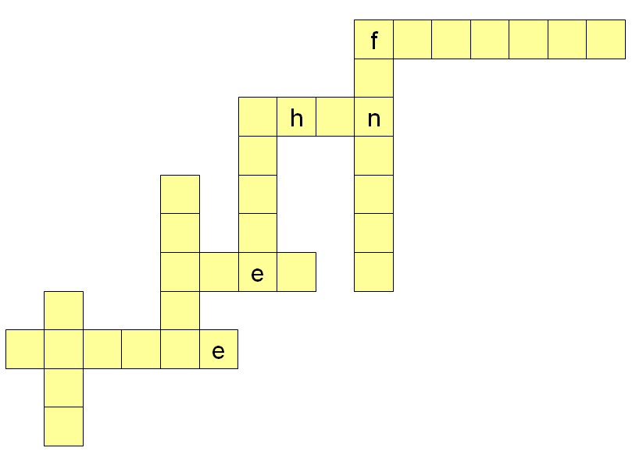
Aim: We are learning about about using auxiliary and modal verbs to show different meanings and verb forms.

Remember that in a sentence:
The subject is what the sentence is about.
The verb is the action or feeling that happens.
The object shows what the action or feeling is about.

In English helping or auxiliary verbs help the main verb to show different meanings such as the time or the type of action.
I might go on holiday next month.
I will work on the upper site today.
I could work some overtime.

There are two groups of helping or auxiliary verbs.

Group 1: Auxiliary verbs
Three auxiliaries verbs are main verbs, too.
be have do
They tell us if just one person is doing something (singular):
She is starting the drill.
They tell us if two or more people are doing something (plural):
They are loading the lorry.

They show us present and past time.
Present: She has gone to check the stores.
Past: She had gone to check the stores.

Present

be  I am we are  you are you are  s/he is they are | have  I have we have  you have you have  s/he has they have | do  I do we do  you do you do  s/he does they do

We will look at the Group 2 helping verbs after the next two tasks.

Task 5: Changing the auxiliary verb from singular to plural
Read the sentences below. They show the auxiliary verb in the singular. Rewrite the sentence changing the subject and verb to the plural. The example shows you what to do.
I am working the night shift.
They are working the night shift.

1. The employer was prosecuted.
2. I am demolishing the building.
3. He is training the operatives.
4. She has worked five days this week.
5. He has signed in.

Now read the sentences below. They shows the auxiliary verb in the present form. Write the sentence changing the auxiliary verb to the past form. The example shows you what to do.

Do you have the accident book?
Did you have the accident book?

6. He is checking the stores.
7. You are working on the upper site.
8. Does it matter?
9. They have started their hammer drills.
10. I do not work that day.

Group 2: Helping or modal verbs
The other nine helping verbs cannot be used as main verbs. They are called modal verbs because they show feelings or judgement.

can | may |  | will |  | shall |  | must
could |  | might |  | would |  | should

These verbs do not have different forms. They do not have an s form. We do not write He coulds do that.
We use these modal verbs to write about things that are possible or probable. We use them for things that are certain, likely or necessary.

A new machine will arrive tomorrow. | That sounds definite.
A new machine should arrive tomorrow. | That sounds likely but not certain
A new machine may arrive tomorrow. | That sounds less likely to happen.
A new machine might arrive tomorrow. | That sounds less likely to happen, too
These modal verbs express politeness, too.
could might would should may

Could I book some leave? is more polite than Can I book some leave?

You might want to think about that.
In general we say or write:
I shall we shall
You will you will
S/he will They will
It will

You can also say:
I will we will

Scots and Americans use I will and we will not shall.
Would you open the door please?
You should take care. That’s sharp.
May I do that for you?

Must expresses duty or obligation.
You must wear the protective clothing.

These modal verbs express future time.
shall will

We shall be there tomorrow.
He will work that day.

Task 6: Find the modal verbs
Read this passage and underline the modal verbs. The first one is done for you.

First aid
When you work on a building site, you should know where the first aid kit is kept. You should know the names of first aiders and how to get help in an emergency. You must have a small travelling first aid kit if you are working away from the main site.
What would you do if someone had an accident? Do you know any first aid? You should think about what you would do in an emergency. First aiders should be easy to identify. They usually have stickers on their hard hats.
Basic first aid may save someone’s life. If you do not know any first aid, you could think about training to be a first aider. You will get time off work to attend. You could become part of the first aid team.

Task 7: Put the auxiliary verb in the gap
Read the sentence and then write the auxiliary verb in the gap. The example shows you what to do.

do | can |  | may |  | will |  | shall |  | must
have |  | could |  | might |  | would |  | should

That’s a fire door. You _______ keep it closed.
That’s a fire door. You __must_ keep it closed.

1. ____ be careful. That’s very sharp.
2. There is some training on working at height next week. You have not done any yet. You _________ put your name down.
3. ______ you help me lift this crate, please?
4. You ______ wear a hard hat at all times on site.
5. If you really want to go to lunch now, then you _______ .
6. I don’t mind where I work next week so I _________ go to the East Street site.
7. That’s really important. I _________ make sure I do it.
8. I __________ offer to do some overtime this weekend but I cannot manage the hours at the moment.
9. I _________ worked for this firm for three years.
10. I’d quite like to earn some more money. I _______ do some overtime this weekend but I need to check with my partner first. I’ll let you know later.
11. I’d like a quick chat later if I ________ .
If you have been working with another person on this task, discuss your answers with them. Some modal verbs are a matter of personal choice.
Task 8: Word puzzle
Use these auxiliary verbs to complete the grid.

could | must | should | may | have
When you have filled it in, you will find another auxiliary verb in the yellow boxes.
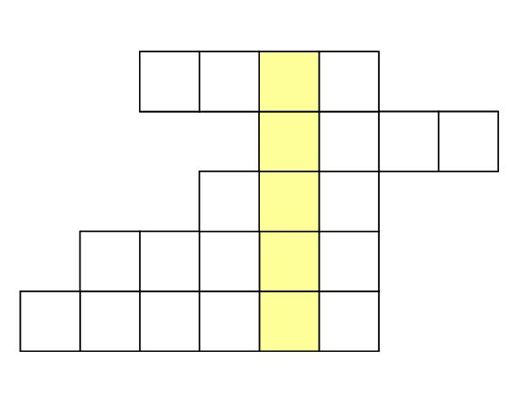

How did you get on?

Module 1: Writing in the workplace answers

Task 1 answers
Ladder safety
Ladders should be used for short term work or light work only. Make sure the work needs only one hand to be used. You should check that there is a good handhold.
Before you use a ladder, check it for splits or cracks in the stiles and rungs. Do not use a painted ladder. You cannot see any damage if the ladder is painted. Ensure that none of the rungs is missing. Report any defects to your supervisor.
Set the ladder on a firm base. Ladder safety posters tell you to set the ladder one unit out to four units up. For instance, you set the ladder one metre out for four metres up. Make sure your boots are clean and you do not have any mud or grease on them. Use both hands on the stiles when you climb up and down the ladder.
Do not stand the ladder on a drum, box or other unstable base and never carry a load up it.

Task 2 answers

1. Use both hands on the stiles.
2. Make sure your boots are clean.
3. Report any defects.
4. Do not carry loads up a ladder. or Don’t carry loads up a ladder.

Task 3 answers

Using a fire extinguisher
Firstly, pull the pin out of the extinguisher. This unlocks the lever.
Then point the extinguisher nozzle at the fire.
Next squeeze the lever above the handle. This releases the contents of the extinguisher.
Sweep the extinguisher from side to side. While you do this make sure you cover the flames.
Sweep the extinguisher back and forth until all the flames are out.
Finally, watch the area. If the flames re-ignite, repeat the process.

Task 4 answers

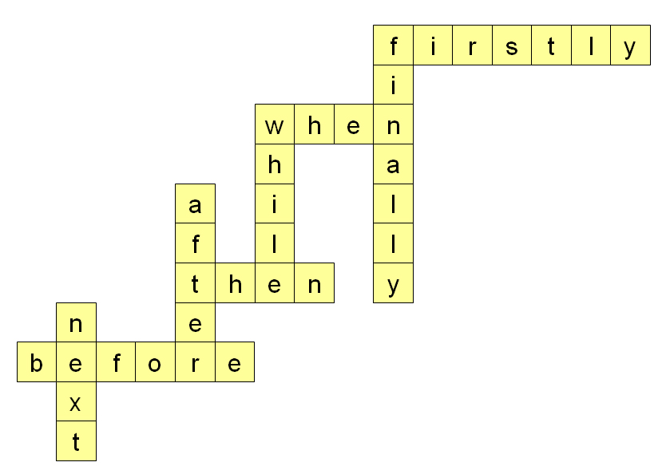

Task 5 answers

1. The employer was prosecuted.
The employers were prosecuted.
2. I am demolishing the building.
We are demolishing the building.
3. He is training the operatives.
They are training the operatives.
4. She has worked five days this week.
They have worked five days this week.
5. He has signed in.
They have signed in.
6. He is checking the stores.
He was checking the stores.
7. You are working on the upper site.
You were working on the upper site.
8. Does it matter?
Did it matter?
9. They have started their hammer drills.
They had started their hammer drills.
10. I do not work that day.
I did not work that day.

Task 6 answers

First aid
When you work on a building site, you should know where the first aid kit is kept. You should know the names of first aiders and how to get help in an emergency. You must have a small travelling first aid kit if you are working away from the main site.
What would you do if someone had an accident? Do you know any first aid? You should think about what you would do in an emergency. First aiders should be easy to identify. They usually have stickers on their hard hats.
Basic first aid may save someone’s life. If you do not know any first aid, you could think about training to be a first aider. You will get time off work to attend. You could become part of the first aid team.

Task 7 answers

1. _ Do_ be careful. That’s very sharp.
There’s only one choice of auxiliary here that makes sense. It is used to stress the need to take care.
2. There is some training on working at height next week. You have not done any yet. You __should__ put your name down.
Should makes the advice stronger than could. Will makes the advice sound more like a command.
3. _ Can you help me lift this crate, please?
You can also choose could or will. Can and could make the request more polite.
4. You _must_ wear a hard hat at all times on site.
There’s not another choice here. This is something that has to happen. You will also gives a sense of something that must happen but it’s not as strong.
5. If you really want to go to lunch now, then you __shall__.
Shall gives a sense that something will definitely happen but you can use will, too.
6. I don’t mind where I work next week so I __could__ go to the East Street site.
Could suggests that this might happen. It is an offer. Should suggests that the person has a duty to change sites, which is not true.
7. That’s really important. I __will__ make sure I do it.
Will is used to show this is definitely going to happen. Should sounds less certain.
8. I __would__ offer to do some overtime this weekend but I cannot manage the hours at the moment.
Would is more polite. Could sounds like the person does not care.
9. I __have__ worked for this firm for three years.
Have is an auxiliary verb that is also a main verb. It is used here to make the present perfect form. It is the only auxiliary that makes sense.
10. I’d quite like to earn some more money. I _might_ do some overtime this weekend but I need to check with my partner first. I’ll let you know later.
Might is used to show possibility. Could sounds less certain.
11. I’d like a quick chat later if I _may__.
May shows politeness. You could use can, too.

Task 8 answers


