Supported Employment
Framework Model
A Proven Effective Framework Model for Learners with Additional Needs

contents
Supported employment
Introduction 2
Framework model
Stage 1 Engagement 3
Stage 2 Pre-employment 4
Stage 3 Employment workshops 5
Stage 4 Employment placements 6
Stage 5 Sustainable Employment 8
additional InformAtion
Employer Business Benefits 10
Reasonable Adjustments 11
Workplace Support 11
Job Coaching 11
National Occupational Standards 12
Training in Systematic Instruction 12
Employment Placements 12
Job Matching 13
Job Carving 13
Employment and Vocational Profiling 13
Job Analysis 13
Alternative Methods of Recruitment 13
Employers Disability Confident Scheme 14

Supported employment Framework Model

Introduction

All learners should have a pathway plan from the earliest of years to assist them with their career aspiration. To find the most suitable job takes time in building confidence and skills to access the job market. Through proven track record this framework will assist you to model a successful supported employment programme/offer.

Supported Employment Framework

Some learners require additional support to achieve this, and this framework has been designed to enable the delivery of high-quality supported employment. It follows a 5-stage model to provide sustainable employment for learners with additional needs.

As a bespoke programme, learners access stages that are appropriate to their needs. Therefore, not every stage needs to be completed. For example, a learner might not need to access stage 3 or 4 as they may have sufficient skills developed at stage 2 to move to stage 5. Other learners might start at stage 1 and move directly to stage 4 or undertake stages 3 and 4 concurrently. Depending on your learner cohort, you will need to devise a programme and staff framework that allows for a personalised approach

Supported Employment Framework Model

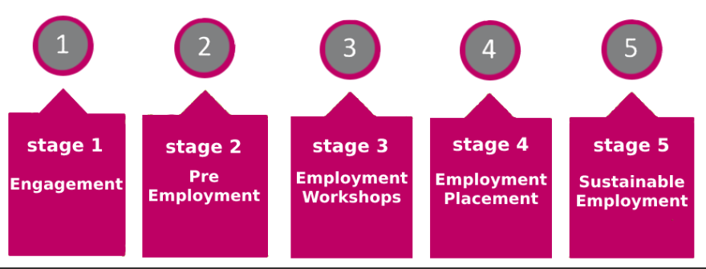

Stage 1 Engagement

Providers are responsible for all initial engagement activity with the learner which will include a discussion about the aim of the programme which is to gain employment. This will determine if it is the right programme for them and to establish any barriers including barriers for their families in gaining sustainable employment such as benefits planning when making decisions about employment.
Job Coach

Once a learner is confirmed as eligible, they must be assigned a job coach who will be their point of contact for the duration of their time on provision. They should follow the principles of National Occupational Standards for Supported Employment and where possible trained or follow principles of Systematic Instruction

Employment and Vocational Profile

The employment and vocational profiling is a document that is used throughout the programme and updated over time with information from work experiences by the learner.

An employment profile is primarily for the provider to capture to assist with gathering key information. It should from part of the initial assessment meeting and shared with the learner throughout the programme. The job coach or learner can add specific employers’ names and details when the learner is ready, and an employer is engaged.

The vocational profile is owned by the learner should include key information such as personal details, preferences, work experience, other experiences, interests, skills and the type of work interest. An action plan should also form part of the vocational profile, so learners understand the areas of focus. It should also include new skills developed and qualifications attained whilst on programme.

The profiles should begin at the earliest opportunity. The profile is an excellent initial employment assessment tool and be completed in conjunction with labour market research. This will allow the learner to make informed choice about their career aspirations. Analysis of job opportunities will help to logging skills acquired and the skills yet to be developed. The job analysis should identify the core requirements for the job role, the employer’s targets for quality and productivity and any relevant cultural issues

Action plan

An action plan should be included and updated so that the learner is fully aware of their role and responsibility in gaining work.

Stage 2 Pre-Employment

From the employment/vocational profile, the Job Coach will be able to plan a programme specific to the learners needs and skills gaps. This will more than likely focus on communication in confidence, interpersonal and verbal skills, travel training, CV writing, job searching, preparing for interviews, induction and the workplace expectation. To prepare learners, they should undertake mock/
simulated events. This works well when local employers support this activity.
Job Analysis
The Job Coach should guide learners to analysis the job opportunity to ensure the job and environment is suitable for the learner. Any jobs that are highly competitive should be pointed out to the learner and sufficient insight to ensure skills are developed / and or managed through employment / vocational profiling.
The job analysis should identify the core requirements for the job role, the employer’s targets for quality and productivity and any relevant cultural issues.
Additional Learning Skills
Additionally, functional math and English should run alongside and is part of a programme of study.
Learning can also extend to opening a bank account, digital safety, stress and wellbeing, money management, outdoor and social events to build resilience and confidence in the community.
Learners should continue updating their employment vocational profile with any relevant new skills gained.
For specific sector skills training required go to stage 3

Stage 3 Employment Workshops

Some sector areas require specific skills to access the workplace such as a food hygiene certificate, first aid, manual handling, customer services etc.
A learner will need to undertake appropriate training or qualifications to be considered for employment.
These programmes can be delivered alongside the pre-employment workshops to enable learners to quickly gain the skills and qualifications required to progress to their intended sector employment.

Stage 4 Employment Placement

This stage will involve working closely with partners so that the learner and employers get the best possible job match considering the learner’s employment vocational profile, their skills and abilities and the activities and requirements of the role.
Employer Engagement
Job Coaches should utilise sources of local labour market intelligence to identify employers and identify a good job match based on learners’ aspirations and preferences as well as matching their strengths, experience, and skills. There should be a range of sector employers and different sized companies that enables good matching, rather than placing a learner to jobs that are most immediately available.
Job Searching
An individualised job search plan should be developed with support from the Job Coach. It is essential the learner takes ownership of this to build job searching independence. The learner should update employment/vocational profile with information of any new job/educational experiences.
Adjustments
Discussion with the learners and/or the employer to identify if any extra assistance or alteration to working practice or the environment is essential. Job Coaches should provide learners with accurate information and assist with evaluating their choices to make an informed decision regarding what is revealed to the employer about having additional needs.
The Job Coach should provide advice and guidance to the employer, ensuring they have knowledge of reasonable adjustments and to agree these.

In addition, give support of how an employer can gain Access to Work and other support that can help them to ensure they are prepared to appropriately support the learner.

Job Matching and Carving

The Job Coach should job match and support employers to develop, design or customise jobs, negotiating with the employer. This might involve techniques such as job carving, job design and analysis of the role to best meet the needs of the individual and employer. See pages 14 for more details.

Risk Assessment
Job Coaches should ensure the employer is aware of their responsibilities and relevant legislation to ensure that workplaces are safe and to ensure the health, safety and wellbeing of learners. A risk assessment to address equality and diversity, health and safety and safeguarding is completed.

Post placement reflection
Following a placement, the learner should reflect on likes and dislikes of the placement and whether the aspirations have changed. Any adjustments and skills gained should be added to the employment/vocational profile.

Stage 5 Sustainable Employment
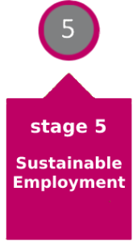

The Job Coach will use their knowledge and expertise to build relationships with employers, adhering to best practice and the 5 Stage Supported Employment Model to engage employers and ensure the best outcomes for learners.
Business Benefits
It is essential that employers understand the business benefits of inclusive employment. The Job Coach can help facilitate this and articulating the business case for employing leaners with additional needs and address employer’s concerns. Details of this are highlighted on page 10.
Job Searching
Throughout the 5 stepped framework, learners should be actively seeking work through job searching in a variety of ways with help from their Job Coach. This could be through internet searching, adverts in local community, sharing a learner’s CV with employers or support from the family with contacts.
The Job Coach should support the learners with applying for jobs, with interview preparation and agree with the employer flexible approaches to recruitment and selection.
Overcoming barriers
The Job Coach should advise and support employers to overcome barriers. For example, employers should be encouraged to use working interviews or work trials which allows learners to demonstrate their skills in the workplace rather than rely on traditional recruitment and selection methods such as formal interviews which can discriminate against some people with additional needs.
Sustained employment
Learners should be guided to work hours, attire, and culture of the organisation and undertake workplace induction. There should be a workplace mentor allocated to support the new employee
Whilst training, work placements, volunteering and internships are an excellent way of gaining skills and developing opportunities for work, these are not considered competitive paid jobs. It is essential that work is paid, and wages are paid at the going rate of pay for the job. This must be at least the National Living Wage per hour rate. The employee enjoys the same terms and conditions as all other employees and the role is valued by managers and colleagues. The job has similar hours and times at work as other employees, with safe working conditions.
Employment Benefits
Learners / employees should be made aware and helped in obtaining comprehensive, individualised work incentives and assistance accessing employment benefits planning thereafter when making decisions about changes in work hours and pay. Employment benefits planning includes the impact on all sources of income and fringe benefits such as Personal Independence Payments, travel concession, Working Tax Credits, Universal Credit, and all costs associated with commencing or changing employment.
Learners / employees should also be provided with assistance about reporting earnings to any other programme that needs to know the new income details such as Housing and Council Tax.
Ongoing Support
There should be ongoing support from the Job Coach for the employee and employer. In the early stages of employment, agree frequent meetings with the employee and employer. It may be intensive during the first few weeks with a view to reducing support gradually and in line with the employee’s needs. This should remain in place for one year of the employment start date as a safety net for both the employee and employer.
Employees where appropriate should be encouraged to increase their working hours and seek progression opportunities and development. Where this is not possible with an employees’ current employer, an additional job could be appropriate. A employees second job should encourage financial independence, career development and seeking options for increased responsibility.
All activity undertaken should be recorded in the action plan.

Additional Information
Employer Business Benefits
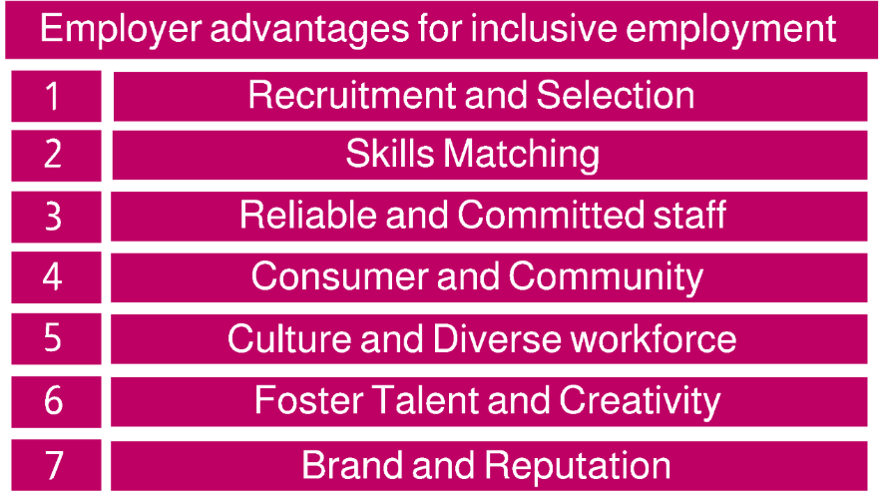
The Job Coach has an important role in highlighting the business benefits to inclusive employment to an employer. There are seven key points that will make an employer think differently and take a new approach to inclusive practice.

By employing someone with additional needs the workplace promotes a culture of inclusion. Employers can save on recruitment costs by accessing a ready-made talent pool of learners. Support employers with refining job descriptions and the language. Inform employers about alternative methods of selection such as work trials and how these operate to make the process of recruitment and selection accessible to those with additional needs. See more details on page 14

Research current vacancies and make employers aware of the ready-made talent pool who are ready to be employed. Share skills with employers and how this matches well with a current vacancy they have.

Employers will benefit by employing a person with additional needs and will quickly see positive attributes and how reliable they are. Employers will benefit for greater productivity due to never being late or absent and have excellent retention as the employee will be loyal and committed to their work. An employer will see politeness, keenness, willingness with a positive attitude.

The reputation will improve with employers embracing inclusion. This translates into business improvements with customer satisfaction, loyalty and positive customers reviews. The diverse workforce will reflect the diverse community and appeal to a wider range of customers and or community they serve. Attracting a wider customer enables businesses to enjoy the purchasing power of the disabled population.

An inclusive culture will have a positive impact of work environment and staff. Employers will benefit from better recruitment, retention, and morale of staff. Inclusion is better for everyone, not just those with additional needs. By removing barriers, employers remove the need to put in extra work for individualised solutions, which can lead to exclusion or even humiliation. Employers should anticipate diverse needs which allows everyone to be welcomed all as equals: recognising the intrinsic value of each employee and what they contribute. Employers can join the disability confident scheme. See page 15 for more details.

Employers are missing out on a talent pool. It makes business sense to be an inclusive employer who appeals to more people. By tapping into this talented pool, employers will benefit from a diverse way of thinking, innovation, and creativity. Being innovative helps an employer have the edge and become market leaders. Diverse teams make better decisions.

By embracing inclusion and diversity,​ the brand, identity, and reputation of the organisation is improved. The business appeals to more people, staff and consumer and is a strong feature of branding and marketing. The business has a workforce that represents the diversity of its customers/ community is more likely to design / produce work with their needs in mind.

Additional Information
Reasonable adjustments
To support and guide employers to help better meet the learner/ employees needs consider some of the following:

- Verbal instruction and prompts
- Demonstrating using simple language
- Written instructions and task sheets
- Ensuring people have more time to learn
- Rest breaks

Workplace support

- Supporting the learner’s/employee’s induction
- Providing on-site training support if needed
- Offering out of work support if required
- Use of naturally occurring praise, reinforcement
- Managing work pressure/ productivity demands
- Understanding and using physical guidance and gestures
- Developing peer support
- Workplace social inclusion
- Ongoing support to address any barriers
- Updating and reviewing the action plan to support progress on a regular basis

The Job Coach
A Job Coach is expected to coordinate employer engagement and liaison with parents, carers and agencies. Before, during and after the placement the Job Coach will undertake employability support workshops and support with job searching and CV writing. In the workplace, the Job Coach will train, mentor, give in-work support, job match, undertake reviews. They will have administrative duties such as record keeping, learner tracking and supporting Access to Work applications and related processes.

National Occupational Standards
National Occupational standards are central in providing employment support for the learner and employer. The standard ensures the practice of a Job Coach adheres to the relevant ethical principles, values and codes of ethical practice that apply within supported employment. Job Coaches are skilled and experienced with job searching, matching and preparing learners for work. They work all year round and match the employers’ opening hours, which could extend to evening and weekend work. A Job Coach has a relentless approach to securing sustainable employment and a strong belief in the learner’s ability and right to work. This enables the team to engage with and inspire learners and their families to aspire to paid work and demonstrate to employers the value they bring to their paid workforce.
Training Systematic Instruction
Training Systematic Instruction (TSI) is a structured approach to teaching vocational and independence skills for learners with additional needs. TSI has an emphasis on errorless learning and encourages decision-making, enabling learners to learn complex tasks.
Systematic instruction such as breaking tasks into steps, “chaining” tasks together and developing a hierarchy of cues will help develop learner skills to carrying out tasks well.

Step 1 Define the instructional objective
Step 2 Choose an appropriate teaching/ prompting strategy and materials
Step 3 Implement the instructional activity/ method
Step 4 Evaluate the instructional activity/method
Step 5 Refine the method and break down steps further
Employment Placements
A placement in a workplace that can be a block of time such as a few days to a week with the purpose of gaining essential work skills. The approach taken to place and train, works well for learners with additional needs.
To secure effective working relationships with an employer, learner skills matching is essential to maintain further placements.
A Job Coach should plan with agreement from the employer’s tasks and expectations to ensure the learner understands their duties whilst in the workplace.
To ensure the placement is successful, it is advised the learners or Job Coach shares the additional support needs with the employer and make suggestions for reasonable adjustment.

Job Matching
Job matching enables Job Coaches to ensure that learners are placed in a job role that matches their abilities, interests and ambitions in a working environment that suits their needs. Successful job matching relies on the effective employment vocational profiling as well as thorough job analysis of the potential role.

Job Carving
The job may involve an element of job carving, whereby learning provider works with the employer to shape a role for a particular individual which is suited to their strengths with consideration of reasonable adjustments that may be needed. This process will result in greater productivity, ability to offer more flexibility to other staff within the workplace.
Job carving customises job duties, swapping job duties to make the most of the learner’s skills and sometimes creating specialist roles. It may be seen as a form of reasonable adjustment when it is used to tailor a job so that it is suitable for a particular worker. It may be that the learner is capable of completing a high percentage of the job tasks and the employer negotiates job duties across a team, so that tasks are shared in a fair and equitable way. Employers may need support to see how this can work well for their business.

Employment and Vocational Profiling

The employment/vocational profile is a learner centred approach to gathering information specifically related to work. It is a way of understanding what the learners experience, skills, abilities, interests, aspirations, and needs are to support them to find a job. It will also identify areas for development as well as the support a learner may need in the workplace. Preparing for Adulthood has guidance on creating a vocational profile.
Job Analysis
Job Coaches will need to use findings from the job analysis and the learner’s employment vocational profiling to determine the fit between a specific job role and the learner. The Job Coach will review a job description, understand the jobs involved and consider whether there is interaction with colleagues and or customers. They will need to know the expectation in the workplace and its policies and culture.
Alternative Methods of Recruitment
Taking a different approach to recruitment and selection will broaden horizons and employers will have access to a wider talent pool.
The Job Coach should provide support to employers to help them to recruit a diverse workforce, taking a targeted approach and engage with learners that are work ready. This will save on the employers advertising costs.

They should also make suggestions to the employer of alternative options available to them, such as alternative recorded application forms, a working Interview or work trial where a learner is given a task and observed while they complete it.
The Job Coach should also assist an employer writing or sharing examples of an inclusive job description that is easy to read, removing non-essential requirements and has inclusive language.

Employers Disability Confident Scheme Disability Confident

Disability Confident organisations play a leading role in changing attitudes for the better. They’re changing behaviour and cultures in their own businesses, networks, and communities, and reaping the benefits of inclusive recruitment practices. The scheme helps employers recruit and retain great people, and:
- draw from the widest possible pool of talent
- secure high-quality staff who are skilled, loyal and hard working
- improve employee morale and commitment by demonstrating that you treat all employees fairly

It also helps customers and other businesses identify those employers who are committed to equality in the workplace.
The scheme has 3 levels designed to support employers on their Disability Confident journey, these are:
- Disability Confident Committed (level 1)
- Disability Confident Employer (level 2)
- Disability Confident Leader (level 3)

All employers join the scheme at level 1(Disability Confident Committed), and progress through the levels as their confidence increases. The scheme is voluntary and access to the guidance, good practice and resources are completely free.

Supported Employment Pathway Plan Framework
Centre for Excellence in SEND (COMMUNITY)
City College Norwich

