 | Support for Excellence programme  Easton / Norfolk Partnership  Adding value to the learner experience | 

Introduction
The Easton / Norfolk Partnership have focused their PRD activities on the learner experience at a course and curriculum level using an innovative ‘matrix’ approach. The reviews conducted have involved staff and learners from all member colleges and learner involvement has been central to the group’s ethos. The feedback from learners has informed many improvements and developments made post-review to improve the learner experience and the group feels that these improvements have contributed to improved lesson observation grades, retention figures and achievement, though making the learning experience better for their students. The group have also benefited professionally from the sharing of peer expertise. This case study outlines the approach used, the feedback gained, the developments made and the resultant impact of the review of learner experience as well as the additional benefits their collaboration has brought to the group at a professional level.
________________________________________________________________________

Group Details
The Easton / Norfolk Partnership group consists of Easton College, East Norfolk Sixth Form College, Great Yarmouth College and Paston Sixth Form College. The group had some pre-existing relationships before joining the SfE programme through shared OTL. This collaboration has since grown immeasurably through peer review and development. The group formed at a time when all four colleges were undergoing an Ofsted inspection and all achieved a grade 2 rating. When discussing their Ofsted outcomes, the group agreed they wanted to work together to move from good to excellent and this has been an underlying motivation throughout their PRD journey so far. The member organisations of this group are all geographically dispersed so have made a strong commitment to make PRD work and ensure that every face-to-face event is effective and valuable. The group has found that being a mix of provider types (one further education college, one land-based college and two sixth form colleges) has allowed them access to a range of student and staff members with varied experiences, meaning that feedback collected and ideas for improvement have been broader and have taken more issues into account.
________________________________________________________________________

Approach
The group started their analysis of the learner journey with some desk-based research looking at the differences in value added measures in areas of the curriculum, entry criteria, recording and the used of value added data (Advanced Level Performance Systems and Learner Achievement Tracker scores), student achievement of Minimum Grades and value added tracking in all four colleges. From this, the group identified factors which appeared to affect the learner experience and created a list of fifteen key questions:

- Differentiated teaching methods
- Extra-curricular activities
- Use of ILPs / progress reviews and minimum grades
- Extra subject help
- Homework
- Use of subject websites
- Literacy and numeracy help
- Extension work in lessons
- Commendations, incentives, contracts, warnings
- Tutorials
- Work experience
- Enrichment
- Use of specialist resources
- Gifted and talented projects
- Other

The group then used a matrix approach (see Appendix 1) to discuss these key questions between the colleges. Each organisation paired up with a staff member from a different organisation and was observed by a third who took notes. Staff from each organisation acted as both interviewers and interviewees and each organisation met with each member of the group at least once. In this way a huge amount of information was shared between all the organisations in a short amount of time. There was no ‘host’ in the process; as each organisation took on both ‘host’ and ‘reviewer’ roles, the information was shared four ways rather than one.

In a separate session the students were involved in a second matrix of interviews (see Appendix 2) where each organisation interviewed the learners at each of the different organisations in the group, asking them about the importance of the fifteen key questions and their feedback on what adds value to the learner experience. The students chosen were those who did not find learning easy, but had made huge progress since coming to college. This session was hugely beneficial.
________________________________________________________________________

Staff feedback
The staff discussion brought out the difference in learning styles between schools and further education such that many students enter the further education system with a different expectation of teaching styles and what is required of them. This highlighted a need to address this issue through more emphasis on study skills in induction and beyond. The staff also discussed Individual Learning Plans (ILPs) and the way that these are used by students sharing different methods of paper-based and electronic ILP systems. Paston Sixth Form College shared their experience of a fully electronic ILP system where tutors and students could regularly update the ILPs throughout the year.
________________________________________________________________________

Response
In response to the feedback received from the staff-sharing exercise, the group has focused more on study skills and the differences between school and college expectations in their respective student inductions. East Norfolk Sixth Form College and Great Yarmouth College have both implemented a new electronic ILP system similar to that at Paston Sixth Form College and are using Virtual Learning Environments much more effectively to help students and staff access and update ILPs throughout the year, ensuring they are up-to-date and relevant.

________________________________________________________________________

Learner feedback
The learner-sharing event elicited a large amount of valuable feedback around the key features which help students improve and make their experience more positive. Some of these feedback points are noted below:

- Trips (including staff) which are relevant to the course, practical lessons using knowledge, doing presentations which are ‘useful to you as a person’.
- Trips to universities for inspiration.
- Commendations, incentives such as praise, prizes, trophies, stickers, letters to parents, posters showcasing good work, student of the month, BTEC awards ceremonies and, above all, chocolate!
- Friendly progress reviews, clearly focused on the individual, feedback from work which tells you exactly what you need to do to improve.
- Knowing the grades needed for your chosen university and course is the most motivating factor in striving to achieve target grades.
- Extra one-to-one help whenever needed, in person or via email from home.
- Knowing that staff are available, approachable and where to find them (and when) is key.
- Time to catch-up on finishing work.
- Good college websites available at home with all worksheets accessible.
- Progress reviews kept online so students and parents can see them.
- Knowing exactly what you need to do for each subject and assignment e.g. assessment objectives and how examiners mark work.
- Timely feedback on homework and assignments.
________________________________________________________________________

Response
The student feedback above was used to inform a staff training event in all the organisations in the group to give staff greater awareness of what students need in order to facilitate progression. Staff members are now more aware that they need to provide instant feedback on progress so that this is understood when the assignment is fresh in the students mind. Students also asked for access to staff, work and progress reviews online when they need it. Each organisation in the group has now worked to improve their use of Virtual Learning Environments to address this, putting all the course worksheets on the VLE and making better use of the forum and Q&A facilities on the VLE to answer student questions posted out of college hours. East Norfolk Sixth Form College has also implemented special ‘catch-up sessions’ for their BTEC students.
________________________________________________________________________

Impact on the learner
The developments made in response to the learner and staff feedback has led to a number of improvements in many of the organisations in the Easton / Norfolk partnership. The group members feel the developments made through PRD has contributed to the following impacts in their organisations:
- Improved lesson observation:
  - Improved internal lesson observation grades at East Norfolk Sixth Form College, up 3% to 77% grades 1or 2.
  - Improved lesson observation grades at Great Yarmouth with 75% of lessons observed as grade 1 or 2.
  - Paston Sixth Form College now uses practice-sharing peer observation when conducting OTL.
- Improved retention and attendance:
  - Improved retention in East Norfolk Sixth Form College from 90% to 93%.
  - Retention rates at Great Yarmouth College at 16-18 have improved by 3% to 93%.
  - Paston Sixth Form College has seen a 2% improvement in college (16-19) attendance to 90%.
- Curriculum area improvements:
  - Improvements in BTEC National Diploma value added scores at East Norfolk Sixth Form College and Improved Higher Grades at BTEC National in Paston Sixth Form College will have been supported by the new ‘catch-up sessions’ implemented in response to the student feedback.
- Other impacts:
  - Great Yarmouth College and East Norfolk Sixth Form College were both runners up in the 2008 Provider of the Year Learner Voice Award.

Although these improvements cannot be attributed directly or solely to PRD activity, the group feels that the improvements made to the learner experience have contributed to the above improvements. As well as improving the group’s scores, this PRD activity has helped develop staff in each of the member organisations and improved their awareness of progression, timely feedback, the use of VLEs, the importance of ILPs and their availability for one-to-one and catch-up sessions.
________________________________________________________________________

Group development
PRD has also provided a number of benefits to the PRD group members as the strong relationships within the group have built a forum for capacity building. The group shares information on current policy decisions, initiatives and opportunities for training allowing them to keep up to date and respond to opportunities more promptly. The group feels they have developed professionally from their PRD experience and the programme has expanded their network in the sector. This has had an additional impact of facilitating career progression amongst their colleagues as contacts in different colleges have often led to identifying candidates for jobs in the member colleges from the PRD network and colleagues.
________________________________________________________________________

Summary
The Easton / Norfolk Partnership PRD group have embraced the collaborative nature of PRD. They have conducted peer reviews that encourage sharing between the staff and teachers of all the member organisations and used an innovative method to gain the best possible information on where they could improve the learner experience for their students and add value to this experience. The developments made – from better use of ILPs and VLEs, to more informed staff and better progression feedback to students – have contributed to some impressive improvements to retention, achievement and OTL scores. The PRD group members and their colleagues have also benefitted professionally from their involvement in PRD through the shared information and expertise between group members. Next steps for the group include close monitoring of the impact of actions made and conducting another review to develop the issues surrounding the learner voice. The group has gone from strength to strength this year and plans to build on their success in the next year.
________________________________________________________________________

The PRD Team
East Norfolk Sixth Form College Anita Gentry
Great Yarmouth College Richard Dade
Easton College Fiona Mylchreest
Paston Sixth Form College Rob John
Appendix 1
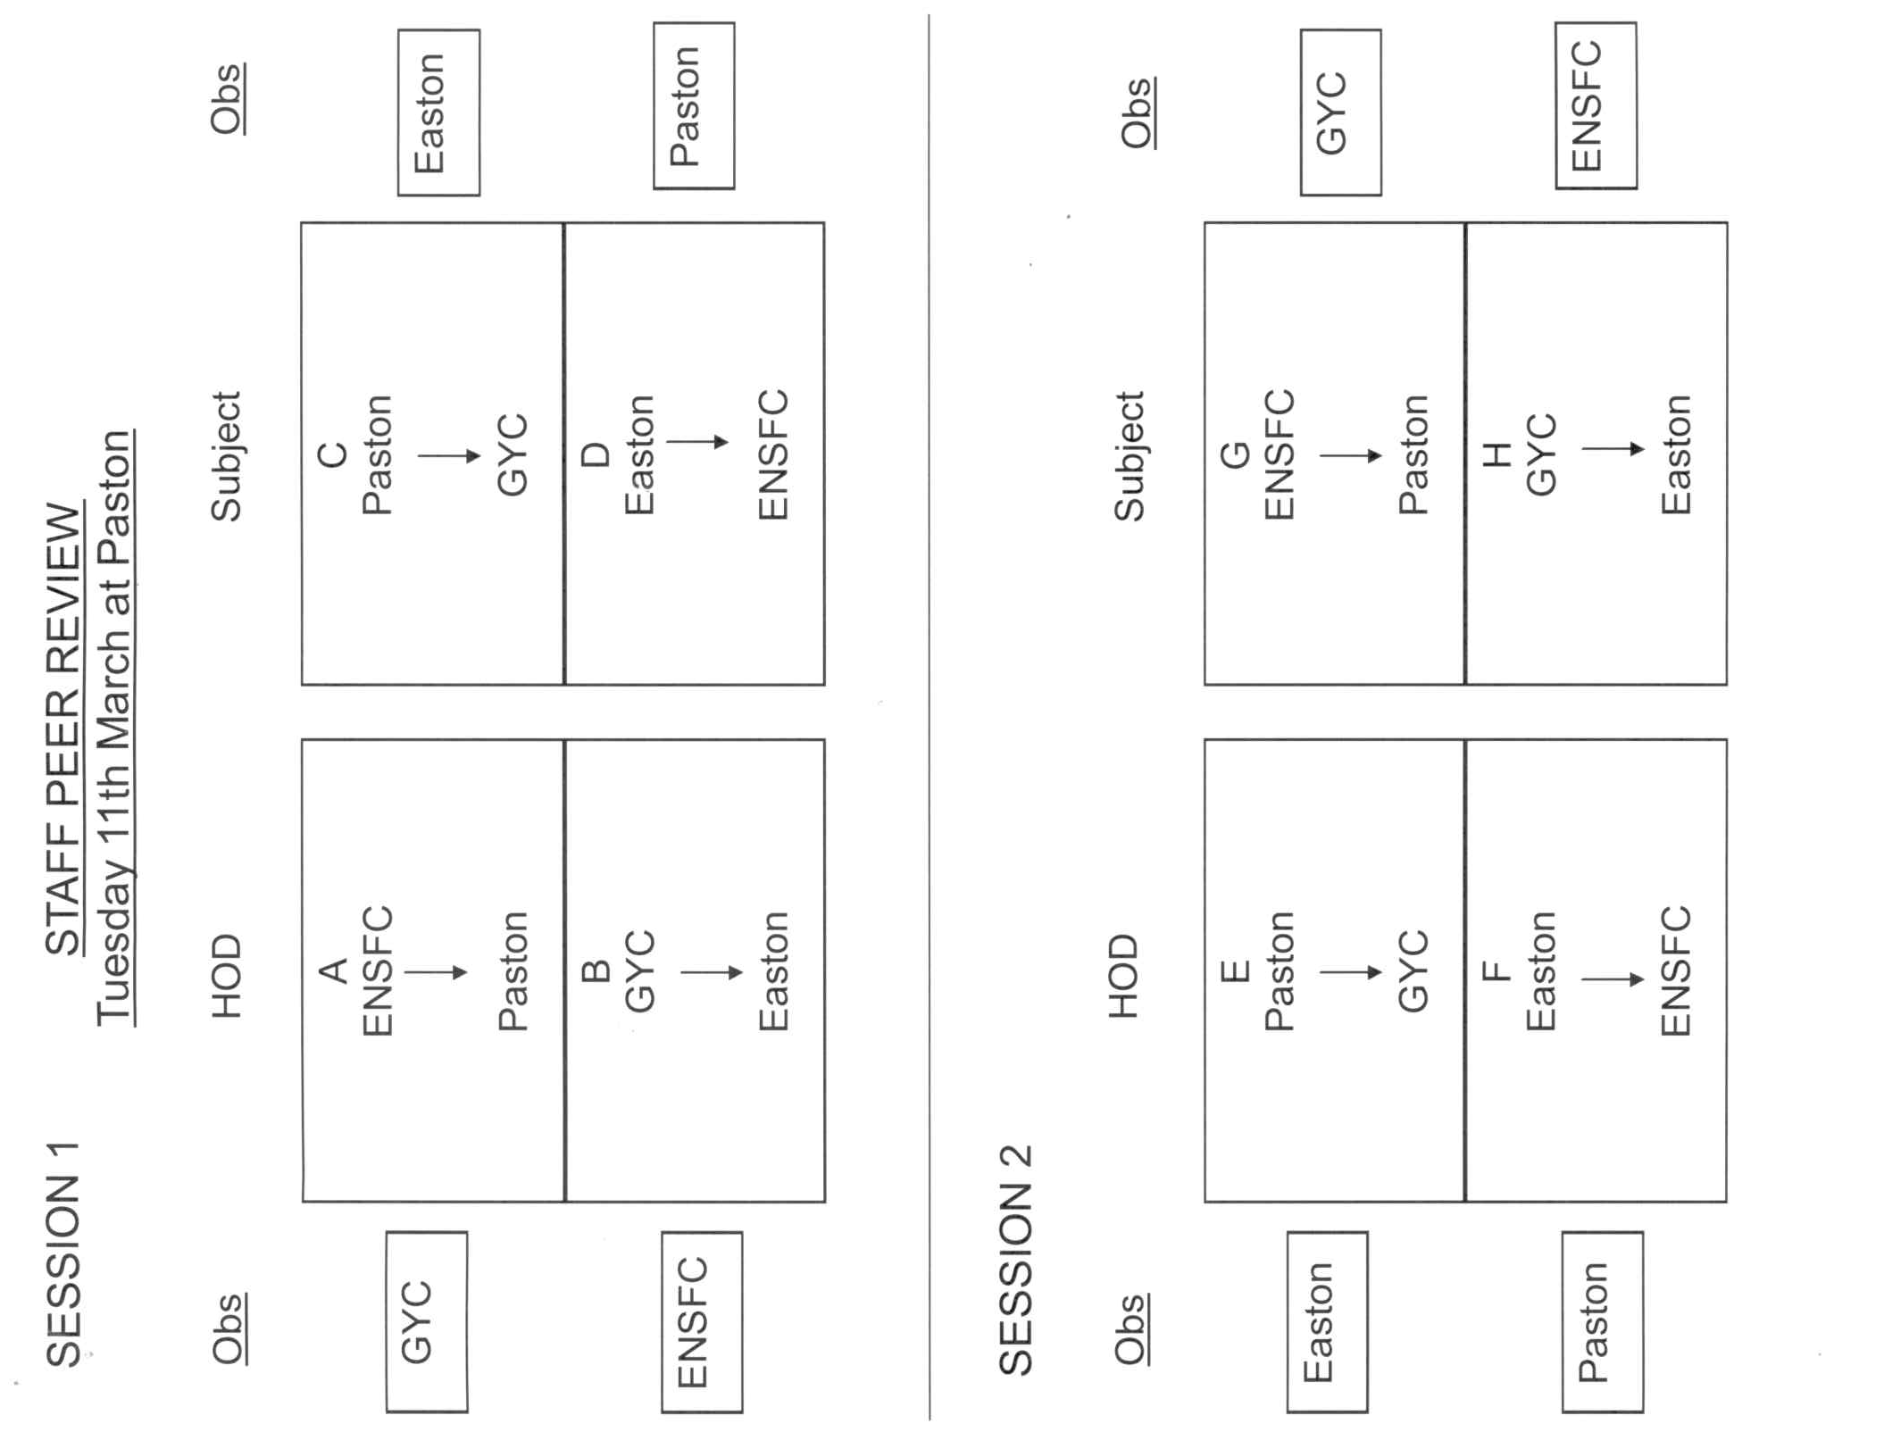
Appendix 2


