

Participant pack

Module 7: Developing the personal maths skills of teachers and assessors

Handling data master class

Handouts

HO 1: Handling data reflection sheet
HO 2: Variance and standard deviation
HO 3: Histograms
HO 4: Spinners exam question
HO 5: Rules of probability
HO 6: Train journey
HO 7: Holiday planning

PowerPoint slide notes
HO 1: Handling data reflection sheet

As you go through the different topics and activities during the session, make notes below regarding topics you feel confident about and those that you need to consolidate further.

Topic / activity | Reflections
Carousel activities
Frequency distributions and mean / median / mode / range
Measures of dispersion (including standard deviation)
Grouped and cumulative frequency distributions
Mean of grouped frequencies
Histograms with unequal intervals
Bivariate analysis (correlation)
Introducing probability
Combined probabilities
Probabilities using relative frequencies

HO 2: Variance and standard deviation

The range is a very simple (and crude) measure of spread, as it only takes account of the minimum and maximum values, and ignores other data in the sample. As such it can be affected by one extreme value in a sample.

Two measures which take account of all the values of a set of data are the variance and the standard deviation. Both these measures are found by calculating the distance of each value from the mean. In both cases, however, the calculations are quite involved, and are easier to achieve on a calculator or spreadsheet.

For the purpose of illustration, the example below illustrates how variance is calculated for the following data set:

8 5 6 9 7

The mean, , is 7:

 | Mean: | Difference: | Difference squared:
8 | 7 | +1 | +1
5 | 7 | -2 | +4
6 | 7 | -1 | +1
9 | 7 | +2 | +4
7 | 7 | 0 | 0

Look at the values in column (3). The values in this column show the distance of each individual data value from the mean. You might think that the average of all the values in this column is a good measure of the spread. Unfortunately if you try it, you will find that the sum of the values (and therefore the average) is zero. This is because the positive and negative values cancel out:

+1 -2 -1 +2 +0 = 0

In calculating the variance we square each of the values; this ensures that they are all positive. You can see the result in column (4).

We then make the result independent of the number of values used () by dividing the sum of the values in this column by . As n = 5 (there are 5 numbers), this gives:

variance (s²) =
= 2

The standard deviation () is the square root of the variance.
= 1.41

Formula for standard deviation:

Microsoft Excel™ functions
There are several useful functions in MS Excel™ that can be used for statistical calculations. The most useful are:

Mean =AVERAGE(Range of cells)

Median =MEDIAN(Range of cells)

Mode =MODE(Range of cells)

Variance =VARP(Range of cells)

Standard deviation =STDEVP(Range of cells)

In each case, for range of cells, highlight the cells containing the data set.
HO 3: Histograms

Histograms are similar to bar charts except that it is the area of each bar which represents the frequency. Histograms can be used for discrete data although they are mostly used for continuous and grouped data.

When drawing histograms it is important that the bars on the horizontal axis should always be drawn at the class boundaries. The height of these bars should be such that the area is proportional to the frequency which it represents.

To make things simple it is helpful if we make the area of each bar equal to the frequency which it represents so that

Class width x height = frequency
and height =

The height of the bars is referred to as the frequency density and the vertical axis of a histogram should be labelled frequency density rather than frequency.

frequency density =

Example

The following information shows the distance travelled by 125 cyclists during a particular month. The distance is measured in miles to the nearest mile.

Distance (miles) | Frequency
0-10 | 20
11-20 | 38
21-30 | 42
31-50 | 18
51-100 | 6
101-150 | 1

Using frequency density = , we can work out the frequency density for each bar as follows:

Distance (miles) | Frequency | Class width | Frequency density
0-10 | 20 | 10.5 | 1.90476 | = 1.90476
11-20 | 38 | 10 | 3.8 | = 3.8
21-30 | 42 | 10 | 4.2 | = 4.2
31-50 | 18 | 20 | 0.9 | = 1.8
51-100 | 6 | 50 | 0.12 | = 0.12
101-150 | 1 | 50 | 0.12 | = 0.02

Using this information to construct the histogram:
Frequency density
4.0
3.0
2.0
1.0
0

0 10 20 30 40 50 60 70 80 90 100 110 120 130 140 150
Distance (miles)

HO 4: Spinners exam question

Taken from LSIS Improving Learning in Mathematics (Session S7): http://tlp.excellencegateway.org.uk/pdf/mat_imp_02.pdf

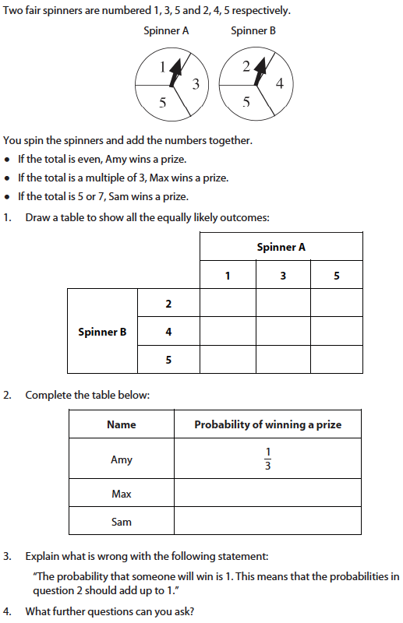

HO 5: Rules of probability

- Addition Rule (‘OR’ rule)

Two or more events are called mutually exclusive if they cannot happen at the same time. For example, when tossing a coin you can get a head or a tail but not both at the same time.

For mutually exclusive events we can apply the addition (‘OR’) rule, which says that:

p(A or B) = p(A) + p(B)

Example: to finish a game, you need to throw a 3 or 6. What is the probability of finishing on the next throw of the dice?

p(3) = p(6) =

p (3 or 6) = p(3) + p(6)

= +

=

- Multiplication (‘AND’ rule)

Two or more events are said to be independent if one event happening has no effect on the other event happening. For example, when tossing a coin, getting a head on the first throw does not affect getting a head on the second throw so these events are independent.

For independent events we can apply the multiplication (‘AND’) rule, which states that:
p(A and B) = p(A) x p(B)

Example: what is the probability of tossing a head on a coin and throwing a six on a dice?
p(head) = p(6) =

p(head and 6) = p(head) x p(6)

=

=

HO 6: Train journey

You are travelling by train from Nottingham to Leeds, and have to change trains at Sheffield. There is very little time to make the change at Sheffield, so if the train from Nottingham to Sheffield is late, but the train from Sheffield to Leeds is on time, you will miss your connection.

What is the probability of you missing the connecting train at Sheffield?

Information
Punctuality and cancellation data published by the train company for the last month:

On-time | 84%
Up to 15 min. late | 7%
15-30 min. late | 4%
More than 30 min. late | 2%
Cancelled | 3%

HO 7: Holiday planning

Sally is planning a fortnight’s winter sun holiday next February, and is looking for somewhere warm and dry. She would like somewhere where the temperature is likely to be at least 20⁰C and where rain can be expected on no more than 3 of her 14 days away.

Use the information below to inform Sally of the likelihood of each resort meeting her requirements, and which one she might choose. Make sure you point out any limitations to your calculations.

Average February temperatures (2004-2011)

Resort | 2004 | 2005 | 2006 | 2007 | 2008 | 2008 | 2010 | 2011
Maria del Mar | 16⁰C | 25⁰C | 21⁰C | 18⁰C | 20⁰C | 17⁰C | 25⁰C | 24⁰C
Geriatikis | 26⁰C | 19⁰C | 23⁰C | 22⁰C | 25⁰C | 27⁰C | 21⁰C | 23⁰C
Puerto Paradiso | 22⁰C | 24⁰C | 20⁰C | 17⁰C | 16⁰C | 23⁰C | 21⁰C | 24⁰C
Tournesol | 18⁰C | 22⁰C | 15⁰C | 22⁰C | 23⁰C | 22⁰C | 22⁰C | 22⁰C

Total number of days rainfall during February (2006-2011)

Resort | 2006 | 2007 | 2008 | 2008 | 2010 | 2011
Maria del Mar | 4 | 8 | 7 | 2 | 2 | 4
Geriatikis | 8 | 5 | 12 | 9 | 4 | 7
Puerto Paradiso | 9 | 5 | 4 | 7 | 3 | 8
Tournesol | 2 | 4 | 1 | 7 | 5 | 3

PowerPoint slide notes



