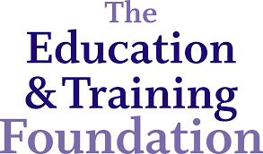

Systems Thinking For Special Needs
Episode Guide & MANUAL

Index

The Course 2

Episode 1: Introduction 4

Episode 2: Understanding Your Challenges 7

Episode 3: Self Awareness 10

Episode 4: Social Awareness 12

Episode 5: System Awareness 15

Episode 6: Action Experiment 17

Episode 7: Impact 20

The Course

Welcome to the Systems Thinking for Special Needs online course. This document has been created to support you while you work through the video content. It attempts to mirror the core content in the course and provides a copy of images and exercises should you want them.

Why?
The Children and Families Act 2014 places a duty on Colleges and others to co-operate with partners to meet the needs of young people with special educational needs. At the same time, services for those with special educational needs or disabilities (SEND) are changing fast, requiring us to fundamentally rethink how we work. In particular, we need new forms of collaborative working which both are highly sensitive to individual needs and enable us to lead beyond our organisation. Despite this, SEND is often under-prioritised. A key function of this course will therefore be to help you make it a higher priority wherever you work.

What You Will Get from the Course
This course, commissioned and funded by the Education and Training Foundation (ETF) as part of their Excellence in Leadership, Management and Governance programme (ELMAG), is for those seeking to radically improve the quality of both service and outcomes for learners within SEND education provision. By the end of the course, participants will:
- have a grounding in systems thinking basics
- be able to make the distinction between types of challenges and how to respond to them
- be able to see their work through a new systems perspective
- have an action plan to apply systems thinking to the real challenges they are working on
- start leading beyond role and organisation with diverse partners within and across their area of responsibility.

Contributors
- Martin Sandbrook, Schumacher Institute (Trainer)
- Rich Wilson, OSCA (Trainer)
- Sue Ward MBE (Awarded for services to further education and young people with mental health conditions).

How Will It Work?
The course has been designed to help you work through your current SEND challenges in real time. This way of working hinges on you doing five things:
- Pausing and reflecting when asked to during each episode.
- Working between episodes when asked.
- Watching with the people you are working together with on your challenges.
- Allowing 45 mins for each episode (although the videos are on average less than 15 minutes long, with the additional discussions that the course should prompt, each should take at least 45 mins).
- Preparing for each episode - making sure you have the right room, materials and work done in advance.

Available Materials
- Training Videos: these are the core content presented by Martin and Rich.
- Sue Ward Videos: supplementary videos for each episode featuring the very experienced SEND expert Sue Ward giving her own reflections on what’s practically needed.
- References: direction to a range of excellent works referenced in the course.
- Course Manual: this document.

Episodes
The course has seven episodes:
- Episode 1: Introduction
- Episode 2: Understand Challenge (Step 1)
- Episode 3: Self Awareness (Step 2)
- Episode 4: Social Awareness (Step 3)
- Episode 5: System awareness (Step 4)
- Episode 6: Action experiment (step 5)
- Episode 7: Impact

The Trainers
The training will be delivered by Martin Sandbrook, Director of the Schumacher Institute; and Rich Wilson, Director of OSCA.
Martin Sandbrook was formerly an accountant, a senior manager in both public and private sectors, a process consultant and a university lecturer in Business and Management. In 2007, he took time out to complete the Responsibility and Business Practice MSc at University of Bath, an experience that changed his whole way of thinking and professional direction. Influenced by this learning and by EF Schumacher’s statement that ‘our task is to look at the world and see it whole’, he now combines his passion and commitment to the ideas of sustainability and systems thinking with his experience in the management of organisations. He supports individuals and organisations to make the shift to a more systemic approach to action. Martin has been a Shared Lives Provider, sharing his home for the last three years with students who have special needs and learning disabilities and who attend the nearby Ruskin Mill specialist college.
Click here for more information about Martin Sandbrook.

Rich Wilson is the director of OSCA, a UN adviser and blogs at the Guardian and
Huffington Post. In 2013 he published the book, Anti Hero: The Secret Leadership Revolution.
In 2004 he founded the democracy charity, The Involve Foundation. He facilitated the largest
conferences of the French and Swedish EU Presidencies; the Digital Agenda Assembly and
the Mobile World Congress. He is a Clore Social Fellow and was winner of Best Presenter at
the 2014 Market Research Society Awards. He is currently helping the UK Government’s
Education & Training Foundation establish their transformative leadership development programme.

Click here for more information about Rich Wilson.

Episode 1: Introduction

Why?
This episode introduces the course, what systems thinking is and why it is relevant to special needs in further education. It also introduces the 5-step approach.

Content
What is Systems Thinking?
Systems Thinking is a way of being and acting in the world which is appropriate for dealing with the complex challenges we face in our lives and work. It transcends but still includes the mechanistic, “everything can be fixed” approach which dominates traditional management thinking.

Self, Social, System
The foundational element of systems thinking that is a key focus in this course is becoming more aware of the systems of which we are part. To do this we have focussed three of the episodes around the three constituents of system awareness:
- Self awareness (episode 3)
- Social awareness (episode 4) and
- System awareness (episode 5).

Figure 1 provides a simple representation of how awareness of these elements sit within one another. First one has to become more self aware of how each of us sees the world; then we can better understand the different ways other people see the world and relate and finally we can become aware of how systems are driving the behaviours and beliefs of others and our self.

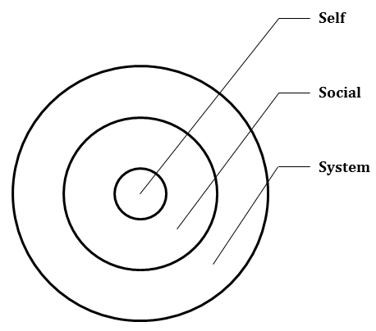
Figure 1: Awareness of Self, Social System

A classic way of illustrating the limits of what we can ever know or see is the ice-berg diagram which has 90% of its mass hidden beneath the sea.
Figure 2: Ice-berg [credit: https://www.flickr.com/photos/jeffmikels/]

Why is Systems Thinking Important to Special Needs?
Systems thinking becomes more important the more complex your work is and, as we explore in episode 2, education and special needs can be extremely complex. Complex situations are characterised by being hard to predict such as teaching a student with special needs who may have changing learning requirements; or having to maintain service standards when the resources available are reduced which may never have been done before. The drive towards increased partnership working is also highlighting the need for better systems thinking. Partnership works best when people understand how they are interconnected to their partners and how their partners exist within a set of different systemic factors.

Three Core Capabilities
At the heart of this course we will be seeking to develop three core capabilities:

Being adaptive: the ability to be sensitive to the particular situation and respond flexibly according to the particular needs as opposed to pushing a particular agenda.

Open minded: the ability to be able to consider various view points.

Seeing the whole picture: the ability to be aware of as much as possible not just the narrow sample of information that we select.

The Five-Step Approach
Figure 3 below outlines the systems thinking for special needs five-step approach.

Figure 3: The System Thinking for Special Needs Five-Step Approach

Exercises
Think about or discuss the following questions:

- Does this approach make sense to you?
- Where are you on the five step approach?
- How could you modify the approach to make it better suit your situation?

Episode 2: Understanding Your Challenges

Why?
The purpose of this episode is to explore the different types of challenges you face and identify those complex challenges which will best be tackled through systems thinking.

Content
Types of Challenges
Here we break challenges down into three types:
- Simple, these are tasks which can be achieved easily, such as producing a lesson plan.
- Complicated, these are difficult challenges which may involve significant thinking and discussions but in the end can be solved, such as producing a timetable for a busy college.
- Complex challenges usually don’t have obvious answers, if indeed they do have answers at all. For example, trying to maximise student performance while cutting resources or getting the most out of students with learning difficulties. Tricky challenges that will require careful and sensitive responses to specific circumstances.

Harvard Professor Robert Heifetz says that many people and organisations confuse technical (complicated) with adaptive (complex) challenges. This is something we see a lot in organisations when people try and gather research for often inherently complex areas which can only be better understood through experience.

Exercises
Exercise 1: Are Challenges Complicated or Complex?
Figure 4 below is a spectrum going from complicated to complex. It can be useful when considering the challenges we face.

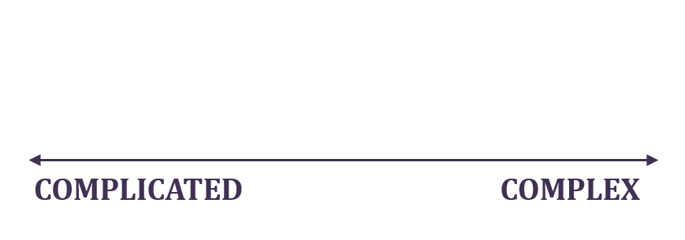
Figure 4: Spectrum Complicated – Complex

An exercise we suggest you plot the following challenges on that spectrum according to your own experience:
- Using someone else’s TV
- Staying Fit
- Ensuring your meetings are effective
- Supporting a person with special needs to learn
- Maintaining SEND service standards with less cash.

Our responses to these questions are shared in the videos.

Exercise 2: Plot Your Challenges on the Complicated to Complex Spectrum
You should be getting a sense of the difference between complicated and complex challenges. We suggest now that on a piece of flip chart paper you draw up the complicated to complex spectrum, and plot all the significant challenges you face on that spectrum, as has been done in Figure 5.

If you are working as a group we recommend that each person spends time writing up several challenges (3-5 each one per post-it note) on their own before you discuss and stick them on the flip chart.

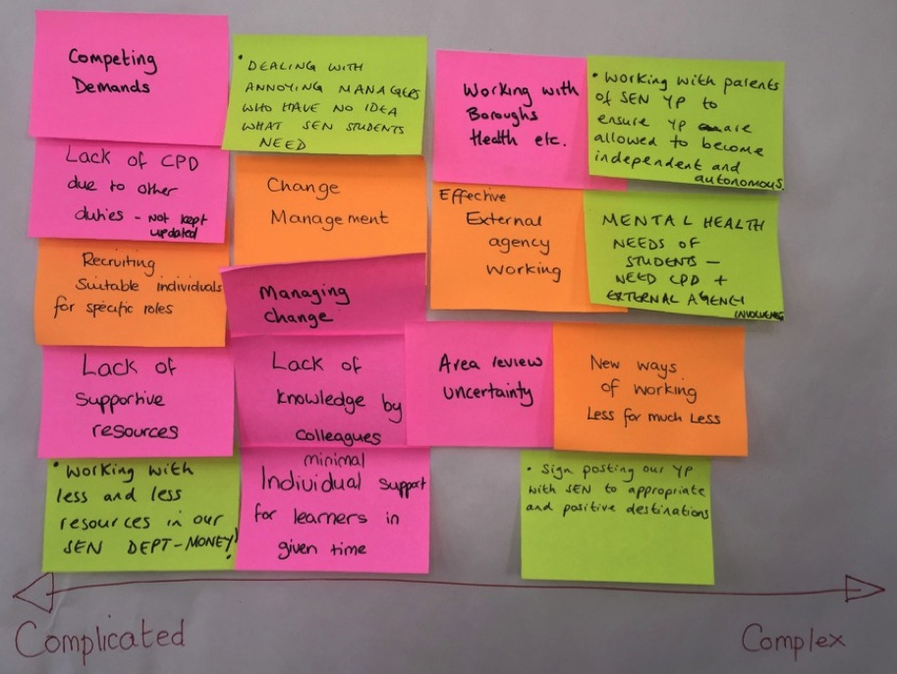
Figure 5: A sample of plotting SEND challenges on the complicated too complex spectrum

When undertaking this exercise as a group it’s critical to explore how different people may see different challenges differently. There tends not to be absolute right and wrong answers here; but seeking to understand one another’s different perspectives is foundational to support systems thinking.
Exercise 3: Challenge Identification
Between now and the next episode we want you to identify the challenge you are going to work with over the rest of this course. This should be a real challenge you are facing now and it should be a challenge that has got what we call ‘potency’. What we mean by potency is:
- It should be generally agreed as very important.
- It should have a diversity of competing views on how to deliver it.
- The final outcome is likely to be unclear in some way.
Examples might be: managing Education Health and Care plans, delivering a major service change or closure, working with parents and carers of those with special needs, or something else.
What’s most important is that it’s real and a challenge you have a strong desire to work on.

Episode 3: Self Awareness (Step 2)

Why?
This episode introduces you to how you see the world, what your worldviews are and how it affects everything you do. At the heart of systems thinking is always seeking to see as complete a picture as possible of what is going on in any given situation. While also recognising that our own view is always inherently limited by our own knowledge, experience and worldview. This episode will help you become aware of how you see the world.

Content
Our Assumption and Beliefs
The consideration of our challenge must start with the questions: How do I see the challenge? What assumptions and beliefs do I hold about it? Because before we can start inquiring about how others may see the challenge, or seek to understand the systemic dynamics influencing the challenge, we must first seek to truly understand how we see the challenge.

Personality Profiles
At some point you may have undertaken a personality profiling exercise such as Myers Briggs. There are very many personality profile tools that exist and we think these can be really helpful to get additional insight into what makes you tick. Figure 6 seeks to illustrate the phenomena of how we are influenced by our experience, this is known as Neuro Linguistic Programming.

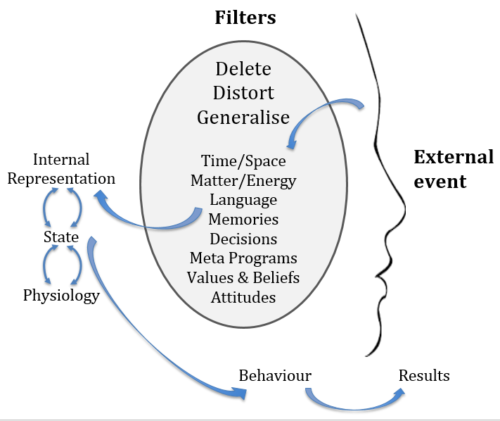
Figure 6: Neuro Linguistic Programming

Information Selection
We tend to select information based upon our programming, see Chris Argyris’ Ladder of Inference in Figure 7. This illustrates the importance of developing an awareness of what you choose to pay attention to (or not pay attention to) and how this shapes your beliefs and ultimately your actions.

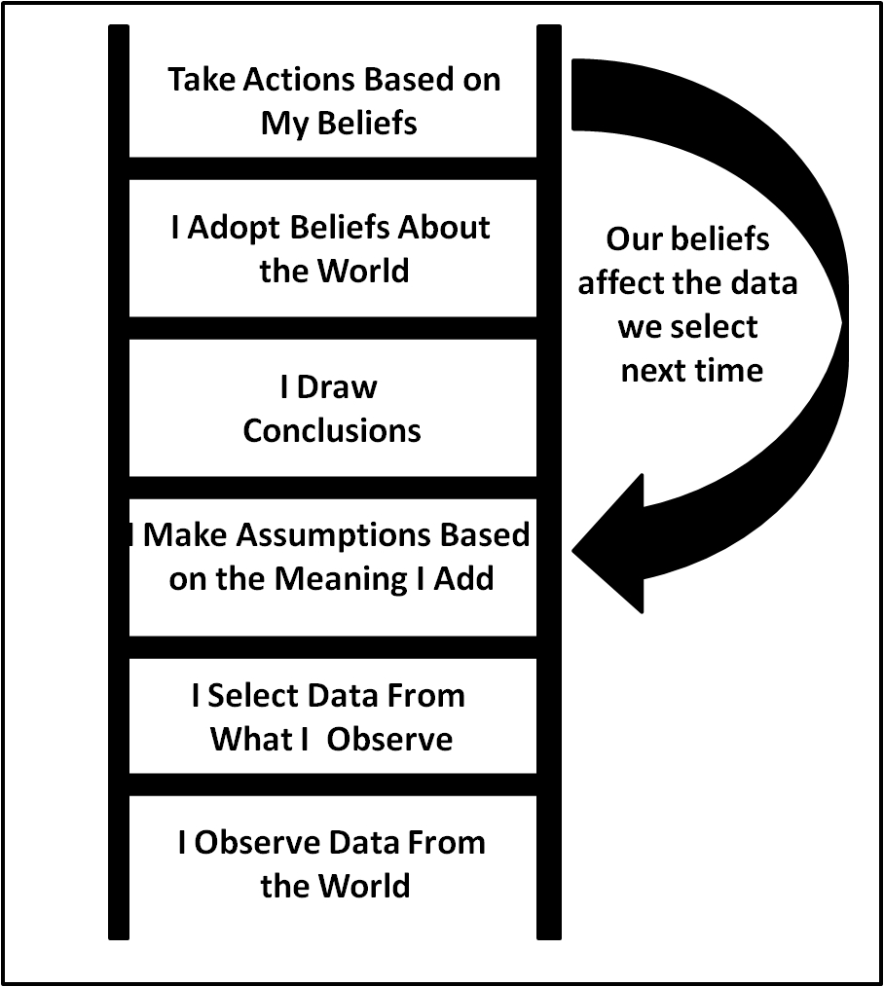
Figure 7: Ladder of Inference (as per Chris Argyris)

Exercises
Exercise 1: Personal Artefact
Find an artefact that you are particularly attached to, something which has some kind of special meaning or significance. Tell the story of how you came by it, why it is important to you, and what values, beliefs and assumptions of yours are reflected in it. Spend five minutes using this to introduce yourself to yourself, or, if working in a group, to introduce yourselves to each other, in a way which tells you something about your assumptions and beliefs.
Exercise 2: Sharing Challenge Assumptions
Think about what your assumptions and beliefs are in relation to the challenge that you identified in episode 2. If you’re in a group, then openly share and discuss, without judgment, what your assumptions and beliefs are with each other.

Exercise 3: From Advocating to Inquiring
Experiment with shifting away from ‘advocating’, (telling others what you think) toward an attitude of ‘inquiring’ (asking how others see it). Be ready to frame/explain this change, even to illustrate it with an example or story, so others are aware that you are experimenting with a different approach. Notice (without judging) the effects – on you, and on others. (As per Torbert and Taylor http://www.williamrtorbert.com/wp-content/uploads/2012/06/HAR-chapter-Torbert-Taylor.pdf)

References
Argyris, C and Schön, D (1974) Theory in Practice. Increasing professional effectiveness, Jossey-Bass, San Francisco
Torbert WR and Taylor SS (2008) Action Inquiry: Interweaving Multiple Qualities of Attention for Timely Action: The Sage Handbook of Action Research, Participative Inquiry and Practice, Sage, London

Episode 4: Social Awareness (Step 3)

Why?
One of the fathers of systems thinking, C. West Churchman, said that “A systems approach begins when first you see the world through the eyes of another.” The purpose of this episode is to begin the process of becoming conscious of the beliefs and perspectives of others.

Content
The Filter Bubble
It’s becoming more and more difficult to ‘see the world through the eyes of another’ because of the internet, and the personalisation embedded in the internet. On our social streams we tend to follow things that we already like and believe in, and search engines will give us results based on previous searches, this limits our exposure to people and ideas different to our own.

Exercises
Exercise 1: Diagram
Look at figure 8 below, what does this diagram mean?

Figure 8: People and Their Worldviews

Thinking about what this diagram could mean, or discussing it with your group should reveal how different perspectives can lead to different answers.

Exercise 2: Personality Type
Below you can see the Myers Briggs personality typology which you may already be familiar with.

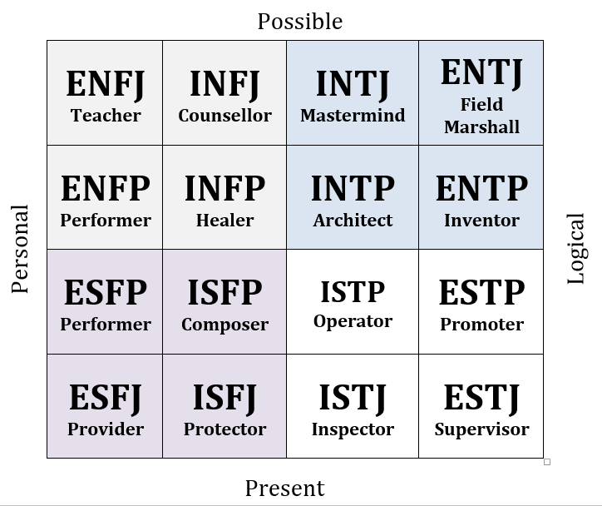
Figure 9: Myers Briggs Table

We’re going to focus on a different personality typology, the Action Logic Framework below, because it is explicitly on systems thinking. There are seven types of leaders according to the Action Logic Framework. Think to yourself, which of these seems to most apply to you. If working in a group, have a conversation about the types you think you are, and what type you think dominates in your organisation. (As with all personality type tests, this can be seen as a useful tool to help us understand ourselves, but definitely not an absolute way of labelling people. It’s important to only employ these tools as far as they are useful.)

Type | Characteristics | Strengths | Weaknesses | 2015 %
Opportunist | Wins any way possible | Good in emergencies and in pursuing sales | Few people want to follow them for the long term
Diplomat | Avoids conflict | Supportive glue on teams | Can’t give painful feedback or make hard decisions | 0%
Expert | Rules by logic and expertise | Good individual contributor | Lacks emotional intelligence | 7%
Achiever | Meets strategic goals | Well suited to managerial work | Inhibits thinking outside of the box | 52%
Individualist | Operates in unconventional ways | Effective in venture and consulting roles | Ignores key organisational processes and people | 33%
Strategist | Generates organisational and personal change | Generates transformations | None | 8%
Alchemist | Generates social transformations | Leads society-wide change | None | 0%
Table 1: Action Logic Framework

Exercise 3: Identifying Stakeholders
Thinking about your challenge, spend some time alone or in your group listing all of the people and stakeholders who are involved.

Map those people you’ve thought of onto the stakeholder mapping tool below.

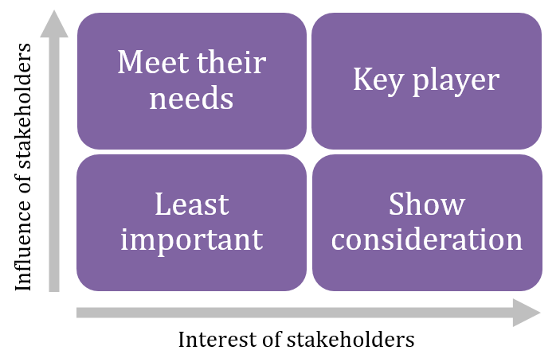
Figure 10: Stakeholder mapping tool

Exercise 4: Social Awareness
Identify 3-6 people who are key players in your stakeholder map. Now try to inhabit their life and imagine what it’s like to life their everyday life, and what their perspective on the world is.

Now identify one really difficult person to work with who is also a key player. Do the same thing and try to inhabit their world.

References
Churchman CW (1968) The Systems Approach, Dell Publishing, New York
Pariser E (2012) The Filter Bubble: What the Internet is Hiding from You, Penguin, London

Episode 5: System Awareness (Step 4)

Why?
Our challenge will be part of a wider system. Identifying the characteristics of this system will help us with our challenge. The purpose of this episode is to establish what it is you are calling the ‘system’, of which your challenge is a part, to try to understand the characteristics and properties of the system, and to ask: how does the system maintain itself and how does it relate to other systems?

Content
Complex Systems
We need a way to deal effectively with complex systems. As the exercises in episode 2 demonstrate, it is important to be able to differentiate complicated challenges from complex challenges, and approach them appropriately. Systems thinking is the appropriate way of dealing with complex problems.

Systems Thinking
Systems thinking is a way of being in the world, and it is based on a model of outer and inner arcs. The outer is a way of seeing systems and their characteristics, and the inner is the attitude of mind we have in relation to the outer.

Exercises
Working alone or with your group, draw three circles. Your challenge is at the centre. In the next ring, the system as it is within your organisation or immediate circle, in the outer ring, the system as it is outside your organisation or network, say in partner organisations. See the example below.

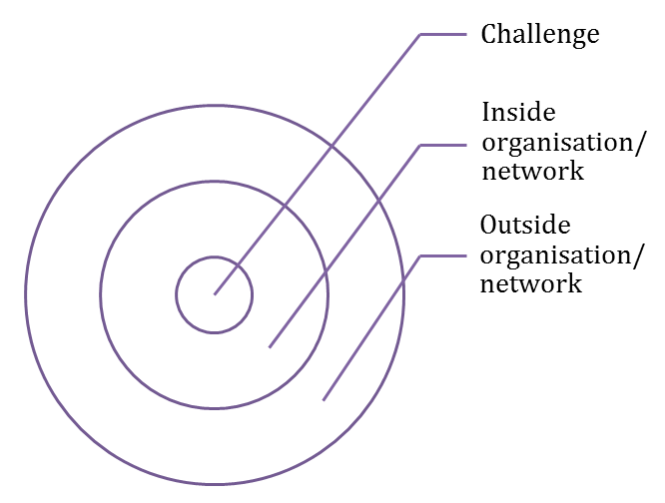
Figure 11: Challenge rings

Identify the key dynamics of the system and populate your circles with this information:

- Where are you placing the boundary? What lies outside? What if you move it?
- What are the parts, the interdependent activities, people, processes etc.?
- What emerges – greater than the sum of the parts?
- What are the goals, the purpose of this system?
- What is the source of energy which keeps the system going?
- Who are the players?
- What are the rules of the game?
- How does the system behave over time? Map some data, or tell stories about it.
- Are there feedback loops – positive or negative?
- How does it self-organise and recover after changes?
- Is it complicated and predictable, or complex and unpredictable?
- What stays the same while constantly changing, or constantly changes while staying the same?
- How does information flow and who has/doesn’t have it?
- Does the system learn?
- What are the constraints, and layers of constraints – people, money, rules, time, perceptions etc.?
- How does the system maintain itself – the underlying assumptions and beliefs?
- What are the relationships?
- Who holds power?
- What is the relationship between this system and others? How does it maintain itself in relation to other systems?
- If you don’t like all this detail, simply ask – what is really going on here? Describe without defining or judging.

References
Meadows D (2008) Thinking in Systems: A Primer, Chelsea Green Publishing

Episode 6: Action Experiment (Step 5)

Why?
We need to apply systems thinking to our challenge.

Analysing something usually means working with the benefit of hindsight, but systems are dynamic, always moving forwards, their context and elements constantly changing. Better to look for solutions to complex systems by looking forwards rather than back, by acting and experimenting, learning from the future.

Content
Systems Mind-set
There are several tools for applying systems thinking – Systems Dynamics, Soft Systems Methodology, and others. See Michael C. Jackson’s book for summaries of 10 such tools.

But key to using all these is to have the systems mind-set, or way of being.

- See the world whole, be aware of the way we are thinking, let go the need to be right.
- See the issue from multiple perspectives with an attitude of genuine learning and curiosity - open, flexible, moving toward solutions, embracing what emerges, describing rather than defining, noticing rather than judging, open to different ways of knowing (intuition, emotion, know-how, expert-led), seeing ‘both-and’ rather than ‘either-or’.

Most significantly, experiment in action, to ‘open a crack to let the light in’ (as per L Cohen).

Action Experiment
Action experiment is about trying out different ways of doing things, to see what effect this has.

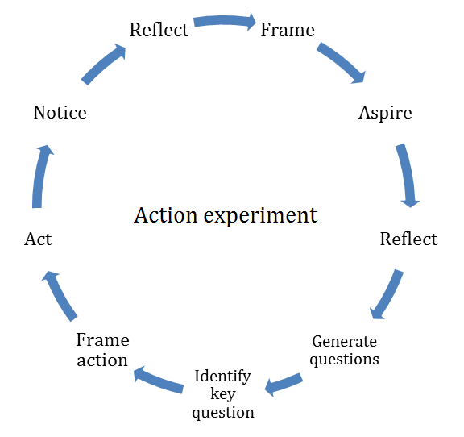
Figure 12: Action Experiment Diagram

An Action Experiment is a way of being, and is likely to involve some or all of:
- Being as inquisitive and curious as I can be
- Trying to notice my own stance and how it might get in the way
- Trying to start conversations, hearing as many points of view as possible, rather than trying to persuade people
- Trying to notice my (and other people’s) assumptions and check them out
- Trying to make as many connections as I can with and between others
- Accepting that there is no right answer – I am learning by doing, letting go of the need to be right

Suggestions
- Start small.
- Start where you feel energised, interested, ‘edgy’.
- Keep your overall aim simple – not trying to change the world (at least not straight away!). Your aspiration may change as the experiment unfolds.

- Start alone or with one or two others.
- Prepare the ground – it may take time to persuade people.
- Work through cycles of action and reflection.
- Enrol others as appropriate, as you go through these cycles and as you gain confidence. Be ready to shift from ‘my’ experiment to ‘our’ experiment.
- Work with those who share your purpose, find friends – how to deal with those outside the group is one of the questions that may need to be answered.
- Work through conversation and relationship.

- Try to be in experimental mode, learning, open to what emerges.
- Answer your questions through action – by acting in the world (which is not the same as just thinking about it).
- Notice what happens. (Noticing is not judging.)
- Notice what effect you are having on this work and what effect is it having on you.
- Notice what effect you are having on others and what effect they are having on you.
- Keep a running record. It helps you and others notice what is going on (small things might matter in creating / not creating big changes).
- Forgive yourself and others.

- Constantly scan – what is emerging, changing?
- What knowledge exists already and how do we use it? (This might be an early question and action)
- What is happening? Be ready to change
- What might we build on? What opportunities are there?
- Are there some symbolic things happening which disguise deeper issues?
- What tools might we use? What is the flow, are there feedbacks, traps etc?

- Notice what emerges and how you respond to it – inner and outer.
- Are you using other ways of knowing – intuition, feeling, action?
- Reflect on this and on what you learn from it. What new questions arise?

- It won’t necessarily be easy!
- If it gets blocked, be prepared to stop and try something different.
- Don’t worry if it’s messy.
- Who do you share it with? Who helps you think about where to go next?

Exercises
In relation to your challenge, think about or discuss what areas you can control, can influence, and can’t control (See figure 13). Then think about what your next steps are to affect the system and benefit the challenge.

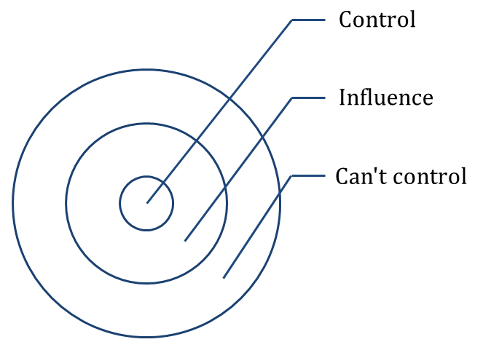
Figure 13: Spheres of Control/Influence

References
Coleman G, Marshall, J and Reason P (2011) Leadership for Sustainability – An Action Research Approach, Greenleaf Publishing, UK
Heron J and Reason P (2006) The Practice of Co-operative Inquiry: Research ‘with’ rather than ‘on’ people. Handbook of Action Research, Chapter 12. Sage, UK
Jackson MC (2003) Systems Thinking: Creative Holism for Managers, Wiley
Marshall J (1999) Living Life as Inquiry: Systematic Practice and Action Research, 12(2), 155-171 Also at http://www.randj.plus.com/Papers/1999%20Marshall%20LivingLifeasInquiry.pdf
McNiff J (2002) Action Research – principles and Practice 3rd Edition, Routledge, UK
Rudolph JW, Taylor, SS and Foldy EG (2001), Collaborative Off-line Reflection: A way to develop skill in action science and action inquiry. In P. Reason & H. Bradbury (Eds.), Handbook of Action Research: Participative Inquiry and Practice (pp. 405-412), Sage Publications, London
Torbert, WR (2004) Action Inquiry: The secret of timely and transforming leadership, Berrett-Koehler Publishers, San Francisco
Torbert WR and Taylor Steven S (2008) Action Inquiry: Interweaving Multiple Qualities of Attention for Timely Action The Sage Handbook of Action Research, Participative Inquiry and Practice, Sage, London
Watton, Collings and Moon on Reflective Writing - http://www.exeter.ac.uk/fch/work-experience/reflective-writing-guidance.pdf

Episode 7: Impact

Why?
Here we explore how you can monitor the impact of your work.

Content
Adaptive Structures
As described in episode 6, the challenges we face over time will change and we will need to continually adapt what we do according to these changing needs. In order to guide how we make these adaptations we think it’s important to gather evidence of our impact. This shouldn’t be laborious evaluations, rather, gathering intelligence as you work to ensure that your actions are as effective as possible. Measuring impact is becoming ever more important within the wider organisational frameworks we are in. So here we outline some simple structures for gathering the key information to inform your work.

Developing a Theory of Change
A Theory of Change is all about getting very clear and explicit about your goals, how you plan to achieve, how you will know when you have achieved them and any assumptions that exist in your approach. It’s incredibly helpful as very often organisations will state a goal such as ‘doubling the life chances of young people’ which might sound impressive but means very little without a lot of extra detail. For example what do we mean by life chances? What is a young person? Why should our model be better than what’s gone before? Table 2 below gives an example of this for a special needs services.

Desired Outcomes | Indicators and verification | Systems thinking theory of Change | Audience and desired competencies and behaviours | Indicators and means of verification for these competencies and behaviours | Outputs (leadership activities) and monitoring
Educational standards improved | Benchmarking against existing metrics (e.g. grades) | If people better understand the systemic dynamics that their organisations operate within they should become more effective as they will understand better where to focus their effort. | SEND managers will better understand systems thinking and therefore behave in ways which show greater sensitivity to elements of the system: e.g. people and organisations. | Production of jointly owned regional strategy that has got high buy-in from staff and stakeholders. | Multi-stakeholder workshops with significant decision-making power.
Table 2: Example Theory of Change Framework

Exercises
Coming back to your challenge now, complete a Theory of Change table for the key outcomes sought for your challenge.

Desired Outcomes | Indicators and verification | Systems Thinking theory of Change | Audience and desired competencies and behaviours | Indicators and means of verification for these competencies and behaviours | Outputs (leadership activities) and monitoring
Table 3: Blank Theory of Change Framework

