

Entry 1: Writing
Manufacturing

Module: Filling in forms

Module aims

Main aim
We are learning about filling in forms.


Module: Filling in forms
Aim: We are learning about filling in forms.
There are times when you need to fill in forms. You might fill in a form about yourself when you start work. You need to write:
- a first name
- a family or last name
- a date of birth
- an address
- a telephone number
You write in capital letters or block capitals for most forms.
A B C D E F G H upper case letters or capital letters
a b c d e f g h lower case letters
You can write a date of birth in full: 20 September 1975
You can write the date in numbers: 20/9/1975 or 20/09/1975
Read this conversation between Baye and Joe. Baye is starting work. Joe fills in his registration form.
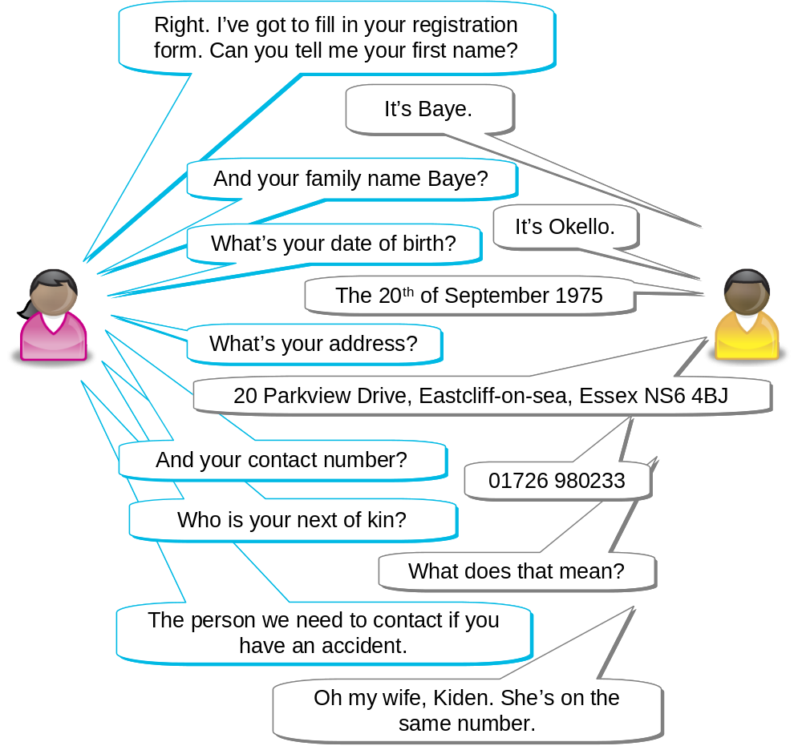
Joe fills in the registration form:
Better Butter Operative Registration Form
Complete in black ink and block capitals.
First name(s): | BAYE
Family name: | OKELLO
Date of birth: | 20/09/1975
Next of kin: | KIDEN OKELLO
Address: | 20 PARKVIEW DRIVE  EASTCLIFF-ON-SEA  ESSEX
Post code: | NS6 4BJ
Telephone: | 01726 980233


Task 1: Fill in the registration form for these workers

1.

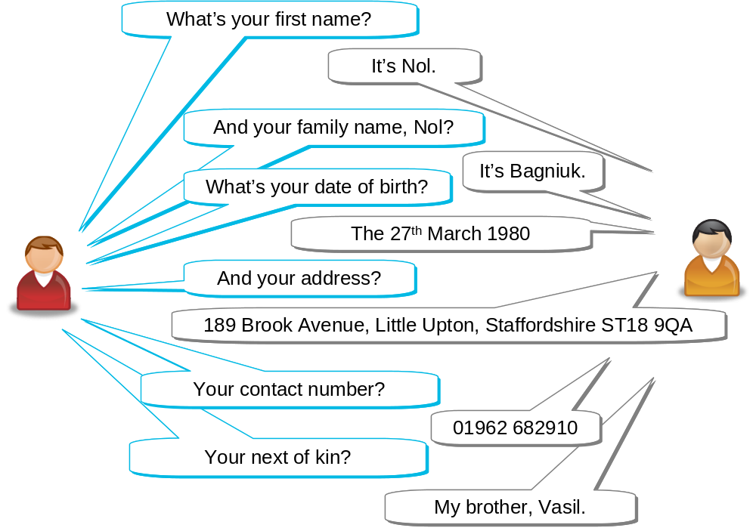

Better Butter Operative Registration Form
Complete in black ink and block capitals.
First name(s):
Family name:
Date of birth:
Next of kin:
Relationship:
Address:
Post code:
Telephone:
2.
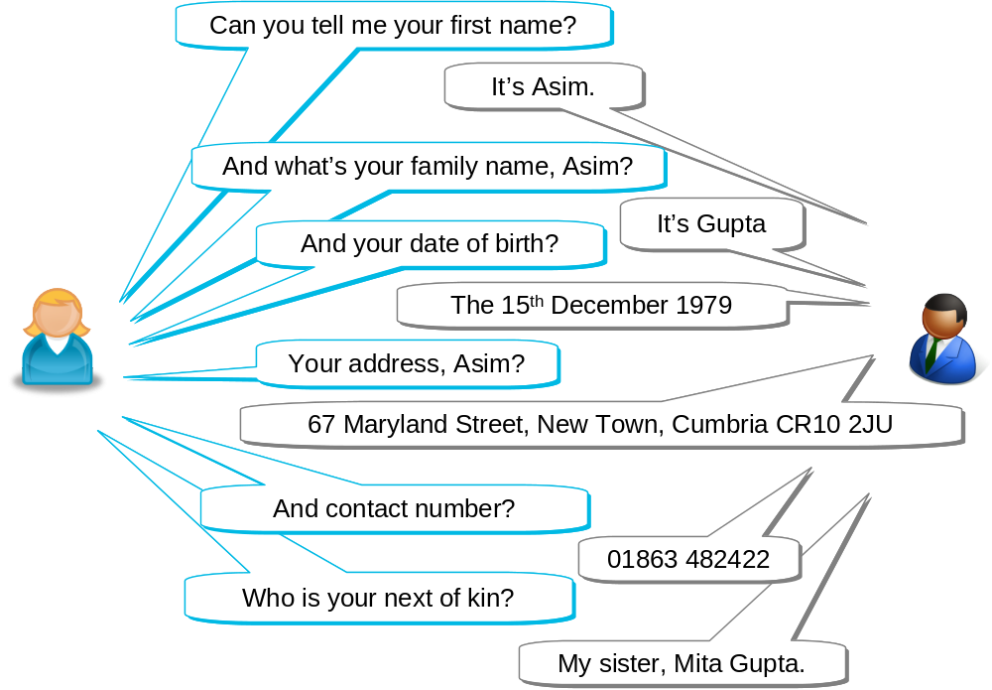

Better Butter Operative Registration Form
Complete in black ink and block capitals.
First name(s):
Family name:
Date of birth:
Next of kin:
Relationship:
Address:
Post code:
Telephone:

How did you get on?

Module 4: Filling in form answers

Task 1 answers

1.

Better Butter Operative Registration Form
Complete in black ink and block capitals.
First name(s): | NOL
Family name: | BAGNIUK
Date of birth: | 27 MARCH 1980 or 27/3/1980
Next of kin: | VASIL
Relationship: | BROTHER
Address: | THE MEADOWS  189 BROOK AVENUE  LITTLE UPTON  STAFFORDSHIRE
Post code: | ST18 9QA
Telephone: | 01962 682910

2.

Better Butter Operative Registration Form
Complete in black ink and block capitals.
First name(s): | ASIM
Family name: | GUPTA
Date of birth: | 15 DECEMBER 1979 or 15/12/1979
Next of kin: | MITA GUPTA
Relationship: | SISTER
Address: | 67 MARYLAND STREET  NEW TOWN  CUMBRIA
Post code: | CR10 2JU
Telephone: | 01863 482422

