
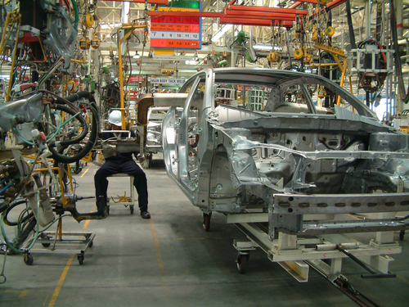
Entry 1: Writing
Manufacturing

Module: Work induction

Module aims

Main aim
We are learning to write in simple sentences.

Other learning aims
We are learning to:
- Use some words from the induction text in this activity
- Write words in the plural.


Module: Induction
Main aim: We are learning to write in simple sentences.

In English simple sentences are made up of:
subject – verb – object or S V O
Sokol wears the gloves. Esha packs the boxes. We fill the bottles.
The subject is what the sentence is about.
The verb is the action that happens.
The object shows what the action is about.
Sentences start with a capital letter:
He has a knife. She helps me. Tell me your name.
Sentences end with a full stop.

Task 1: Answering questions in sentences

You are using the text below to answer questions in sentences. Read the text. Then read the questions. Find the answer in the text. Finish the sentence from the text.

Work induction
You have an induction when you start a new job. An induction  is for people who are new at work. One of the people in charge  gives the induction. | 
Induction is training about the job. It lasts for several days or  weeks. You learn about the job. You learn about the company. | 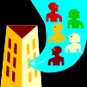
You learn where to report when you start work. | 
You find out about the clothes you must wear. You find out  where to change your clothes at the start of your shift. | 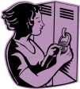
Questions can start with:
What to find out something
Who to know about a person
Where to know about a place
How to find out a way to do something
Questions end with a question mark ?

1. What is an induction?
An induction is _____________________________.
2. Who gives the talk?
One of _____________________________.
3. What do you find out?
You find out _____________________________.
You find out _____________________________.

Work induction
You find out if you need to wear clothes to keep safe. The  person in charge gives you the safety clothes you need to  wear. | 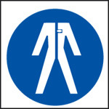
You find out the health and safety rules. | 
You learn where to go for first aid. | 
You find out what to do if there is a fire or an emergency. | 
You must tell the person in charge if something is not clear. | 
Ask the person to say it again or say it in another way. | 

4. Who gives you the safety clothes you need to wear?
The person _____________________________.
5. What do you learn?
You find out _____________________________.
6. What must you do is something is not clear?
You must _______________________________.

Task 2: Subject verb object
Here are some sentences about induction. Use the information to show which word is the:
the subject the verb the object
We have done an example for you.

A | person | in charge | gives | a | talk
 | S |  | V |  | O

1. An induction is a talk.
2. The talk is for new people.
3. You meet people at work.
4. You learn the rules.
5. You get a locker.
6. You find out about first aid.
7. Your employer gives the clothes.
8. You tell the person in charge.

Using punctuation
Each sentence starts with a capital or upper case letter: A T H
Each sentence ends in a full stop.
We use capital letters for:
People’s names: Ola, Mary
Names of places: London, Manchester
Names of companies: Browns Ltd
Names of days or months: Monday, April
When you write about yourself you use a personal pronoun: I
Task 3: Using punctuation
Look at the writing. It needs some punctuation. Put in the correct punctuation. The first one is an example.
Sokol gets tran some boxes
Sokol gets Tran some boxes.
1. i need to go to First Aid.
2. His name is azi.
3. Please put that in the locker
4. where does Ewa clock on?
5. You must not smoke in the factory
6. where do I report?
7. You are working afternoon shift on monday.
8. Take the dust mask to ola.

Task 4: Writing simple sentences
Dana and Ewa look at the factory floor. They look at things that need to be done. Dana writes some short notes.
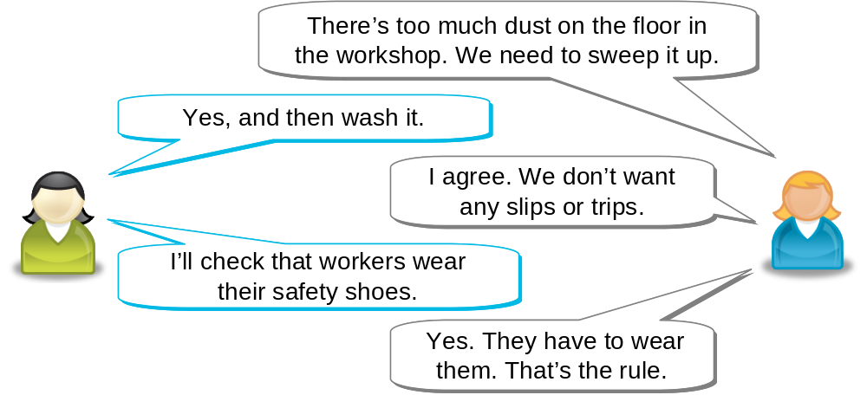
What does Dana write?
Dana writes:
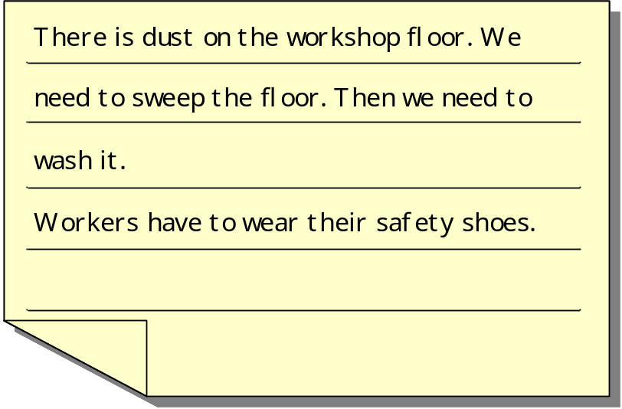

1. Tran is checking the work with Mike.
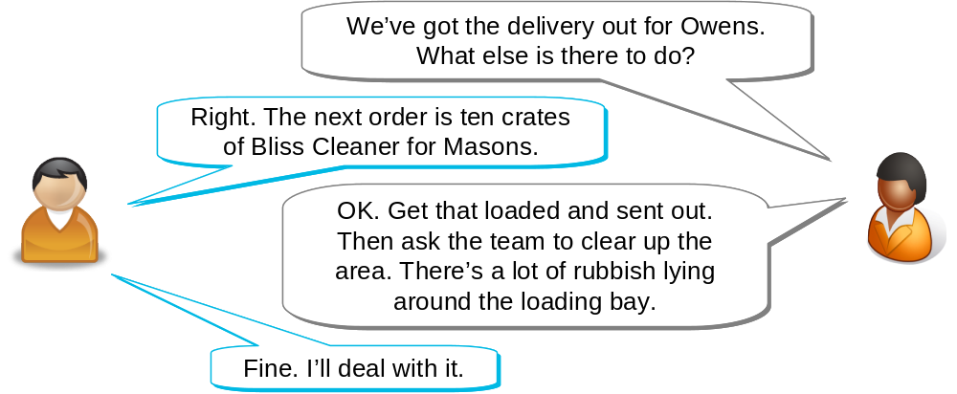

Write the notes for Tran in sentences.
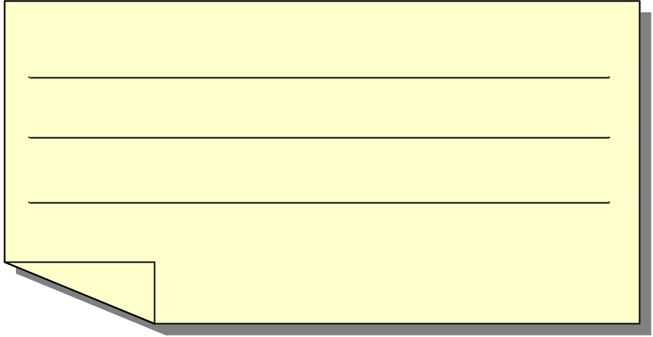

2. Talia is checking the line with Ola.
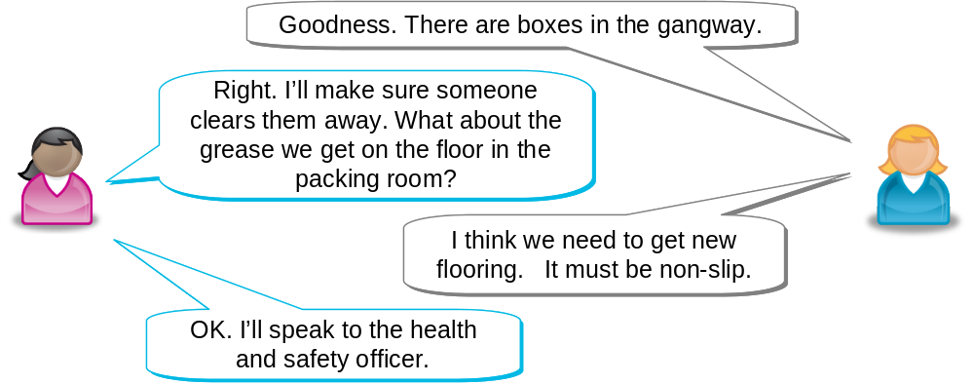

Write the notes for Talia in sentences.

Aim: We are using some words from the induction text in this activity. We are learning about writing words in the plural.

Making the plural of nouns
A noun is a word that names something. A noun tells you the name of a person, too.
When you write about more than one thing, you add an s to the end of the noun.
fire fires
tabard tabards

If a noun ends in s ss x z sh ch, you add es to the end of the word.
scratch scratches
brush brushes
box boxes

There are some words that do not follow the rule.
person people
woman women
man men
child children
foot feet

Task 5: Plurals
Here are some words from the work induction text. The words are in a sentence. They have a line under them. Write that word in the plural in the gap. The example shows you what to do.

There is one trilby hat.
There are some trilby hats.
1. Get the box off the track
Get the _______ off the track.
2. He needs a beard snood.
They need some beard _________.
3. There is a new person today.
There are some new _____________ today.
4. Pack the watch in the box.
Pack the ____________ in the box.
5. Ola wears a high viz jacket in the warehouse.
Ola and Ewa wear high viz _________________ in the warehouse.
6. There is an oil splash on the factory floor.
There are some oil ______________ on the factory floor.
7. The man changes his clothes in the locker room.
The __________ change their clothes in the locker room.
8. Follow the health and safety rule.
Follow the health and safety __________ .

Task 6: Word grid
Here are some of the words from the reading tasks. Fill these words into the word grid. We have put some letters in the grid to help you. The first one is an example.

induction | report | safety | locker
training | clock | exit | clothes
emergency | shift | health | supervisor
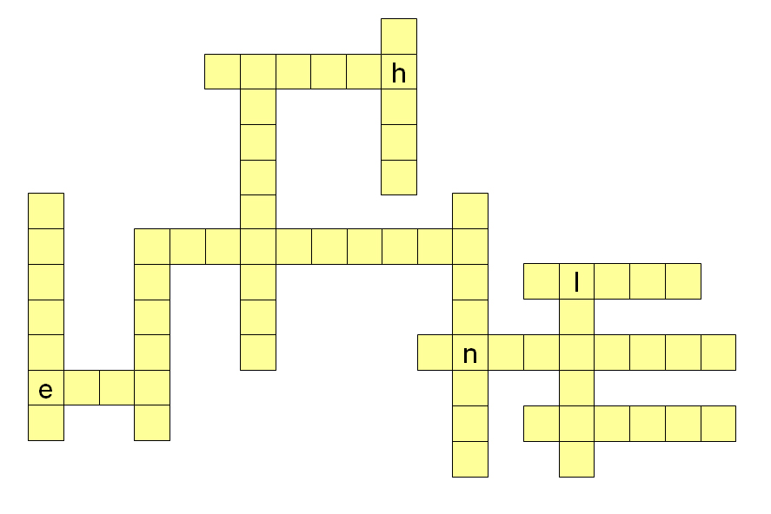

How did you get on?

Module 1: Induction answers

Task 1 answers

1. What is an induction?
An induction is _____for people who are new at work_____.
2. Who gives the talk?
One of _____ the people in charge gives the induction____.
3. What do you find out?
You find out ____ about the clothes you must wear_______.
You find out _____ where to change your clothes at the start of your shift______.
4. Who gives you the safety clothes you need to wear?
The person __ in charge gives you the safety clothes you need to wear________.
5. What do you learn?
You find out _____where to go for first aid__________.
6. What must you do is something is not clear?
You must ______ tell the person in charge if something is not clear_______.

Task 2 answers

1. An | induction |  |  |  |  |  |  | is |  |  |  |  | a |  |  | talk.
 | S |  |  |  |  |  |  | V |  |  |  |  |  |  |  | O
2. The |  |  | talk |  |  |  | is |  |  |  |  | for new |  |  |  |  |  |  |  | people.
 |  |  | S |  |  |  | V |  |  |  |  |  |  |  |  |  |  |  |  | O
3. You |  |  |  |  | meet |  |  | people |  |  |  |  |  |  |  |  | at work.
S |  |  |  |  | V |  |  | O
4. You |  |  |  | learn |  |  |  |  | the |  |  |  |  | rules
S |  |  |  | V |  |  |  |  |  |  |  |  |  | O
5. You |  |  |  | get |  |  |  |  | a |  |  |  | locker.
S |  |  |  | V |  |  |  |  |  |  |  |  | O
6. You |  | find out |  |  |  |  |  |  |  | about |  |  |  |  | first aid.
S |  | V |  |  |  |  |  |  |  |  |  |  |  |  | O
7. Your |  |  |  |  | employer |  |  |  |  |  | gives |  |  |  |  |  |  | the |  |  |  | clothes.
 |  |  |  |  | S |  |  |  |  |  | V |  |  |  |  |  |  |  |  |  |  | O
8. You |  |  |  |  |  | tell |  |  |  |  | the |  |  |  |  |  |  | person |  |  |  |  | in charge.
S |  |  |  |  |  | V |  |  |  |  |  |  |  |  |  |  |  | O

Task 3 answers

1. I need to go to first aid.
2. His name is Azi.
3. Please put that in the locker.
4. Where does Ewa clock on?
5. You must not smoke in the factory.
6. Where do I report?
7. You are working afternoon shift on Monday.
8. Take the dust mask to Ola.

Task 4 answers

Your note might look like this:
1.
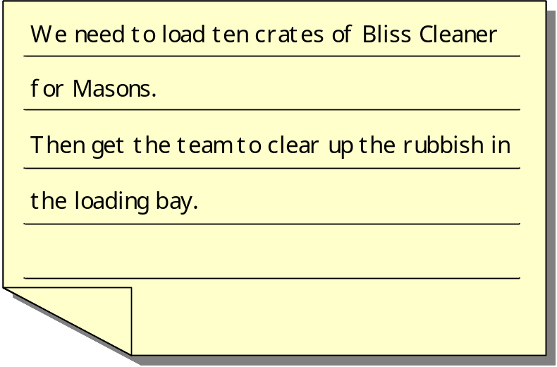

2.
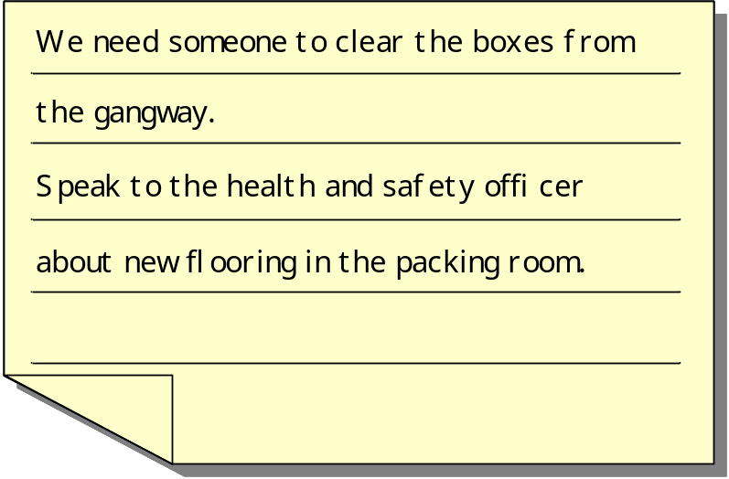
Task 5 answers

There is one trilby hat.
There are some trilby hats.
1. Get the box off the track
Get the ___boxes__ off the track.
2. He needs a beard snood.
They need some beard __snoods__.
3. There is a new person today.
There are some new ___people__ today.
4. Pack the watch in the box.
Pack the ____watches___ in the box.
5. Ola wears a high viz jacket in the warehouse.
Ola and Ewa wear high viz ____jackets____ in the warehouse.
6. There is an oil splash on the factory floor.
There are some oil ___splashes____ on the factory floor.
7. The man changes his clothes in the locker room.
The ___men__ change their clothes in the locker room.
8. Follow the health and safety rule.
Follow the health and safety ___rules___.

Task 6 answers



