
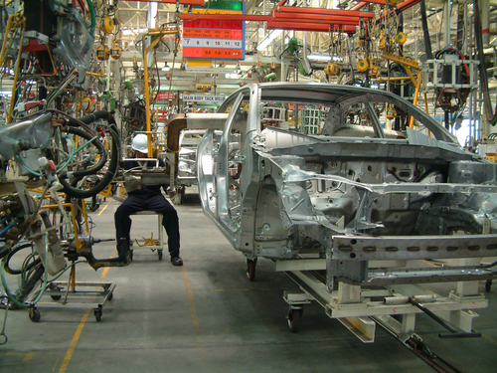
Entry 1: Writing
Manufacturing

Module: Taking notes from a talk

Module aims

Main aim

We are learning to take notes from a talk.


Aim: We are learning to take notes from a talk.
Each factory has a fire evacuation process. Fire evacuation is a way of getting people out of the building in an emergency. You learn about fire evacuation during your induction.


Task 1: New words and phrases

Listen to the talk called Fire Evacuation. Write any new words or phrases in the grid below under word or phrase.

Word or phrase | Meaning

Now listen to the next section of the talk. Listen to the meaning of some of the new words. Write the meaning next to the word or phrase in your own language if you want.

Task 2: Fire evacuation
Listen to the fire evacuation talk again. Make notes of the steps in the evacuation rules. Write the notes in order of what happens. Remember you do not need to write in whole sentences. When you listen to a talk, you take short notes. You can write notes in phrases. Phrases are groups of words.

For instance: If you see a fire, raise the alarm.
You might write: See fire – raise alarm.

Fire evacuation procedure

▼
▼
▼
▼
▼
▼
▼

Task 3
Now write down the fire evacuation for your own factory.

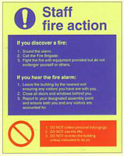

Fire evacuation for_____________________________________

How did you get on?

Module 3: Taking notes from a talk answers

Task 1 answers
Your notes might look like this.

Word or phrase | Meaning
fire evacuation | the way you clear a building in a fire
supervisor | the person in charge of you at work
fire alarm | the bell that rings to warn people about a fire
machine | a piece of equipment with moving parts
fire exit | a way out of the building in a fire evacuation
assembly point | a safe place where people gather outside the building  It can be called a muster point
fire marshal | a person in charge of an area during a fire evacuation

Task 2 answers

See fire – raise the alarm
▼
Report fire to supervisor
▼
Alarm sounds – leave job
▼
Turn off machines
▼
Follow evacuation signs
▼
Use nearest exit
Walk – don’t run
▼
Go to assembly point
Check with fire marshal
▼
Return when told

