
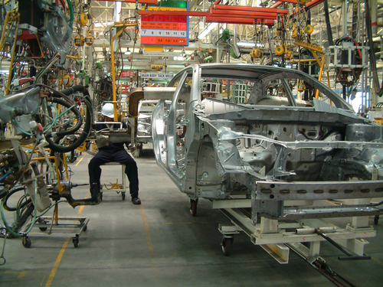
Entry 1: Writing
Manufacturing

Module: Taking notes

Module aims

Main aim
We are learning how to take short notes.


Module: Taking notes
Aim: We are learning how to take short notes.
You do not need to write everything in sentences when you are at work. Sometimes you can write notes instead. You can write the notes in phrases. A phrase is a group of words. It is not a sentence.
You write notes when:

you take a telephone message | 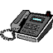
you make a list | 
you make notes about training. | 

For instance, read this phone call:

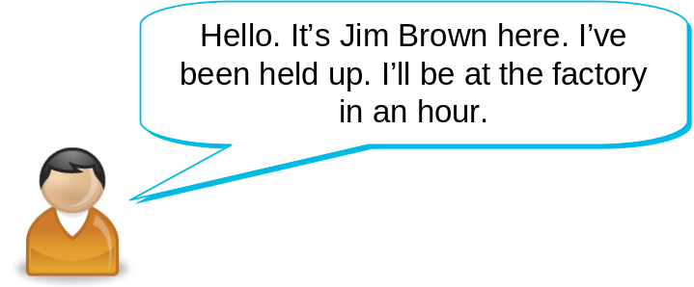
The note might say:

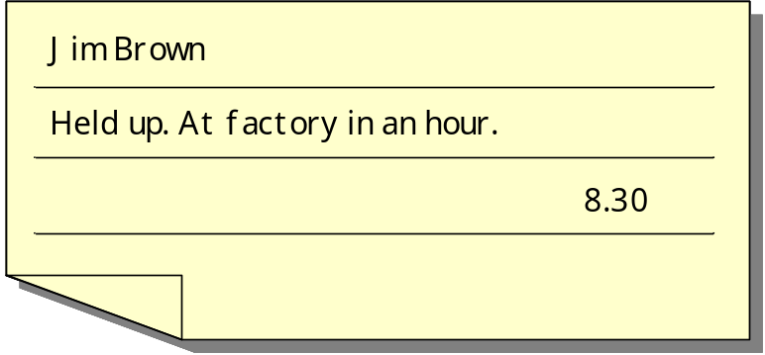
You have training when you work in manufacture. When you have training you make notes. Notes help you remember important things. You do not need to write the notes in sentences.
Read this training session and make notes about what you need to do if you cannot go to work.

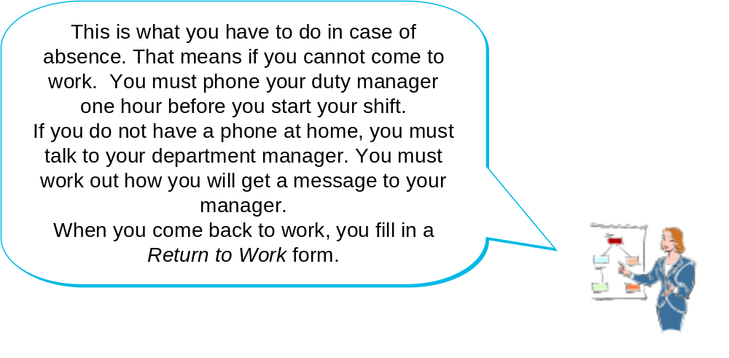
You might write these notes:
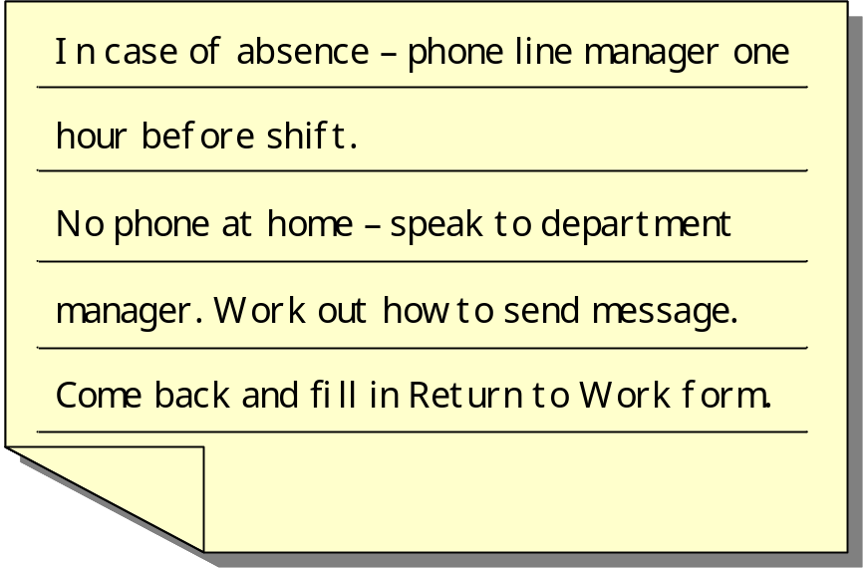

Task 1: Making notes from training

Read this conversation at a training event. Then write notes to help you remember what to do.
1.

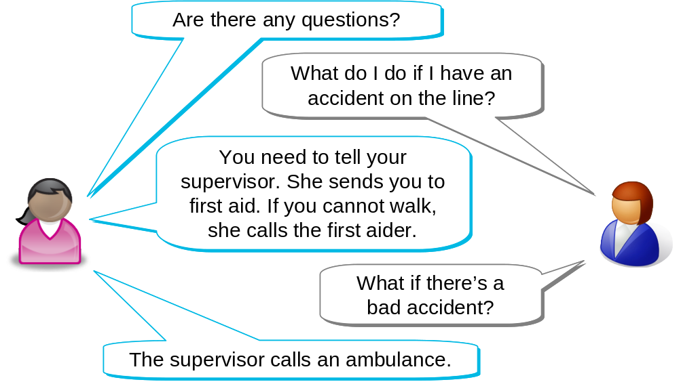

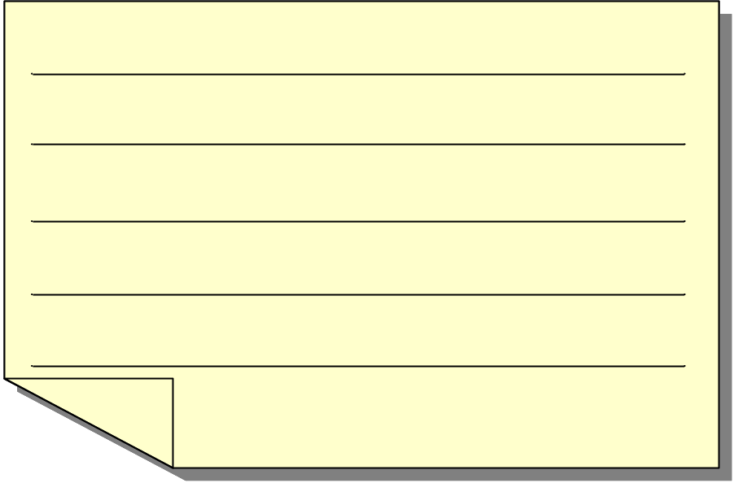
2.
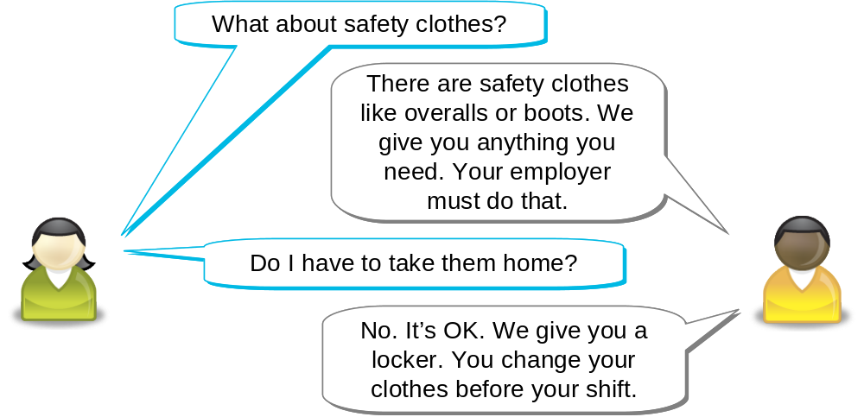

3.

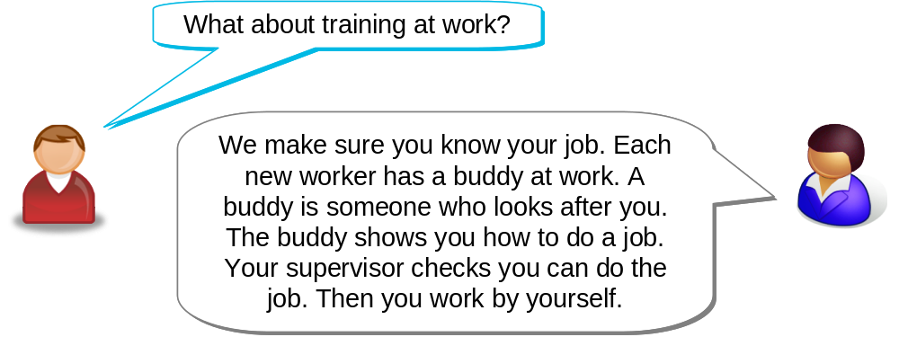

How did you get on?

Module 2: Taking notes answers

Task 1 answers
1.
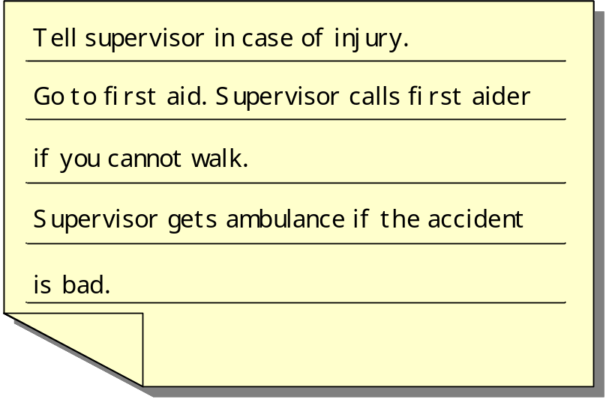
2.
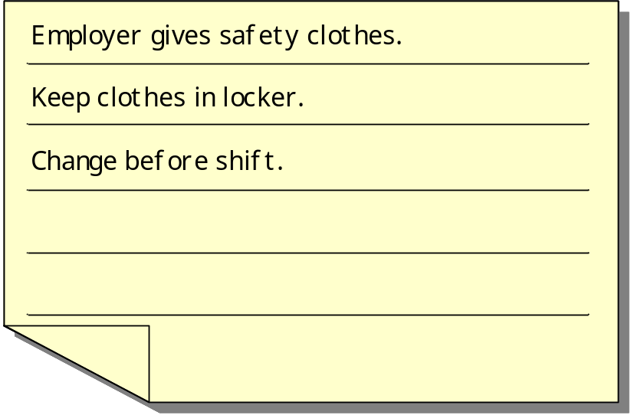
3.


