
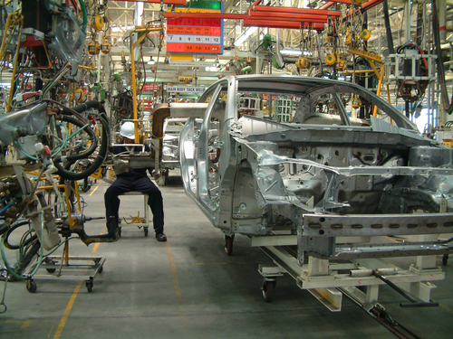
Entry 2: Writing
Manufacturing

Module: Writing accident reports

Module aims

Main aim

We are learning to write in simple and compound sentences.

Module: Writing accident reports

Aim: We are learning to write in simple and compound sentences.
When you work in manufacture, there are times when you need to write in simple and compound sentences:
notes or letters | 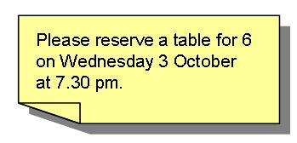 | 
‘near miss’ and accident reports | 
In English simple sentences are made up of:
subject – verb – object or S V O
Sokol weas the gloves. Esha packs the boxes. We fill the bottles.
The subject is what the sentence is about.
The verb is the action that happens.
The object shows what the action is about.
You can join two simple sentences together with a conjunction. A conjunction is a word that joins two sentences together. This makes a compound sentence.
These are conjunctions you see a lot.
and but as or
Sokol wears the gloves and he goes in the fridge.
Jojo works the pouch cutter but she does not work the feeder.
I am cleaning the oil spill as the floor is slippery.
You work on the yoghurt line here or you work in Packing with Mike.
and joins two sentences about a similar subject together
but joins two sentences when the second sentence refers back to the first – the second part usually contrasts with the first
as joins two sentences when the second sentence shows the reason for the first
or joins two sentences where they show a choice between two things

Task 1: Using conjunctions

Join these sentences together. Use the conjunction that suits the meaning. The example shows you what to do.

and | but | as | or
Talia went to the canteen and she ate her lunch.

1. Tran looked for his supervisor ______ he did not find him.
2. Work in Packing this morning ______ they need some help.
3. Boris packs the boxes ______ he loads them on the rack.
4. You can work in Packing this afternoon _____ you can work in Disposal.
5. The line was down for ten minutes _____ it is running now.
6. Ola does the pre-start checks _____ then she presses the start button.
7. You must obey the Health and Safety rules _____ you get the sack.
8. You need to work in the warehouse for a while _____ the line is down.
9. Lech moved the rolls of cloth _____ he stored them in the warehouse

Task 2: Using conjunctions
Read this text about Ola. Then write the passage again using these linking words.

and | but | as | or
Only use them where you think it helps the text to make good sense.
Tran went to work on Monday. He clocked on by the office. Then he went to the locker room. He came back to the office. He could not find his locker key. The person in the office had a master key. She opened Tran’s locker for him. He changed his clothes. He went to check his machine. He did the pre-start checks. The machine did not start. He reported it to Maintenance. They repaired it. His supervisor asked him to work nights next week. She said he could work mornings.
_________________________________________________________________
_________________________________________________________________
_________________________________________________________________
_________________________________________________________________
_________________________________________________________________
_________________________________________________________________
_________________________________________________________________
_________________________________________________________________
_________________________________________________________________
_________________________________________________________________
_________________________________________________________________
_________________________________________________________________
_________________________________________________________________
Using punctuation
Each sentence starts with a capital or upper case letter: A T H
Each sentence ends in a full stop .
We use capital letters for:
People’s names: Stef, Novak, Lee, Yin, Omar, Shafi
Word check
These are called
proper nouns.
Place names: London, or Manchester Airport
Names of companies: Browns Ltd.
Names of days and months: Monday, June
When you write about yourself, you use a personal pronoun…I
Questions end with a question mark. ?
Task 3: Using punctuation
Look at the writing. It needs some punctuation. Put in the correct punctuation. The example shows you what to do.
Tran works with boris on friday
Tran works with Boris on Friday.
1. on Tuesday i worked in the loading bay.
2. Ola worked in birmingham before she came here.
3. you must follow the operating instructions
4. Can you work any overtime on thursday?
5. His name is azi he lives in Sheffield.
6. he is starting work next monday.
7. please help me move these crates i am taking them to the warehouse.

Remember in the module Duties at Work you looked at:
- using helping verbs to show meaning You must do that.
- using the present tense He helps her.
- using the present continuous She working on the line.
- using the past tense We finished yesterday.
In this section we have looked at:
- using linking words to join sentences
- using full stops and capital letters.
You are going to use all these things to write short reports at work.
Task 4: Writing accident reports

Sometimes accidents happen at work. All accidents and near misses must be reported. Ivan is talking about his accident with Rob. Read what Ivan says.
Write the accident reports. Write in sentences and try to use the linking words. The first one is an example.
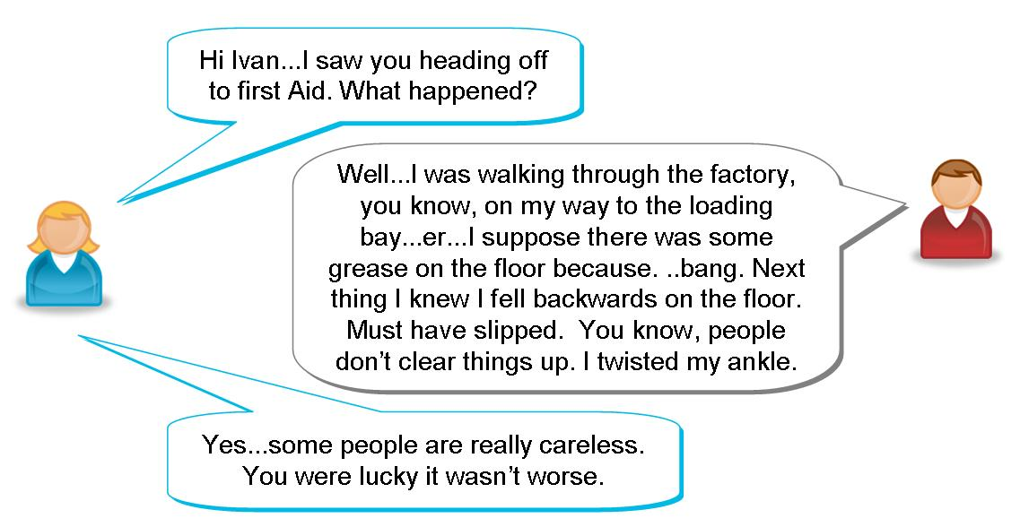

What does Ivan write?

Ivan writes: | 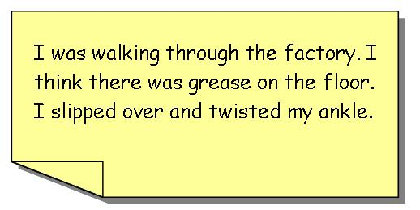

1. Read about Jojo’s accident.
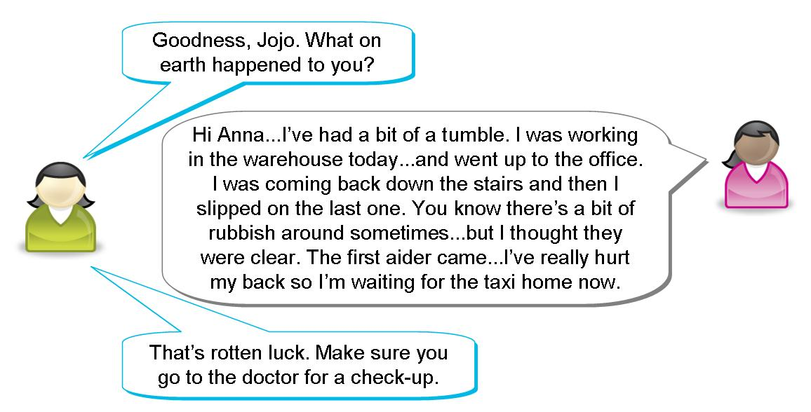
Write the report for Jojo
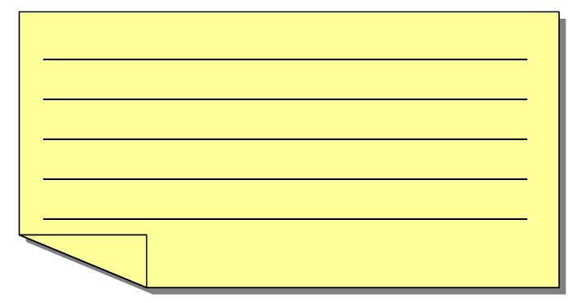

2. Read about Maria’s accident.
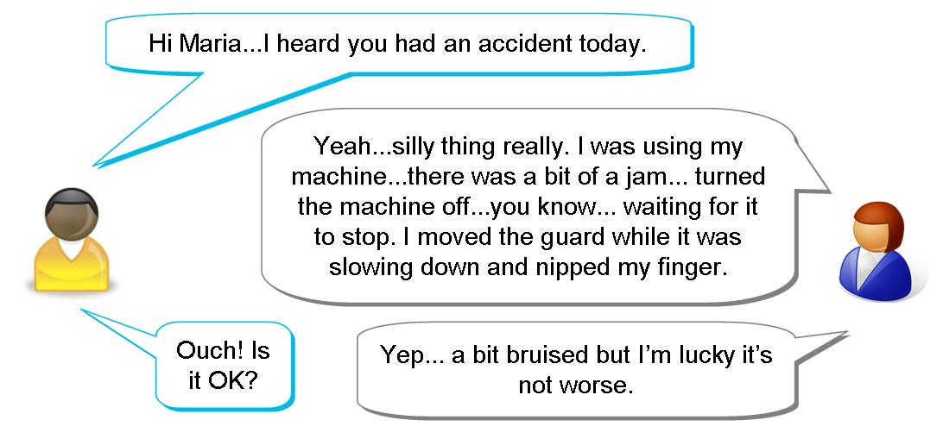
Write the report for Maria

1. Read about Tran’s accident.
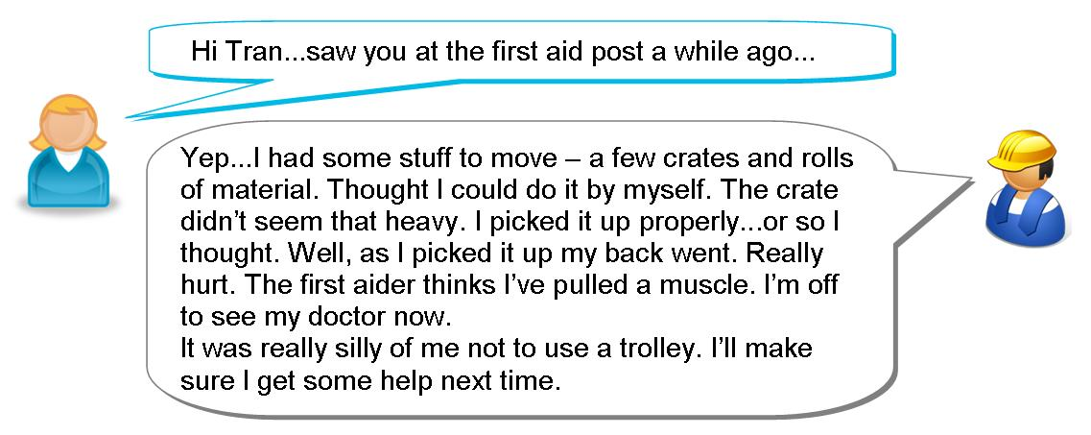
Write the report for Tran

Sickness self-certificate
There are times at work when you need to write in sentences on forms. When you are ill at work, you need to fill in a sickness self-certificate. You have to write about your illness.
This is an example of a sickness self certificate. Your workplace will have its own version.
Look through it and pick out any key words or phrases that you do not know.

PERSONAL DETAILS (Please use BLOCK CAPITALS.)
MR/MS/MISS/MRS | FAMILY NAME |  |  | FIRST NAME(S)
PERIOD OF SICKNESS
FROM  (first day on which you were sick) |  | (day) | date |  | month | year
TO  (final day on which you were sick) |  | (day) | date |  | month | year
DETAILS OF SICKNESS
Please give information about the reason for your absence.

Is the absence because of an injury that happened at work? (Please tick the box.)
Yes  No 
(If YES you should complete an Accident Report Form from HR.)
Do you consider you have a disability (as defined by the DDA)? Yes  No 
Is the absence because of the disability? Yes  No 
DECLARATION BY EMPLOYEES
I declare that the above information is correct.
Signed:..............................................................................................................

Key words and phrases
You might have picked out
period of sickness | the time you are off work ill | 
details of sickness | information about the illness | 
absence | not at work | 
reason for your absence | why you are not at work | 
disability | not being able to use your body or senses fully | 
DDA | The Disability Discrimination Act – this is a law that says that employers have to support people with a disability: there are disabilities named in the Act | 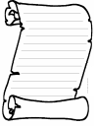
injury | getting hurt in an accident | 
Accident Report Form | a form at work that you fill in if you have an accident | 
declaration | signing that something is true | 

Filling in days and dates
If the form asks for a day, you must write the name of the day:

Monday | Tuesday |  | Wednesday |  | Thursday
Friday |  | Saturday |  | Sunday
If you are asked for a date, you can write it in numbers. For instance:
17 10 2009 is the same as 17th October 2009
Illnesses that might stop you working
a bad cold | 
a migraine | 
a skin infection | 
an accident when you were not at work | 
diarrhoea | 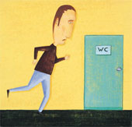
sickness or vomiting | 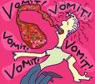
stomach pains or upset stomach | 

Task 5: Filling in a sickness self-certificate
Fill in the sickness self-certificate. Use your own first and last name. Use these notes to fill in these sections:

PERIOD OF SICKNESS From Tuesday 9th April to Thursday 11th April this year

DETAILS OF SICKNESS (Remember to write this section in complete sentences.)
upset stomach sickness diarrhoea

PERSONAL DETAILS (Please use BLOCK CAPITALS.)
MR/MS/MISS/MRS | FAMILY NAME |  |  | FIRST NAME(S)
PERIOD OF SICKNESS
FROM  (first day on which you were sick) |  | (day) | date |  | month | year
TO  (final day on which you were sick) |  | (day) | date |  | month | year
DETAILS OF SICKNESS
Please give information about the reason for your absence.

Is the absence because of an injury that happened at work? (Please tick the box.)
Yes  No 
(If YES you should complete an Accident Report Form)
Do you consider you have a disability (as defined by the DDA)? Yes  No 
Is the absence because of the disability? Yes  No 
DECLARATION BY EMPLOYEES
I declare that the above information is correct.
Signed:..............................................................................................................

How did you get on?

Module 2: Writing accident reports answers

Task 1 answers

1. Tran looked for his supervisor but he did not find him.
2. Work in Packing this morning as they need some help.
3. Boris packs the boxes and he loads them on the rack.
4. You can work in Packing this afternoon or you can work in Disposal.
5. The line was down for ten minutes but it is running now.
6. Ola does the pre-start checks and then she presses the start button.
7. You must obey the Health and Safety rules or you get the sack.
8. You need to work in the warehouse for a while as the line is down.
9. Lech moved the rolls of cloth and he stored them in the warehouse

Task 2 answers

Tran went to work on Monday. He clocked on by the office and then he went to the locker room. He came back to the office as he could not find his locker key. The person in the office had a master key and she opened Tran’s locker for him. He changed his clothes and he went to check his machine. He did the pre-start checks but the machine did not start. He reported it to Maintenance and they repaired it.
His supervisor asked him to work nights next week or she said he could work mornings.

Task 3 answers

1. On Tuesday I worked in the loading bay.
2. Ola worked in Birmingham before she came here.
3. You must follow the operating instructions.
4. Can you work any overtime on Thursday?
5. His name is Azi. He lives in Sheffield.
6. He is starting work next Monday.
7. Please help me move these crates. I am taking them to the warehouse.

Task 4 answers
Your reports might look like this.

1. | 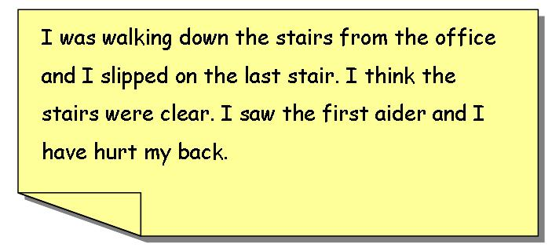
2. | 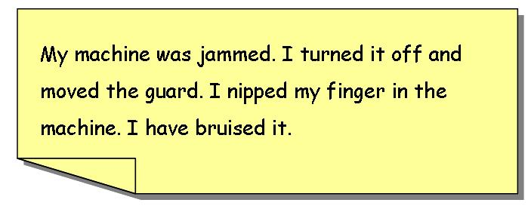
3. | 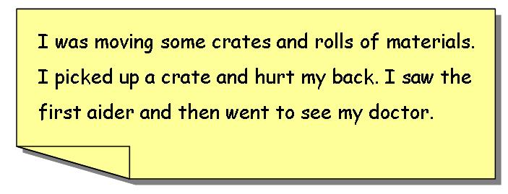

Task 5 answers

PERSONAL DETAILS (Please use BLOCK CAPITALS.)
MR/MS/MISS/MRS | FAMILY NAME |  |  | FIRST NAME(S)
PERIOD OF SICKNESS
FROM  (first day on which you were sick) |  | (day)  TUESDAY | date  9 |  | month  4 | year  20__
TO  (final day on which you were sick) |  | (day)  THURSDAY | date  11 |  | month  4 | year  20__
DETAILS OF SICKNESS
Please give information about the reason for your absence.
I HAD AN UPSET STOMACH WITH SICKNESS AND DIARRHOEA.
Is the absence because of an injury that happened at work? (Please tick the box.)
Yes  No 
(If YES you should complete an Accident Report Form)
Do you consider you have a disability (as defined by the DDA)? Yes  No 
Is the absence because of the disability? Yes  No 
DECLARATION BY EMPLOYEES
I declare that the above information is correct.

Signed:..............................................................................................................

