
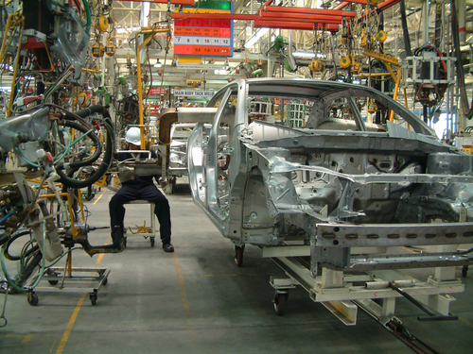
Entry 1: Reading
Manufacturing

Module: Words for work

Module aims

Main aim
We are learning the name of some things you use at work.

Other learning aims
We are learning:
- The letters of the alphabet
- The names of clothes you wear at work
- How to give instructions

Module: Words at work

Aim: We are learning the names of some things you use at work.


Task 1: The Alphabet
We call the 26 letters we use to make words the alphabet.
There two types of letters:
Upper case A B C D E F G H I J K L M N O P Q R S T U V W X Y Z
Lower case: a b c d e f g h i j k l m n o p q r s t u v w x y z
Find the word that starts with the letter. Underline the word. The first one shows you what to do.
Find the word that starts with c.
cap | gloves | beard | shoe
net | tabard | hat | coat
Find the word that starts with n.
cap | gloves | beard | shoe
net | tabard | hat | coat
Find the word that starts with g.
cap | gloves | beard | shoe
net | tabard | hat | coat
Find the word that starts with h.
cap | gloves | beard | shoe
net | tabard | hat | coat
Find the word that starts with c.
gloves | beard |  | shoe |  | net
tabard |  | hat |  | coat
Find the word that starts with t.
cap | gloves | beard | shoe
net | tabard | hat | coat
Find the word that starts with b.
cap | gloves | beard | shoe
net | tabard | hat | coat
Find the word that starts with s.
gloves | beard |  | shoe |  | net
tabard |  | hat |  | coat

Task 2: Clothes for work
Here are clothes you wear in food production. Match the name to the picture. Write it under the picture.

safety shoe | beard snood |  | safety boot |  | white coat |  | cap
tabard |  | safety gloves |  | hair net |  | trilby hat

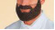 |  | 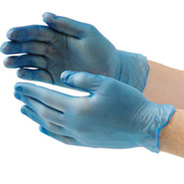 |  | 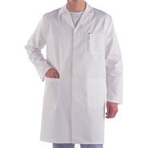

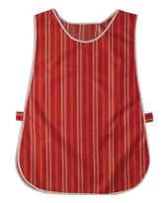 |  | 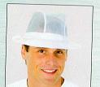 |  | 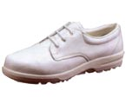

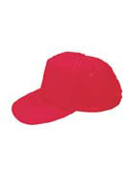 |  | 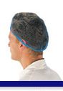 |  | 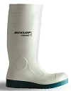

Task 3: Word grid
Here are clothes you wear in food production. Write their names in the grid. There are letters in the grid to help you.

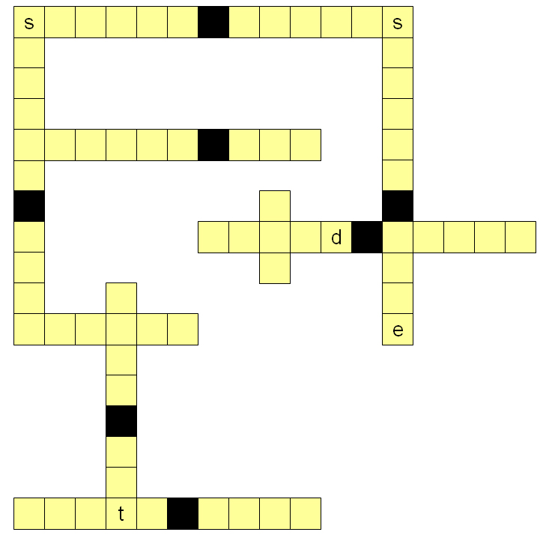
Task 4: Clothes for work
Can you name the clothes? Write the correct word. The first one shows you what to do.

Put on your safety _gloves_.
boots
shoes
gloves
hat
Put on your __________.
safety boots
beard snood
white coat
hair net
Put on your __________ .
hair net
white coat
safety boots
safety hat
Put on your __________ .
beard snood
safety shoes
hair net
trilby hat
Put on your __________ .
boots
tabard
gloves
shoes
Put on your safety __________ .
gloves
shoes
boots
hat
Task 5: The Alphabet
We call the 26 letters we use to make words the alphabet.
There two types of letters:
Upper case A B C D E F G H I J K L M N O P Q R S T U V W X Y Z
Lower case: a b c d e f g h i j k l m n o p q r s t u v w x y z
Find the word that starts with the letter. Underline the word. The first one shows you what to do.
Find the word that starts with m.
shoe | mask | hat | jacket
Find the word that starts with b.
mask | hat | shoe | boot
Find the word that starts with j.
jacket | glasses | overalls | boots
Find the word that starts with g.
jacket | glasses | overalls | boots
Find the word that starts with h.
shoe | boot | mask | hat
Find the word that starts with o.
jacket | overalls | glasses | boots
Find the word that starts with s.
mask | hat | boot | shoe

Task 6: Clothes for work
Here are clothes you wear in factory production. Match the name to the picture. Write it under the picture.

safety glasses | overalls |  | safety shoe |  | mask
hard hat |  | safety jacket |  | safety boot

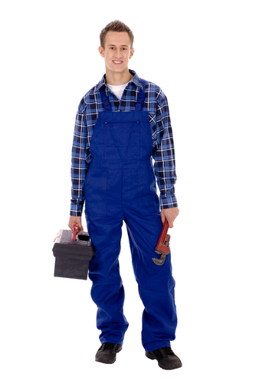 |  | 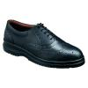 |  | 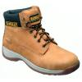

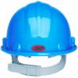 |  | 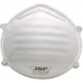

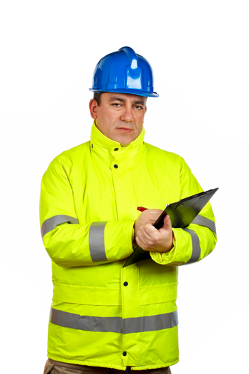 |  | 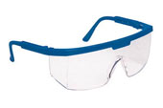
Task 7: Word grid
Here are clothes you wear in factory production. Write the name in the grid. There are letters in the grid to help you.

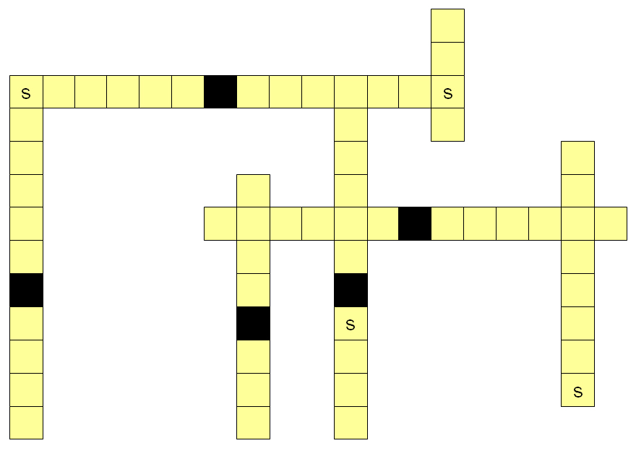
Task 8: Clothes for work
Can you name the clothes? Write the correct word. The first one shows you what to do.

Put on your safety _mask_.
boots
shoes
mask
hard hat
Put on your safety __________.
boots
glasses
shoes
jacket
Put on your safety __________ .
boots
glasses
shoes
jacket
Put on your __________ .
hard hat
safety shoes
overalls
jacket
Put on your safety __________ .
boots
hat
glasses
shoes
Put on your __________ .
jacket
shoes
boots
hard hat

Giving instrcutions
Aim: We are learning how to give instructions.
In English simple sentences are made up of:
subject – verb – object or S V O
Sokol wears the gloves.
Esha packs the boxes.
We fill the bottles.
Sentences for instructions can start with a verb:
Use the cardboard cartons.
Or with the subject:
You must use the cardboard cartons to pack the bottles.
If you want to tell someone not to do something you can say:
Do not eat your food in the factory.
Don’t eat your food in the factory.
Or:
You must not eat your food in the factory.
You mustn’t eat your food in the factory.
The supervisor says:
Please eat your food in the canteen.
Usually, in English you say please when you ask someone to do something.
Is the word order the same in your language? If not, this task will help you learn English word order.
Word check
Mustn’t and don’t are short forms of must not and do not.
They are called contractions.
Task 9: Giving instructions
Make an instruction from the words. The first one shows you what to do.

Stack |  | the |  | boxes |  | there

boxes | stack | there | the

lunch | eat | canteen | the | in

your | start | shift | 8 am | at

break | your | at | take | 10.30

three | get | from | crates | stores

potatoes | first | these | use

the | box | first | find | aid

the | in | gangways | walk

How did you get on?

Module 1: Words at work answers

Task 1 answers

cap | gloves | beard | shoe
net | tabard | hat | coat
Find the word that starts with n.
cap | gloves | beard | shoe
net | tabard | hat | coat
Find the word that starts with g.
cap | gloves | beard | shoe
net | tabard | hat | coat
Find the word that starts with h.
cap | gloves | beard | shoe
net | tabard | hat | coat
Find the word that starts with c.
gloves | beard |  | shoe |  | net
tabard |  | hat |  | coat
Find the word that starts with t.
cap | gloves | beard | shoe
net | tabard | hat | coat

Find the word that starts with b.
cap | gloves | beard | shoe
net | tabard | hat | coat
Find the word that starts with s.
gloves | beard |  | shoe |  | net
tabard |  | hat |  | coat

Task 2 answers

beard snood |  | safety gloves |  | white coat

tabard |  | trilby hat |  | safety shoe

cap |  | hair net |  | safety boot
Word check
When we talk about more than one thing, we put an s at the end of the word.
1 boot 2 boots
1 glove 2 gloves

Task 3 answers

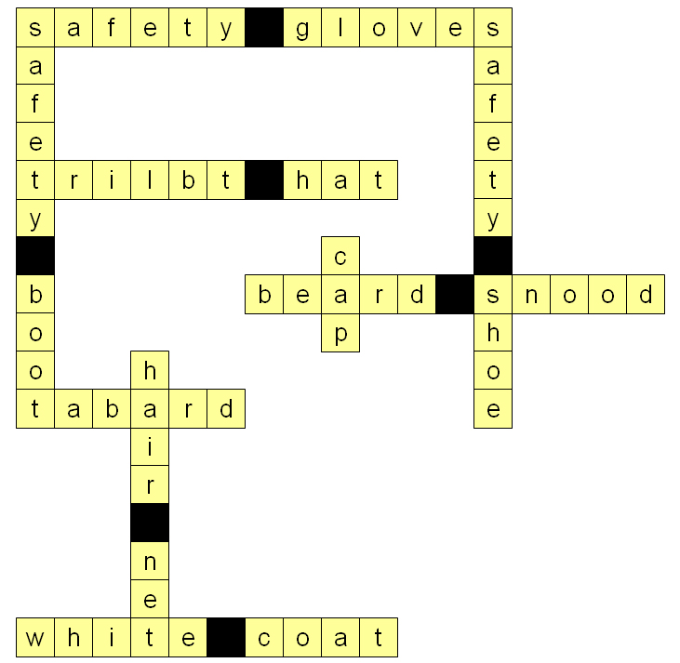

Task 4 answers

Put on your safety gloves.
boots
shoes
gloves
hat
Put on your hair net.
safety boots
beard snood
white coat
hair net
Put on your white coat.
hair net
white coat
safety boots
safety hat
Put on your trilby hat.
beard snood
safety shoes
hair net
trilby hat
Put on your tabard .
boots
tabard
gloves
shoes
Put on your safety boots.
gloves
shoes
boots
hat

Task 5 answers
Find the word that starts with m.
shoe | mask | hat | jacket
Find the word that starts with b.
mask | hat | shoe | boot
Find the word that starts with j.
jacket | glasses | overalls | boots
Find the word that starts with g.
jacket | glasses | overalls | boots
Find the word that starts with h.
shoe | boot | mask | hat
Find the word that starts with o.
jacket | overalls | glasses | boots
Find the word that starts with s.
mask | hat | boot | shoe

Task 6 answers

overalls |  | safety shoe |  | safety boot

hard hat |  | mask

safety jacket |  | safety glasses

Task 7 answers

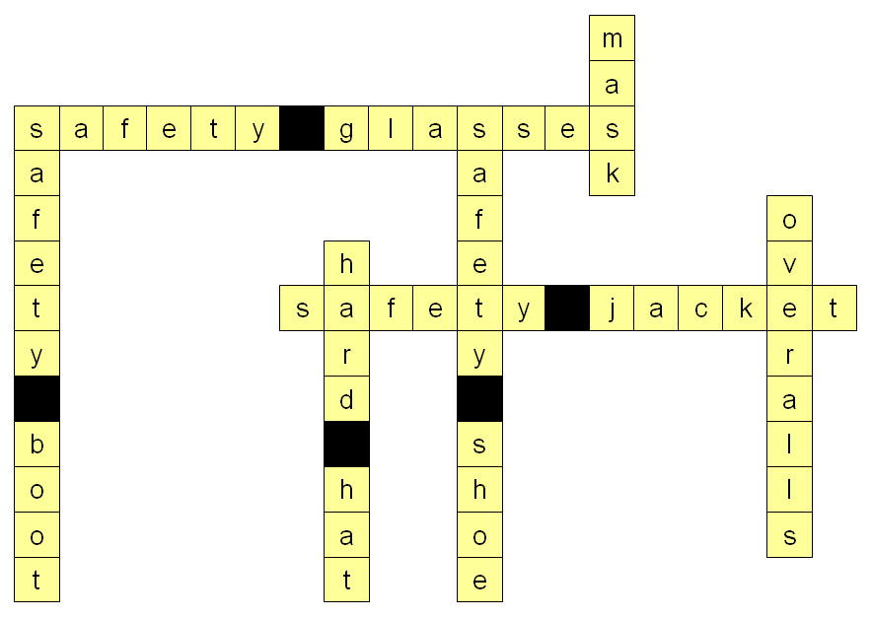

Task 8 answers

Put on your safety mask.
boots
shoes
mask
hard hat
Put on your safety glasses.
boots
glasses
shoes
jacket
Put on your safety jacket.
boots
glasses
shoes
jacket
Put on your overalls.
hard hat
safety shoes
overalls
jacket
Put on your safety boots.
boots
hat
glasses
shoes
Put on your hard hat.
jacket
shoes
boots
hard hat

Task 9 answers

Stack |  | the |  | boxes |  | there

Eat |  | lunch |  | in |  | the |  | canteen

Start |  | your |  | shift |  | at |  | 8 am

Take |  | your |  | break |  | at |  | 10.30

Get |  | three |  | crates |  | from |  | stores

Use |  | these |  | potatoes |  | first

Find |  | the |  | first |  | aid |  | box

Walk |  | in |  | the |  | gangways

