
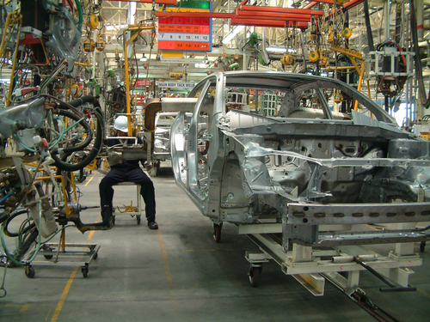
Entry 3: Reading
Manufacturing

Module: Health and safety signs

Module aims

Main aim
We are learning about personal protection and health and safety at work.

Other learning aims
We are learning:
- The order of instructions
- The meaning of words and symbols on health and safety signs

Module: Health and safety signs

There are different kinds of safety signs.

Blue circles tell you what you must do.
They are called mandatory signs.
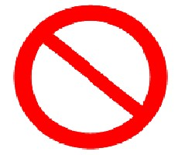 | Red circles with a line tell you what you must not do or use.  They are called prohibitive signs.
Black and Yellow triangles tell you to be careful.
They are called warning signs. You might see the words warning or caution written on the sign
 | Green and white squares or rectangles give you information about first aid or emergency exits.
 | Red squares or rectangles give information about fire equipment.

Personal Protective Equipment (called PPE for short)
When you work in the manufacturing industry, there are items of protective equipment that you must use to do particular tasks at work.

 | You wear eye protection to keep your eyes safe from dust and grit.
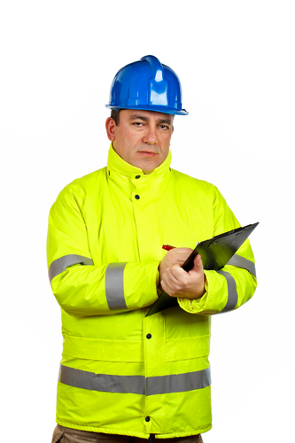 | A high visibility jacket makes sure that you can be seen clearly on the factory floor or in the warehouse. Remember – visible means can be seen.  Sometimes, you will read Hi-vis or Hi viz. This is a quick way of writing high visibility.
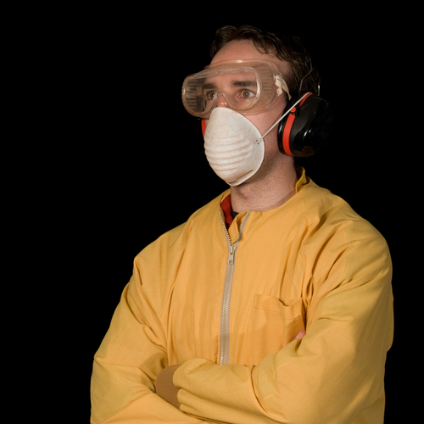 | You wear a dust mask when you use any machinery that creates fine dust.
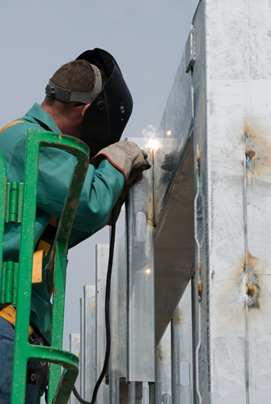 | This is face protection. You wear a face mask when you use any machinery where something could hit your face.
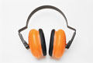 | These are ear defenders. You wear them to protect your ears from damage caused by loud noise.
Remember
When you see a blue sign, you must do what it says. If a blue sign shows an item of protective equipment, you must wear it to do the job.

Task 1: Test yourself
Can you find these signs in your factory? What do you think they mean?
This sign means:
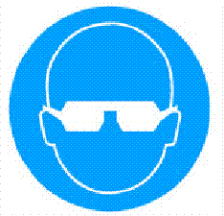 |  you must wear eye protection
 |  you must not wear your own glasses
 |  caution – strong lights in this area
 |  wear eye protection if you want to
This sign means:
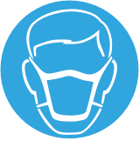 |  caution – dusty or dirty area
 |  you can wear a dust mask if you like
 |  you must wear a dust mask
 |  dust masks stored here
This sign means:
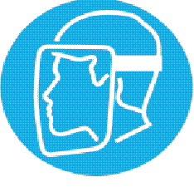 |  caution – take care of your face
 |  you must not throw things
 |  face protection stored here
 |  you must wear face protection
This sign means:
 |  wear ear protection if you want
 |  you must wear ear protection
 |  you must not make a noise
 |  caution – noisy machinery

This sign means:
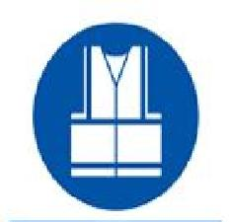 |  you must wear a visibility jacket
 |  warning – be safe, be seen
 |  visibility jackets stored here
 |  you can wear your own clothes

Fire extinguishers
Basically, here are four types of fire extinguisher:
- Water
- Foam
- CO₂ (carbon dioxide)
- Dry powder
They work in different ways. They all stop the fire from burning by either:
1. removing heat from the fire or
2. removing oxygen from the fire (oxygen is in the air).
Remember: removing means taking away.
They each have their benefits and problems.
If the extinguishers are new, they will be red with coloured handles or a coloured ‘shoulder’ or band. If they are older, the whole cylinder will be the colour that shows what kind fire the extinguisher can be used on.
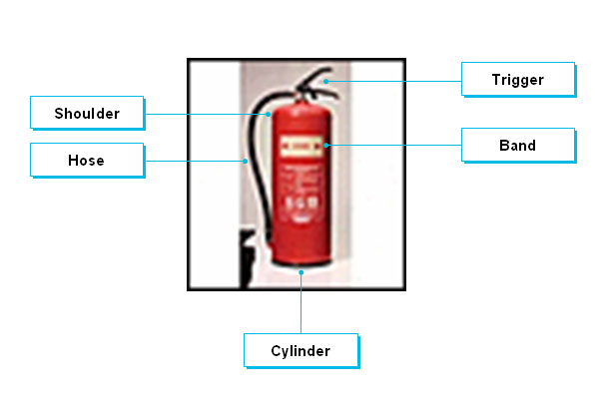
Task 2
Look at these instructions for using a fire extinguisher. Write 1, 2, 3 and 4 in the box to show the order you think you should follow to use an extinguisher.

Pull the trigger

Pull out the pin

Take the extinguisher to where you will use it

Aim the hose or nozzle
Remember
Only use an extinguisher after raising the alarm – letting other people know about the fire.
Make sure you have a means of escape – a way to leave the area safely.
Use the right kind of extinguisher for the fire.
Task 3
Look at this table about fire extinguishers.

Colour band and type | Best for: | Dangers | Puts out the fire by:
Red  Water | Solids - wood, cloth, paper, plastics | Do not use on burning fat or oil.  Do not use on electrical appliances. | cooling burning material
Blue  Dry Powder  Standard | Liquids - grease, fats, oil, paint, petrol  Electrical equipment | Do not use on chip or fat pan fires.  Does not easily penetrate equipment - fire may re-ignite. | knocking down flames and by smothering the fire  providing some cooling effect
Cream  AFFF  Multi-purpose  (Aqueous film-forming foam) | Solids - wood, cloth, paper, plastics, etc.  Liquids - grease, fats, oil, paint, petrol | Do not use on chip or fat pan fires.  Do not use on electrical appliances. | smothering fire with foam film on surface of burning liquid  having a cooling action with a wider extinguishing use than water on solids
Black  Carbon Dioxide CO₂ | Liquids - grease, fats, paint, petrol  Electrical equipment | Do not use on chip or fat pan fires.  Does not cool fire well - fire may re-ignite.  Fumes from CO₂ extinguishers can be harmful if used in confined spaces. | smothering the flames with a vaporising liquid gas which keeps out oxygen in the air
Word check
appliance means piece of equipment
to penetrate means to force a way inside
smothering means covering completely so no air gets in
to re-ignite means to burn again
Remember:
re is an element (prefix) added to the beginning of a word to change its meaning
re means to do something again
For instance: I must rethink my plans. We should re-site the shed.
confined means enclosed, kept in
vaporising means becoming vapour (mist or fumes)
Answer these questions using the information from the table about fire extinguishers.
How does this type of extinguisher put out fires?
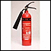 |  It gets rid of heat
 |  It keeps out oxygen
 |  It removes the fuel
 |  It makes the fire wet
This fire extinguisher contains:
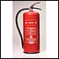 |  foam
 |  carbon dioxide (CO₂)
 |  water
 |  dry powder

To put out an oil fire, you must not use:
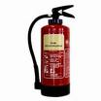 |  | 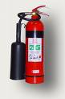 |  | 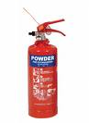 |  | 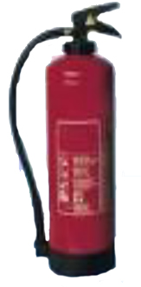
 |  |  |  |  |  | 
This extinguisher must not be used on:
 electrical fires
 wood fires
 burning furniture
 burning clothes
Which two extinguishers can be used on electrical fires?
 |  |  |  |  |  | 
If you discover a large fire, the first thing you should do is:
 shut down your machine
 finish what you are doing
 try to put out the fire
 raise the alarm

Which two extinguishers can be used on oil fires?
 |  |  |  |  |  | 
This extinguisher can be used to put out:
 burning oil
 electrical fires
 wood fires
 burning petrol
This extinguisher must not be used on:
 electrical fires
 wood fires
 burning oil
 burning petrol
This fire extinguisher contains:
 water
 foam
 dry powder
 carbon dioxide (CO₂)

Black and yellow signs
Another name for black and yellow signs is hazard signs.

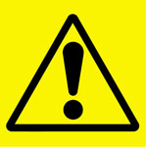 | Black and yellow signs are very important in the manufacturing industry. They are warning signs. They tell you to be careful.

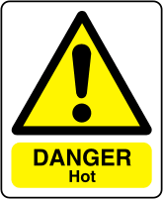 | 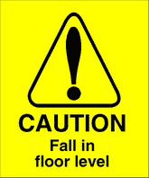
These signs tell you why you must be careful.
Warning signs may say Caution, Beware, Danger or Warning.
They all mean that you must be careful.

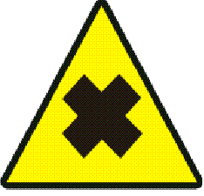 | When you see this sign, it tells you about something that could harm or irritate you if:  - you breathe it in  - it touches your skin.
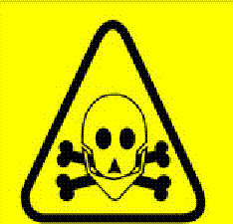 | When you see this sign, it tells you about something that is toxic or very toxic.  This means it could cause your death or make you very ill.
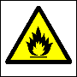 | This sign means that something is flammable. This means that you need to take care because it could catch fire easily.
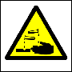 | This sign tells you that a liquid or substance is corrosive. That means that it could burn you or make your skin very sore.
Task 4: Test yourself
Can you remember what these signs mean?
This sign tells you about something that can:
 harm you
 catch fire easily
 burn your skin
 kill you
This sign tells you about something that can:
 burn your skin
 catch fire easily
 irritate your skin
 kill you
This sign tells you about something that can:
 catch fire easily
 harm you if you breath it in
 cause your death
 burn your skin
This sign tells you about something that can:
 cause your death
 catch fire easily
 burn your skin
 harm you if you breath it in

How did you get on?

Module 3: Health and safety signs answers

Task 1 answers
This sign means:
 you must wear eye protection
 you must not wear your own glasses
 caution – strong lights in this area
 wear eye protection if you want to
This sign means:
 caution – dusty or dirty area
 you can wear a dust mask if you like
 you must wear a dust mask
 dust masks stored here
This sign means:
 caution – take care of your face
 you must not throw things
 face protection stored here
 you must wear face protection
This sign means:
 wear ear protection if you want
 you must wear ear protection
 you must not make a noise
 caution – noisy machinery

This sign means:
 you must wear a visibility jacket
 warning – be safe, be seen
 visibility jackets stored here
 you can wear your own clothes
Remember
When you see: Eye protection must be worn
it is another way of writing: You must wear eye protection
Task 2 answers

Pull the trigger | 3

Pull out the pin | 2

Take the extinguisher to where you will use it | 1

Aim the hose or nozzle | 4

Task 3 answers
How does this type of extinguisher put out fires?
 It gets rid of heat
 It keeps out oxygen
 It removes the fuel
 It makes the fire wet
This fire extinguisher contains:
 foam
 carbon dioxide (CO₂)
 water
 dry powder
To put out an oil fire, you must not use:
 |  |  |  |  |  | 
This extinguisher must not be used on:
 electrical fires
 wood fires
 burning furniture
 burning clothes

Which two extinguishers can be used on electrical fires?
 |  |  |  |  |  | 
If you discover a large fire, the first thing you should do is:
 shut down your machine
 finish what you are doing
 try to put out the fire
 raise the alarm
Which two extinguishers can be used on oil fires?
 |  |  |  |  |  | 
This extinguisher can be used to put out:
 burning oil
 electrical fires
 wood fires
 burning petrol

This extinguisher must not be used on:
 electrical fires
 wood fires
 burning oil
 burning petrol
This fire extinguisher contains:
 water
 foam
 dry powder
 carbon dioxide (CO₂)

Task 4 answers

 harm you
 catch fire easily
 burn your skin
 kill you
This sign tells you about something that can:
 burn your skin
 catch fire easily
 irritate your skin
 kill you
This sign tells you about something that can:
 catch fire easily
 harm you if you breath it in
 cause your death
 burn your skin
This sign tells you about something that can:
 cause your death
 catch fire easily
 burn your skin
 harm you if you breath it in

