
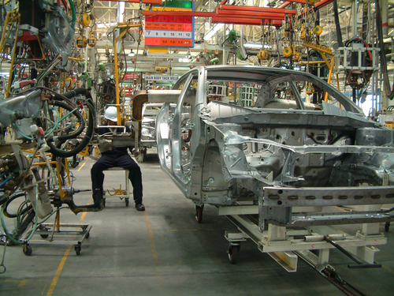
Level 1: Writing
Manufacturing

Module: Planning for appraisal review

Module aims

Main aim
We are learning to write in complex sentences using conjunctions, phrases and clauses.


Aim: We are learning to write in complex sentences using conjunctions, phrases and clauses.
When you work in manufacture, you have a review of your skills and you identify areas where you would like more training. You can identify the qualifications you would like to do.
When you review your skills, there will be:
- skills that are common to all jobs
communication | 
personal and people skills | 
health and safety | 
improvement in production | 
quality control | 
equality and diversity | 
- skills that are specific to a certain job, for instance:
repairing and maintaining machines | 
When you prepare for your review or write evidence for a qualification, you will use different types of writing:
- short notes to help you think about what you will write
- formal writing in simple, compound and complex sentences.

Remember, a simple sentence or main clause has:
subject | verb | (and sometimes) object
Carlos | took | the boxes
A compound sentence is two main clauses joined by a conjunction:
subject | verb | object | conjunction
Carlos | took | the boxes | and

subject | verb | object
he | carried | them to the store.
A complex sentence is one that has a main clause and one or more subordinate clauses:
subject | verb | object | subordinate clause
Carlos | took | the boxes | because he was going to the store.

It is called a subordinate clause because it cannot stand alone.
We can write:
Carlos took the boxes. This is a complete piece of meaning.
But not:
because he was going to the store.
This clause cannot stand alone. It needs to be added to the main clause to make sense.

At Entry 3 you also learned about the pronouns that can start a subordinate clause:
that | who | which | where | when

that and which | shows an animal or thing | 
who | shows a person | 
where | shows a place | 
when | shows time | 
Remember
If you need to revise the different kinds of sentence, look at the Entry 2 and 3 Writing materials
Using phrases
A phrase is a group of words without a verb. It cannot be a sentence or main clause because it does not have a verb. A phrase is used to tell you more about:
the subject the verb or the object of a sentence.
Carlos, the new operative, took the boxes.
This phrase is used to tell you more about Carlos. You show it is a phrase by using a comma to separate it from the main clause where this is appropriate. The sentence would still make sense if you took the phrase away.
Carlos took the boxes.
These phrases tell you more about the verb and the object.
Without a great deal of effort, Carlos carried the boxes.
Carlos took the boxes to the store on the east side of the factory.
Task 1: Find the phrases

Read this text and underline the phrases in it. The first one is done for you.
Manual lifting statement for a National Vocational Qualification
I work as a factory operative for ABC Fruit Ltd. As part of my job I have to move boxes of prepared fruit from the store to the production area. This task is part of my regular duties in the factory. When I get to the store I check the documentation from the production line to make sure that I pick up the fruit that they need.
When I locate the fruit, I check the bottom of the boxes because sometimes they get wet. In those situations the bottom of the box can give way so I have to be careful with them.
During my manual handling training I was shown the correct way to lift loads. I put a hand operated trolley by the boxes and lift the fruit from the shelves onto it. I follow safe and correct lifting practices.
I make sure the boxes are correctly loaded on the trolley and secured before I start off. I make sure the route to the production area is clear, too, and there is nothing that is blocking the way.
Task 2: Put in the phrases
Read the sentences. There are some phrases with them. Rewrite the sentence and put in the phrase where you think it should go. There might be more than one place where it makes sense. The example shows you what to do.
Nita is on day shift this week. the supervisor
Nita, the supervisor, is on day shift this week.

1. Ivan said that he wanted to do a qualification. during his review
2. Slips and trips account for many injuries. a common cause of accidents
3. The line went down. for the second time during the morning
4. Ola asked if she could see Jim. at the end of the shift the union representative
5. Mike loaded the boxes. onto the trolley with great care
6. Tran’s accident happened. during the morning on the production line
7. Tran had slipped over. on the pool of water the casualty
8. I was eating my lunch. during the break in the canteen
9. Ewa changed her clothes. the new member of staff in the locker room
10.The bottom of the boxes can get wet. in the storeroom.

Using conjunctions
Aim: We are learning to use conjunctions in a range of complex sentences.
You have learnt a range of conjunctions at Entry 2 and Entry 3.
At Entry 2, you learned to join two simple sentences (or main clauses) together with a conjunction to make a compound sentence.
and | but | as | or

and joins two sentences about a similar subject together
but joins two sentences when the second sentence refers back to the first
as joins two sentences when the second sentence shows the reason for the first or shows the time when something happens
or joins two sentences where they show a choice between two things
At Entry 3, you added some more conjunctions to this list.

Group 1: Conjunctions to do with time

when |  | before |  | since |  | 
while | until |  | after |  | whenever
Group 2: Conjunctions with special meanings

...although the weather could improve...  ...unless you change your mind...  ...whether or not you agree with me...  ...because we are running late...  ...where Connie left it...  ...provided it stops raining...  ...if we get lunch finished soon... | 
There are some more conjunctions you can add to this list:

yet | for | nor | than | though | how
When a conjunction joins two main clauses together, the clauses still make sense if they stand alone.
I went to the storeroom and I loaded the boxes.
I went to the storeroom. I loaded the boxes.
Some conjunctions are only used to join a main clause to a subordinate clause to make a complex sentence. You learned about subordinate clauses at Entry 3.
main clause | subordinate clause
We cannot start the line | until Maintenance repairs it.
The most common conjunctions that join subordinate clauses are:
although | if | since | unless
until | because | whereas | while
If you accept constructive feedback, you can learn from your mistakes.
Sometimes these conjunctions have more than one word:
in order that | such that | assuming that | so that | in case
The number of accidents will be reduced this year assuming that all members of staff follow the safety procedures.
I have changed the shift rota in order that you can attend the training on Tuesday..

Task 3: Put in the conjunction
Look at this piece of text from a review. Write a conjunction in the gaps from the list that you think makes best sense. Use each conjunction once. The first one is an example.

since | although | so that | and
for | before | assuming that | provided

I feel I have achieved the goals set in my development plan since I had my last review 12 months ago. In my role as Team Leader, I am responsible for developing an effective team, maintaining safe working practices ________ ensuring the smooth running of the production line. Overall, I feel that my leadership of the team has been highly competent ________ there have been occasional challenges to overcome. At the moment, we are running with two part time posts unfilled. In the coming year, the team will continue to achieve the company’s objectives _______ staff are recruited to these posts.
I have maintained a high level of quality control _____ _______ wastage levels are kept to a minimum. ________ __________ there will be no unplanned changes to work patterns during the forthcoming year I expect the high production level to be maintained. I have completed my NVQ Level 2 in Food Manufacture in Production Control Skills. I am waiting ______ the next enrolment period to start _________ I register for my NVQ Level 3 in Specialist Management Skills.
Task 4: Put in the subordinate clause
Look at this text from an annual review. The writer used a range of subordinate clauses to explain some of the achievements made by the team during the past year. The subordinate clauses are missing. Put them back in the text where you think they make best sense. The first one is done for you.
since I was promoted to the role of team leader
so that the team’s relationship was affected
which has resulted in a significant improvement in the team’s record
that were agreed in my last review
that staff have attended the relevant health and safety training
because we have ensured we follow the correct start up and shut down procedures since I became team leader shortly before the last review
who have developed poor timekeeping habits over the last couple of years
before I became team leader
which were reviewed in the discussion
although at times this has been hard to achieve

What were the major disappointments or frustrations in your job over the last year?
Since I was promoted to the role of team leader, I feel I have achieved the performance targets ______________________________________________ .
Two of the key performance indicators ________________________________ ___________________ concerned the poor timekeeping record of the team and the high accident rate for nips and tucks.
At the start of the year, there had been a number of staffing changes___________ _______________________________________ . _______________________ _____________________________, I have worked hard to improve motivation, _________________________________________. There are members of staff _______________________________________________________________ .
I feel that I have addressed these timekeeping issues in a firm but fair way _____ ________________________________________________________________ . __________________________, the accident rate for nips and tucks was too high. I have ensured ____________________________________________________ .
We have discussed the issues from the training. The accident rate for the team has reduced _________________________________________________________.
Planning for your review
Before you have a review, you need to plan what you will write. You need to make notes on:
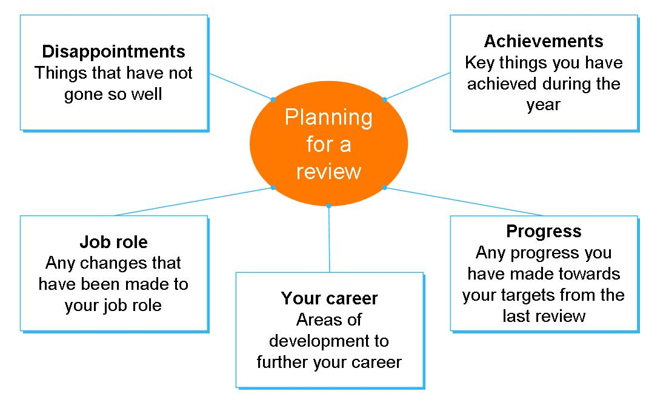
Task 5: Review of performance
If you are working in manufacture, look at your job description. Write one or two paragraphs on:
What are the major achievements in your job in the last 12 months?
________________________________________________________________
________________________________________________________________
________________________________________________________________
________________________________________________________________
________________________________________________________________
________________________________________________________________
________________________________________________________________
________________________________________________________________
________________________________________________________________
________________________________________________________________
________________________________________________________________
________________________________________________________________
If you are not working yet, look at a skills profile of a job you would like to do. Write one or two paragraphs in preparation for a job application on:
What are the major strengths you would bring to this job role?
Here are some words that you might find useful.
Talking about yourself – your qualities
sociable | hard-working | conscientious | reliable
team worker | pleasant | capable | willing
trustworthy | flexible | reliable | loyal
problem solver | positive | motivated | thoughtful
thorough | competent | helpful | cheerful
dependable | responsible | keen | positive

________________________________________________________________
________________________________________________________________
________________________________________________________________
________________________________________________________________
________________________________________________________________
________________________________________________________________
________________________________________________________________
________________________________________________________________
________________________________________________________________
________________________________________________________________
________________________________________________________________
________________________________________________________________
________________________________________________________________

How did you get on?

Module 2: Planning for appraisal review

Task 1 answers

Manual lifting statement for a National Vocational Qualification
I work as a factory operative for ABC Fruit Ltd. As part of my job I have to move boxes of prepared fruit from the store to the production area. This task is part of my regular duties in the factory. When I get to the store I check the documentation from the production line to make sure that I pick up the fruit that they need.
When I locate the fruit, I check the bottom of the boxes because sometimes they get wet. In those situations the bottom of the box can give way so I have to be careful with them.
During my manual handling training I was shown the correct way to lift loads. I put a hand operated trolley by the boxes and lift the fruit from the shelves onto it. I follow safe and correct lifting practices.
I make sure the boxes are correctly loaded on the trolley and secured before I start off. I make sure the route to the production area is clear, too, and there is nothing that is blocking the way.

Task 2 answers

1. During his review, Ivan said that he wanted to do a qualification.
2. Slips and trips, a common cause of accidents, account for many injuries.
3. During the morning the line went down for the second time.
For the second time during the morning the line went down.
The line went down for the second time during the morning.
4. The union representative, Ola, asked if she could see Jim at the end of the shift.
Ola, the union representative, asked if she could see Jim at the end of the shift.
Ola asked if she could see Jim, the union representative, at the end of the shift.
At the end of the shift the union representative, Ola, asked if she could see Jim.
At the end of the shift, Ola, the union representative, asked if she could see Jim.
At the end of the shift, Ola asked if she could see Jim, the union representative.
5. With great care, Mike loaded the boxes onto the trolley
6. During the morning, Tran’s accident happened on the production line.
Tran’s accident happened during the morning on the production line.
Tran’s accident happened on the production line during the morning.
7. The casualty, Tran, had slipped over on the pool of water.
Tran, the casualty, had slipped over on the pool of water.
8. During the break, I was eating my lunch in the canteen.
I was eating my lunch in the canteen during the break.
9. Ewa, the new member of staff, changed her clothes in the locker room.
In the locker room Ewa, the new member of staff, changed her clothes.
10. The bottom of the boxes can get wet in the storeroom.
The bottom of the boxes in the storeroom can get wet.

Task 3 answers
I feel I have achieved the goals set in my development plan since I had my last review 12 months ago. In my role as team leader, I am responsible for developing an effective team, maintaining safe working practices and ensuring the smooth running of the production line. Overall, I feel that my leadership of the team has been highly competent although there have been occasional challenges to overcome. At the moment, we are running with two part time posts unfilled. In the coming year, the team will continue to achieve the company’s objectives provided staff are recruited to these posts.
I have maintained a high level of quality control so that wastage levels are kept to a minimum. Assuming that there will be no unplanned changes to work patterns during the forthcoming year I expect the high production level to be maintained. I have completed my NVQ Level 2 in Food Manufacture in Production Control Skills. I am waiting for the next enrolment period to start before I register for my NVQ Level 3 in Specialist Management Skills.

Task 4 answers
What were the major achievements in your job over the last year?
Since I was promoted to the role of team leader, I feel I have achieved the performance targets that were agreed in my last review.
Two of the key performance indicators which were reviewed in the discussion concerned the poor timekeeping record of the team and the high accident rate for nips and tucks.
At the start of the year, there had been a number of staffing changes so that the team’s relationship was affected. Since I became team leader shortly before the last review, I have worked hard to improve motivation, although at times this has been hard to achieve. There are members of staff who have developed poor timekeeping habits over the last couple of years. I feel that I have addressed these timekeeping issues in a firm but fair way which has resulted in a significant improvement in the team’s record.
Before I became team leader, the accident rate for nips and tucks was too high. I have ensured that staff have attended the relevant health and safety training. We have discussed the issues from the training. The accident rate for the team has reduced because we have ensured we follow the correct start up and shut down procedures.

