
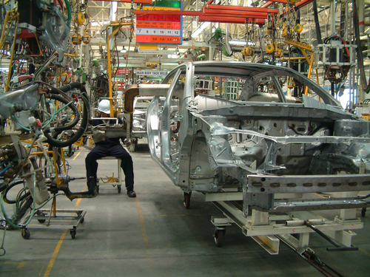
Level 1: Reading
Manufacturing

Module: Following written instructions

Module aims

Main aim
We are reading information from a table of written instructions and checking the meaning of key words and phrases.

Other learning aims
We are learning:
- Looking at the words and phrases used in the Shut down instructions to understand their meaning
- To identify key items of information in the text
- Reading for meaning to complete information in a table
- Learning about hazard signs for dangerous goods

Module: Following written instructions
Aim: We are reading information from a table of written instructions and checking

the meaning of key words and phrases.
It is Lech’s first week at Better Spreads Ltd. He is working as a conveyor line operator. His supervisor has been training him to do the job. These are his instructions for shutting down the line operation.
Read instructions across the table from left to right.
Shut down instructions for Conveyor 2 line operator
Responsibility |  | Health and safety
- Follow shutdown procedures  - Ensure end-run cleaning process |  | Correct protective clothing MUST be worn.  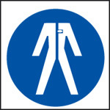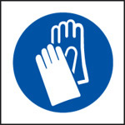  It is the responsibility of the line operator to ensure that all health and safety procedures are carried out and to report any breaches to the health and safety representative.
1. Shut down | At end of run  Carry out shut down procedure:  - press stop button  - switch mains power to OFF  - remove key, check power status | 1. Always check that the power status indicator shows that all power to the machine is off.  DO NOT PROCEED until all power is OFF.
2. Dismantle and clean hopper | Move drive units to UP position  Disconnect hopper  Remove hopper for cleaning  Hose down line and pipes  Ensure removal of all material | 2.
3. Dismantle and clean rollers | Move BDA from home position to lift rollers  Remove rollers for cleaning | 3.
4. Bins and totes | Return tote bins and trays to Wash up  Scrap bins must be weighed, weights recorded and bins removed to Disposal bay | 4.
Instructions are written using the imperative form of the verb. They are an order or command. This means instead of writing:
Subject verb
You return the tote bins and trays to Wash up.
You write:
verb
Return the tote bins and trays to Wash up.
You leave out the subject from the sentence.

Task 1
You read each line of instructions across the table from left to right. Each line shows:
- a stage of the work
- the instructions for that stage
- and the health and safety checks that must be followed at each stage.
Some of the health and safety instructions are missing from the table.You get an idea where they should go by the content of the health and safety advice.
Show where each instruction should be in the table. Put the correct number of the stage beside each one – that is 2 3 4.

Operate safe lifting techniques.

Wet floors are dangerous. Operate a clean-as-you-go procedure. Do not leave floors wet.

If rollers show wear or damage, they must be replaced. Damaged rollers must go to Maintenance for recoating.

Written instructions word check

Shut down instructions for Conveyor 2 line operator
Responsibility |  | Health and safety
- Follow shutdown procedures  - Ensure end-run cleaning process |  | Correct protective clothing MUST be worn.  It is the responsibility of the line operator to ensure that all health and safety procedures are carried out and to report any breaches to the health and safety representative.
1. Shut down | At end of run  Carry out shut down procedure:  - press stop button  - switch mains power to OFF  - remove key, check power status | 1. Always check that the power status indicator shows that all power to the machine is off.  DO NOT PROCEED until all power is OFF.
2. Dismantle and clean hopper | Move drive units to UP position  Disconnect hopper  Remove hopper for cleaning  Hose down line and pipes  Ensure removal of all material | 2. Wet floors are dangerous. Operate a clean-as-you-go procedure. Do not leave floors wet.  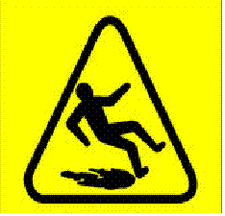
3. Dismantle and clean rollers | Move BDA from home position to lift rollers  Remove rollers for cleaning | 3. If rollers show wear or damage, they must be replaced. Damaged rollers must go to Maintenance for recoating.
4. Bins and totes | Return tote bins and trays to Wash up  Scrap bins must be weighed, weights recorded and bins removed to Disposal bay | 4. Operate safe lifting techniques.

Vocabulary
Read Shut down instructions again and underline any words or phrases (small groups of words) that you do not understand. Look them up in a dictionary or ask someone you work with to explain what they mean. You can write the meaning in your home language.

Word |  | Meaning

Word check
A prefix is an element added to the front of a base word.
We can add the prefix dis in front of some words to add to their meaning.
dis means not
dis +mantle dismantle not whole or together (the original word comes from the French word desmanteller meaning to take away a mantle which was a protective cloak or covering people wore)
dis +connect disconnect remove a connection?
dis + pose dispose not placed – to put somewhere else or to get rid of
You might have chosen some of these words and phrases.

responsibility | duty
procedure | an established way of doing things
ensure | make sure or certain
process | the stages of doing a job
breach | break the rules
representative | a person who speaks for a group of people
power status | this shows what is happening to the power supply at a particular moment
proceed | continue
dismantle | take apart
disconnect | remove the connection
clean-as-you-go | the name of a routine where you clean up at each stage of the job rather than doing it all at the end
Maintenance | the name of the team at work that looks after the machines and equipment (remember that capital letters are used for the names of places or departments at work)
operate | use
safe lifting techniques | established ways of lifting safety that people are advised to use
disposal | get rid of something

Task 2: Word check
Aim: We are looking at the words and phrases used in the shut down instructions to understand their meaning.
Read the Shut down instructions again and check that you understand the words and phrases used in it. Look at the sentences below. Use the text to help you work out which word should go in the gap. Underline the word that suits the meaning of the sentence. The first one is an example.
Follow shutdown _____________ .
responsibilities | breaches | rollers | procedures

It is the __________________ of the line operator to ensure that all health and safety procedures are carried out.
process | responsibility | procedure | status

You must ___________ that the end-run cleaning process is followed.
remove | weigh | ensure | operate

If there are any_______________ of the health and safety procedures, report them to the health and safety representative.
procedures | processes | responsibilities | breaches

There is a cleaning ________________ you must follow when you shut down the operation.
process | responsibility | breach | maintenance

At the end of the run, remove the key and check the power ____________ .
breach | process | status | hopper
If you have any concerns about health and safety, speak to your health and safety
________________________ .
breach | operator | representative | maintenance

The second stage is to ___________ and clean the hopper.
remove | hose | weigh | operate

Before you remove the hopper for cleaning, you must _____________ it.
dispose | recoat | disconnect | report

If you ________________________ , it means you clean up at each stage when you carry out a job.
end-run | clean-as-you-go | dispose | operate

If the rollers are damaged, take them to the ____________ department for recoating.
disposal | wash up | maintenance | health and safety

When you pick up the tote bins, you must operate safe lifting _______________ .
processes | breaches | techniques | responsibilities

Scrap bins must be weighed and bins removed to the _______________ bay.
disposal | wash up | maintenance | health and safety

Task 3: Shut down instructions
Aim: We are learning to identify key items of information in the text.
Read the shut down instructions again. Can you tell if these statements are right or wrong? Put a tick in the column. The first one has been done for you.

 | Right | Wrong
The line operator is responsible for ensuring that all health and safety procedures are carried out. | ✓
It does not matter whether or not you wear protective clothing.
When you carry out the shut down procedure, the first thing you do is press the stop button.
You move the drive units to the DOWN position to disconnect the hopper.
When you clean the hopper, you must make sure all material is removed.
When you hose down the line and pipes, you should not leave the floors wet.
Damaged rollers must be taken to the Disposal bay.
If rollers are worn or damaged, they should be replaced.
When the scrap bins are weighed, the weight does not have to be recorded.
Take the tote bins and trays back to Maintenance.
When you lift the tote bins, you must make sure you lift them correctly.

Task 4: Slips and trips at work
Aim: We are reading for meaning to complete information in a table.
Slips and trips are the most common cause of non-fatal major injuries and account for over half of all reported injuries to members of the public.
Read this risk assessment for slips and trips. Some of the information about safe methods has not been put in the table. Put the information in the right place. The first one is done for you.

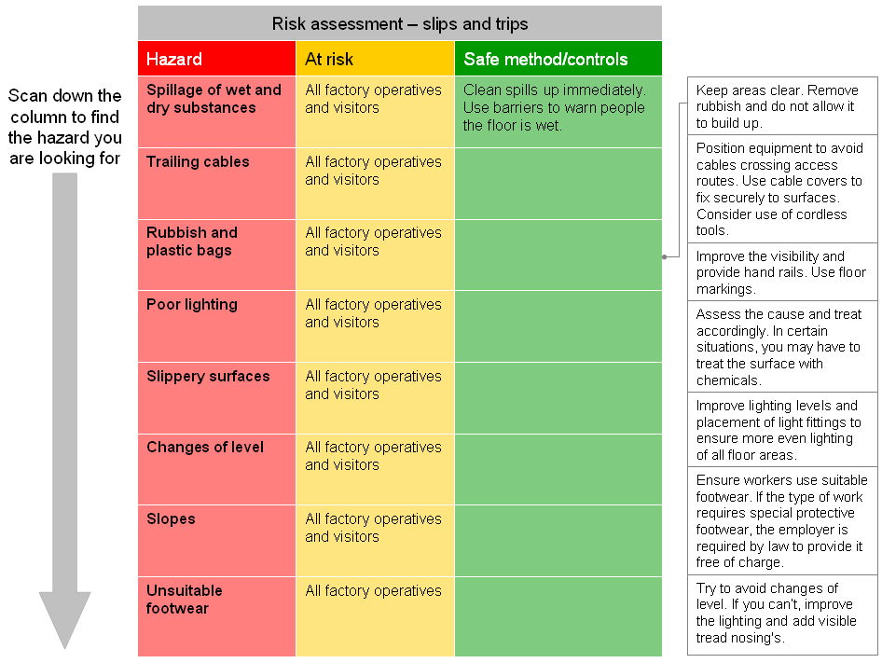

Hazard diamonds
Aim: We are learning about hazard signs for dangerous goods.
When you work in manufacturing, you will sometimes store and handle goods that are marked with hazard diamonds. These diamonds show everyone what kind of materials the package contains.
The people who pack and transport the goods have a duty to identify the hazards of the goods they intend to transport. There are nine classes, some with divisions, as shown below:

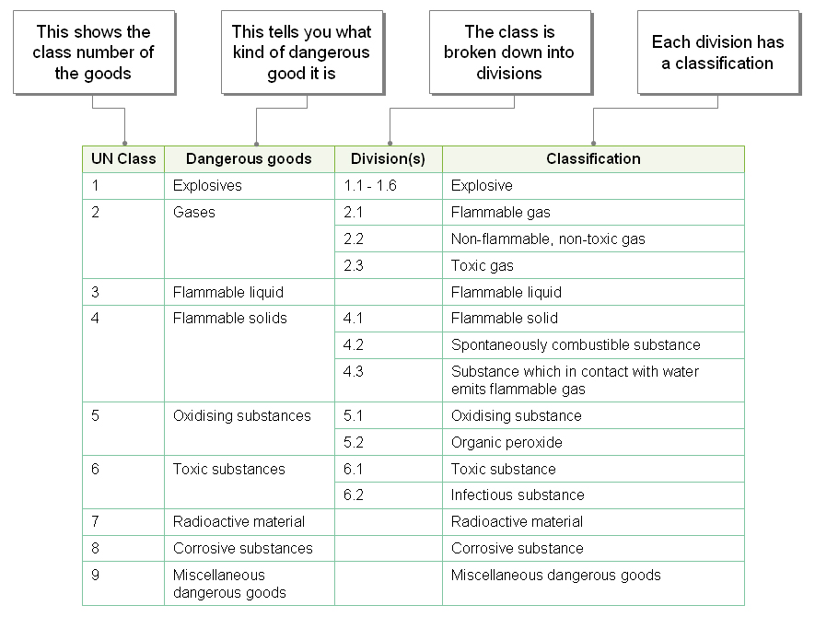

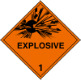 | The hazard diamond tells about the class of material. This diamond shows you the sign for explosive material, a written description and the class number.  Explosive material can blow up.

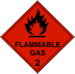 |  | 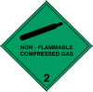 |  | 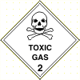 |  | 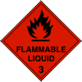 |  | 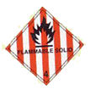
When you see this sign, it means that the substance is flammable. This means that it is very likely to catch fire or ignite. |  | Non-flammable means that this compressed gas will not catch fire. |  | This sign shows that the gas is toxic. This means that it could kill you if you breathe it in. |  | Flammable liquid means that this is a liquid that can catch fire. |  | Flammable solid means that this is solid matter that can catch fire.

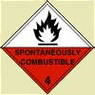 |  | 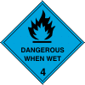 |  | 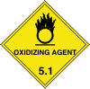 |  | 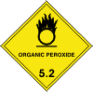 |  | 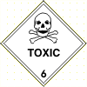
The substance has a low temperature when it can catch fire on contact with oxygen. |  | This substance can give off a flammable gas (it can catch fire) on contact with water. |  | Oxidising means something that can join (combine) with oxygen on contact with the air. |  | An organic peroxide is a compound from natural sources containing a single bond of oxygen. |  | When you see this sign, it means that the substance is toxic. This means that it is deadly: it can kill you.

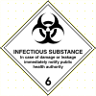 |  | 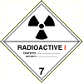 |  | 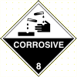 |  | 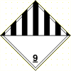
Infectious substances are those that can cause disease in humans or animals. |  | This sign shows that the substance is radioactive. |  | When you see this sign, it means that the substance is corrosive. This means that it could irritate your skin or burn your skin very badly. |  | Class 9 is miscellaneous. This is a word that means mixed and is used for everything else that does not have a class description.

Task 5: Test yourself
Use the information about hazard diamonds to find out what these signs mean.
Which sign means flammable substance?
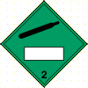 |  | 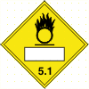 |  | 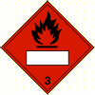 |  | 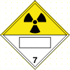
 |  |  |  |  |  | 
This sign means:
 compressed gas
 radioactive material
 infectious substance
 toxic gas
Which sign means toxic substance?
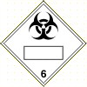 |  | 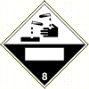 |  |  |  | 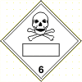
 |  |  |  |  |  | 
This sign means:
 compressed gas
 radioactive material
 infectious substance
 oxidising agent
Which sign means corrosive substance?
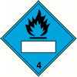
 |  |  |  |  |  | 
This sign means:
 compressed gas
 radioactive material
 flammable substance
 corrosive material
Which sign means oxidising substance?
 |  |  |  |  |  | 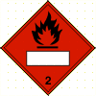
 |  |  |  |  |  | 

How did you get on?

Module 2: Following written instructions answers

Task 1 answers

Operate safe lifting techniques. | 4

Wet floors are dangerous. Operate a clean-as-you-go procedure. Do not leave floors wet. | 2

If rollers show wear or damage, they must be replaced. Damaged rollers must go to Maintenance for recoating. | 3

Task 2 answers

Follow shutdown _____________ .
responsibilities | breaches | rollers | procedures

It is the __________________ of the line operator to ensure that all health and safety procedures are carried out.
process | responsibility | procedure | status

You must ___________ that the end-run cleaning process is followed.
remove | weigh | ensure | operate

If there are any_______________ of the health and safety procedures, report them to the health and safety representative.
procedures | processes | responsibilities | breaches

There is a cleaning ________________ you must follow when you shut down the operation.
process | responsibility | breach | maintenance

At the end of the run, remove the key and check the power ____________ .
breach | process | status | hopper

If you have any concerns about health and safety, speak to your health and safety
________________________ .
breach | operator | representative | maintenance

The second stage is to ___________ and clean the hopper.
remove | hose | weigh | operate

Before you remove the hopper for cleaning, you must _____________ it.
dispose | recoat | disconnect | report

If you ________________________ , it means you clean up at each stage when you carry out a job.
end-run | clean-as-you-go | dispose | operate

If the rollers are damaged, take them to the ____________ department for recoating.
disposal | wash up | maintenance | health and safety

When you pick up the tote bins, you must operate safe lifting _______________ .
processes | breaches | techniques | responsibilities

Scrap bins must be weighed and bins removed to the _______________ bay.
disposal | wash up | maintenance | health and safety

Task 3 answers
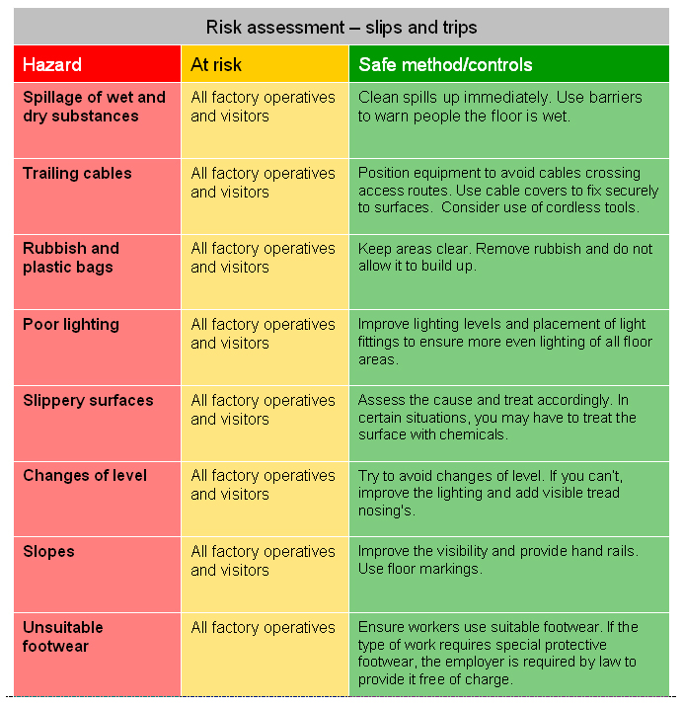

Task 5 answers
Which sign means flammable substance?
 |  |  |  |  |  | 
This sign means:
 compressed gas
 radioactive material
 infectious substance
 toxic gas
Which sign means toxic substance?
 |  |  |  |  |  | 
This sign means:
 compressed gas
 radioactive material
 infectious substance
 oxidising agent
Which sign means corrosive substance?
 |  |  |  |  |  | 
This sign means:
 compressed gas
 radioactive material
 flammable substance
 corrosive material
Which sign means oxidising substance?
 |  |  |  |  |  | 

