
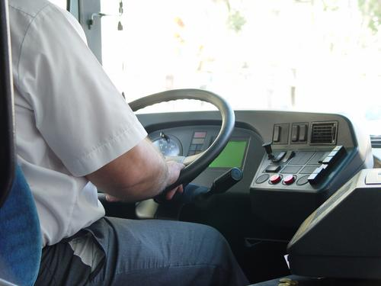
Entry 1: Reading
Transport

Module: Learning about your job

Module aims

Main aim
We are learning about induction training.

Other learning aims
We are learning:
- To read texts about induction for meaning
- Verbs for giving instructions
- Verbs we use at work
- Words for telling the time

Module: Learning about your job

Aim: We are going to learn about induction training. You will find out the meanings of some of the words used in the text.

Task 1: Starting a new job
Read the text about induction. Find these words in the text. Underline them. The first one is an example.
in charge | names |  | keep safe |  | training
rules |  | start |  | clothes

Induction is training for people starting a new job. One of the people in charge gives a talk. | 
The talk tells you about the work you do. | 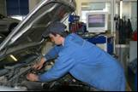
You learn the names of people who tell you what to do. | 
You find out where to sign your name when you start work. | 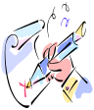
You learn to work safely. You learn the Health and Safety rules. | 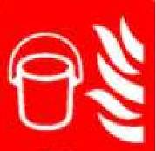
You find out about the clothes you wear to keep safe. | 

What do the words in the text mean?
induction training for new workers
in charge leading the work
safely not in danger
Task 2:
Find these words in the text. Draw a line under them.
first aid | emergency | things | accident | person

Induction

You need to know where things are. | 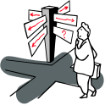
You learn where to go if you need first aid. | 
You find out what to do if there is an emergency. An accident is an emergency. | 
You must tell the person in charge if you do not understand something. | 
Ask the person to say it again or say it in another way. | 
What do the words in the text mean?
first aid for people who are hurt or ill
emergency something that people do not expect to happen – a fire or accident is an emergency
Remember
We call the letters a, e, i, o, u vowels. Other letters are called consonants.
When a word starts with a vowel we use an. For other words we use a.
A site, a hat, an induction talk, an emergency.

Read the text again

Induction

Induction is training for people starting a new job. One of the people in charge gives a talk.
The talk tells you about the work you do.
You learn the names of people who tell you what to do.
You find out where to sign your name when you start work.
You learn to work safely. You learn the health and safety rules.
You find out about clothes you wear to keep safe.

Word check
You see the words Health and Safety at work. You see these words together because they have a special meaning. They are a short form for the Health and Safety at Work Act. This is a law to keep you safe at work.
Ask if you do not understand. You can say:
Sorry I don’t understand.
Please say that again.
I don’t know what you mean. Can you explain?
Excuse me, can you say that again. I don’t understand.

Task 3: Fill in the gap
These sentences have a gap. Use the words to fill the gap.
Here is an example:
I go to the canteen to eat my lunch.
office | Platform | store room | canteen
Now you try

Report to the person ________________ of the team.
at home | in charge | on leave | at work

The _____________ talk for new people is in the training room.
work | induction | holiday | office

The alarm rings when there is an __________________. |  |  |  | 
emergency | election | emission | erosion

Go to ______________ if you cut yourself.
eye wash | the assembly point | first aid | the canteen

Work ________ and take care all the time. |  |  |  | 
swiftly | slowly | softly | safely
Task 4: Arthur’s First Day
Read this text about Artur. It has some gaps. Write a word in the gap to complete the sentences.

aid | names | charge | understand
clothes | induction | new job | rules

This is Artur. He is starting a new job. He is a driver.
He meets Jenny. She is his line manager.
She is the person in ___________.
She tells Artur about his job. She tells him. Jenny tells him to work safely. This is called an ___________ talk.
She tells him to work safely. She tells him the __________ to wear to keep safe.
She tells him what to do if there is an emergency.
He must follow the Health and Safety _________. If he hurts himself he must go to first ______________.
She tells him the _____________ of the other drivers.
He meets the mechanics and the office staff. They are all friendly and helpful. She tells him to ask her anything he does not _________. She is happy to tell him again.
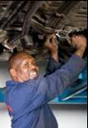 |  | 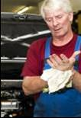

Other names for your line manager are your boss or supervisor.
A fire is an emergency.
An accident is an emergency
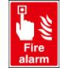

Learning about your job
Jenny tells Artur about the clothes he has to wear to work safely. She tells him about his duties. She tells him
- to come to work on time
The word duties is the plural of duty. One duty, two duties. When a word ends in a consonant + y the plural is – ies.
an emergency
many emergencies
- to wear his uniform
- to read his shift roster
- to do safety checks
- to learn the rules
- to smile at passengers
She gives him a uniform and a high visibility jacket.

Task 5
Here are some of the things Artur has to do. Put a ✓ that says what the picture shows. The first one is an example.
 |  Wear his uniform
 |  Smile at passengers
 |  Learn the rules
 |  Do safety checks

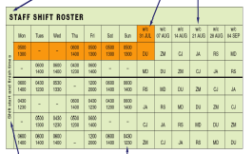 |  Learn the rules
 |  Do safety checks
 |  Read his shift roster
 |  Come to work on time

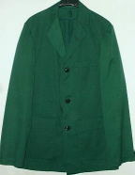 |  Wear his uniform
 |  Come to work on time
 |  Smile at passengers
 |  Learn the rules

 |  Do safety checks
 |  Come to work on time
 |  Smile at passengers
 |  Read his shift roster

 |  Smile at passengers
 |  Learn the rules
 |  Do safety checks
 |  Come to work on time
Task 6: Verbs
Look at these words: is, do, start, tells, wear, work, keep, drive. We call them verbs. They are doing or action words.
Can you put these verbs in the sentences? The first one is an example.
asks | do |  | com |  | is |  | gives
does |  | helps |  | wears |  | drives

1. Artur asks the mechanic to help him to do a safety check.
2. Artur __________ a uniform with a green jacket.
3. The office staff __________ to work on time.
4. Jenny __________ Artur learn about his job.
5. Artur __________ a bus from Bristol to Cardiff.
6. Harsha ________ a train from York to Leeds.
7. Jenny __________ Artur’s boss.
8. She __________ him a new uniform.

Artur reads the shift roster. He writes down the times he has to work.
Monday Training 08:00 to 12:00
Tuesday First shift 05:00 to 11:00
Training 15:00 to 1800
Wednesday Second shift 06:00 to 14:00
Thursday Second shift 06:00 to 14:00
Friday Day off
Saturday Third shift 12:00 to 20:00
Sunday Day off

Task 7: Verbs
Look at the sentences below. Put a tick ✓ to say if the answer is yes or no. The first one is an example.

 | Yes | No
You do not work on a day off. | ✓
On Tuesday Artur starts work at 5 in the morning.
Artur has a day off on Saturday.
Artur goes home at 18:00 on Saturday.
Another way to say 14:00 is 2 pm.
Rosters and timetables use the 24-hour clock.

The 24-hour clock starts at 00:00 hours and ends at 23:59.
Another way to say 00:00 is 12 am.
04:00 is 4 am
14:00 is 2 pm
am means in the morning.
pm means in the afternoon.
12 am is midnight. This is short for middle of the night.
12 pm is midday. This is short for middle of the day.
Another word for midday is noon.

Task 8: The 24-hour clock
We are learning to read the 24 hour clock. Can you match the time on the clock with the numbers? The first one is an example.
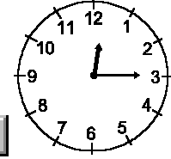 |  | 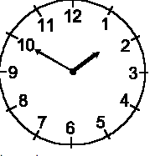 |  | 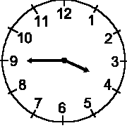 |  | 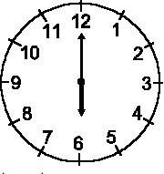
15:45 |  | 00:15 |  | 18:00 |  | 01:50

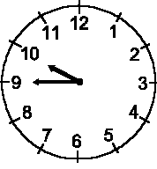 |  | 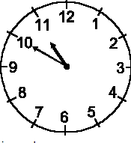 |  | 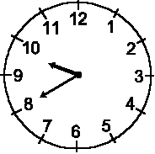 |  | 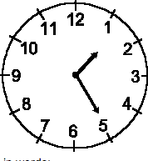
22:50 |  | 9:45 |  | 01:25 |  | 21:40

How did you get on?
Module 1: Learning about your job answers

Task 1 answers

Induction is training for people starting a new job. One of the people in charge gives a talk.
The talk tells you about the work you do.
You learn the names of people who tell you what to do.
You find out where to sign your name when you start work.
You learn to work safely. You learn the Health and Safety rules.
You find out about the clothes you wear to keep safe.

Task 2 answers

You need to know where things are.
You learn where to go if you need first aid.
You find out what to do if there is an emergency. An accident is an emergency.
You must tell the person in charge if you do not understand something.
Ask the person to say it again or say it in another way.

Task 3 answers

Report to the person ___in charge____ of the team.
at home | in charge | on leave | at work

The ___induction___ talk for new people is in the training room.
work | induction | holiday | office

The alarm rings when there is an ____emergency____.
emergency | election | emission | erosion

Go to ___first aid____ if you cut yourself.
eye wash | the assembly point | first aid | the canteen

Work __safely__ and take care all the time.
swiftly | slowly | softly | safely

Task 4 answers

This is Artur. He is starting a new job. He is a driver.
He meets Jenny. She is his line manager.
She is the person in __charge__.
She tells Artur about his job. She tells him. Jenny tells him to work safely. This is called an ___induction___ talk.
She tells him to work safely. She tells him the __clothes__ to wear to keep safe.
She tells him what to do if there is an emergency.
He must follow the Health and Safety __rules___. If he hurts himself he must go to first _____aid______.
She tells him the ____names_____ of the other drivers.
He meets the mechanics and the office staff. They are all friendly and helpful. She tells him to ask her anything he does not __understand__. She is happy to tell him again.

Task 5 answers

 Wear his uniform
 Smile at passengers
 Learn the rules
 Do safety checks

 Learn the rules
 Do safety checks
 Read his shift roster
 Come to work on time

 Wear his uniform
 Come to work on time
 Smile at passengers
 Learn the rules
 Do safety checks
 Come to work on time
 Smile at passengers
 Read his shift roster

 Smile at passengers
 Learn the rules
 Do safety checks
 Come to work on time

Task 6 answers

1. Artur asks the mechanic to help him to do a safety check.
2. Artur ___wears____ a uniform with a green jacket.
3. The office staff ___come___ to work on time.
4. Jenny ___helps____ Artur learn about his job.
5. Artur ___drives____ a bus from Bristol to Cardiff.
6. Harsha __drives___ a train from York to Leeds.
7. Jenny ____is______ Artur’s boss.
8. She ___gives____ him a new uniform.

Task 7 answers

 | Yes | No
You do not work on a day off. | ✓
On Tuesday Artur starts work at 5 in the morning. | ✓
Artur has a day off on Saturday. |  | ✓
Artur goes home at 18:00 on Saturday. |  | ✓
Another way to say 14:00 is 2 pm. | ✓

Task 8 answers

15:45 |  | 00:15 |  | 18:00 |  | 01:50

22:50 |  | 9:45 |  | 01:25 |  | 21:40

