
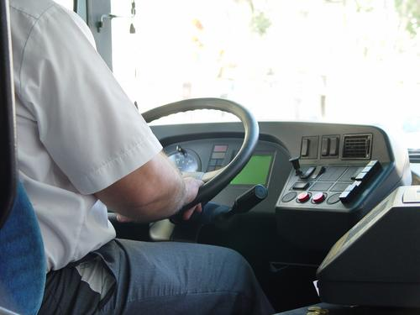
Entry 2: Reading
Transport

Module: Learning about your job

Module aims

Main aim
We are learning to read texts about jobs in transport and working safely.

Other learning aims
We are learning:
- To read texts to show we understand them
- To use headings to find information
- To use terms about hazards
- To use the simple past
- To use adjectives
- To order an instruction text about safe lifting

Module: Learning about your job
Aim: We are learning what different workers do in the transport industry.
Words you need
assist help
baggage compartment section of the bus or coach for luggage
cope to deal with something difficult
breakdown when the bus or coach stops working
issue to give something to someone
queries questions
usually most of the time
regular often, usually at the same time every day week, month, or year
schedule at the time on the timetable


Read about bus and coach drivers

Bus and coach drivers drive passengers on short or long journeys.
A bus driver usually:  - drives on a route that is regular, local and short  - picks up and sets down passengers at stops  - takes money, issues tickets  checks season tickets or travel cards. | 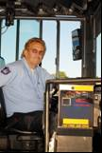
A coach driver usually:  - drives on longer trips  - loads and unloads large luggage into the coach baggage compartment.  Coach drivers on tourist buses may tell passengers about interesting places on the journey. | 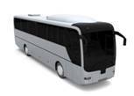
Both bus and coach drivers:
- check their vehicles to make sure they are in good working order
- pick up and drop off passengers, greet them politely and answer queries
- deal with any bad behaviour
- help passengers who have difficulty getting on or off the vehicle
- try to keep to their schedule while driving safely and legally
cope with emergencies, such as breakdowns, accidents or illness.

Task 1: Understanding the different tasks bus and coach drivers do
Put a ✓ in the box to say who does what task. The first one is an example.

 |  | Bus driver | Coach driver | Both
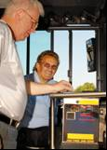 | Issue tickets | ✓
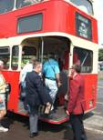 | Help passengers to get on or off the vehicle.
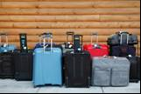 | Load and unload luggage
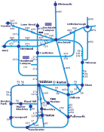 | Drive on a short, regular route
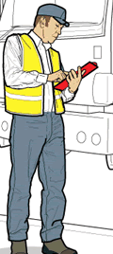 | Check vehicles
 | Tell passengers about interesting places on the journey.

Train drivers

Task 2: Features of a text
Writers use different ways to help you find information in a text. For example they use features like headings, subheadings and bullet points. Read the text below.
We have put a number next to a heading, subheading and the bullet points. Can you write the number in the box next to the name. The first one is an example.


1 Working as a train driver
3 What is the work like?
Train drivers have to make sure trains get to their destinations safely and on time. They drive passenger and freight trains on local, national and underground networks.
Train drivers:
2
- make equipment and engine checks
- follow signalling instructions during the journey
- make passenger announcements and control automatic doors
- arrive and leave stations at the right time
- position engines in the depot or at a platform at the end of their shift.
Train drivers also record any incidents during a shift, for example equipment problems, hazards or delays.
3 What are the hours and working conditions?
Train drivers normally work 35 to 42 hours a week. This may be spread over four or five shifts (or 'turns') including weekends, evenings and nights. If you work on freight or engineering trains, you usually have more night shifts.

Heading | 1
Sub-heading
Bullet points

Words from the text
announcements what drivers tell passengers using a microphone
automatic doors doors that open when the driver presses a button
delays things that make you late
destination the place you are going to
engineering the work of an engineer to build or repair tracks or trains.
freight goods carried by trains, ships or lorries
hazard something that can cause harm or an accident
maintenance what you do to make sure something works
position put the train in the right place

Task 3: Verbs
Aim: We are learning language used to write about jobs.
Can you complete these sentences with the right verb? Put a tick ✓  in the box next to the right word. The first one is an example.

Train drivers __________ make sure trains get to their destinations safely and on time. |  check
 |  must
 |  work

Freight trains ____________ heavy goods. |  must
Freight trains ____________ heavy goods. |  carry
Freight trains ____________ heavy goods. |  wear

The driver ____________ the train at platform 1. |  works
The driver ____________ the train at platform 1. |  positions
The driver ____________ the train at platform 1. |  carries

The driver opens the _____________ doors. |  automatic
The driver opens the _____________ doors. |  risk
The driver opens the _____________ doors. |  signalling

A cow on the track is a ______________. |  risk
A cow on the track is a ______________. |  shift
A cow on the track is a ______________. |  hazard

Signalling problems can cause _____________. |  shift
Signalling problems can cause _____________. |  delays
Signalling problems can cause _____________. |  risks

Task 4: Problems on the line - hazards and delays
Fazia drives a train from Belston to Westfield. She is having a bad week. She writes a report of the things that have happened to her. Can you say if they are hazards or delays? The first one is an example.

 |  | Hazard | Delay
Monday | The engineering work on my line was not finished. We had to go at half our normal speed. |  | ✓
Tuesday | A group of children were throwing stones at the train.
Wednesday | The bus I take to work was diverted. The journey took 20 minutes longer and I did not arrive at the depot on time.
Thursday | A train in front of me broke down in the tunnel. The signal was red for one hour.
Friday | There was a very bad storm last night. I noticed branches on the line outside Belston.
Friday | On my way back I was thinking about the weekend and missed a red signal.
Words from the text
branches parts of a tree
broke down stopped working
diverted made to go on a different route
normal usual

We have written the key words in alphabetic order for you to write in your personal glossary.
Task 5: The past tense
Look at the verbs above. Fazia is writing about actions in the past. She uses the past tense. Can you underline the verbs?
Now use the present tense of the verbs in these sentences. The first one is an example.
The engineering work on my line is not finished. We have to go at half our normal speed.
A group of children ________ throwing stones at the train.
The bus I take to work _______ diverted. The journey _______ 20 minutes longer.
A train in front of me ___________ down in the tunnel. The signal _______ red.
There __________ a very bad storm. I ____________ branches on the line outside Belston.
I___________ thinking about the weekend.
I___________ a red signal.

Risks and hazards
Aim: We are learning adjectives related to hazards and risks. The words in the text in bold are adjectives.
Employers must tell their workers about the hazards in their workplace. A hazard is a thing or an act that can harm you. Another word for hazard is danger. For example, a car driving fast in a built up area is a hazard.
A risk is the chance that the hazard will cause an accident. If the traffic is slow the risk of an accident is low. If there is a lot of fast traffic and people crossing roads the risk of an accident is high. Oil on the ground is a hazard. It makes the ground slippery. There is a risk that someone will slip on it and hurt themselves.
Good employers do everything they can to protect you from risks. They give you training to make sure that you work safely. They give you protective clothing. You must help your employer to find out about the hazards and risks in your job. You must look out for hazards. You must be careful. You must wear protective clothing like high visibility jackets and non-slip shoes.
Words from the text
accident something bad that happens that causes hurt or damage
avoid stay away from something or someone
built up area an area with lots of buildings, houses and shops
hazard something that can harm you
high visibility clothes bright coloured clothes that are easy to see
(hi-vis is the short form of high visibility)
protective something that keeps you safe
risk the chance that something will happen

Adjectives are describing words. Words like safe, wet, empty, high, low are adjectives. Some adjectives are made from root words:

danger + ous becomes dangerous
hazard + ous becomes hazardous
oil + y becomes oily

We call groups of letters like +ous or +y suffixes.

Task 6: Adjectives

slow | hi-vis | punctual | bad
broken | protective | ready | dangerous
late | careless | slippery | early
faulty |  | careful

Artur has overslept again. He tries to be punctual but his alarm clock is ___________. |  |  | 
When the weather is ___________ the traffic is slow.
He is ___________ again. He puts on his __________ jacket and runs across the depot. |  |  | 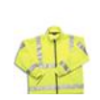
A __________ cleaner forgot to dry the floor and it is __________. |  |  | 
Artur slips and falls on his arm. He ___________ his arm and has to go to the hospital. |  |  | 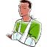
Hira is always ________. Today she has to fix a _________ engine.  It is ___________ and careful work. It can be _____________ so she wears  _____________ clothing – overalls, a hard hat and gloves. |  |  | 
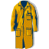 | 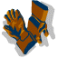
She fixes a _________ valve. She checks the ___________ connections.
She makes sure the engine is fixed and __________ to leave on time.

Instructions

Aim: We are learning the language for giving instructions.
If you have to lift heavy objects you should do a manual handling training course. This activity will help you understand the instructions on your course.

Task 7
These pictures show you how to lift heavy objects safely. The descriptions are below in the wrong order. Write the number of the description next to the picture. The first one is an example.

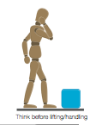 |  | 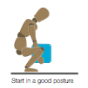 |  | 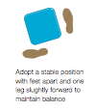
3
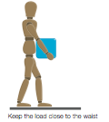 | 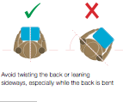 |  |  |  | 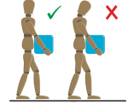
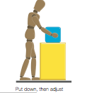
1. If you need to adjust the load, put it down first.
2. Next get a good hold. Hug the load with the heaviest side next to your body.
3. Think before you lift. Should you use a handling aid or ask someone to help you?
4. Start with a good posture. Don’t stoop or squat. It's better to slightly bend your back, hips and knees.
5. Take a stable position. Feet should be apart with one slightly forward to keep your balance.
6. Don’t twist your back or lean sideways, especially when your back is bent.
7. Don’t stoop or squat when you put it down. Bend your knees.
8. Look ahead. Don't look down at the load.

Words from the text
adjust change
handling aid equipment you use to move heavy objects – a trolley is a handling aid
posture the way a person stands
stable firmly fixed, not easy to move or shake
stoop bend the top half of your body
squat sit close to the ground with your knees bent
twist turn round and round

Giving instructions
There are different ways to give instructions. Some of the instructions are quite simple – Bend your knees. Others explain why or how you do something. They may start with the word if or say it’s better to…
Task 8
Here are the instructions in the right order. Can you underline the instruction verbs in the sentences? Instruction verbs tell you what to do. The first one is an example.
1. Think before you lift. Should you use a handling aid or ask someone to help you?
2. Next get a good hold. Hug the load with the heaviest side next to your body.
3. Start with a good posture. Don’t stoop or squat. It's better to slightly bend your back, hips and knees.
4. Take a stable position. Feet should be apart with one slightly forward to keep your balance.
5. Don’t twist your back or lean sideways, especially when your back is bent.
6. Look ahead. Don't look down at the load.
7. If you need to adjust the load, put it down first.
8. Don’t stoop or squat when you put it down. Bend your knees.

How did you get on?

Module 2: Learning about your job answers

Task 1 answers

 |  | Bus driver | Coach driver | Both
 | Issue tickets | ✓
 | Help passengers to get on or off the vehicle. |  |  | ✓
 | Load and unload luggage |  | ✓
 | Drive on a short, regular route | ✓
 | Check vehicles |  |  | ✓
 | Tell passengers about interesting places on the journey. |  | ✓

Task 2 answers

Heading | 1
Sub-heading | 3
Bullet points | 2

Task 3 answers

Train drivers __________ make sure trains get to their destinations safely and on time. |  check
 |  must
 |  work

Freight trains ____________ heavy goods. |  must
Freight trains ____________ heavy goods. |  carry
Freight trains ____________ heavy goods. |  wear

The driver ____________ the train at platform 1. |  works
The driver ____________ the train at platform 1. |  positions
The driver ____________ the train at platform 1. |  carries

The driver opens the _____________ doors. |  automatic
The driver opens the _____________ doors. |  risk
The driver opens the _____________ doors. |  signalling

A cow on the track is a ______________. |  risk
A cow on the track is a ______________. |  shift
A cow on the track is a ______________. |  hazard

Signalling problems can cause _____________. |  shift
Signalling problems can cause _____________. |  delays
Signalling problems can cause _____________. |  risks

Task 4 answers

 |  | Hazard | Delay
Monday | The engineering work on my line was not finished. We had to go at half our normal speed. |  | ✓
Tuesday | A group of children were throwing stones at the train. | ✓
Wednesday | The bus I take to work was diverted. The journey took 20 minutes longer and I did not arrive at the depot on time. |  | ✓
Thursday | A train in front of me broke down in the tunnel. The signal was red for one hour. |  | ✓
Friday | There was a very bad storm last night. I noticed branches on the line outside Belston. | ✓
Friday | On my way back I was thinking about the weekend and missed a red signal. | ✓

Task 5 answers
The engineering work on my line was not finished. We had to go at half our normal speed.
A group of children __were throwing__ throwing stones at the train.
The bus I take to work ___was____ diverted. The journey __took__ 20 minutes longer.
A train in front of me ____broke_____ down in the tunnel. The signal ___was____ red.
There ____was_____ a very bad storm. I ____noticed_____ branches on the line outside Belston.
I___was_____ thinking about the weekend.
I___missed_____ a red signal.

The engineering work on my line is not finished. We have to go at half our normal speed.
A group of children __are throwing__ throwing stones at the train.
The bus I take to work ___is____ diverted. The journey __takes__ 20 minutes longer.
A train in front of me ____breaks_____ down in the tunnel. The signal ___is____ red.
There ____is_____ a very bad storm. I ____notice_____ branches on the line outside Belston.
I___am_____ thinking about the weekend.
I___miss____ a red signal.

Task 6 answers

Artur has overslept again. He tries to be punctual but his alarm clock is ___broken____.
When the weather is ____bad_______ the traffic is slow.
He is __late____ again. He puts on his ___high-vis____ jacket and runs across the depot.
A ___careless_______ cleaner forgot to dry the floor and it is __slippery___.
Artur slips and falls on his arm. He ___breaks____ his arm and has to go to the hospital.
Hira is always ___early___. Today she has to fix a ___faulty____ engine.
It is ___slow____ and careful work. It can be ____dangerous_____ so she wears __protective____ clothing – overalls, a hard hat and gloves.
She fixes a ___leaky______ valve. She checks the __electrical__ connections.
She makes sure the engine is fixed and ___ready___ to leave on time.
You can turn an adjective into its opposite by adding un:

un + safe unsafe
un + punctual unpunctual
un + broken unbroken

un is a prefix.
You may find it helpful to learn adjectives with their opposites:
late early
careless careful
broken fixed
slow fast
dangerous safe
bad good

Task 7 and 8 answers
1. Think before you lift. Should you use a handling aid or ask someone to help you?
2. Start with a good posture. Don’t stoop or squat. It's better to slightly bend your back, hips and knees.
3. Take a stable position. Feet should be apart with one slightly forward to keep your balance.
2. Next get a good hold. Hug the load with the heaviest side next to your body.
5. Don’t twist your back or lean sideways, especially when your back is bent.
6. Look ahead. Don't look down at the load.
7. If you need to adjust the load, put it down first.
8. Don’t stoop or squat when you put it down. Bend your knees.

