
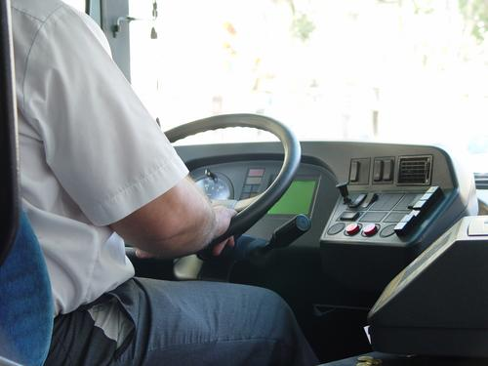
Entry 3: Reading
Transport

Module: Reading workplace information

Module aims

Main aim
We are learning to read workplace documents.

Other learning aims
We are learning:
- To use text features and layout to find information in safety posters and fire extinguisher labels
- To obtain information from a table
- To read a text on avoiding back pain for meaning and detail
- About adjectives and adverbs; learning to use prefixes

Module: Reading workplace information
This is a first aid poster that you might see at work. Look at the way it has been set out to help you find information quickly.
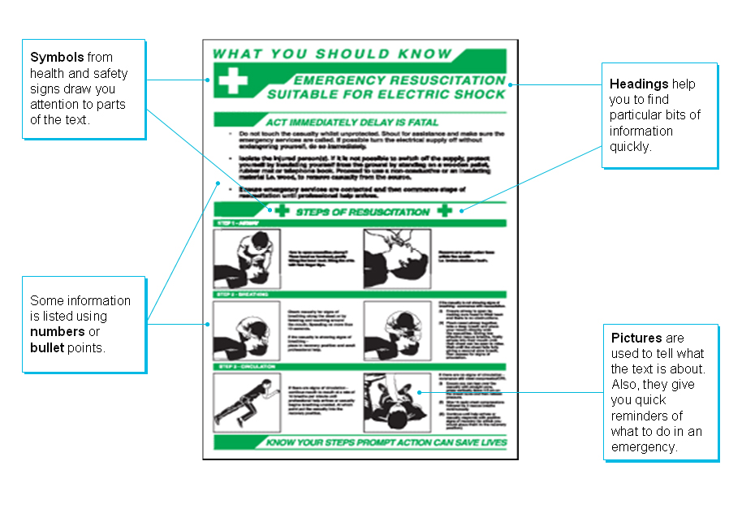
Reading instructions
Aim: We are learning about pictures and language for giving instructions.
These signs use colours to tell you what they are about. Red tells you that they are fire signs.

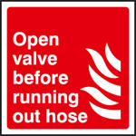 | 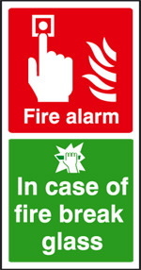 | 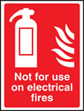 | 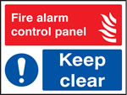
Green gives you safety information. Blue gives orders.

These signs give you instructions about how to use fire extinguishers.
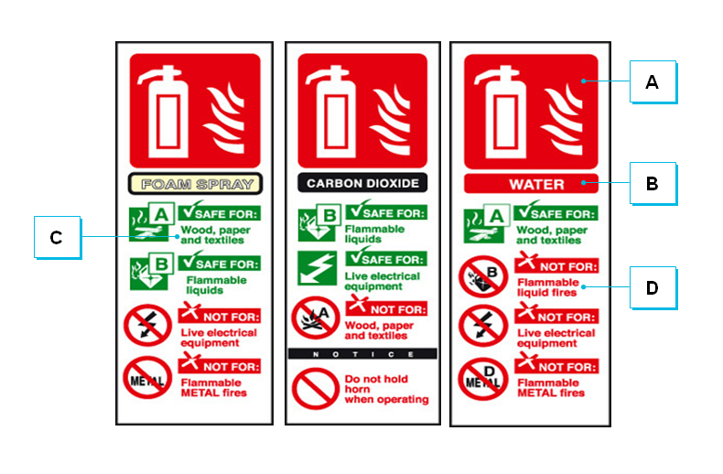The colours symbols and words tell you the type of extinguisher and the type of fire it is meant for.


Task 1: Words that mean the same thing
Test yourself. Write the letter next to the description of the part of the fire extinguisher label. The first one is an example.

A | B | C | D

Symbol that tells you what you must not use the extinguisher for | D
Symbol that tells you what you can use the fire extinguisher for
Symbol that tells you that this is equipment for fighting a fire
Words that tell you what the fire extinguisher is for

Write down what each colour means:
Blue Green Red
________________ is for fire fighting information.
_________________ gives orders.
________________ tells you about safety.

Fire extinguishers
It is important to be very careful and to make sure you know how to use fire extinguishers.
Basically, there are four types of fire extinguisher:
- Water
- Foam
- CO₂ (carbon dioxide)
- Dry powder
They work in different ways. They all stop the fire from burning by either:
1. removing heat from the fire or
2. removing oxygen from the fire (oxygen is in the air).
Remember: removing means taking away.
They each have their benefits and problems.
If the extinguishers are new, they will be red with coloured handles or a coloured ‘shoulder’ or band. If they are older, the whole cylinder will be the colour that shows what kind fire the extinguisher can be used on.
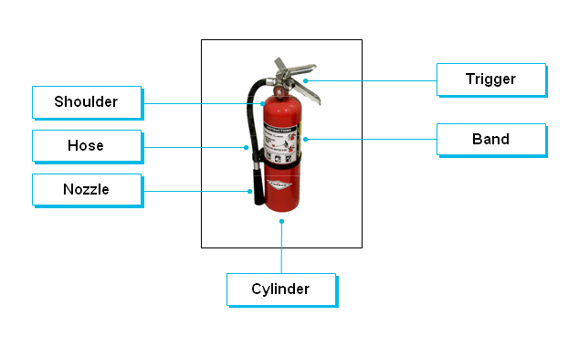
Task 2
Look at these instructions for using a fire extinguisher. Write 1, 2, 3 and 4 in the box to show the order you think you should follow to use an extinguisher.
Pull the trigger
Pull out the pin
Take the extinguisher to where you will use it | 1
Aim the hose or nozzle
Aim: We are learning to get information from a table.
Look at this table about fire extinguishers. To read the table look at the headings.
These headings tell you about the information downwards in columns.
These headings tell you about the information that goes sideways in rows.

Colour band and type | Best for: | Dangers | Puts out the fire by:
Red  Water | Solids - wood, cloth, paper, plastics | Do not use on burning fat or oil. Do not use on electrical appliances. | Cooling burning material
Blue  Dry Powder  Standard | Liquids - grease, fats, oil, paint, petrol.  Electrical equipment | Do not use on chip or fat pan fires. Does not easily penetrate equipment - fire may re-ignite. | Knocking down flames and by smothering the fire. Providing some cooling effect
Cream  AFFF  Multi-purpose  (Aqueous film-forming foam) | Solids - wood, cloth, paper, plastics, etc.  Liquids - grease, fats, oil, paint, petrol | Do not use on chip or fat pan fires.  Do not use on electrical appliances. | Smothering fire with foam film on surface of burning liquid  having a cooling action with a wider extinguishing use than water on solids
Black  Carbon Dioxide CO₂ | Liquids - grease, fats, paint, petrol  Electrical equipment | Do not use on chip or fat pan fires. Does not cool fire well - fire may re-ignite. Fumes from CO₂ extinguishers can be harmful if used in confined spaces. | Smothering the flames with a vaporising liquid gas which keeps out oxygen in the air
Word check
appliance means piece of equipment
to penetrate means to force a way inside
smothering means covering completely so no air gets in
to re-ignite means to burn again

Remember
re is an element (prefix) added to the beginning
of a word to change its meaning
re means to do something again
For instance:
I must rethink my plans.
We should re-site the shed.

confined means enclosed, kept in
vaporising means becoming vapour (mist or fumes)

Task 3
Answer these questions using the information from the table about fire extinguishers. Put a tick  in the right box. The first one is an example.

This fire extinguisher contains:
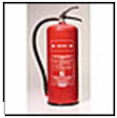 |  foam
 |  carbon dioxide (CO₂)
 |  water
 |  dry powder

How does this type of extinguisher put out fires?
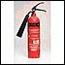 |  It gets rid of heat
 |  It keeps out oxygen
 |  It removes the fuel
 |  It makes the fire wet

To put out an oil fire, you must not use:
 | 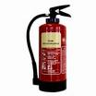 |  | 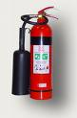
 | 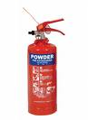 |  | 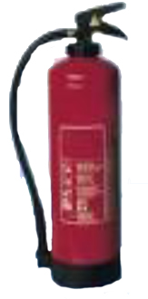

This extinguisher must not be used on:
 electrical fires
 wood fires
 burning furniture
 burning clothes

Which two extinguishers can be used on electrical fires?
 |  | 
 |  | 

If you discover a large fire, the first thing you should do is:
 put your tools away.
 finish what you are doing
 try to put out the fire
 raise the alarm

To put out an oil fire, you must not use:
 |  | 
 |  | 

This extinguisher must not be used on:
 electrical fires
 wood fires
 burning furniture
 burning clothes

Task 4
Aim: We are learning to explain how to do something or how something happens.
Look at the verbs in the column with the heading Puts fires out by... They all end with -ing. When you explain how to do something, you often use the word by and add -ing to the verb – drive becomes driving.
Complete these sentences with the right form of these verbs.
drive | keep | cool | knock
down | smother | use | stay
How does water put out wood, cloth, or paper fires?
By _________ the material that is burning.
How does dry powder work?
By _______ down flames and by ___________ the fire.
How does vaporising liquid gas smother flames?
By _____________ oxygen out of the air.
How do you find information quickly from a leaflet or poster?
By __________ headings, pictures or symbols.
How can you save fuel?
By ___________ smoothly and ____________ at a steady speed.

Remember

Only use an extinguisher after raising the alarm – letting other people know about the fire.

Make sure you have a means of escape – a way to leave the area safely.

Use the right kind of extinguisher for the fire.

Looking after yourself at work. Read the leaflet Is driving giving you a pain in the back? on the next page, on preventing back pain.
Words you need
adequate good enough
adjust change something a little bit to make it more correct
average the result you get when you add all the numbers and divide the total by the number of amounts
discomfort slight pain
forcefully strongly, with effort
hours on end a long time
posture the way you hold your body, stand or sit
strain pain caused by using part of the body too much or wrongly
stretching making something longer
slumping sitting low in your seat with head and shoulders bent
relax make parts of your body less stiff
tension stiffness or tightness
twist turn your body to face a different direction
Is driving giving you a pain in the back?
Sitting in a fixed position for hours on end and the constant vibrations of the wheels, it's not surprising so many drivers get backache.
Research found that people driving over 25,000 miles a year took an average of 22 days a year off work with a bad back, compared with just over three days for low mileage drivers. Train drivers took over 40 days off work.
There are things that we can all do to avoid damaging our backs or to reduce existing discomfort.
Are you sitting comfortably?
Your seat may feel comfortable when you first sit in it but, after a long period of travelling, you may feel discomfort or back pain. Seats that do not provide adequate support can strain your back.
Any lack of support is more serious if you have a back injury or are suffering from muscular back strain. Good, supportive seating can help to reduce discomfort, and may also prevent backache.
What should you do while driving
Think about your posture: keep your chin in, don't grip the wheel too tightly as this tenses your muscles and adds to stress, relax your shoulders and keep your head upright.
Adjust the seat so that you are comfortable and it supports your lower back and so you can see clearly without having to stretch or twist.
Make sure you can operate the controls without stretching or twisting.
If your seat has a driver’s weight adjustment make sure it is adjusted correctly for your weight.
Steer, brake, accelerate and change gears smoothly.
Avoid bad postures, e.g. slumping in your seat, constantly leaning forward or sideways or driving with your back twisted.
Take regular breaks if you can, to avoid sitting in the same position for too long.
Exercise at the wheel
When you stop at lights or are held up, try these simple exercises to relieve muscle tension.
- Pull in your stomach muscles, breathe out forcefully, relax and repeat.
- Raise your shoulders towards your ears, push the shoulders backwards
against the seat, relax and repeat.
Task 5
Aim: We are looking at the words and phrases, or groups of words, used in the text to understand the meaning.
Find the right word or phrase to complete the sentence. Use the headings to find them in the text. The first one is an example.

Gripping the wheel too tightly | 6
After a long period of travelling
Lack of support is more serious
Slumping in your seat is
Adjust the seat so that
Supportive seating
Adjust your seat
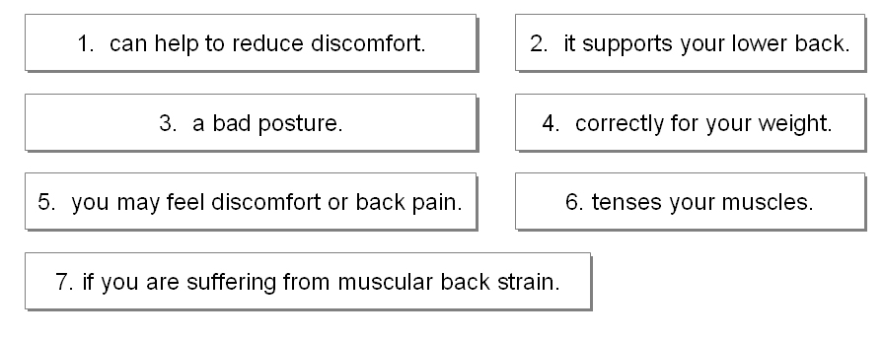

Aim: We are learning about adjectives and adverbs.
Adjectives are describing words. They tell you more about a noun.
blue sign comfortable seat
Adverbs are also describing words. They tell you more about verbs.
Sit comfortably drive safely
Adverbs are usually made by adding the letters -ly to an adjective.
comfortable comfortably

Task 6
Read the text again and underline all the adjectives and adverbs you find. Some words can have several functions - first can be an adjective, an adverb or a noun.
Is driving giving you a pain in the back?
There are things that we can all do to avoid damaging our backs or to reduce existing discomfort.
Are you sitting comfortably?
- Your seat may feel comfortable when you first sit in it but, after a long period of travelling, you may feel discomfort or back pain. Seats that do not provide adequate support can strain your back.
- Any lack of support is more serious if you have a back injury or are suffering from muscular back strain. Good, supportive seating can help to reduce discomfort, and may also prevent backache.
What should you do while driving
- Think about your posture: keep your chin in, don't grip the wheel too tightly as this tenses your muscles and adds to stress, relax your shoulders and keep your head upright.
- Adjust the seat so that you are comfortable and it supports your lower back
and so you can see clearly without having to stretch or twist.
- Make sure you can operate the controls without stretching or twisting.
- If your seat has a driver’s weight adjustment make sure it is adjusted
correctly for your weight.
- Steer, brake, accelerate and change gears smoothly.
- Avoid bad postures, e.g. slumping in your seat, constantly leaning forward or sideways or driving with your back twisted.
- Take regular breaks if you can, to avoid sitting in the same position for
too long.
Exercise at the wheel
When you stop at lights or are held up, try these simple exercises to relieve muscle tension:
- Pull in your stomach muscles, breathe out forcefully, relax and repeat.
- Raise your shoulders towards your ears, push the shoulders backwards
against the seat, relax and repeat.

Task 7
Aim: We are learning how to make the text into a short list of instructions.
We have written the main points in the text as a list. Put a tick  against the things you should do and a cross ✗ against the ones you shouldn’t do. The first one is an example.

 | Yes | No
Think about your posture. | ✓
Keep your chin in.
Grip the wheel too tightly.
Relax your shoulders.
Keep your head upright.
Adjust the seat so that you are comfortable.
Stretch or twist.
Steer, brake, accelerate and change gears smoothly.
Slump in your seat.
Lean forward or sideways.
Drive with your back twisted.
Take regular breaks.
Avoid sitting in the same position for too long.
Write new words and phrases in your personal glossary. You may find it helpful to keep words made from the same root word together.

Word check
A prefix is an element added to the front of a base word.
A suffix is an element added to the end of a root word.
We can add the prefix dis or un in front of some words to add to their meaning.
dis means not
dis + comfort = discomfort slight pain
un + comfort + able = uncomfortable not uncomfortable
un + comfort + ably = uncomfortably not comfortably
You can also add the prefixes dis and un to verbs to change their meaning:

dis + like means not to like
un + fasten means to open

Note that not all words that start with dis- or un- mean not.

Task 8: Test yourself – using prefixes
You have learnt the prefixes re-, dis- and un-. Look at the sentences below.
Add the prefix dis- un- or re- to the root word to change its meaning. For example:
It’s ______ fair to blame the baggage handlers for the delay – the conveyor belt broke down.
It’s unfair to blame the baggage handlers for the delay – the conveyor belt broke down.
The angry customer was ____satisfied with the driver’s explanation for the late arrival.
The angry customer was dissatisfied with the driver’s explanation for the late arrival.
He ___started the engine after ___charging the battery.
He restarted the engine after recharging the battery.

Now you try:
Claiming for hours you haven’t worked is _____honest.
Control told the driver to __route the train via Birmingham.
This space is reserved for passengers with a ___ability.

This ticket machine is so ____reliable, it has broken down twice today.
We clean the plane after the passengers ____ embark.
During a fire drill, the fire warden tells you when to _____-enter the building.
The mechanic ____connected the faulty unit from the engine and ___placed it with a new one.
A passenger fell over when I made an emergency stop but he was ___hurt.
Pilar and Marek are quarrelling again. They ___agree on everything.
Pilar says Marek is rude and ______helpful.

How did you get on?

Module 3: Reading workplace information answers

Task 1 answers

Symbol that tells you what you must not use the extinguisher for | D
Symbol that tells you what you can use the fire extinguisher for | C
Symbol that tells you that this is equipment for fighting a fire | A
Words that tell you what the fire extinguisher is for | B

Blue Green Red
______Red______ is for fire fighting information.
______Blue_______ gives orders.
_____Green_______ tells you about safety.

Task 2 answers

Pull the trigger | 3
Pull out the pin | 2
Take the extinguisher to where you will use it | 1
Aim the hose or nozzle | 4

Task 3 answers

How does this type of extinguisher put out fires?
 It gets rid of heat
 It keeps out oxygen
 It removes the fuel
 It makes the fire wet

To put out an oil fire, you must not use:
 |  | 
 |  | 

This extinguisher must not be used on:
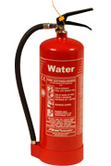 |  electrical fires
 |  wood fires
 |  burning furniture
 |  burning clothes

Which two extinguishers can be used on electrical fires?
 |  | 
 |  | 

If you discover a large fire, the first thing you should do is:
 put your tools away.
 finish what you are doing
 try to put out the fire
 raise the alarm

Task 4 answers
By __cooling___ the material that is burning.
How does dry powder work?
By __knocking___ down flames and by __smothering__ the fire.
How does vaporising liquid gas smother flames?
By ___keeping____ oxygen out of the air.
How do you find information quickly from a leaflet or poster?
By ___using____ headings, pictures or symbols.
How can you save fuel?
By ___driving____ smoothly and ___staying____ at a steady speed.

Task 5 answers

Gripping the wheel too tightly | 6
After a long period of travelling | 5
Lack of support is more serious | 7
Slumping in your seat is | 3
Adjust the seat so that | 2
Supportive seating | 1
Adjust your seat | 4

Task 6 answers

The adjectives are in blue and the adverbs in green.
Note that adverbs usually end in -ly.

Is driving giving you a pain in the back?
There are things that we can all do to avoid damaging our backs or to reduce existing discomfort.
Are you sitting comfortably?
- Your seat may feel comfortable when you first sit in it but, after a long period of travelling, you may feel discomfort or back pain. Seats that do not provide adequate support can strain your back.
- Any lack of support is more serious if you have a back injury or are suffering from muscular back strain. Good, supportive seating can help to reduce discomfort, and may also prevent backache.
What should you do while driving
- Think about your posture: keep your chin in, don't grip the wheel too tightly as this tenses your muscles and adds to stress, relax your shoulders and keep your head upright.
- Adjust the seat so that you are comfortable and it supports your lower back
and so you can see clearly without having to stretch or twist.
- Make sure you can operate the controls without stretching or twisting.
- If your seat has a driver’s weight adjustment make sure it is adjusted
correctly for your weight.
- Steer, brake, accelerate and change gears smoothly.
- Avoid bad postures, e.g. slumping in your seat, constantly leaning forward or sideways or driving with your back twisted.
- Take regular breaks if you can, to avoid sitting in the same position for
too long.
Exercise at the wheel
When you stop at lights or are held up, try these simple exercises to relieve muscle tension:
- Pull in your stomach muscles, breathe out forcefully, relax and repeat.
- Raise your shoulders towards your ears, push the shoulders backwards
against the seat, relax and repeat.

Task 7 answers

 | Yes | No
Think about your posture. | ✓
Keep your chin in. | ✓
Grip the wheel too tightly. |  | ✓
Relax your shoulders. | ✓
Keep your head upright. | ✓
Adjust the seat so that you are comfortable. | ✓
Stretch or twist. |  | ✓
Steer, brake, accelerate and change gears smoothly. | ✓
Slump in your seat. |  | ✓
Lean forward or sideways. |  | ✓
Drive with your back twisted. |  | ✓
Take regular breaks. | ✓
Avoid sitting in the same position for too long. | ✓

Or you could say it like this:
Do
- think about your posture
- keep your chin in
- relax your shoulders
- keep your head upright
- adjust the seat so that you are comfortable
- steer, brake, accelerate and change gears smoothly
- take regular breaks
- avoid sitting in the same position for too long.
Don’t
- grip the wheel too tightly
- stretch or twist
- slump or twist
- lean forwards or sideways
- drive with your back twisted.

Task 8 answers
Claiming for hours you haven’t worked is dishonest.
Control told the driver to reroute the train via Birmingham.
This space is reserved for passengers with a disability.
This ticket machine is so unreliable, it has broken down twice today.
We clean the plane after the passengers disembark.
During a fire drill, the fire warden tells you when to re-enter the building.
The mechanic disconnected the faulty unit from the engine and replaced it with a new one.
A passenger fell over when I made an emergency stop but he was unhurt.
Pilar and Marek are quarrelling again. They disagree on everything.
Pilar says Marek is rude and unhelpful.

