
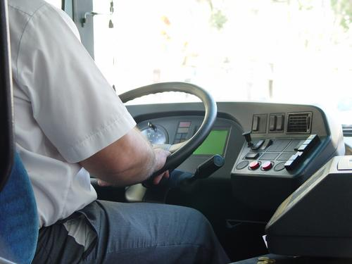
Entry 1: Writing
Transport

Module: Induction

Module aims

Main aim

We are learning to write in simple sentences.

Other learning aims
We are learning to:
- Use words you see and hear at work
- To write words in the plural


Module: Induction
Main aim: We are learning to write in simple sentences.

In English simple sentences are made up of:
subject – verb – object or S V O
Mona checks tickets. Faris drives a bus. We handle baggage.
The subject is what the sentence is about.
The verb is the action that happens.
The object shows what the action is about.
Sentences start with a capital letter:
He has a knife. She helps me. Tell me your name.
Sentences end with a full stop.

Task 1: Induction

We are using a text about induction training to answer questions in sentences. Read the text. Then read the questions. Find the answer in the text. Complete the sentences from the text.
Induction is training for new employees. Your line manager gives a talk on your first day. Your line manager is the person in charge. You learn what to do in your job. You learn the names of people who tell you what to do. You learn the names of other people you work with.

Other names for a line manager:
manager
supervisor
boss
team leader
fleet leader

Write the name of your line manager’s job:
___________________
Questions can start with:
What to find out something
Who to know about a person
How to find out a way to do something
Questions end with a question mark ?

1. What is an induction?
An induction is ___training for new employees___.
2. Who gives the talk?
Your ___________________
3. Who is in charge?
Your line manager _________________
4. How long does your induction last?
Your induction_______________________________
5. What do you find out?
You find out_______________________________
You find out_______________________________
6. What do we tell you about?
We tell you about_______________________________

In this company your induction lasts for six weeks. Everyone who works for us learns the same things. This makes sure that each person does a good job.
You find out how to do different tasks. You learn how to use equipment. You find out where to go for first aid.
We tell you about health and safety.

Word check
You see the words health and safety at work. These words have a special meaning. They are a short form for the Health and Safety at Work Act. This is a law to keep you safe at work.
Task 2: Parts of a sentence
Here are some sentences about induction. Use the information to show which word is the:
the subject the verb the object
We have done an example for you.

Your | manager | gives | a | talk
 | S | V |  | O

1. The talk is on the first day.
2. You learn the names of people.
3. The induction lasts for four weeks.
4. Each person learns the same things.
5. Each person does a good job.
6. She drives a train.
7. He finds out about safety equipment.
8. You ask the person in charge.

Using punctuation
Each sentence starts with a capital or upper case letter: A T H
Each sentence ends in a full stop.
We use capital letters for:
People’s names: Hakim Merid, Maya, Deren
Names of places: Bristol, London, Preston, Gatwick Airport
Names of companies: Boots, Aldi, First Bus, Virgin
Names of days or months: Monday, April
When you write about yourself: I

Task 3: Using punctuation
Look at the writing. It needs some punctuation. Put in the correct punctuation. The first one is an example.
sara gives albin a uniform
Sara gives Albin a uniform.
1. i need the file
2. my name is maya
3. please help me carry the parcels
4. can you get asim a cup of tea?
5. you must not smoke there
6. what day am i working?
7. you are working on tuesday
8. i go to london on friday

We call words that begin with a capital letter proper nouns.

Task 4: Writing simple sentences
Sometimes you have to write things down. You write down the times you work on your time sheet. You write notes to other people. You write reports. You write names of things and numbers. We are practising writing in simple sentences.
In this example Hakim, a new bus driver, is at the end of his shift. A passenger smashed a bottle of juice at the back of the bus. Read what he says to Rula. Read what Rula says to Hakim. He writes a note. He uses simple sentences.
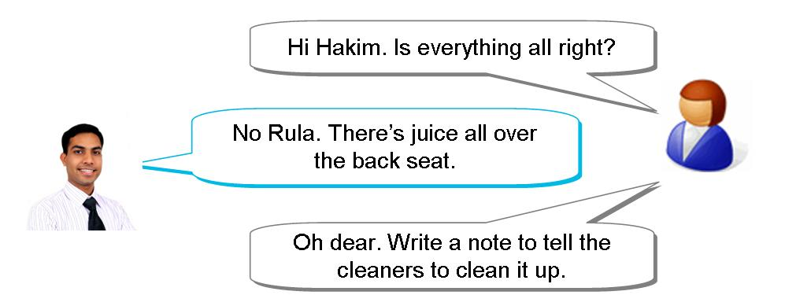
What does Hakim write in his note?
Hakim writes:
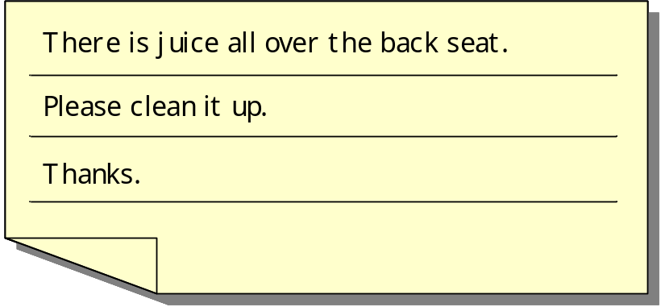

1. Hakim returns to the depot. He meets Rula. Read their conversation and then write an entry for Hakim’s report. Write in simple sentences.
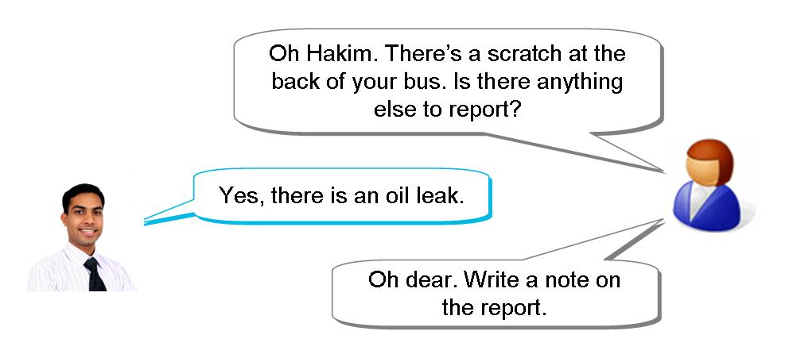
Write the report:
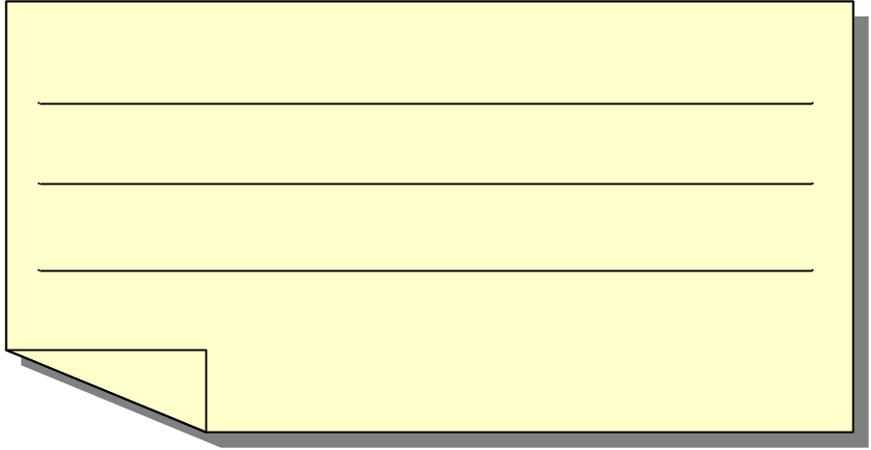

2. Dara is a new station assistant. It is the end of his shift. Maras, the station manager, asks him to write a message. Read their conversation. Then write a note for Dara. Write in simple sentences.
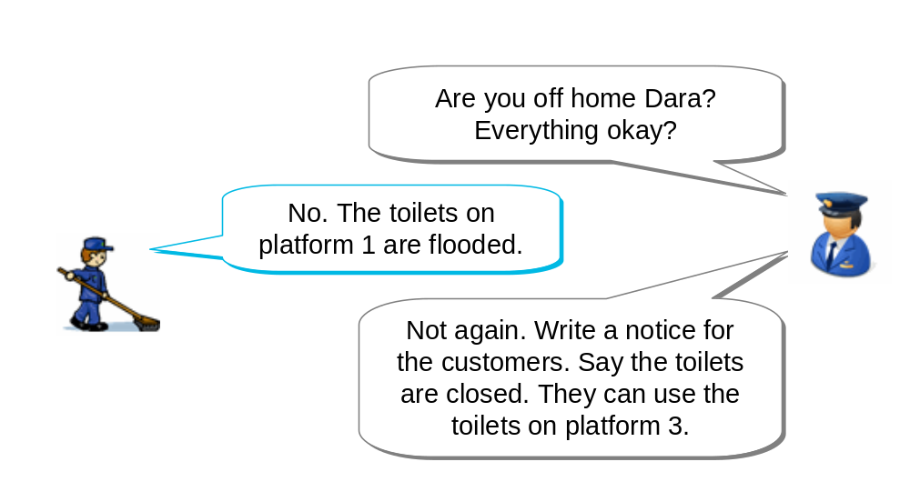

Write the notice for the customers:

Aim: We are using words you hear and see at work in this activity. We are learning about writing words in the plural. Plural means more than one.

Making the plural of nouns
A noun is a word that names something. The word train is a noun. Your name is a noun.
When you write about more than one thing, you add an s to the end of the noun.
driver drivers
week weeks

If a noun ends in s ss x z sh ch, you add es to the end of the word.
scratch scratches
bus buses
box boxes

There are some words that do not follow the rule.
person people
woman women
man men
child children
foot feet
Word Check
singular the form of the word we use when we write or talk about one thing
plural the form of the word we use when we write or talk about two or more things

Task 5: Plurals
Here are some words you hear at work. The words are in a sentence. They have a line under them. Write that word in the plural in the gap. The first one is an example. Note how some verbs change.

There is one job to do.
There are many jobs to do.
1. Check the baggage label.
Check the baggage _______.
2. The person buys a ticket.
The _________ buy tickets.
3. Induction lasts a week.
Induction lasts six ________ .
4. The man learns to use the public address system.
The _____ learn to use the public address system.
5. The manager is in charge.
The ____________ are in charge.
6. The woman is a trainer.
The _________ are trainers.
7. Write your name on the roster.
Write your ________ on the roster.
8. There is one thing to do.
There are many _______ to do.

Task 6: Word grid
Here are some of the words from the reading tasks. Fill these words into the word grid. We have put some letters in the grid to help you. The first one is an example.

induction | people | home | fire
supervisor | weeks | women | boss
person | emergency | things | names
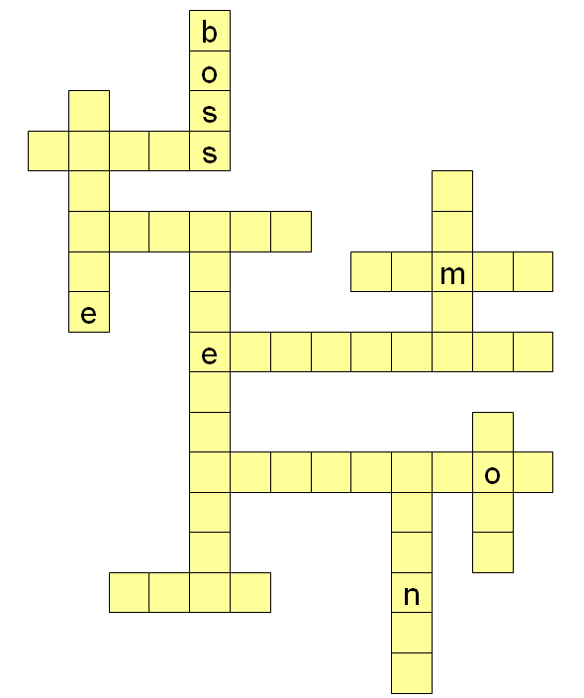

How did you get on?

Module 1: Induction answers

Task 1 answers

1. What is an induction?
An induction is ___training for new employees___.
2. Who gives the talk?
Your ___line manager gives a talk on your first day____
3. Who is in charge?
Your line manager ___is the person in charge_____
4. How long does your induction last?
Your induction________lasts for six weeks_________
5. What do you find out?
You find out______how to do different tasks___________
You find out______where to go for first aid____________
6. What do we tell you about?
We tell you about______health and safety____________

Task 2 answers

1. The |  |  |  | talk |  |  |  |  | is |  |  |  | on |  |  |  |  | the |  |  |  |  |  |  | first |  |  |  |  |  | day.
 |  |  |  | S |  |  |  |  | V |  |  |  |  |  |  |  |  |  |  |  |  |  |  |  |  |  |  |  |  |  | O
2. You |  |  |  |  |  | learn |  |  |  |  |  | the |  |  |  |  |  |  | names |  |  |  |  |  |  |  |  |  |  | of |  |  | people.
S |  |  |  |  |  | V |  |  |  |  |  |  |  |  |  |  |  |  | O
3. The |  |  | induction |  |  |  |  |  |  |  |  |  |  |  |  | lasts |  |  |  |  |  | for |  |  |  |  |  | six |  |  |  |  |  | weeks.
 |  |  | S |  |  |  |  |  |  |  |  |  |  |  |  | V |  |  |  |  |  |  |  |  |  |  |  |  |  |  |  |  |  | O
4. Each |  |  |  |  |  |  | person |  |  |  |  |  |  | learns |  |  |  |  |  |  |  |  | the |  |  |  |  |  | same |  |  |  |  |  | things.
 |  |  |  |  |  |  | S |  |  |  |  |  |  | V |  |  |  |  |  |  |  |  |  |  |  |  |  |  |  |  |  |  |  |  | O
5. Each |  |  |  |  |  |  | person |  |  |  |  |  |  | does |  |  |  |  |  | a |  |  |  |  |  | good |  |  |  |  |  | job.
 |  |  |  |  |  |  | S |  |  |  |  |  |  | V |  |  |  |  |  |  |  |  |  |  |  |  |  |  |  |  |  | O
6. She | drives |  |  |  |  |  |  |  |  |  | a train
S | V |  |  |  |  |  |  |  |  |  | O
7. You |  | find |  |  |  |  |  | out |  |  |  |  |  |  | about |  |  |  |  |  |  |  |  | safety equipment.
S |  | V |  |  |  |  |  |  |  |  |  |  |  |  |  |  |  |  |  |  |  |  |  | O
8. You |  |  |  |  | tell |  |  |  |  | the |  |  |  |  |  |  | person |  |  |  |  |  |  |  |  |  | in |  |  | charge.
S |  |  |  |  | V |  |  |  |  |  |  |  |  |  |  |  | O

Task 3 answers

1. I need the file.
2. My name is Maya
3. Please help me carry the parcels.
4. Can you get Asim a cup of tea?
5. You must not smoke there.
6. What day am I working?
7. You are working on Tuesday.
8. I go to London on Friday.

Task 4 answers

Your note might look like this:
1.
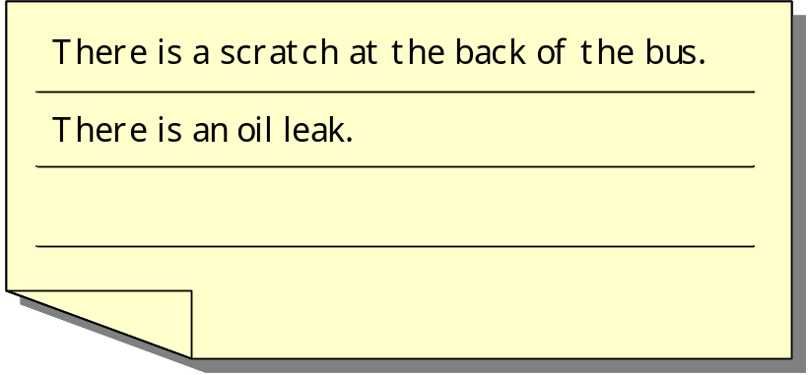

2.

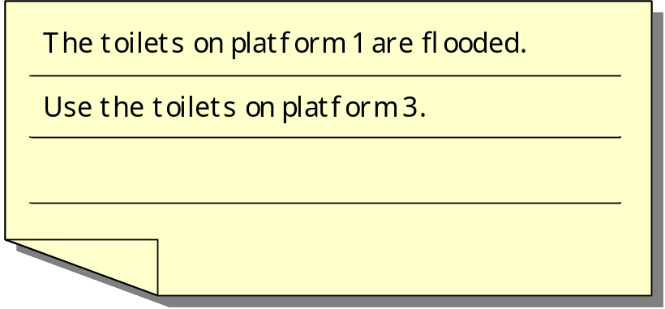

Task 5 answers

There is one job to do.
There are many jobs to do.
1. Check the baggage label.
Check the baggage __labels__.
2. The person buys a ticket.
The __people___ buy tickets.
3. Induction lasts a week.
Induction lasts six __weeks___.
4. The man learns to use the public address system.
The __men___ learn to use the public address system.
5. The manager is in charge.
The ___managers____ are in charge.
6. The woman is a trainer.
The ___women_____ are trainers.
7. Write your name on the roster.
Write your __names___ on the roster.
8. There is one thing to do.
There are many __things___ to do.

Task 6 answers



