
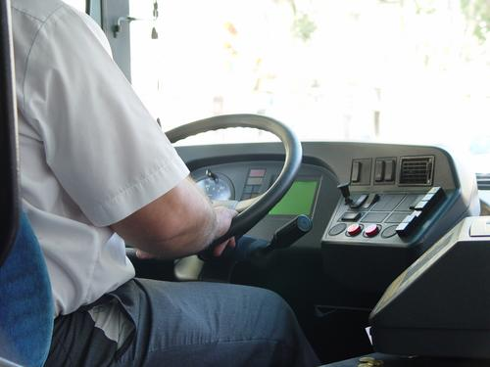
Entry 2: Writing
Transport

Module: Writing formal messages and reports

Module aims

Main aim

We are learning to write in simple and compound sentences.

Module: Writing formal messages and reports

Aim: We are learning to write in simple and compound sentences.
There are times when you need to write in simple sentences.
You use sentences when you write:

formal messages | 
formal messages | 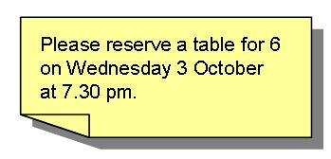
incident and accident reports. | 

subject – verb – object or S V O
Artur tries the brakes. Mona gives change. We move the trolleys.

The subject is what the sentence is about.
The verb is the action that happens.
The object shows what the action is about.
You can join two simple sentences together with a conjunction. A conjunction is a word that joins two sentences together. This makes a compound sentence.
These are conjunctions you see a lot.
and but as or
Artur tries the brakes and he checks the horn
Linda sells tickets but she does not clean the platform.
I want to call control as I need to report a problem.
He works days in the week or he does evenings at the weekend.
and joins two sentences about a similar subject together
but joins two sentences when the second sentence refers back to the first – the second part usually contrasts with the first
as joins two sentences when the second sentence shows the reason for the first
or joins two sentences where they show a choice between two things

Task 1: Using conjunctions


Join these sentences together. Use the conjunction that suits the meaning. The example shows you what to do.

and | but | as | or
He can go back to the depot now. The mechanic fixed the brakes.
He can go back to the depot now as the mechanic fixed the brakes.

1. Rita checked the tyres ______ she adjusted the wheel nuts.
2. Jules tried to keep to the timetable ______ there was a signal failure.
3. You can unload the plane ______ you can help me check the tags.
4. Frank needs a hi vis jacket _____ he is working on the track.
5. You can issue tickets _____ you can help on the information desk.
6. You need a trolley _____ those bags are very heavy.
7. I checked the first aid box _____ replaced the bandages.
8. The bus has a defect _____ it’s safe to go to a changeover point.

Task 2: Joining sentences
Read this text about Cam’s training day. Then write the passage again using these linking words.

and | but | as | or
Only use them where you think it helps the text to make good sense.
Cam came to work on Tuesday. He went straight to the training room. The door was locked. The instructor was late. Cam went to get a key. He opened the door for the trainees. The instructor arrived. He started to tell the trainees about manual handling. Lifting loads carefully is important. You can damage your back. When you have to lift a very heavy load you can use different lifting aids. You can ask someone to help you. Cam took notes. He wanted to make sure he remembered.
Cam came to work on Tuesday and he went straight to the training room.
Punctuation
Each sentence starts with a capital or upper case letter: A T H C L
Each sentence ends in a full stop.
We use capital letters for:
People’s names: Stef, Novak, Lee, Yin, Omar, Shafi
Names of places: Bristol, London, Preston, Queen Street Station, Stansted Airport
Names of companies: Arriva, First Group, Virgin, Transport for London
Names of days or months: Monday, April
When you write about yourself: I
We call nouns that start with capital letters proper nouns.
Questions end with a question mark. ?
Task 3: Using punctuation
Look at the writing. It needs some punctuation. Put in the correct punctuation. The example shows you what to do.
maya shows salim how to check codes
Maya shows Salim how to check codes.
1. i drove from leeds to bradford and back for six months
2. my training starts on monday
3. oleg is on holiday in august.
4. can you do the shift on thursday evening
5. my sister maria is my next of kin she lives at 14 lever grove
6. olenka asks luke for the staff rotas
7. i work for a company called city transport

Remember in the module Duties at Work we practised:
- using helping verbs to show meaning You must do that.
- using the present tense He helps her.
- using the present continuous She is checking the windows.
- using the past tense We trained yesterday.
In this module we have looked at:
- using linking words to join sentences
- using full stops and capital letters.
We are going to use all these things to write short reports at work.
Task 4: Writing accident and incident reports
If there is an accident at work or you hurt yourself, you need to write an incident or accident report. Read what Omar tells Rula about an accident at work. No one was hurt. Read the report.
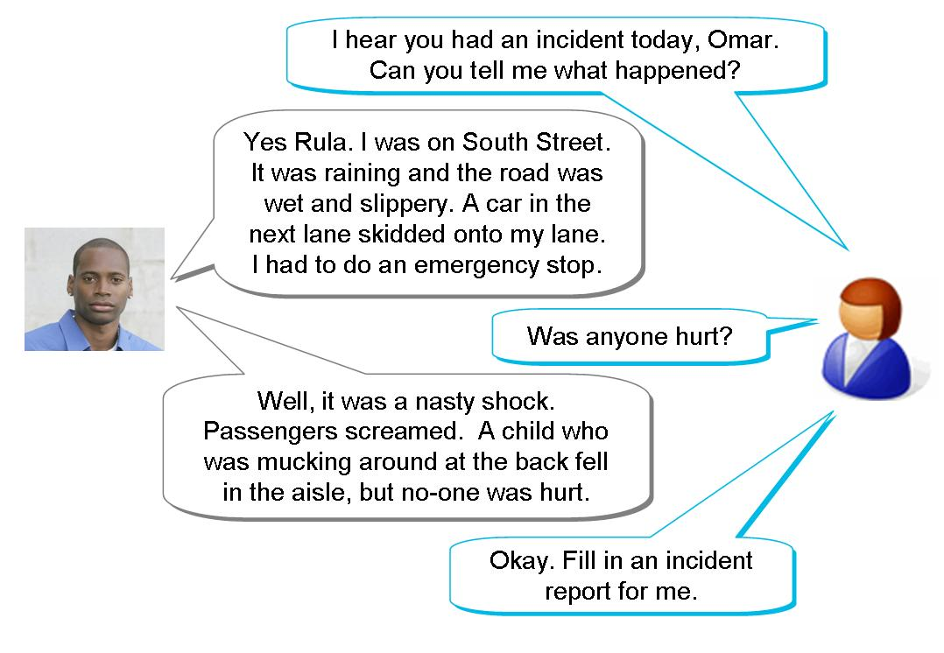
When Omar writes the report he only writes the facts. He does not write everything he tells Rula. He does not write what he thinks.
He writes in formal language.
Read Omar’s report on the next page:

City Transport
Incident Report Form
Remember to sign and date the form and ask your manager to countersign it.

Drivers full name: |  |  | Omar Sayeed |  |  |  | Employee number: |  |  |  |  |  |  |  |  | A456
Depot: | Bow Street |  |  | Route: |  | 34 | Fleet no: |  |  | 1612 |  | Vehicle reg: T192 LDV
Date of incident: |  |  |  | 12/02/09 |  |  | Time: |  |  |  |  |  | 14:25
Exact location of incident: |  |  |  | South Street, 100 metres from junction with Tiller Road.
Was anyone injured: |  |  |  | Y / N |  |  |  | Who?
Nature of injury:
Were the police involved: |  |  |  |  | Y / N |  |  | PC name/no./station:
Crime reference no: |  |  |  |  |  |  |  | Is CCTV available? |  |  |  |  |  |  | Y / N
Type of incident: please tick ✓
 Vandalism |  |  Collision in depot |  |  |  |  |  |  |  Passenger |  |  |  |  |  Traffic
Description of incident (give as much information as possible)
It was raining and the road was wet. A car skidded in front of the bus. I did an emergency stop. A child fell over in the aisle. No-one was hurt.

The words accident and incident are sometimes used to mean the same thing.
Here an incident is a bad event that may cause damage or hurt someone.
An accident is used to mean a bad event when someone is hurt or something is badly damaged.

Vocabulary
collision a vehicle banging into another vehicle or something else
no short form of number
location place
vandalism crime of damaging something on purpose
CCTV closed-circuit television, TV cameras that send signals to monitors used for security

1. Some time later Omar is involved in another incident. Read what he says and write the description for him.
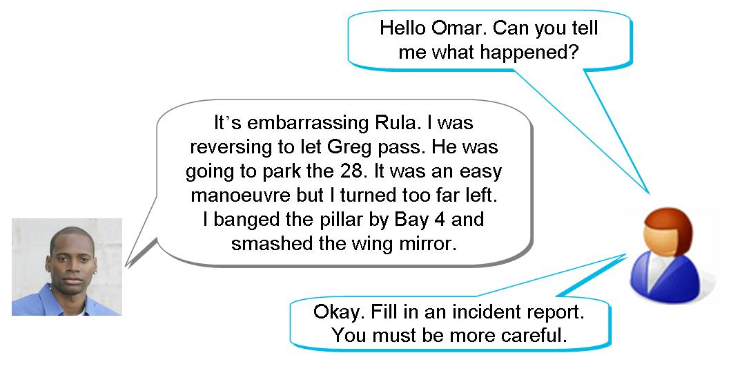

1. Fill in the incident report for Omar.

City Transport
Incident Report Form
Remember to sign and date the form and ask your manager to countersign it.

Drivers full name: |  |  | Omar Sayeed |  |  |  | Employee number: |  |  |  |  |  |  |  |  | A456
Depot: | Bow Street |  |  | Route: |  | 34 | Fleet no: |  |  | 1612 |  | Vehicle reg: T192 LDV
Date of incident: |  |  |  | 12/04/09 |  |  | Time: |  |  |  |  |  | 14:25
Exact location of incident:
Was anyone injured: |  |  |  | Y / N |  |  |  | Who?
Nature of injury:
Were the police involved: |  |  |  |  | Y / N |  |  | PC name/no./station:
Crime reference no: |  |  |  |  |  |  |  | Is CCTV available? |  |  |  |  |  |  | Y / N
Type of incident: please tick ✓
 Vandalism |  |  Collision in depot |  |  |  |  |  |  |  Passenger |  |  |  |  |  Traffic
Description of incident (give as much information as possible)

Filling in an accident report form
Accident report forms are similar to incident report forms. Rudi is a baggage handler. He has an accident at work. Read what Rudi tells Olenka about his accident.
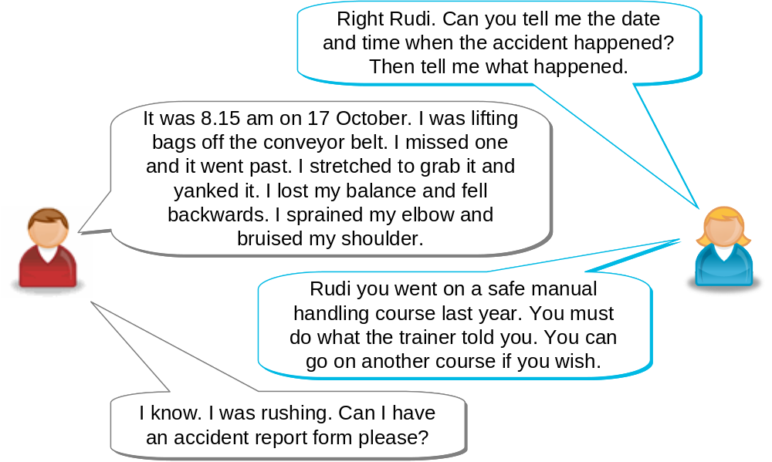

Key words and phrases
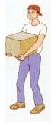 |  |  |  | 
cannot see over the top |  | shoulder |  | elbow
injured getting hurt in an accident
bruise an injury where the skin is not broken but is a dark colour
safe manual handling picking up and carrying heavy objects safely
occupation name of job
sprain an injury to a joint, elbows, ankles and wrists are joints
yank slang for pull with a quick movement

Filling in days and dates
If the form asks for a day, you must write the name of the day:

Monday | Tuesday |  | Wednesday |  | Thursday
Friday |  | Saturday |  | Sunday
If you are asked for a date, you can write it in numbers. For instance:
17 10 2009 is the same as 17th October 2009
Accident report form
This is an example of an accident report form. Your workplace will have its own forms. We have filled it in for Rudi.

ABC Ground Handling
Accident Report Form
Date of accident: |  | 17th October 2009
Time of accident: |  | 8.15 am
Address where accident happened: |  | Dalton Airport  Airport Way  Dalton
Postcode: |  | DA21 6SX
Full name of injured person: |  | Rudi Perera
Mr/Ms/Other: |  | Mr
Home Address: |  | 23 Swan Street  Dalton
Postcode: |  | DA6 3LX
Occupation: |  | Baggage Handler
Description of accident: |  | I was lifting bags of the conveyor belt. I stretched to grab a bag. I pulled it off, lost my balance and fell backwards. I sprained my elbow and bruised my shoulder.
Signed: | R. Perera |  | Date: | 20 October 2009
2. Now you try. Read about this accident and fill in the form with your address, the address of your workplace and a description of the accident.
You were on a training course at 15:30 on Friday 5 April. When you stopped for a break you went to get a cup of coffee. A cleaner was washing the floor. here was a sign but you did not see it. You came round the corner but did not see the bucket on the floor. You tripped over it. You sprained your left wrist and bruised your arm badly. You went to the hospital. They put your arm in a sling. You wrote the report when you came back to work on Thursday 11 April.

Accident Report Form
Date of accident: |  | ________________________________
Time of accident: |  | ________________________________
Address where accident happened: |  | ________________________________  ________________________________  ________________________________
Postcode: |  | ________________________________
Full name of injured person: |  | ________________________________
Mr/Ms/Other: |  | ________________________________
Home Address: |  | _________________________________  _________________________________  _________________________________
Postcode: |  | _________________________________
Occupation: |  | _________________________________
Description of accident: |  | _________________________________________________  _________________________________________________  _________________________________________________  _________________________________________________
Signed: | _________________ |  | Date: | _______________________

Sickness self-certificate
When you are ill at work, you need to fill in a sickness self-certificate. You have to write about your illness.
This is an example of a sickness self certificate. Your workplace will have its own version.
Look through it and pick out any key words or phrases that you do not know.

PERSONAL DETAILS (Please use BLOCK CAPITALS.)
MR/MS/MISS/MRS | FAMILY NAME |  |  | FIRST NAME(S)
PERIOD OF SICKNESS
FROM  (first day on which you were sick) |  | (day) | date |  | month | year
TO  (final day on which you were sick) |  | (day) | date |  | month | year
DETAILS OF SICKNESS
Please give information about the reason for your absence.

Is the absence because of an injury that happened at work? (Please tick the right box.)
Yes  No 
(If YES you should complete an Accident Report Form)
Do you consider you have a disability (as defined by the DDA)? Yes  No 
Is the absence because of the disability? Yes  No 
DECLARATION BY EMPLOYEES
I declare that the above information is correct.
Signed:..............................................................................................................

Key words and phrases
You might have picked out:
period of sickness the time you are off work sick
details of sickness information about the illness
absence not at work
reason for your absence why you are not at work
disability not being able to use your body fully
DDA The Disability Discrimination Act – this is a law that says that employers have to support people with a disability, there are disabilities named in the Act
Accident Report Form A form at work that you fill in if you have an accident
declaration signing that something is true
Illnesses that might stop you working
a bad cold | 
a migraine | 
a skin infection | 
an accident when you were not at work | 
diarrhoea | 
sickness or vomiting | 
stomach pains or upset stomach | 

Common illnesses
a cold an infection in the nose and throat, you may have a sore throat, head, chest or muscles, you may cough and have a slight fever
flu short for influenza, it’s like a very bad cold
diarrhoea an infection which makes your body’s solid waste come out in a liquid form, it is also called the runs as you have to run to the toilet
migraine a very bad headache, sometimes with sickness or vomiting
skin infection sore, itchy skin, sometimes called rashes or dermatitis

Task 5: Filling in a sickness self-certificate
Fill in the sickness self-certificate. Use your own first and last name. Use these notes to fill in these sections:

PERIOD OF SICKNESS From Tuesday 9th April to Thursday 11th April this year

DETAILS OF SICKNESS (Remember to write this section in complete sentences.)

headache sore throat fever

PERSONAL DETAILS (Please use BLOCK CAPITALS.)
MR/MS/MISS/MRS | FAMILY NAME |  |  | FIRST NAME(S)
PERIOD OF SICKNESS
FROM  (first day on which you were sick) |  | (day) | date |  | month | year
TO  (final day on which you were sick) |  | (day) | date |  | month | year
DETAILS OF SICKNESS
Please give information about the reason for your absence.

Is the absence because of an injury that happened at work? (Please tick the box.)
Yes  No 
(If YES you should complete an Accident Report Form)
Do you consider you have a disability (as defined by the DDA)? Yes  No 
Is the absence because of the disability? Yes  No 
DECLARATION BY EMPLOYEES
I declare that the above information is correct.
Signed:..............................................................................................................

How did you get on?

Module 2: Writing formal messages and reports answers

Task 1 answers

1. Rita checked the tyres __and___ she adjusted the wheel nuts.
2. Jules tried to keep to the timetable ___but___ there was a signal failure.
3. You can unload the plane ___or___ you can help me check the tags.
4. Frank needs a hi-vis jacket __as__ he is working on the track.
5. You can issue tickets __or__ you can help on the information desk.
6. You need a trolley __as___ those bags are very heavy.
7. I checked the first aid box __and___ replaced the bandages.
8. The bus has a defect __but___ it’s safe to go to a changeover point.

Task 2 answers

Cam came to work on Tuesday and he went straight to the training room. The door was locked as the instructor was late. Cam went to get a key and he opened the door for the trainees. The instructor arrived and he started to tell the trainees about manual handling. Lifting loads carefully is important as you can damage your back. When you have to lift a very heavy load you can use different lifting aids or you can ask someone to help you. Cam took notes as he wanted to make sure he remembered.

Task 3 answers
1. I drove from Leeds to Bradford and back for six months.
2. My training starts on Monday.
3. Oleg is on holiday in August.
4. Can you do the shift on Thursday evening?
5. My sister Maria is my next of kin. She lives at 14 Lever Grove.
6. Olenka asks Luke for the staff rosters.
7. I work for a company called City Transport.

Task 4 answers
Your reports might look like this.
1.

City Transport
Incident Report Form
Remember to sign and date the form and ask your manager to countersign it.

Drivers full name: |  |  | Omar Sayeed |  |  |  | Employee number: |  |  |  |  |  |  |  |  | A456
Depot: | Bow Street |  |  | Route: |  | 34 | Fleet no: |  |  | 1612 |  | Vehicle reg: T192 LDV
Date of incident: |  |  |  | 22/04/09 |  |  | Time: |  |  |  |  |  | 10:45
Exact location of incident:
Was anyone injured: |  |  |  | Y / N |  |  |  | Who?
Nature of injury:
Were the police involved: |  |  |  |  | Y / N |  |  | PC name/no./station:
Crime reference no: |  |  |  |  |  |  |  | Is CCTV available? |  |  |  |  |  |  | Y / N
Type of incident: please tick ✓
 Vandalism |  |  Collision in depot |  |  |  |  |  |  |  Passenger |  |  |  |  |  Traffic
Description of incident (give as much information as possible)
I was reversing to let the no 28 bus pass. I turned too far left.
I banged the pillar by Bay 4 and smashed the wing mirror.

2.

Accident Report Form
Date of accident: |  | __5 April 20____________________
Time of accident: |  | __15.30_________________________
Address where accident happened: |  | ___(write your workplace address)____  ________________________________  ________________________________
Postcode: |  | ________________________________
Full name of injured person: |  | ___(write your name and address)_____
Mr/Ms/Other: |  | ________________________________
Home Address: |  | _________________________________  _________________________________  _________________________________
Postcode: |  | _________________________________
Occupation: |  | _________________________________
Description of accident: |  | I came out of the training room to make a cup of coffee._____  I went round a corner and tripped over a bucket on the floor.__  I sprained my left wrist and bruised my arm badly. I went_____  To the hospital. My arm is in a sling._____________________
Signed: | _________________ |  | Date: | ___11 April 20______________

Task 5 answers

PERSONAL DETAILS (Please use BLOCK CAPITALS.)
MR/MS/MISS/MRS | FAMILY NAME |  |  | FIRST NAME(S)
PERIOD OF SICKNESS
FROM  (first day on which you were sick) |  | (day)  TUESDAY | date  9 |  | month  4 | year  20__
TO  (final day on which you were sick) |  | (day)  THURSDAY | date  11 |  | month  4 | year  20__
DETAILS OF SICKNESS
Please give information about the reason for your absence.
I HAD A BAD COLD WITH A SORE THROAT, HEADACHE AND FEVER

Is the absence because of an injury that happened at work? (Please tick the box.)
Yes  No 
(If YES you should complete an Accident Report Form)
Do you consider you have a disability (as defined by the DDA)? Yes  No 
Is the absence because of the disability? Yes  No 
DECLARATION BY EMPLOYEES
I declare that the above information is correct.

Signed:..............................................................................................................

