
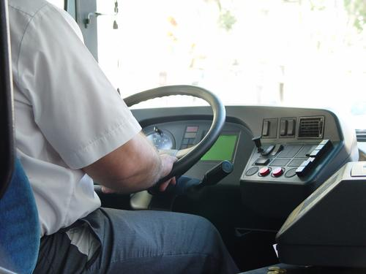
Level 1: Reading
Transport

Module: Training and qualifications

Module aims

Main aim
We are learning to read information on training and qualifications.

Other learning aims
We are learning:
- Terms about training
- To read information on tests and training for meaning and detail
- To ask questions about texts
- Practicing using how much and how many


Module: Training and qualifications
Coach and Bus drivers have to have a special licence called the Passenger Carrying Vehicle Licence. From September 2008 all drivers have to pass a new test for a Driver Certificate of Professional Competence or Driver CPC. Experienced drivers also have to do regular training. Olga, the training manager for Forward Travel gives staff from the driving division a talk on the new qualification. This is part of her presentation.
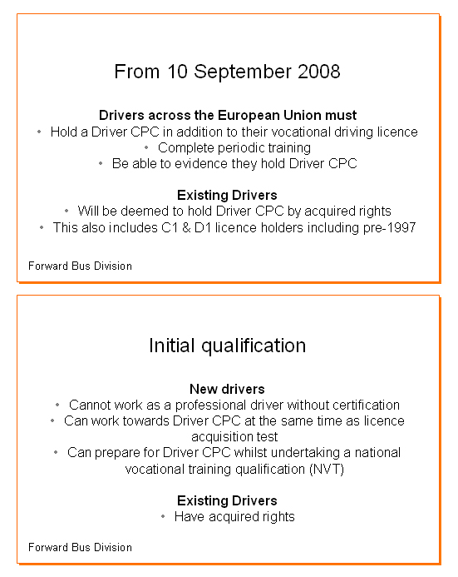


Task 1: Understanding words and phrases
Read the slides and check any words or phrases (groups of words) that you do not understand. Sometimes the other words in the sentence can give you an idea about what the word means. Answer these questions about the information from the slides. Put a tick ✓ in the correct box. The first one is an example.

 | Yes | No
You must have a driving licence to start driving a bus or coach. | ✓
If you passed your test to drive passenger carrying vehicles before 1997 you are allowed to work as a bus driver.
Acquired rights to drive are rights your employer gives you.
Periodic training is training you do while you are employed as a driver.
You can do training for your CPC while learning to be a professional coach or bus driver.
Periodic means something that happens regularly over a period of time.
All drivers must do initial training before starting to work as a professional.

Vocational qualifications are qualifications you do for a particular job. In the UK we have a system of National Vocational Qualifications (NVQ). People over the age of 18 with a full driving licence who want to become bus, coach or lorry drivers
can work towards a National Vocational Qualification Level 2 in Road
Passenger Transport.

What type of training do drivers have to do?
You can obtain a Driver CPC by completing four hours of theory testing and two hours of practical tests. The tests can be taken in modules. A module is a unit or part of a course or test that you can take when you are ready. When you complete and pass all the modules you achieve a qualification, a certificate or, in this case a vocational licence and Driver CPC.
The modules will be:
- 2 hours 30 minutes theory test
- 1 hour 30 minutes theory test (case studies)
- 1 hour 30 minutes practical test
- 30 minutes practical demonstration of vehicle safety.
The following table shows the modular approach to acquiring a vocational licence and/or Driver CPC:

 | Module 1  Theory Test  Multiple choice and hazard perception test  (2 ½hrs) | Module 2  Case studies  (1 ½ hrs) | Module 3  Practical test  (1 ½ hrs) | Module 4  Driver CPC Practical test  Vehicle safety demo  ( ½ hr)
Licence acquisition only | * |  | *
Full Driver CPC | * | * | * | *
Upgrade to Driver CPC |  | * |  | *

Theory test Module 1 has 100 multiple choice questions and 20 hazard perception clips. The pass mark will be 85. The number of hazard perception clips will increase in April 2008.

Theory test Module 2 Candidates have to answer questions on case studies. They have 1 hour 30 minutes to complete this module.

Practical test Modules 3 and 4 follow the current ‘show me, tell me’ methodology that is used in the practical driving test taken by all car drivers. Candidates have to demonstrate their knowledge of vehicle safety.

Task 2: Language in official documents
We are looking at the expressions used in official documents to see if you understand the full meaning of the expressions used in the presentation. Look at these phrases or sentences and match them with one that means the same. The first one is an example.
You are exempt from this test. |  | Short video films showing dangers on the road.
Hazard perception clips |  | The test does not have to be taken all at once. You can do different parts at different times.
Practical test |  | You need to pass a test by answering questions using a computer.
The tests can be taken in modules. |  | A test where you do something instead of only writing.
Multiple choice questions |  | You don’t have to do this test because of your experience or qualifications.
You need to pass theory tests. |  | An approach or way of doing something.
Methodology |  | A test that gives you different answers and you choose the right one.

What’s in the training?
A syllabus is a plan of the subjects that you study on a course. Olga showed the drivers this slide and gave them more information about the content of each of the main groups of subjects.
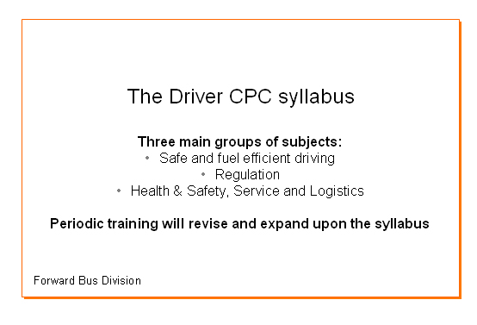
Task 3
These boxes tell you more about each of the main groups of subjects. Can you write the number – 1, 2 or 3 as a heading for each box?
This may include:  - rules about using a tacograph  - the hours you are allowed to drive  - the breaks you must take  - when you should take breaks. |  | This may include:  - first aid  - passenger safety  - customer service  - dealing with emergencies  - personal wellbeing.

This may include:
- fuel consumption
- vehicle loading
- pollution
- reducing wear and tear on the vehicle.

Periodic training
Read what Olga says about the training drivers need to do.

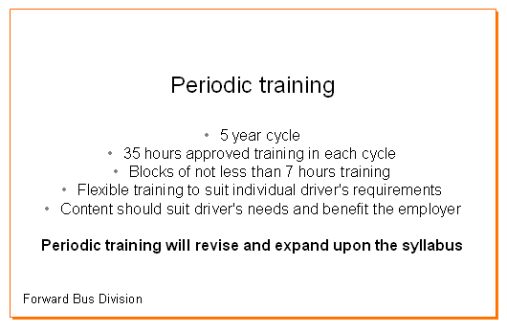

Key words and phrases
5-year cycle a group or series of events that are repeated after five years
block a group of things, here it means a training module
flexibility can be changed or adapted easily, the opposite of flexible is inflexible
maximum the most, greatest amount, the opposite of maximum is minimum
relevant as close as possible to what the drivers need or want to learn, the opposite of relevant is irrelevant

Task 4: Asking questions
Olga tells her audience to ask her questions. These are the questions they ask about periodic training. Olga’s answers are below the questions. Can you match the answers to the questions? Write the number of the answer beside the question. The first one is an example.

The drivers’ questions:
3 | How many hours training do I have to do?
 | Do all of us have to do periodic training or is it just for drivers who are new or who got their licence in another country?
 | Do we have to do more tests?
 | I am an experienced driver, how much time do I have to complete periodic training?
 | What do we have to learn on the training?
 | Can we choose the training we do?
Olga’s answers:
1. Periodic training applies to ALL professional drivers.
2. Periodic training has to be completed every five years.
3. Each 5-year cycle requires 35 hours of training in modules of at least seven hours.
4. The training syllabus is the same as the initial qualification syllabus.
5. We aren’t telling drivers what training they have to complete or when they have to do it. This gives maximum flexibility and allows drivers and their employers to choose the most relevant training according to the driver’s need at the time, e.g. first aid training, training on new equipment or training on new regulations.
6. There is no test at the end of periodic training.

Remember
Remember: if a question starts with how many? or how much? the answer has a number in it.
Task 5: How much? How many?
We use how much to ask about things you cannot count.
How much diesel do you need? 100 litres
How much time do you spend driving? 4 hours

We use how many to ask about things you can count.
How many litres do you need? 100 litres
How many hours do you spend driving? 4 hours

Choose much or many to complete the following questions. The first one is an example.
How much / many is the fare to Bristol?
How much / many kilometres from the city centre to Whitfield Park?
How much / many tickets did you sell today?
How much / many training do I need to do?
How much / many leg room is there on this plane?
How much / many bags do you have?

How did you get on?

Module 1: Training and qualifications answers

Task 1 answers

 | Yes | No
You must have a driving licence to start driving a bus or coach. | ✓
If you passed your test to drive passenger carrying vehicles before 1997 you are allowed to work as a bus driver. | ✓
Acquired rights to drive are rights your employer gives you.
Periodic training is training you do while you are employed as a driver. | ✓
You can do training for your CPC while learning to be a professional coach or bus driver. | ✓
Periodic means something that happens regularly over a period of time. | ✓
All drivers must do initial training before starting to work as a professional. |  | ✓

Task 2 answers

You are exempt from this test. |  | You don’t have to do this test because of your experience or qualifications.
Hazard perception clips |  | Short video films showing dangers on the road.
Practical test |  | A test where you do something instead of only writing.
The tests can be taken in modules. |  | The test does not have to be taken all at once. You can do different parts at different times.
Multiple choice questions |  | A test that gives you different answers and you choose the right one.
You need to pass theory tests. |  | You need to pass a test by answering questions using a computer.
Methodology |  | An approach or way of doing something.

Task 3 answers
2. Regulation |  | 3. Health and safety, service and logistics
This may include:  - rules about using a tacograph  - the hours you are allowed to drive  - the breaks you must take  - when you should take breaks. |  | This may include:  - first aid  - passenger safety  - customer service  - dealing with emergencies  - personal wellbeing.

1. Safe and fuel efficient driving
This may include:
- fuel consumption
- vehicle loading
- pollution
- reducing wear and tear on the vehicle.
Task 4 answers

The drivers’ questions:
3 | How many hours training do I have to do?
1 | Do all of us have to do periodic training or is it just for drivers who are new or who got their licence in another country?
6 | Do we have to do more tests?
2 | I am an experienced driver, how much time do I have to complete periodic training?
4 | What do we have to learn on the training?
5 | Can we choose the training we do?

Olga’s answers:
1. Periodic training applies to ALL professional drivers.
2. Periodic training has to be completed every five years.
3. Each 5-year cycle requires 35 hours of training in modules of at least seven hours.
4. The training syllabus is the same as the initial qualification syllabus.
5. We aren’t telling drivers what training they have to complete or when they have to do it. This gives maximum flexibility and allows drivers and their employers to choose the most relevant training according to the driver’s need at the time, e.g. first aid training, training on new equipment or training on new regulations.
6. There is no test at the end of periodic training.

Task 5 answers

How much / many kilometres from the city centre to Whitfield Park?
How much / many tickets did you sell today?
How much / many training do I need to do?
How much / many leg room is there on this plane?
How much / many bags do you have?

