
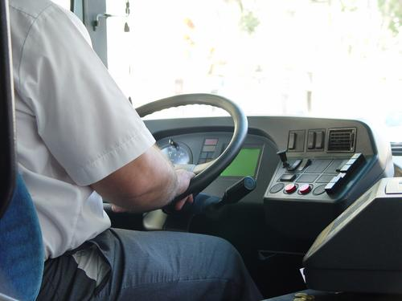
Level 1: Writing
Transport

Module: Progressing in your job

Module aims

Main aim
We are learning to write in complex sentences using conjunctions, phrases and clauses.

Other learning aims
We are learning to:
- Use phrases and subordinate clauses;
- Plan a presentation


Aim: We are learning to write in complex sentences using conjunctions, phrases and clauses.
Good employers will invite you to an annual review of your skills and identify areas where you would like or need more training. There will be:
- skills that are common to all jobs
communication | 
personal and people skills | 
health, safety and security | 
service improvement | 
quality | 
equality and diversity | 
- skills that are specific to a certain job
leadership skills to become a supervisor or team leader
marshalling aircraft for aviation ground staff
mechanical knowledge of the vehicle you drive.

There are other occasions when you might need to talk or write about your job. For example if you apply for a new job or when you are doing an exam. When you prepare for your review, you will use different types of writing:
- short notes to help you think about what you will write
- formal writing in simple, compound and complex sentences.

Remember, a simple sentence or main clause has a:
subject | verb | (and sometimes) object
Hillel | wrote | an accident report
A compound sentence is two main clauses joined by a conjunction:
subject | verb | object | conjunction
The driver | tested | the rear lights | and then

subject | verb | object
he | turned on | the control key
A complex sentence is one that has a main clause and one or more subordinate clauses:
subject | verb | subordinate clause
The pilot light | was off | because a cab door was still open.

It is called a subordinate clause because it cannot stand alone.
We can write:
The pilot light was off. This is a complete piece of meaning.
But not:
because a cab door was still open.
This clause cannot stand alone. It needs to be added to the main clause to make sense.
At Entry 3 you also learned about the pronouns that can start a subordinate clause:
that | who | which | where | when

that and which | shows an animal or thing | 
who | shows a person | 
where | shows a place | 
when | shows time | 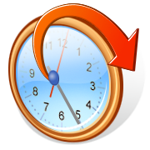

Remember
If you need to revise the different kinds of sentence, look at the Entry 2 and 3 Writing materials.

Using phrases
A phrase is a group of words without a verb. It cannot be a sentence or main clause because it does not have a verb. A phrase is used to tell you more about:
the subject the verb or the object of a sentence.
Nam, the Route Operations Manager, made an announcement.
This phrase is used to tell you more about Nam. You show it is a phrase by using a comma to separate it from the main clause where this is appropriate. The sentence would still make sense if you took the phrase away.
Nam made an annoucement.
These phrases tell you more about the verb and the object.
Without making a mistake, Lev completed his practical driving test.
With great skill, Renato drove the new high speed engine.
Task 1: Find the phrases

Read this text and underline the phrases in it. The first one is an example.
My role as a Route Operations Manager
The operations role consists of the day to day running of train services with a strong emphasis on customer service. My team have to keep customers and staff informed about the service, especially during disruptions. We must be sure that our information is consistent, reliant and concise, as well as easy to understand.
Based in London and networked, our system is designed to pass on information to websites, National Rail enquiries, station announcements and text alerts, maintaining accuracy is of the highest importance. Every decision has an impact on our customers so we do our best to get it right.
With over ten years’ experience, I have got a broad knowledge of different aspects of the industry. I started out in catering on the trains, before moving on to train revenue. After a stint as a guard, I worked in planning and then operations. All this has helped my relationship with my team. As their manager, trainer and mentor, they know I understand the pressures they are under. At the same time, they also know I am aware of any tricks they can get up to.

Task 2: Put in the phrases
Read the sentences. There are some phrases with them. Rewrite the sentence and put in the phrase where you think it should go. There might be more than one place where it makes sense. The example shows you what to do.
Osman will start his first shift on Friday. the new driver.
Osman, the new driver, will start his first shift on Friday.

1. Nita demonstrated correct lifting techniques. enthusiastic after her training
2. Tom asked for an early morning shift. nervous after his accident
3. We are going to have lunch. in the canteen after everyone has finished the training activity
4. I drove my first route successfully on supervised service without needing directions.
5. Uncomfortable seats can cause permanent damage. In some cases to your back.
6. Tom was asked to read a registration mark. for his eyesight test at a distance of 20 metres
7. He wrote an accident report. clearly describing the facts the day after the event.
8. Most control switches are placed in front of the driver. commonly used such as door opening buttons
9. Bill drove off the motorway. Feeling sleepy for a snooze.

Using conjunctions
Aim: We are learning to use conjunctions in a range of complex sentences.
You have learnt a range of conjunctions at Entry 2 and Entry 3.
At Entry 2, you learned to join two simple sentences (or main clauses) together with a conjunction to make a compound sentence.
and | but | as | or

and joins two sentences about a similar subject together
but joins two sentences when the second sentence refers back to the first
as joins two sentences when the second sentence shows the reason for the first or shows the time when something happens
or joins two sentences where they show a choice between two things
At Entry 3, you added some more conjunctions to this list.

Group 1: Conjunctions to do with time

when |  | before |  | since |  | 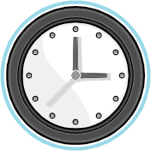
while | until |  | after |  | whenever
Group 2: Conjunctions with special meanings

...although the weather could improve...  ...unless you change your mind...  ...whether or not you agree with me...  ...because we are running late...  ...where Carla put it...  ...provided it stops raining...  ...if we get the baggage loaded soon... | 
There are some more conjunctions you can add to this list:
yet | for | nor | than | though | how
When a conjunction joins two main clauses together, the clauses still make sense if they stand alone.
I completed all the checks and I signed off the train log.
I completed all the checks. I signed off the train log.
Some conjunctions are only used to join a main clause to a subordinate clause to make a complex sentence. You learned about subordinate clauses at Entry 3.

main clause | subordinate clause
You cannot leave the depot | until you have checked the vehicle.
The most common conjunctions that join subordinate clauses are:
although | if | since | unless
until | because | whereas | while
Sometimes these conjunctions have more than one word:
in order that | such that | assuming that | so that | in case

If you accept constructive feedback, you can learn from your mistakes.
We shall reduce delays assuming that the new signalling system has fewer failures.
I have changed the shift rota in order that everyone completes the training this week.

Task 3: Put in the conjunction
Look at this piece of text from an interview with a train driver. Write a conjunction in the gaps from the list that you think makes best sense. Some conjunctions are used more than once. The first one is an example.

before | although |  | apart from |  | so that
and | even if |  | assuming that |  | for
in order that | that |  | provided |  | when
as well as |  | where |  | because

What did you have to do to become a train driver?
I was a ticket inspector before I became a train driver. You sit an entrance exam first. The training takes the best part of a year to complete. It is a modular course __________ you complete one part __________ move on to the next. Personal Track Safety or PTS is probably the easiest module. It makes everyone follows the safest procedures __________ on or near the line. Next comes route learning __________ you accompany a qualified driver over all the routes ________ you are allowed to drive.
The most difficult part is learning the rules. We call our rule book the book of death. Nearly all the rules have been made __________ someone has lost their life on the railway in the past so you need to know them backwards.
__________ you have passed the test on rules you do the traction course next. This is the first time you drive a train. You need to learn how to fix simple problems on the trains you drive __________ to incorporate the rules you have learned.
__________ you pass this part you are sent out with a driver trainer __________ you drive real passenger trains under instruction. This lasts for about 17 weeks. At the end of each module you sit an exam that lasts a whole day. __________ the tests are tough, you are allowed to attempt a test twice. The final exam is eight days long. You are assessed driving over all the routes you learn __________ being tested again on everything you have already passed.
What are the perks of this job?
________________ earning a good salary, you are your own boss – I am on my own most of the time with no-one looking over my shoulder. I can’t see myself doing anything else ever. __________ driving is not for you there are loads of jobs on the railway ____________ you can meet interesting and fun people.
Task 4: Writing about your job
Before you prepare to write about yourself or your job, you need to plan what you will write. You need to make notes on:
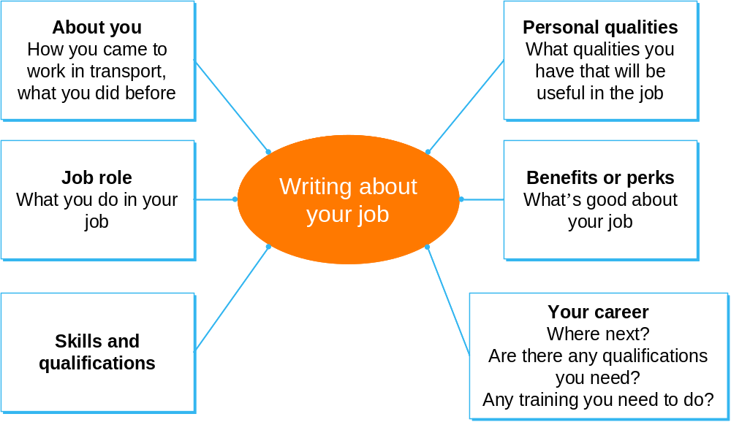

You could ask a co-worker or a friend to interview you about your job using the headings from the boxes above.
Here are some words that you might find useful.

Talking about yourself – your qualities
sociable | hard-working | conscientious | reliable
team worker | pleasant | capable | willing
trustworthy | flexible | punctual | loyal
problem solver | positive | motivated | thoughtful
thorough | competent | helpful | cheerful
dependable | responsible | keen | positive

Now think about your skills – we have put some examples in for you.

Talking about yourself – your skills
leadership | languages  (say what they are) | good with people
 |  | able to work alone

________________________________________________________________
________________________________________________________________
________________________________________________________________
________________________________________________________________
________________________________________________________________
________________________________________________________________
________________________________________________________________
________________________________________________________________
________________________________________________________________
________________________________________________________________
________________________________________________________________
________________________________________________________________
________________________________________________________________

How did you get on?

Module 2: Progressing in your job answers

Task 1 answers
My role as a Route Operations Manager
The operations role consists of the day to day running of train services with a strong emphasis on customer service. My team have to keep customers and staff informed about the service, especially during disruptions. We must be sure that our information is consistent, reliant and concise, as well as easy to understand.
Based in London and networked, our system is designed to pass on information to websites, National Rail enquiries, station announcements and text alerts, maintaining accuracy is of the highest importance. Every decision has an impact on our customers so we do our best to get it right.
With over ten years’ experience, I have got a broad knowledge of different aspects of the industry. I started out in catering on the trains, before moving on to train revenue. After a stint as a guard, I worked in planning and then operations. All this has helped my relationship with my team. As their manager, trainer and mentor, they know I understand the pressures they are under. At the same time, they also know I am aware of any tricks they can get up to.

Task 2 answers

1. Nita, enthusiastic after her training, demonstrated correct lifting techniques.
2. Tom, nervous after his accident, asked for an early morning shift.
3. After everyone has finished the training activity, we are going to have lunch in the canteen.
or
We are going to have lunch in the canteen after everyone has finished the training activity.
4. I drove my first route successfully, without needing directions, on supervised service.
5. In some cases, uncomfortable seats can cause permanent damage to your back.
6. Tom was asked to read a registration mark at a distance of 20 metres for his eyesight test.
7. The day after the event he wrote an accident report clearly describing the facts.
or
He wrote an accident report clearly describing the facts the day after the event.
8. Most commonly used control switches, such as door opening buttons, are placed in front of the driver.
9. Feeling sleepy, Bill drove off the motorway for a snooze.

Task 3 answers
I was a ticket inspector before I became a train driver. You sit an entrance exam first. The training takes the best part of a year to complete. It is a modular course __in that________ you complete one part ___and_____ move on to the next. Personal Track Safety or PTS is probably the easiest module. It makes everyone follows the safest procedures ____when______ on or near the line. Next comes route learning __where________ you accompany a qualified driver over all the routes ____before____ you are allowed to drive.
The most difficult part is learning the rules. We call our rule book the book of death. Nearly all the rules have been made ___because____ someone has lost their life on the railway in the past so you need to know them backwards.
Assuming that____ you have passed the test on rules you do the traction course next. This is the first time you drive a train. You need to learn how to fix simple problems on the trains you drive ____and______ to incorporate the rules you have learned.

Provided____ you pass this part you are sent out with a driver trainer ___and____ you drive real passenger trains under instruction. This lasts for about 17 weeks. At the end of each module you sit an exam that lasts a whole day. __Although____ the tests are tough, you are allowed to attempt a test twice. The final exam is eight days long. You are assessed driving over all the routes you learn ____as well as______ being tested again on everything you have already passed.
What are the perks of this job?
Apart from______ earning a good salary, you are your own boss – I am on my own most of the time with no-one looking over my shoulder. I can’t see myself doing anything else ever. __Even if________ driving is not for you there are loads of jobs on the railway ___where____ you can meet interesting and fun people.

