WEBEX – SCREEN PRINTS

WebEx ‘One-Click’

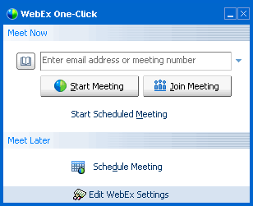

Launched from icon on desktop screen; it allows you to start a session on an ad-hoc basis or schedule a session that is going to run at a future date. This event information is inserted into the Outlook calendar.

Invitation email

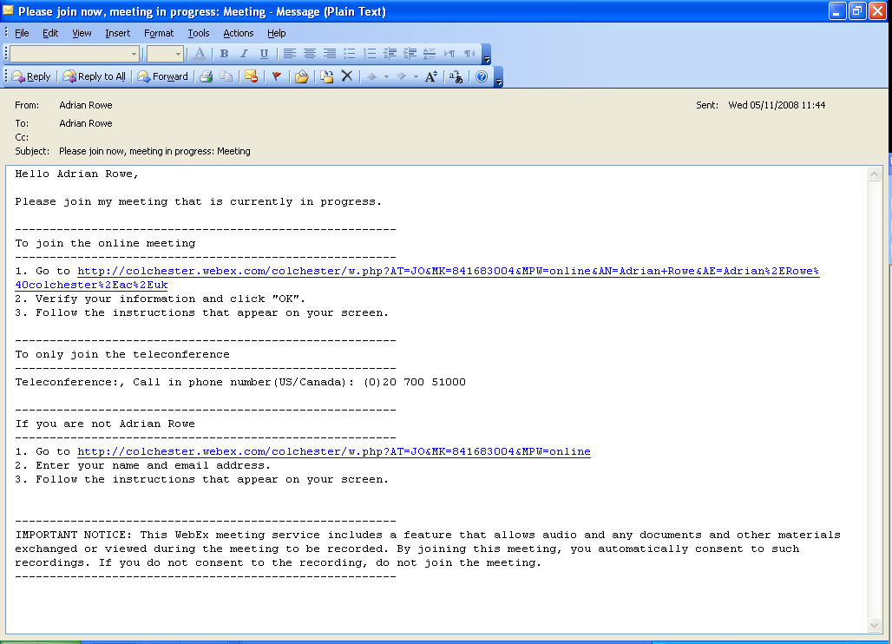
The participants are sent an email that includes a link for them to use to join the session.
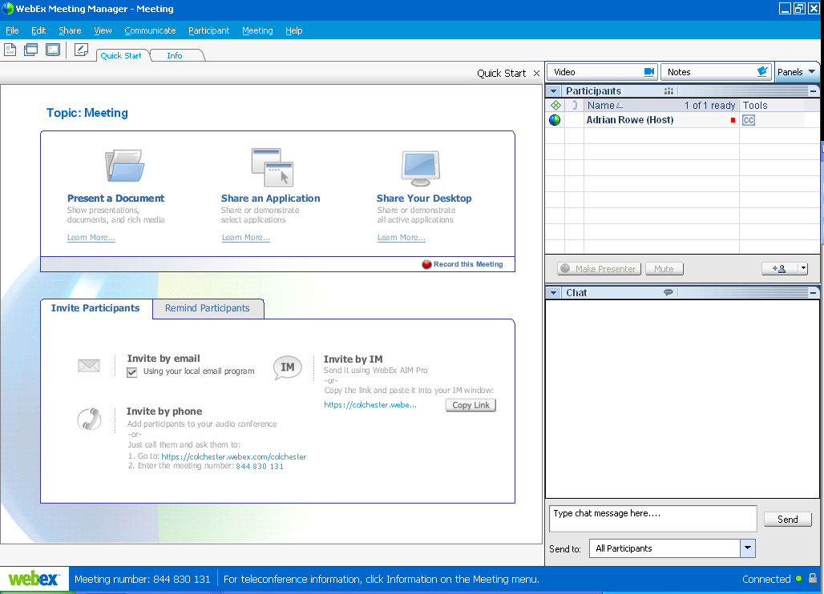
This is the initial display that is presented to the host and the participants alike. The names of the participants will be displayed in the Participants panel. The host can give them control by passing the WebEx ball.

Video & Audio Communication

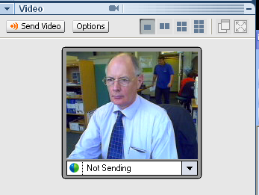
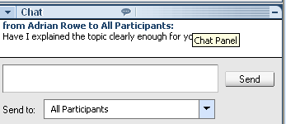
During a session it is possible to communicate using a telephone connection, integrated VOiP or text Chat.

Webcams can be used at certain points during a session to enhance the session by keeping the participants engaged.

Feedback Request

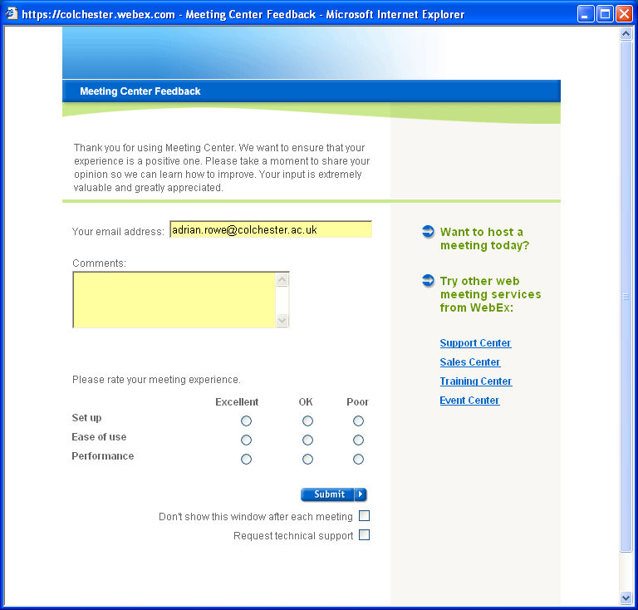
Participants are encouraged to complete a feedback survey at the conclusion of each session they take part in.

